UNITED STATES
SECURITIES AND EXCHANGE COMMISSION
Washington, D.C. 20549
SCHEDULE 14A
Proxy Statement Pursuant to Section 14(a) of
the Securities Exchange Act of 1934 (Amendment No. )
Filed by the Registrant ☒
Filed by a party other than the Registrant ☐
Check the appropriate box:
☐ |  |  |  |  |  | Preliminary Proxy Statement
☐ |  |  |  |  |  | Confidential, for Use of the Commission Only (as permitted by Rule 14a-6(e)(2))
☒ |  |  |  |  |  | Definitive Proxy Statement
☐ |  |  |  |  |  | Definitive Additional Materials
☐ |  |  |  |  |  | Soliciting Material under §240.14a-12

Micron Technology, Inc.
(Name of Registrant as Specified in Its Charter)
(Name of Person(s) Filing Proxy Statement, if other than the Registrant)
Payment of Filing Fee (Check all boxes that apply):
☒ |  |  | No fee required
☐ |  |  | Fee paid previously with preliminary materials.
☐ |  |  | Fee computed on table in exhibit required by Item 25(b) per Exchange Act Rules 14a-6(i)(1) and 0-11

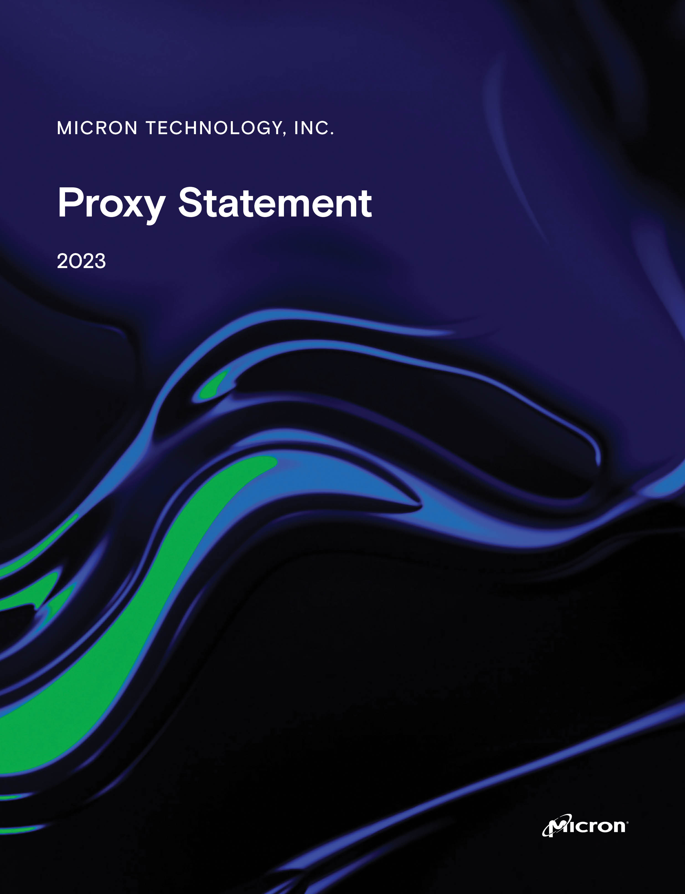





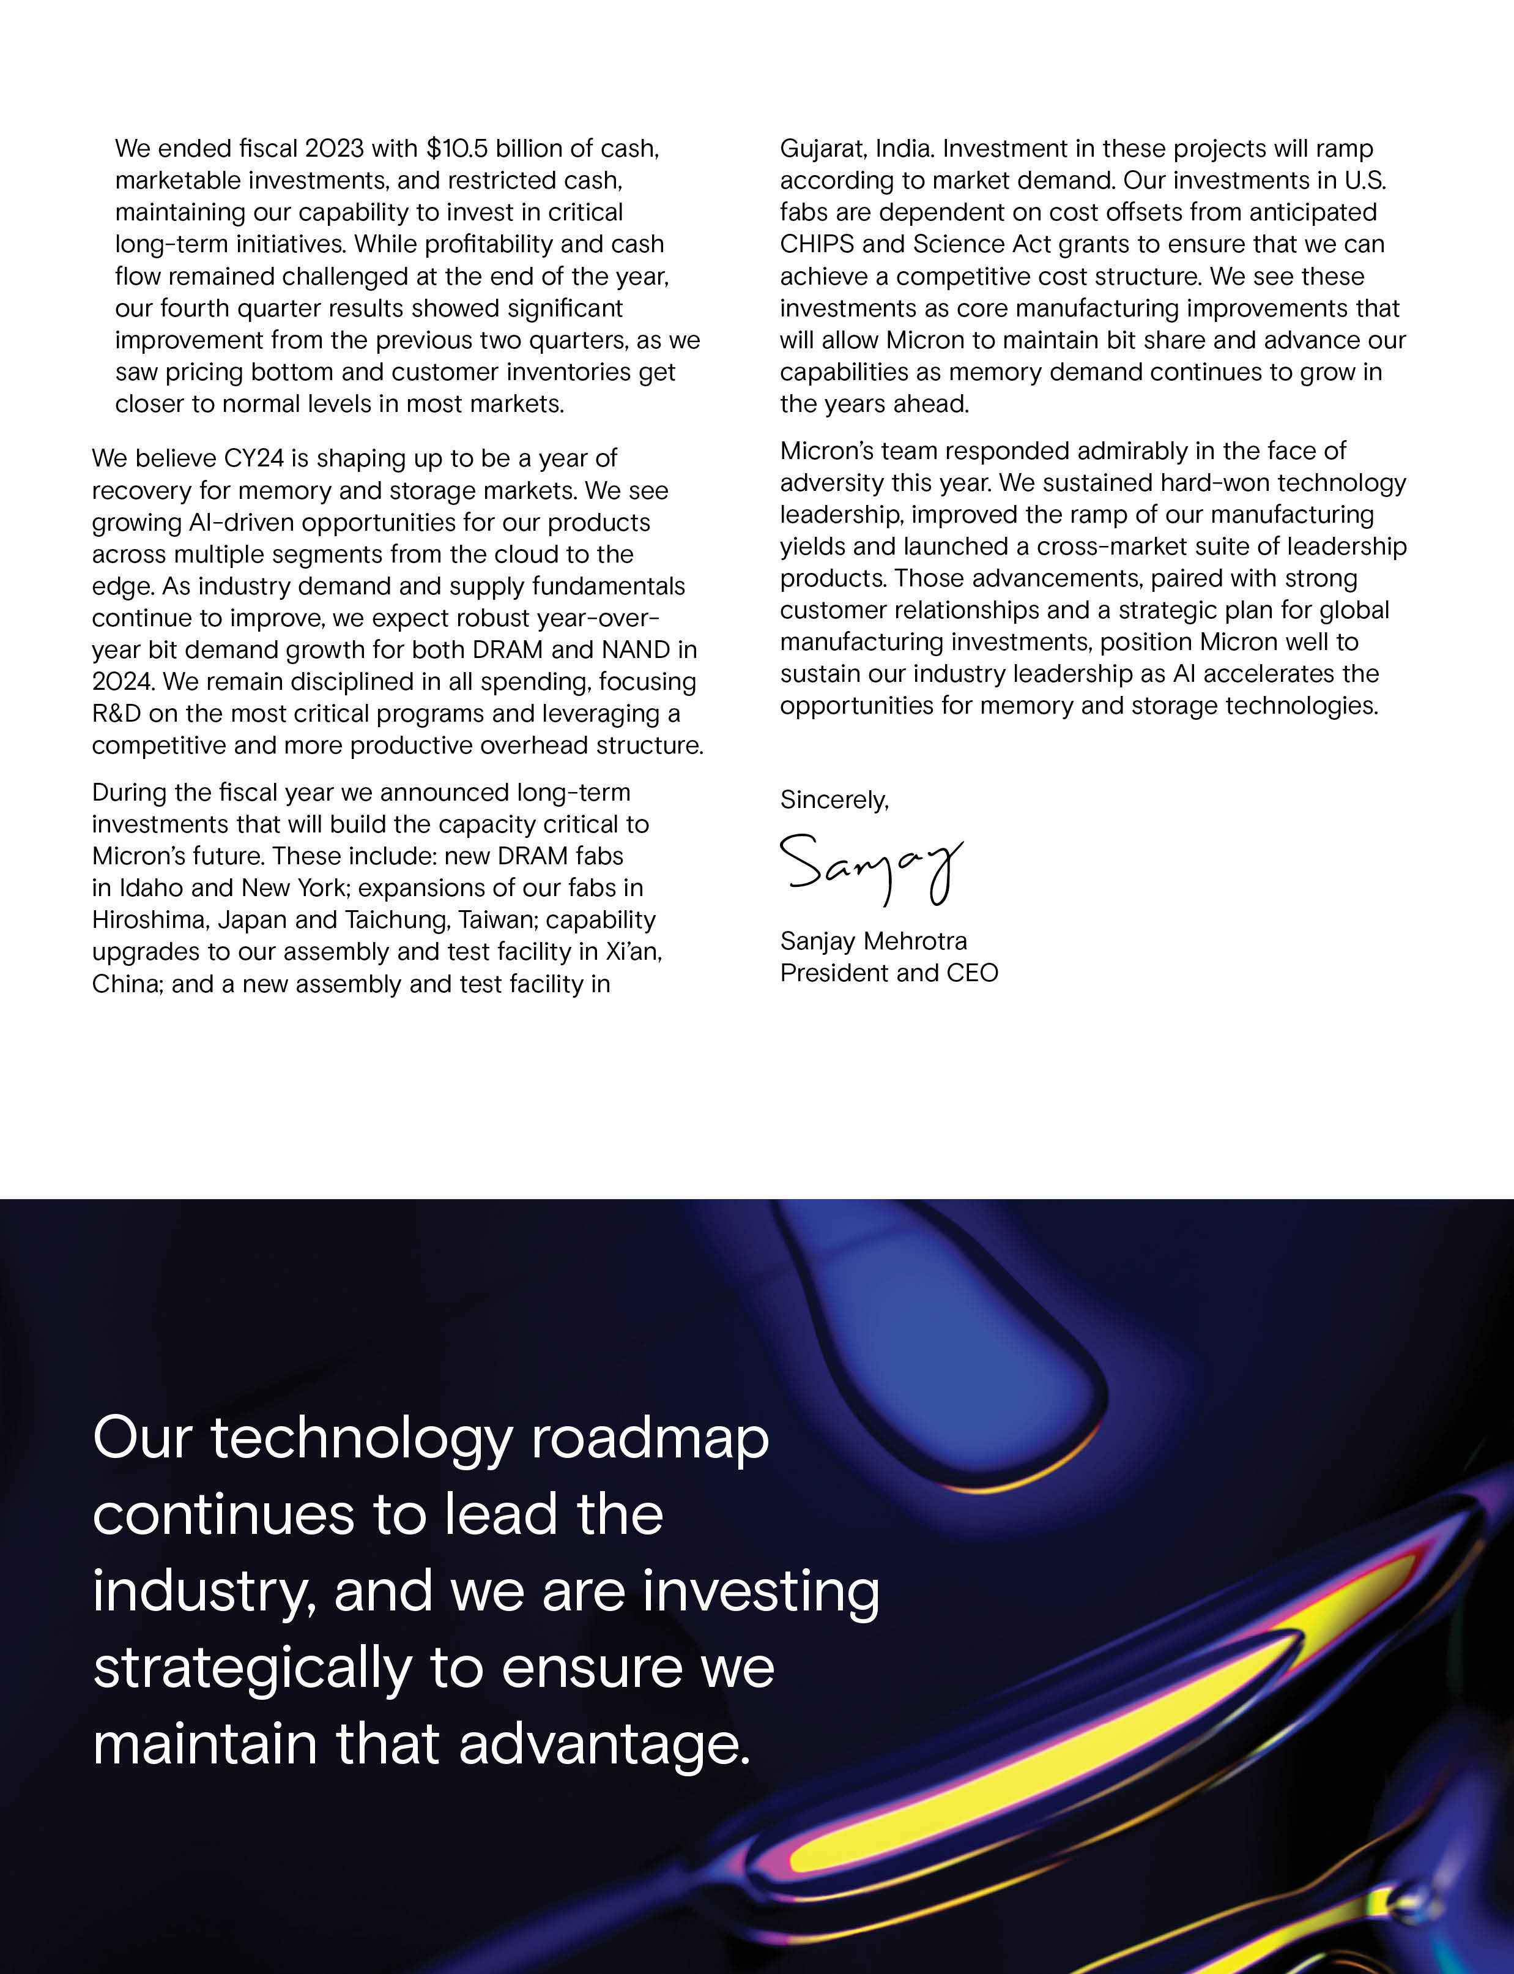

Notice of Fiscal 2023 Annual Meeting of Shareholders
January 18, 2024
To the Shareholders:

NOTICE IS HEREBY GIVEN that the Fiscal 2023 Annual Meeting of Shareholders of Micron Technology, Inc., a Delaware corporation, will be held virtually on January 18, 2024, at 9:00 a.m., Pacific Standard Time, for the purposes listed below. As used herein, “we,” “our,” “us,” the “Company,” and similar terms refer to Micron Technology, Inc., unless the context indicates otherwise.

1. To elect eight (8) directors to serve for the ensuing year and until their successors are elected and qualified;
2. To approve, on a non-binding basis, the compensation of our Named Executive Officers;
3. To approve, on a non-binding basis, the frequency (every one, two or three years) with which our shareholders will have an advisory vote on the compensation of our Named Executive Officers;
4. To ratify the appointment of PricewaterhouseCoopers LLP as our independent registered public accounting firm for the fiscal year ending August 29, 2024;
5. To vote on a shareholder proposal included in the accompanying proxy statement, if properly presented at the meeting; and
6. To transact such other business as may properly come before the meeting or any adjournment thereof.

The foregoing items of business are more fully described in the Proxy Statement accompanying this Notice.

Shareholders of record at the close of business on November 20, 2023 are entitled to receive notice of and to vote at the meeting and any postponements or adjournments of the meeting. A complete list of shareholders entitled to vote at the meeting will be available for ten days prior to the meeting at the Company’s headquarters and online during the meeting by visiting www.virtualshareholdermeeting.com/MU2023.

The Securities and Exchange Commission permits proxy materials to be furnished over the Internet rather than in paper form. Accordingly, unless otherwise requested, we are sending our shareholders a notice (the “Notice”) regarding the availability of this Proxy Statement, our Annual Report on Form 10-K for fiscal 2023, and other proxy materials (together, the “proxy materials”) via the Internet. This electronic process gives you fast, convenient access to the proxy materials, reduces the impact on the environment, and reduces our printing and mailing costs. If you received the Notice by mail, you will not receive a printed copy of the proxy materials in the mail. The Notice instructs you on how to access and review the proxy materials. The Notice also instructs you on how you may submit your vote over the Internet. If you received a Notice by mail and would like to receive a copy of our proxy materials by electronic mail or mail, you should follow the instructions for requesting such proxy materials included in the Notice.

We are pleased to provide shareholders with the opportunity to participate in the annual meeting online via the Internet in a virtual-only meeting format to facilitate shareholder attendance and provide a consistent experience to all shareholders regardless of location. We will provide a live webcast of the annual meeting at www.virtualshareholdermeeting.com/MU2023, where you will also be able to submit questions and vote online. You will not be able to attend the meeting at a physical location.

To ensure your representation at the meeting, you are urged to vote, whether or not you attend the meeting. You may vote by telephone or electronically via the Internet by following the instructions on the Notice. Alternatively, if you received a paper copy, you may sign, date, and return the proxy card in the postage-prepaid envelope enclosed for that purpose. Please refer to the instructions included with the proxy card for additional details. Shareholders attending the meeting may vote using the virtual meeting platform even if they have already submitted their proxy, and any previous votes that were submitted by the shareholder, whether by Internet, telephone, or mail, will be superseded by the vote that such shareholder casts at the meeting.
 |  |  |  |  |  | By Order of the Board of Directors
Boise, Idaho  November 29, 2023 |  |  |  |  |  | Mike Myers  Vice President, Interim General Counsel and Corporate Secretary

YOUR VOTE IS IMPORTANT. PLEASE SUBMIT YOUR PROXY PROMPTLY.

TABLE OF CONTENTS
Proxy Section |  |  | Page |  |  |  |  |  | Frequently Requested Information |  |  | Page
Information Concerning Solicitation and Voting |  |  | 1 |  |  |  |  |  | Auditor Fees |  |  | 81
Proposal 1 – Election of Directors |  |  | 4 |  |  |  |  |  | Beneficial Ownership Table |  |  | 87
Certain Relationships and Related Transactions |  |  | 23 |  |  |  |  |  | Board Diversity Matrix |  |  | 12
Director Compensation |  |  | 24 |  |  |  |  |  | Board Leadership |  |  | 20
Executive Compensation and Related Information |  |  | 27 |  |  |  |  |  | CEO Pay Ratio |  |  | 68
Proposal 2 – Say-on-Pay |  |  | 27 |  |  |  |  |  | Compensation Consultant |  |  | 51
Compensation Discussion and Analysis |  |  | 28 |  |  |  |  |  | Director Biographies |  |  | 6
Compensation Committee Report |  |  | 59 |  |  |  |  |  | Director Independence |  |  | 20
Summary Compensation Table |  |  | 60 |  |  |  |  |  | Director Skills and Experience Matrix |  |  | 5
Grants of Plan-Based Awards |  |  | 63 |  |  |  |  |  | Director Stock Ownership Guidelines |  |  | 26
Outstanding Equity Awards |  |  | 65 |  |  |  |  |  | Director Tenure |  |  | 12
Option Exercises and Stock Vested |  |  | 67 |  |  |  |  |  | Diversity, Equality, and Inclusion |  |  | 15
Nonqualified Deferred Compensation |  |  | 67 |  |  |  |  |  | Financial Performance |  |  | 28
Chief Executive Officer Pay Ratio |  |  | 68 |  |  |  |  |  | Human Capital and Culture |  |  | 15
Potential Payments Upon Termination or Change in Control |  |  | 69 |  |  |  |  |  | Pay-for-Performance |  |  | 34
Equity Compensation Plan Information |  |  | 74 |  |  |  |  |  | Peer Group |  |  | 53
Pay Versus Performance |  |  | 76 |  |  |  |  |  | Perquisites |  |  | 60
Proposal 3 - Frequency of Say-on-Pay |  |  | 80 |  |  |  |  |  | Related Party Transactions |  |  | 23
Audit Committee Matters |  |  | 81 |  |  |  |  |  | Sustainability |  |  | 16
Proposal 4 - Ratification of Appointment of PricewaterhouseCoopers LLP |  |  | 81
Proposal 5 - Shareholder Proposal |  |  | 83
Principal Shareholders |  |  | 87
Notice of Electronic Availability of Proxy Materials |  |  | 88
Incorporation by Reference of Certain Financial Information |  |  | 88
Householding of Proxy Statements and Annual Reports |  |  | 88
Cautionary Note on Forward-Looking Statements |  |  | 89
Deadline for Receipt of Shareholder Proposals |  |  | 89

Table of Contents
PROXY STATEMENT
FISCAL 2023 ANNUAL MEETING OF SHAREHOLDERS

January 18, 2024
9:00 a.m. Pacific Standard Time
____________________________

INFORMATION CONCERNING SOLICITATION AND VOTING

General

This proxy statement (the “Proxy Statement”) is furnished in connection with the solicitation of proxies on behalf of the Board of Directors of Micron Technology, Inc. (the “Board”), for use at the Fiscal 2023 Annual Meeting of Shareholders to be held on January 18, 2024, at 9:00 a.m., Pacific Standard Time, or at any adjournment or postponement thereof (the “Annual Meeting”). The purpose of the Annual Meeting is set forth herein and in the accompanying Notice of Fiscal 2023 Annual Meeting of Shareholders. The Annual Meeting will be held via a live webcast, and there will not be a physical meeting location. You will be able to attend the annual meeting online and to vote your shares electronically on the virtual meeting platform by visiting www.virtualshareholdermeeting.com/MU2023 and entering the 16-digit control number included in our Notice, on your proxy card, or in the instructions that accompanied your proxy materials.

Shareholders will be able to submit questions before the Annual Meeting through www.proxyvote.com or during the Annual Meeting using the virtual meeting platform. Relevant questions submitted before or during the Annual Meeting will be addressed after the Annual Meeting in the Investor Relations section of our website at www.micron.com.

We encourage you to access the Annual Meeting before it begins. Online check-in will start approximately 15 minutes before the Annual Meeting. If you have difficulty accessing the meeting or other technical or logistical issues, please call the technical support number that will be posted on the virtual Annual Meeting login page. We will have technicians available to assist you.

The Notice, this Proxy Statement, and related proxy card are first being made available on or about November 29, 2023, to all shareholders entitled to vote at the meeting.

Shareholders can vote their shares using one of the following methods:

•Vote through the Internet at www.proxyvote.com, using the instructions included in the notice regarding the Internet availability of proxy materials, the proxy card, or voting instruction card;

•Vote by telephone using the instructions on the proxy card or voting instruction card if you received a paper copy of the proxy materials;

•Complete and return a written proxy or voting instruction card using the proxy card or voting instruction card if you received a paper copy of the proxy materials; or

•Attend the meeting and vote electronically on the virtual meeting platform.

Internet and telephone voting are available 24 hours a day, and if you use one of those methods, you do not need to return a paper proxy or voting instruction card. Unless you are planning to vote at the Annual Meeting, your vote must be received by 11:59 p.m., Eastern Standard Time, on January 17, 2024.

1
Table of Contents
Record Date

Shareholders of record at the close of business on November 20, 2023 (the “Record Date”) are entitled to receive notice of and to vote at the meeting.

Revocability of Proxy

Any proxy given pursuant to this solicitation may be revoked by the person giving it at any time before its use by attending the Annual Meeting and voting online or by delivering to us a written notice of revocation at Micron Technology, Inc., Attn.: Corporate Secretary, 8000 South Federal Way, Boise, Idaho 83716 or corporatesecretary@micron.com or another duly executed proxy bearing a date later than the earlier given proxy but prior to the date of the Annual Meeting.

Solicitation

The Board of Directors is soliciting proxies for use at the Annual Meeting. We will bear the cost of solicitation. In addition, we may reimburse brokerage firms and other persons representing beneficial owners of shares for their expenses in forwarding solicitation materials to such beneficial owners. Proxies may be solicited by our directors, officers, and employees, without additional compensation, personally or by telephone or Internet. We have engaged the services of D.F. King & Co., a proxy solicitation firm, in connection with the solicitation of proxies. Although the exact cost of the solicitation services is not known at this time, it is anticipated that the fees paid by us for these services will be approximately $12,500.

Outstanding Shares

We have one class of stock outstanding, common stock, $0.10 par value per share (the “Common Stock”). As of the Record Date, 1,103,733,774 shares of Common Stock were issued and outstanding and entitled to vote.

Voting Rights and Required Vote

Under the Delaware General Corporation Law, our Restated Certificate of Incorporation, and our Amended and Restated Bylaws (“Bylaws”), each shareholder will be entitled to one vote for each share of Common Stock held at the Record Date for all matters. The required quorum for the transaction of business at the Annual Meeting is a majority in voting power of shares of our Common Stock issued and outstanding on the Record Date and entitled to vote thereat, present in person or represented by proxy. Shares that are voted “FOR,” “AGAINST,” or “ABSTAIN” are treated as being present at the Annual Meeting for the purposes of establishing a quorum. Broker non-votes will also be considered present and entitled to vote for purposes of determining the presence or absence of a quorum for the transaction of business.

Shares held in a brokerage account or by another nominee are considered held in “street name” by the shareholder or “beneficial owner.” A broker or nominee holding shares for a beneficial owner does not have discretion to vote on non-routine matters, such as matters relating to the election of directors and Proposals 2, 3 and 5 unless the broker or nominee receives specific voting instructions from the beneficial owner of the shares. A broker “non-vote” occurs when the broker or nominee does not receive voting instructions from the beneficial owner and does not have discretion to direct the voting of the shares.

Directors will be elected if the number of votes cast “FOR” a particular director exceeds the number of votes cast “AGAINST” that same director, with abstentions and broker-non votes not counted as a vote cast “FOR” or “AGAINST” that director’s election. With respect to all other items of business to be considered at the meeting, the “FOR” vote of the holders of a majority of the voting power of the shares of Common Stock attending online in person or represented by proxy is required in order for such matter to be considered approved by the shareholders. For such proposals, abstentions will have the same effect as voting against such items of business, and broker non-votes, if any, will have no effect on the outcome of the proposal. On the proposal to approve, on an advisory basis, the frequency of holding future advisory votes on the compensation of the Company’s Named Executive Officers, the voting option that receives the greatest number of votes, even if that option is not
2 | 2023 Proxy Statement
Table of Contents
approved by the holders of a majority of the voting power of the shares of Common Stock attending online in person or represented by proxy, will be considered the frequency preferred by shareholders.

Voting of Proxies

The shares of Common Stock represented by all properly executed proxies received by 11:59 P.M. Eastern Standard Time, on January 17, 2024 will be voted in accordance with the directions given by the shareholders. If no instructions are given with respect to a properly executed proxy timely received by us, the shares of Common Stock represented thereby will be voted (i) FOR each of the nominees named herein as directors, or their respective substitutes as may be appointed by the Board, (ii) FOR a non-binding resolution to approve the compensation of our Named Executive Officers as described in this Proxy Statement, (iii) Every “ONE YEAR” on the non-binding vote on the frequency of an advisory vote to approve the compensation of our Named Executive Officers, (iv) FOR ratification of the appointment of PricewaterhouseCoopers LLP as our independent registered public accounting firm for the fiscal year ending August 29, 2024, (v) AGAINST the shareholder proposal and (vi) in the discretion of the proxy holders for such other business which may properly come before the Annual Meeting.

3
Table of Contents
PROPOSAL 1 - ELECTION OF DIRECTORS
•All directors elected annually by a simple majority of votes cast
•Independent Board Chair
•Seven of eight director nominees are independent

Our Board is presenting eight (8) nominees for election as directors at the Annual Meeting. Each of the nominees is currently a member of our Board and was elected to our Board at the Fiscal 2022 Annual Meeting of Shareholders. Each director elected at the Annual Meeting will serve until our Fiscal 2024 Annual Meeting of Shareholders and until a successor is duly elected and qualified, except in the case of death, resignation or removal of such director. Each of the nominees has consented to be named in this Proxy Statement and to serve as a director if elected. If any nominee is unable or unwilling to stand for election or serve as a director if elected, the persons named as proxies may vote for a substitute nominee designated by our existing Board, or our Board may choose to reduce its size.

BOARD RECOMMENDATION

The Board recommends voting “FOR” the election of each of the nominees.

VOTE REQUIRED FOR APPROVAL

Each director nominee will be elected as a director if such nominee receives the affirmative vote of a majority of the votes cast with respect to his or her election (in other words, the number of shares voted “FOR” a director must exceed the number of votes cast “AGAINST” that director). Shareholders are not permitted to cumulate votes with respect to the election of directors.

If a nominee who is serving as a director is not elected at the Annual Meeting by the requisite majority of votes cast, Delaware law provides that the director would continue to serve on our Board as a holdover director. However, under our Bylaws, any incumbent director who fails to be elected must offer to tender his or her resignation to our Board following the procedures established by the Governance and Sustainability Committee. The Governance and Sustainability Committee will then make a recommendation to our Board on whether to accept or reject the resignation or whether other action should be taken. Our Board will act on the resignation, taking into account the Governance and Sustainability Committee’s recommendation, and publicly disclose its decision and the rationale behind it within 90 days from the date the election results are certified. Any director who offers to tender his or her resignation will not participate in the Board’s or the Governance and Sustainability Committee’s decision.

4 | 2023 Proxy Statement
Table of Contents
SUMMARY OF SKILLS AND EXPERIENCE OF DIRECTOR NOMINEES

The following table highlights the specific skills, experience, qualifications and attributes that each of the director nominees brings to the Board. A particular director nominee may possess other skills, experience, qualifications or attributes even though they are not indicated below.

Skills and Experience |  |  | Richard M. Beyer |  |  | Lynn A. Dugle |  |  | Steven J. Gomo |  |  | Linnie M. Haynesworth |  |  | Mary Pat McCarthy |  |  | Sanjay Mehrotra |  |  | Robert E. Switz |  |  | MaryAnn Wright
Independence |  |  | • |  |  | • |  |  | • |  |  | • |  |  | • |  |  |  |  |  | • |  |  | •
Multinational experience |  |  | • |  |  | • |  |  | • |  |  | • |  |  | • |  |  | • |  |  | • |  |  | •
Executive leadership (public or private) |  |  | • |  |  | • |  |  | • |  |  | • |  |  | • |  |  | • |  |  | • |  |  | •
Research and development |  |  | • |  |  | • |  |  |  |  |  | • |  |  |  |  |  | • |  |  | • |  |  | •
Technology industry |  |  | • |  |  | • |  |  | • |  |  | • |  |  | • |  |  | • |  |  | • |  |  | •
Corporate strategy |  |  | • |  |  | • |  |  | • |  |  | • |  |  | • |  |  | • |  |  | • |  |  | •
Corporate development |  |  | • |  |  | • |  |  | • |  |  |  |  |  |  |  |  | • |  |  | • |  |  | •
Corporate governance |  |  | • |  |  | • |  |  | • |  |  |  |  |  | • |  |  | • |  |  | • |  |  | •
Operations |  |  | • |  |  | • |  |  | • |  |  | • |  |  |  |  |  | • |  |  | • |  |  | •
Marketing |  |  | •
Cybersecurity |  |  |  |  |  | • |  |  |  |  |  | •
Other public board service |  |  | • |  |  | • |  |  | • |  |  | • |  |  | • |  |  | • |  |  | • |  |  | •
Finance |  |  | • |  |  | • |  |  | • |  |  |  |  |  | • |  |  | • |  |  | • |  |  | •
Auditing / accounting |  |  |  |  |  | • |  |  | • |  |  |  |  |  | • |  |  |  |  |  | •

5
Table of Contents
Nominees For Election
Board of Directors
  Richard M.  Beyer  Independent |  |  | Professional Experience
 |  |  | - |  |  | Chairman and Chief Executive Officer of Freescale Semiconductor, Inc. from 2008 through June 2012; director from 2008 to 2013.
 |  |  | - |  |  | Prior to Freescale, Mr. Beyer was President, Chief Executive Officer and a director of Intersil Corporation from 2002 to 2008.
 |  |  | - |  |  | Mr. Beyer previously served in executive management roles at FVC.com, VLSI Technology, and National Semiconductor Corporation, and served three years as an officer in the United States Marine Corps.
 |  |  | - |  |  | Within the past five years, Mr. Beyer served on the Board of Directors of Dialog  Semiconductor.
 |  |  | Other Current Public Company Directorships
 |  |  | - |  |  | None
 |  |  | Board Skills, Qualifications, and Expertise
 |  |  | Mr. Beyer’s experience as the chief executive officer and a director at leading technology companies provides our Board expertise in the technology industry and also in corporate strategy, financial management, operations, marketing, and research and development, all of which are critical to achieving our strategic objectives. We believe these experiences, qualifications, attributes, and skills qualify Mr. Beyer to serve as a member of our Board.
Age 75 | Director Since 2013 | Committees Compensation (Chair), Governance and Sustainability, Security

  Lynn A. Dugle  Independent |  |  | Professional Experience
 |  |  | - |  |  | Chairman, Chief Executive Officer, and President of Engility Holdings Inc., an NYSE-listed engineering services firm, from March 2016 to January 2019.
 |  |  | - |  |  | Prior to Engility, Ms. Dugle was Corporate Vice President, President of Intelligence and Information Systems of Raytheon Company from January 2009 to March 2015.
 |  |  | - |  |  | Within the past five years, Ms. Dugle served on the Board of Directors of State Street Corporation.
 |  |  | Other Current Public Company Directorships
 |  |  | - |  |  | EOG Resources, Inc.
 |  |  | - |  |  | KBR, Inc.
 |  |  | - |  |  | TE Connectivity Ltd.
 |  |  | Board Skills, Qualifications, and Expertise
 |  |  | Ms. Dugle’s experience as chairman and chief executive officer of a public engineering services firm and senior officer of a leading public technology company provides our Board expertise in information, technology, cybersecurity, corporate strategy, operations, and research and development, all of which are critical to achieving our strategic objectives. We believe these experiences, qualifications, attributes, and skills qualify Ms. Dugle to serve as a member of our Board.
Age 64 | Director Since 2020 | Committees Audit, Security (Chair)
6 | 2023 Proxy Statement
Table of Contents
Board of Directors

  Steven J.  Gomo  Independent |  |  | Professional Experience
 |  |  | - |  |  | Executive Vice President, Finance and Chief Financial Officer from October 2004 until his retirement in December 2011, and Senior Vice President, Finance and Chief Financial Officer from August 2002 to September 2004 at NetApp, Inc., a storage and data management company.
 |  |  | Other Current Public Company Directorships
 |  |  | - |  |  | Nutanix, Inc.
 |  |  | - |  |  | Enphase Energy, Inc.
 |  |  | Board Skills, Qualifications, and Expertise
 |  |  | Mr. Gomo’s experience as the chief financial officer of a public technology company provides our Board expertise in the technology industry, particularly in the areas of finance, accounting, treasury, investor relations, and securities, which contribute valuable insights and perspectives to our business and operations. We believe these experiences, qualifications, attributes, and skills qualify Mr. Gomo to serve as a member of our Board.
Age 71 | Director Since 2018 | Committees Audit, Finance (Chair)

  Linnie M. Haynesworth  Independent |  |  | Professional Experience
 |  |  | - |  |  | Sector Vice President, Cyber and Intelligence Mission Solutions Division from January 2016 to 2019, and Sector Vice President and General Manager from December 2013 to 2019 at Northrop Grumman, a defense and space company.
 |  |  | Other Current Public Company Directorships
 |  |  | - |  |  | Truist Financial Corporation
 |  |  | - |  |  | Automatic Data Processing, Inc.
 |  |  | - |  |  | Eastman Chemical Company
 |  |  | Board Skills, Qualifications, and Expertise
 |  |  | Ms. Haynesworth’s experience as the sector vice president and general manager of a public defense and space company provides our Board expertise in technology integration, cybersecurity (including a Certificate in Cybersecurity Oversight), enterprise strategy, risk management, and large complex system development, delivery, and deployment, and contributes valuable insights and perspectives to our business and operations. Additionally, Ms. Haynesworth became a Member of the Defense Business Board of the United States Department of Defense in November 2021. We believe these experiences, qualifications, attributes, and skills qualify Ms. Haynesworth to serve as a member of our Board.
Age 66 | Director Since 2021 | Committees Governance and Sustainability, Security

7
Table of Contents
Board of Directors

  Mary Pat  McCarthy  Independent |  |  | Professional Experience
 |  |  | - |  |  | Vice Chair of KPMG LLP, the U.S. member firm of the global audit, tax, and advisory services firm, from July 1998 until her retirement in December 2011. Ms. McCarthy joined KMPG in 1977, became a partner in 1987, and held numerous senior leadership positions with the firm during her tenure.
 |  |  | Other Current Public Company Directorships
 |  |  | - |  |  | Palo Alto Networks, Inc.
 |  |  | Board Skills, Qualifications, and Expertise
 |  |  | Ms. McCarthy’s experience advising numerous companies on financial and accounting matters as a Certified Public Accountant (ret.) provides our Board deep technical expertise in financial and accounting matters, and contributes valuable insights and perspectives to our business and operations. We believe these experiences, qualifications, attributes, and skills qualify Ms. McCarthy to serve as a member of our Board.
Age 68 | Director Since 2018 | Committees Audit (Chair), Finance

  Sanjay  Mehrotra  Chief Executive  Officer |  |  | Professional Experience
 |  |  | - |  |  | Mr. Mehrotra has served as Micron’s President, Chief Executive Officer, and Director since May 2017.
 |  |  | - |  |  | Prior to that, Mr. Mehrotra co-founded and led SanDisk Corporation as a start-up in 1988 until its eventual sale in May 2016, serving as its President and Chief Executive Officer from January 2011 to May 2016 and as a member of its Board of Directors from July 2010 to May 2016.
 |  |  | Other Current Public Company Directorships
 |  |  | - |  |  | CDW Corporation
 |  |  | Board Skills, Qualifications, and Expertise
 |  |  | Mr. Mehrotra has 42 years of experience in the semiconductor memory industry, and as a co-founder of SanDisk, he offers a unique perspective on the industry and has significant senior leadership and technological expertise. In addition, Mr. Mehrotra’s experience provides our Board expertise in finance, corporate development, corporate governance, and business strategy, all of which are critical to achieving our strategic objectives. We believe these experiences, qualifications, attributes, and skills qualify Mr. Mehrotra to serve as a member of our Board.
Age 65 | Director Since 2017 | Committee Finance
8 | 2023 Proxy Statement
Table of Contents
Board of Directors

  Robert E.  Switz  Independent,  Chair of the  Board |  |  | Professional Experience
 |  |  | - |  |  | President and Chief Executive Officer of ADC Telecommunications, Inc., a supplier of network infrastructure products and services, from August 2003 until December 2010 and Chairman from 2008 until December 2010, when Tyco Electronics Ltd. acquired ADC. Mr. Switz joined ADC in 1994 and throughout his career there held numerous leadership positions.
 |  |  | - |  |  | Within the past five years, Mr. Switz served on the Board of Directors of Gigamon, Inc., and Mandiant, Inc.
 |  |  | Other Current Public Company Directorships
 |  |  | - |  |  | Marvell Technology Group Ltd.
 |  |  | Board Skills, Qualifications, and Expertise
 |  |  | Appointed Chair of Micron’s Board of Directors in 2012, Mr. Switz’s experience as Chief Executive Officer and Chairman of a leading technology company and history and leadership on Micron’s Board provide the Board expertise in the technology industry as well as international business operations, finance, corporate development, corporate governance, and management, all of which are critical to achieving our strategic objectives. We believe these experiences, qualifications, attributes, and skills qualify Mr. Switz to serve as a member of our Board.
Age 77 | Director Since 2006 | Committees Compensation, Governance and Sustainability

9
Table of Contents
Board of Directors

  MaryAnn  Wright  Independent |  |  | Professional Experience
 |  |  | - |  |  | Group Vice President of Engineering and Product Development of Johnson Controls International (“JCI”) from 2013 to 2017. Ms. Wright also served as Vice President and General Manager for Johnson Controls’ Hybrid Systems business and as CEO of Johnson Controls-Saft from 2007 to 2009.
 |  |  | - |  |  | Prior to joining JCI, Ms. Wright served in the Office of the Chair and was EVP Engineering, Sales and Program Management at Collins & Aikman from 2006 to 2007.
 |  |  | - |  |  | Prior to that, Ms. Wright held several executive positions at Ford Motor Company, including Chief Engineer, from 2003 to 2005, and Director of Sustainable Mobility Technologies and Hybrid and Fuel Cell Vehicle Programs from 2004 to 2005.
 |  |  | - |  |  | Within the past five years, Ms. Wright served on the Board of Directors of Maxim Integrated Products, Inc. and Delphi Technologies.
 |  |  | Other Current Public Company Directorships
 |  |  | - |  |  | Group 1 Automotive, Inc.
 |  |  | - |  |  | Brunswick Corporation
 |  |  | - |  |  | Solid Power, Inc.
 |  |  | Board Skills, Qualifications, and Expertise
 |  |  | Ms. Wright’s extensive experience in, and knowledge of, the automotive industry (OEM and Tier 1 supplier), public board experience and her expertise in vehicle, advance powertrain, and energy storage system technologies, provide our Board expertise in the technology industry as well as business operations, finance, corporate development, corporate governance, and management, all of which are critical to achieving our strategic objectives. We believe these experiences, qualifications, attributes, and skills qualify Ms. Wright to serve as a member of our Board.
Age 61 | Director Since 2019 | Committees Compensation, Governance and Sustainability (Chair)

There are no family relationships between any of our directors or executive officers.

The Board recommends voting “FOR” approval of the nominees listed above.
10 | 2023 Proxy Statement
Table of Contents
Director Nominations and Board Refreshment and Diversity

Nomination Process

The Governance and Sustainability Committee regularly reviews the appropriate size and composition of the Board, including by anticipating vacancies and required expertise for the effective oversight of the Company. In evaluating the existing Board and any desired characteristics of potential nominees, the Governance and Sustainability Committee considers, among other things, the knowledge, experience, integrity, and judgment of the candidates, their contribution to the diversity of backgrounds, experience and skills on the Board, and their ability to devote sufficient time and effort to their duties as directors and provide appropriate oversight. The Governance and Sustainability Committee considers the following skills and experience particularly relevant: experience in the semiconductor industry or related industries; strong business acumen and judgment; excellent interpersonal skills; business relationships with key individuals in industry, government, and education that may be of assistance to us and our operations; familiarity with accounting rules and practices; and “independence” as defined and required by the Listing Rules of the Nasdaq Stock Market LLC (“Nasdaq”) and relevant rules and regulations of the Securities and Exchange Commission (“SEC”). The Governance and Sustainability Committee then recommends the selected candidates to the Board.

When the Board decides to add directors to the Board, the Governance and Sustainability Committee may work with a third party executive search firm to assist in identifying and evaluating potential candidates.

Although the Governance and Sustainability Committee has not established specific diversity guidelines, the Board seeks to maintain a balance of perspectives, qualities, and skills on the Board to obtain a diversity of viewpoints to better understand the technical, economic, political, and social environments in which we operate and to enhance Micron’s performance. Accordingly, the Governance and Sustainability Committee takes into account the personal characteristics, experience, and skills of current and prospective directors, including gender, race, and ethnicity, to ensure that our Board comprises a broad range of perspectives, and measures success by, among other things, the range of viewpoints represented on the Board.

Shareholder Nomination and Recommendation of Director Candidates

Advance Notice Procedures

Our Bylaws permit shareholders to nominate directors at an annual meeting of shareholders or at a special meeting at which directors are to be elected. A shareholder may nominate a director candidate by delivering a written notice to our Corporate Secretary at our principal executive offices. Such notice must comply with the timing and disclosure requirements set forth in our Bylaws. A nomination will not be included in our proxy materials unless submitted in compliance with the proxy access process described below. A copy of our Bylaws can be found on the Corporate Governance page of our website at www.micron.com and is available in print without charge upon request to corporatesecretary@micron.com.

Proxy Access

Our Bylaws also permit a shareholder or a group of up to 20 shareholders owning continuously for at least three years shares representing in the aggregate at least 3% of the total voting power of the Company’s outstanding Common Stock (collectively, an “eligible shareholder”) to nominate and include shareholder-nominated director candidates in our proxy materials for annual meetings of shareholders. An eligible shareholder meeting the specified eligibility requirements set forth in the Bylaws is generally permitted to nominate the greater of (i) two director nominees or (ii) 20% of the number of directors in office. Use of the proxy access process to submit shareholder nominees is subject to additional eligibility, procedural, and disclosure requirements set forth in Article II, Section 11 of our Bylaws. A copy of our Bylaws can be found on the Corporate Governance page of our website at www.micron.com and is available in print without charge upon request to corporatesecretary@micron.com.

11
Table of Contents
Recommendations

Shareholders may also recommend candidates for consideration by our Governance and Sustainability Committee. Shareholders recommending candidates for consideration by our Governance and Sustainability Committee should submit their written recommendation no later than one hundred twenty (120) calendar days in advance of the date of our proxy statement released in connection with the previous year's annual meeting of shareholders.

The Governance and Sustainability Committee will evaluate director candidates recommended by shareholders for election to our Board in the same manner and using the same criteria as it uses for any other director candidate. If the Governance and Sustainability Committee determines that a shareholder-recommended candidate is suitable for membership on our Board, it will include the candidate in the pool of candidates to be considered for nomination upon the occurrence of the next vacancy on our Board or in connection with the next annual meeting of shareholders.

Board Refreshment and Diversity

The Board believes that periodic Board refreshment can provide new experiences and fresh perspectives to our Board and is most effective if it is sufficiently balanced to maintain continuity among Board members that will allow for the sharing of historical perspectives and experiences relevant to the Company. Our Board seeks to achieve this balance through its director succession planning process, as well as in response to the annual Board and individual director assessment process discussed below. With the appointments of Ms. Haynesworth in 2021, Ms. Dugle in 2020, Ms. Wright in 2019, and Ms. McCarthy and Mr. Gomo in 2018, our Board refreshed its composition while maintaining institutional knowledge with directors of varying lengths of tenure.

The Governance and Sustainability Committee is committed to continuing to identify and recruit highly qualified director candidates with diverse experiences, perspectives, and backgrounds to join our Board. The table below provides certain information regarding the composition of our Board. Each of the categories listed in the table below has the meaning as it is used in Nasdaq Rule 5605(f) and related instructions.

Board Diversity Matrix
(as of September 1, 2022 and August 31, 2023)
Total Number of Directors |  |  | 8
 |  |  | Female |  |  | Male |  |  | Non-Binary |  |  | Did Not Disclose Gender
Part I: Gender Identity
Directors |  |  | 4 |  |  | 4 |  |  | - |  |  | -
Part II: Demographic Background
African American or Black |  |  | 1 |  |  | - |  |  | - |  |  | -
Alaskan Native or Native American |  |  | - |  |  | - |  |  | - |  |  | -
Asian |  |  | - |  |  | 1 |  |  | - |  |  | -
Hispanic or Latinx |  |  | - |  |  | - |  |  | - |  |  | -
Native Hawaiian or Pacific Islander |  |  | - |  |  | - |  |  | - |  |  | -
White |  |  | 3 |  |  | 3 |  |  | - |  |  | -
Two or More Races or Ethnicities |  |  | - |  |  | - |  |  | - |  |  | -
LGBTQ+ |  |  | - |  |  | - |  |  | - |  |  | -
Did Not Disclose Demographic Background |  |  | - |  |  | - |  |  | - |  |  | -
Additional Diversity Characteristics
Military Veteran |  |  | - |  |  | 1 |  |  | - |  |  | -
12 | 2023 Proxy Statement
Table of Contents
The Board’s Role and Responsibilities

Shareholder Outreach

Our relationship with our shareholders plays an important part in our long-term success. Our shareholders have regularly shared their insights and perspectives with us over the years through our investor relations program, which involves one-on-one meetings and conferences and roadshows, among other engagements. At the 2022 annual meeting of shareholders, our annual shareholder advisory vote on Named Executive Officer compensation, commonly referred to as the “say-on-pay vote,” received the support of 71% of the votes cast. We were unsatisfied with this level of support. Accordingly, we developed an expanded, integrated shareholder engagement effort that included outreach to our shareholders’ investor stewardship and governance teams to understand the concerns that drove shareholders’ say-on-pay voting decisions, as well as any other feedback on areas of interest from shareholders, including environmental, social and governance matters.
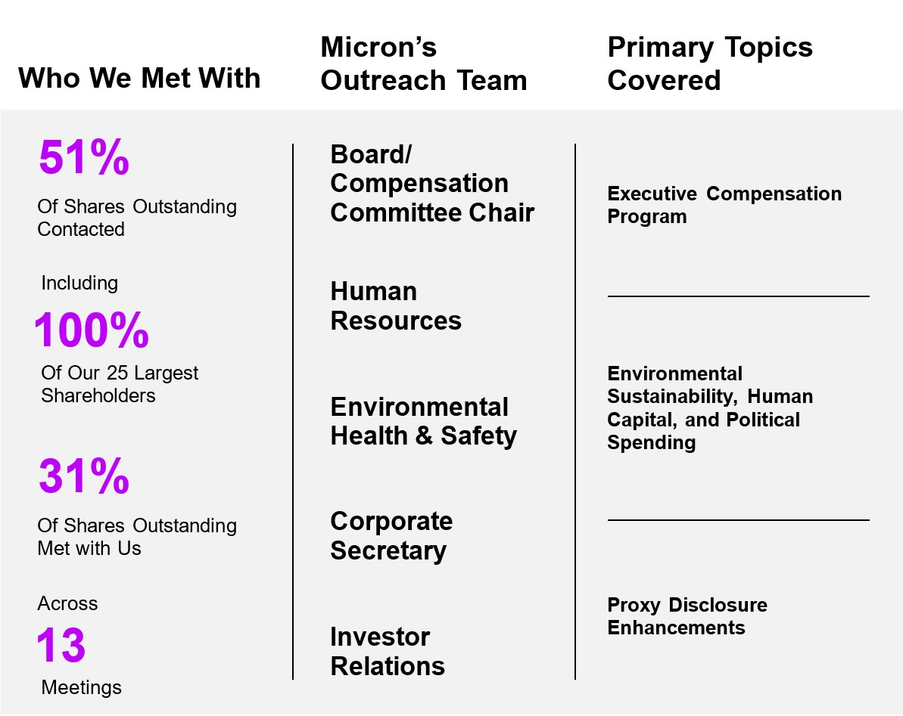
Our discussions with shareholders included senior members of our legal, human resources, sustainability and investor relations teams. Meetings with 26% of our outstanding shares included our independent Chairman of the Board. Our conversations covered executive compensation, sustainability and human capital matters, and our governance and political practices, with a particular focus on compensation to well-position us to evolve our programs and practices in a responsive manner. We heard from shareholders that they appreciated the engagement, and suggested that we enhance our disclosure to describe our shareholder engagement efforts. We value the views of our shareholders, which were shared with our full Board and relevant committees and carefully considered in making changes to our fiscal 2024 compensation program. Below is a summary of the feedback we received through these engagement efforts and how we have responded.
13
Table of Contents

What We Heard |  |  | Our Perspective/How We Responded
Executive Compensation
Increase the weighting of PRSUs awarded to the CEO to at least 60% of equity award value |  |  | We increased the weighting of total equity value allocated to PRSUs in the equity mix from 50% to 65% for our CEO.
Adopt a cap on rTSR PRSU payouts in the event of negative absolute TSR performance |  |  | To further align rTSR PRSU awards with shareholders’ experience, we modified 2024 fiscal year awards to cap payouts at target if the Company’s absolute TSR is negative, even if the Company’s rTSR performance exceeds target.
Increase the rigor of the rTSR PRSU target at median performance |  |  | We increased the rTSR PRSUs performance level required to earn target payout from the 50th to 55th percentile of the SOX index to require outperformance at target and revised the payout curve for these awards to double the outperformance required relative to peers to achieve maximum payout from +25pp to +50pp.
Provide the Compensation Committee’s rationale regarding the performance periods used for PRSU awards |  |  | A minority of investors we spoke with expressed their preference that performance-based, long-term incentives utilize a performance period of three years, and encouraged us to explain the Compensation Committee’s rationale for our current PRSU performance periods, which measure performance in years two and three of the performance period (see “Performance-based RSUs Granted in Fiscal 2023” for full details regarding our 2023 PRSU awards). Given the extreme cyclicality of the memory industry (which is significantly different than that experienced by other companies in our peer group) and the challenges related to precisely forecasting market cycles over long time horizons, the Compensation Committee believes that its current approach to assessing performance enables us to set aggressive goals tied to longer-term performance while still enabling the flexibility needed to address the distorting effects that industry cyclicality presents in any given year. A single observation point at the end of three years can misrepresent the actual progress made by the Company towards its strategic goals, due to the unpredictable effects of cyclicality, and two observation points, at the end of year 2 and year 3 can provide a better representation of the trajectory of the Company performance. After careful consideration, these factors led the Compensation Committee to maintain our existing approach to performance periods for our 2024 PRSU awards.
Proxy Statement Disclosure Enhancements
Add disclosure addressing compensation metric selection rationale, targets and actual achievement to the extent possible without resulting in “competitive harm” |  |  | •We have provided detailed information regarding the changes being made for fiscal year 2024 that further enhance the rigor of our program, and have committed to disclose the profitability goals used under our fiscal 2024 annual incentive awards and actual results against those goals following completion of the performance period.  •We have significantly enhanced disclosures regarding our rationale for the metrics used in our program, targets set and results achieved, except where such disclosure is likely to cause us “competitive harm,” in which case we have clearly indicated our competitive harm concerns.
Enhance disclosure of environmental and social compensation metrics used |  |  | We have provided additional details regarding our compensation goals focused on environmental sustainability and diversity, equality, and inclusion metrics and milestones.

14 | 2023 Proxy Statement
Table of Contents
Environmental Sustainability, Human Capital, and Political Spending
Shareholders were generally complimentary of our 2023 sustainability report and the progress of our efforts to date, and encouraged us to consider additional disclosure regarding efforts related to water stewardship, supply chain due diligence, greenhouse gas emissions and energy usage in our next sustainability report |  |  | We appreciate hearing shareholders’ areas of focus as we look ahead. The aim of our 2023 sustainability report and sustainability progress summary was to provide a detailed accounting of our progress toward achievement of our sustainability goals and to recount our specific contributions over the past year. The report also shared our vision for sustainable development in the years ahead. With each report we will continue to consider the additional information that our stakeholders need and request regarding our efforts, taking into consideration feedback we receive from shareholders as we continue to develop our programs.
With respect to human capital, consider high level disclosure of diversity targets, continue successful pay equity practices, and use caution when employing artificial intelligence in the recruiting process |  |  | Through our membership in the Alliance for Global Inclusion, we are working toward a unified set of diversity and inclusion goals and metrics and the appropriate level of public disclosure. We continue to achieve pay equity and use artificial intelligence to identify, analyze, and address any disparities in pay, as well as to eliminate the potential for bias in our hiring practices. As artificial intelligence develops, we are mindful of the risks and exercise caution in our implementation of artificial intelligence technologies.
Increase disclosure of Board oversight of political and lobbying expenditures |  |  | We have added disclosure in this Proxy Statement of the Governance and Sustainability’s responsibility in overseeing and monitoring the manner in which the Company conducts its public policy and government affairs.

Human Capital and Culture

We believe our people are our most important resource and a critical driver of our competitive advantage. Central to our continuous innovation is an ingrained culture of inclusion, well-being, and continuous learning. Our Board considers the creation and maintenance of a diverse and inclusive environment to be a crucial element of the Company’s business strategy, including effectively addressing customer, shareholder, and other stakeholder needs, and believes each Micron hire is an opportunity to enhance the competencies, skills, talent, experience, and perspectives in our Company with diverse perspectives, backgrounds, and viewpoints. The Board has tasked the Company’s management team with taking a proactive approach to developing the semiconductor workforce of the future, and periodically reviews our programs and processes to ensure continual improvement. In addition to this proactive approach to improving our Company, the Board encouraged the Company to commit resources to the well-being of our communities across the globe. Such resources include the Company-established Micron Foundation whose purpose is to provide grants that increase access to STEM education and careers and towards resources for basic living needs. In fiscal 2023, we invested in strategic partnerships to bolster the representation of underrepresented groups, upheld pay equity, and continued our work to strengthen our culture of inclusion. The diversity, equality, and inclusion (“DEI”) commitments set forth in our 2023 DEI Report extend beyond Micron to the broader communities where we work and live, and exemplify our dedication to accelerating inclusive economic prospects, nurturing diverse business ecosystems, and ensuring their sustainable growth. Micron’s business requires the kind of innovation and resilience that can only be delivered by a supply chain that embraces inclusive sourcing practices. In fiscal 2023, we met our annual target and achieved over $500 million in spending with Tier 1 and Tier 2 diverse suppliers.

Diversity

Our Board believes a diverse workforce is a competitive advantage and that diverse teams drive more innovation, delivering value to our customers and increased returns to shareholders. We believe diverse teams expand creativity and problem-solving, lead to better decision-making, and enhance team member engagement and retention. Encouraged by our Board, our proactive strategies tap into latent talent, reaching out to communities of women, veterans, people with disabilities, rural communities, and other underrepresented groups globally. This is bolstered by leveraging cutting-edge technologies, forming robust industry alliances, fostering academic collaborations, and curating innovative avenues for non-traditional talent pathways like apprenticeships and return-to-work programs.

15
Table of Contents
Equality

We believe our vision to enrich life for all includes how we compensate our employees. We analyze our global compensation and benefits to ensure opportunities for all employees because our People value makes it essential that we pay everyone fairly. In fiscal 2023, we proudly achieved global pay equity across bonuses and stock awards. With the assistance of a third-party specialist and state-of-the-art technology, we analyze and rectify any disparities in compensation. This rigor encompasses all groups: including women, veterans, people with disabilities, and specific racial and ethnic communities. Furthermore, our pay equity analysis for salary will be conducted when we reinstate base pay increases.

Inclusion

We believe that creating an inclusive culture at Micron helps us unleash the human potential of our team members, so everyone feels seen, heard, valued, and respected. These values help us create an environment where team members know they can bring their whole selves to work developing the next solution for artificial intelligence, advanced health care technology, self-driving cars, or whatever our applications need to do to drive technology forward. To further this mission, we have mandated comprehensive training for all employees on fostering a respectful workplace, free from harassment or discrimination. As we navigate the complexities of a volatile global economy, we have also rolled out tailored training modules to empower our leaders to navigate uncertainties with confidence. Furthermore, recognizing the significance of mental health and well-being, we have introduced a suite of masterclasses focused on fostering resilience and long-term wellness for our employees. We also leverage our 10 Employee Resource Groups (“ERGs”), whose members are our ambassadors of inclusion. ERG membership swelled to 47% globally in fiscal 2023, and we reward our ERG leaders with stock grants for their leadership.

For a detailed insight into our DEI initiatives and their global impact, please refer to our latest DEI Annual Report available at micron.com/DEI.

Sustainability

Our commitment to understanding and addressing environmental, social, and governance (“ESG”) issues along our value chain and in our communities is a critical part of our culture and our vision to transform how the world uses information to enrich life for all. Our Board considers ESG issues to be an integral part of its business oversight and our corporate strategy and has encouraged a proactive approach toward mitigating our impact on the environment, supporting our team members and the communities in which they live, respecting human rights, driving transparency and accountability in our supply chain, and developing innovative products that support a sustainable future. We have developed and are executing on a sustainability strategy in response to these issues that leverages our leading products, responsible sourcing and operations, and engaged team members.

The Board, supported by the Governance and Sustainability Committee and other Board committees as needed, oversees and monitors the development and integration of this strategy and regularly reviews sustainability performance. Board oversight includes, but is not limited to, material ESG trends and related long- and short-term impacts of the Company’s operations, supply chains, and products, as well as the Company’s activities and annual public reporting on these topics directed by the Company’s Sustainability Council, sustainability staff, and various teams implementing the Company’s sustainability efforts.

The Governance and Sustainability Committee reviews and discusses ESG issues at each regularly-scheduled committee meeting. Discussions and reports to the committee include information about significant ESG issues, such as observations from consultations with team members, customers, investors, and other stakeholders about their interests and expectations for us; our social and environmental impacts and benefits; and the impacts of these issues on our business. The Governance and Sustainability Committee regularly reviews the implementation of our long-term environmental goals and aspirations. We expect to allocate about $1 billion of capital expenditures to support these goals, though we cannot guarantee that our environmental goals and aspirations set forth below will be realized. These goals and initiatives have been developed based in part on feedback from investors, customers, and team members, and are a critical component of our management of
16 | 2023 Proxy Statement
Table of Contents
evolving physical, regulatory, market, supply chain, and other risks and opportunities related to climate change, water availability, and other ESG issues.

Our Environmental Goals and Aspirations
 |  |  | Goals |  |  | Aspirations
Emissions: |  |  | 75% reduction in greenhouse gas emissions per unit of production in calendar year 2030 vs. calendar year 2018  42% absolute reduction in scope 1 emissions by calendar year 2030 vs. calendar year 2020 |  |  | Net zero scope 1 and 2 emissions by  calendar year 2050
Energy: |  |  | 100% renewable energy in U.S. operations in calendar year 2025  100% renewable energy in Malaysia in calendar year 2022 |  |  | 100% renewable energy worldwide, where available
Water: |  |  | 75% water conservation through reuse, recycling, and restoration in calendar year 2030 |  |  | 100% water conservation through reuse,  recycling, and restoration
Waste: |  |  | 95% reuse, recycle, and recovery and zero hazardous waste to landfill in calendar year 2030* |  |  | Zero waste to landfill through waste minimization,  reuse, recycling, and recovery
* Subject to vendor availability

In fiscal 2023, the Board also reviewed:

•our annual sustainability report content and processes, which in fiscal 2023 included indexes and information aligning with the Sustainability Accounting Standards Board (“SASB”) semiconductor industry standard and Taskforce on Climate-related Financial Disclosures (“TCFD”), supporting investor requests to align with the SASB standard and TCFD recommendations;

•our responsible sourcing and human rights efforts, including our conflict minerals report outlining our response to human rights and other concerns related to mineral sourcing as well as our annual modern slavery and human trafficking statement;

•our human capital initiatives, including our talent acquisition, retention, and development policies and practices; and

•findings from team member, customer, investor and other stakeholder engagement exercises.

We strive to make a positive impact on our team members, the communities in which we operate, and the planet, as well as our customers’ sustainability performance. We plan to continue regular consultation with stakeholders regarding environmental and social issues and report annually on our progress in these efforts. Our 2023 Sustainability Report, available at micron.com/sustainability, includes more details about the ways we are committed to sustainable practices and supporting our global community. Our Sustainability Report, and the information at or accessible through our website, are not part of or incorporated by reference into this Proxy Statement.

Risk Assessment and Mitigation

We operate in a dynamic economic, social, and political landscape, making structured and conscientious risk management more important than ever. Our Board reviews and oversees our enterprise risk management program, which is a unified approach to risk management that helps us achieve a shared understanding of risks and make informed business decisions. This approach enhances our capability to address future events that create uncertainty and respond in an efficient and effective manner. It also facilitates prompt action to mitigate identified risks and embeds risk management into our culture.

17
Table of Contents
The Board has delegated primary oversight of our enterprise risk management process to the Audit Committee, which conducts reviews of our risk assessment and enterprise risk management policies as described below, including overseeing the management of risks related to financial reporting and compliance. Other Board committees provide additional insights into our enterprise risk management program in the areas of their core competencies, and report to the Board regularly on matters relating to the following specific areas of risk the committees oversee:

•The Compensation Committee oversees management of risks relating to our compensation plans and programs.

•The Finance Committee oversees the Company’s strategies for management of significant financial risks.

•The Governance and Sustainability Committee oversees risks associated with the Board’s governance, director independence, the Company’s human capital programs and sustainability initiatives, and public policy and government affairs activities.

•The Security Committee oversees risks associated with physical security and cybersecurity.

In performing their oversight responsibilities, the Board and each committee has full access to management, as well as the ability to engage independent advisors. In addition, the Chairman of the Board leads regular executive sessions of the independent directors, facilitates cross-committee feedback, and fosters open dialogue and constructive feedback among the independent directors, which further supports the Board’s ability to fulfill its risk oversight duties.

Enterprise Risk Management Process

We designed our enterprise risk management program to clearly identify risk management roles and responsibilities, bring together senior management to discuss risk, promote visibility and constructive dialogue, and facilitate risk response and mitigation strategies. The Audit Committee plays a key role in this process, and the full Board conducts periodic reviews.

•As an initial step, our Vice President of Risk Advisory Services representative meets periodically with business unit and functional area heads to identify significant financial and nonfinancial risk exposures and to develop risk mitigation measures and contingency plans.

•After we collect data from stakeholders throughout the Company, our Risk Advisory Services representative summarizes the results of these meetings and creates a consolidated risk profile.

•Our Risk Advisory Services representative then reviews this risk profile with our senior management, seeking input and agreement on mitigation and response strategies. This process is iterative, and repeats as significant risks are added to, or are removed from, the enterprise risk management program.

•Our Risk Advisory Services representative attends quarterly Audit Committee meetings, where the Audit Committee reviews our risk profile and mitigation and response strategies, as well as our progress toward mitigating identified risks. This process repeats for the full Board periodically.

•After incorporating input from the Audit Committee and/or the full Board, Risk Advisory Services designs our internal audit strategies and plans to minimize the impact of relevant risks.

Compensation Risks

The Compensation Committee reviews our compensation programs annually and has concluded that our compensation policies and practices are not reasonably likely to create situations that would have a material adverse effect on us. In making this assessment, we, with guidance from our outside compensation consultants, reviewed our compensation programs to determine if the programs’ provisions and operations create undesired or unintentional risk of a material nature. The Compensation Committee then reviewed the results of our findings with our outside compensation consultant. This risk assessment process included a review of program policies
18 | 2023 Proxy Statement
Table of Contents
and practices; program analysis to identify risk and risk-control related to the programs; and determinations as to the sufficiency of risk identification, the balance of potential risk to potential reward, and risk-control. Although the Compensation Committee reviewed all compensation programs, the Committee focused on the programs with variability of payout, with the ability of a participant to directly affect payout, and the controls on participant action and payout. In most cases, our compensation policies and practices are centrally designed and administered and are substantially the same across the Company. Certain internal groups have different or supplemental compensation programs tailored to their specific operations and goals, and programs may differ by country due to variations in local laws and customs.

Cybersecurity Risks

The Security Committee regularly reviews and oversees our policies and practices to identify and mitigate cybersecurity risks. Our management team under the direction of our Corporate Vice President and Chief Information Officer updates the Security Committee at least quarterly on cybersecurity matters. Our cybersecurity policies and practices follow the cybersecurity framework of the National Institute of Standards and Technology (NIST). We engage third parties to perform assessments of our risks from material cybersecurity threats and cybersecurity measures at least annually. The results of those assessments are reported to the Security Committee, and we make adjustments to our cybersecurity policies and practices as necessary in light of the assessments. While we have not experienced a material information security (cybersecurity) incident in the past three fiscal years, we maintain an information security (cybersecurity) risk insurance policy as a matter of good practice.

Board Processes and Policies

Code of Business Conduct and Ethics

Acting ethically is a critical part of our culture and our vision to transform how the world uses information to enrich life for all. The Board has adopted a Code of Business Conduct and Ethics that is applicable to all our directors, officers, and team members. The Code of Business Conduct and Ethics sets out our expectations regarding the treatment of our team members, customers, and the communities in which we operate, as well as our commitment to high product quality, ethical and legal sourcing of our materials, and acting with integrity for our investors. A copy of our Code of Business Conduct and Ethics is available at www.micron.com and is also available in print without charge upon request. Any amendments or waivers of the Code of Business Conduct and Ethics will also be posted on our website within four business days of the amendment or waiver as required by applicable rules and regulations of the SEC and the Listing Rules of Nasdaq.

Anti-Hedging Policy

Our Insider Trading Policy prohibits officers and directors from engaging in speculative transactions involving the Company's securities, including short sales or puts, calls or other options on the Company's common stock.

Board Self-Evaluation

The Governance and Sustainability Committee oversees the Board’s ongoing and annual assessments of its effectiveness, including the effectiveness of its committees and directors. All directors complete an evaluation form for the Board and for each committee on which they serve. These forms include ratings for certain key metrics, as well as the opportunity for written comments. The comments provide key insights into the areas directors believe the Board can improve or in which its performance is strong. Evaluation topics include number and length of meetings, topics covered and materials provided, committee structure and activities, Board composition and expertise, succession planning, director participation and interaction with management, and promotion of ethical behavior. Our Board considers the results when making decisions on the composition, structure and responsibilities of our Board and its committees, agendas and meeting schedules for our Board and its committees, and changes in the performance or functioning of our Board, and such evaluations are taken into account when the Board makes decisions regarding nominations of directors.

19
Table of Contents
Director Skills Evaluation

The Governance and Sustainability Committee oversees the Board’s ongoing and annual assessments of the Board’s composition and the skills each director possesses. The Governance and Sustainability Committee has identified and continually refines a list of skills, attributes, and experiences that it believes will result in an effective, dynamic, and diverse Board. The Governance and Sustainability Committee then reviews each director on a matrix of relevant skills and qualifications in an effort to identify any needed skills, experiences, or perspectives. The Governance and Sustainability Committee uses the insights this matrix provides to recommend committee assignments and inform searches for new director candidates or opportunities to refresh Board composition.

Director Time Commitment Policy

Our Corporate Governance Guidelines provide that no non-employee member of the Board may serve on the board of directors of more than four other public companies and no employee member of the Board may serve on the board of directors of more than two other public companies. However, this limitation will not apply if the Board determines that simultaneous service does not impair the ability of the member to effectively serve on the Board. A director’s time commitment is considered as part of the director nomination process and is reviewed annually.

Board Structure

Director Independence

The Board has determined that directors Beyer, Dugle, Gomo, Haynesworth, McCarthy, Switz, and Wright qualify as independent directors. In determining the independence of our directors, the Board has adopted independence standards that mirror the criteria specified by applicable laws and regulations of the SEC and the Listing Rules of Nasdaq. None of these directors have a relationship which, in the opinion of the Board, would interfere with the exercise of independent judgment in carrying out the responsibilities of a director.

Board Leadership Structure

Mr. Switz has served as our independent Chair of the Board since February 2012. We do not have a fixed policy on whether the roles of Chair of the Board and CEO should be separate or combined. The Board’s determination to have an independent, non-employee director as our Chair is based on the Board’s consideration of our and our shareholders’ best interests under the current circumstances. The Board periodically reviews our leadership structure and when appropriate, recommends changes to the Board’s leadership structure, taking into consideration the needs of the Board and the Company at such time. The Board believes Mr. Switz provides strong and independent oversight and helps ensure effective collaboration among the directors based on his past leadership of our Board, experience as chief executive officer and chairman of a leading technology company and past and current membership on other public company boards.

In his role as Chair, Mr. Switz oversees our Board and facilitates the flow of information between it and management. This fosters open dialogue and constructive feedback among our independent Board members and management. In particular, our Chair has the following duties and responsibilities, as determined by the Board and as set forth in our Corporate Governance Guidelines:

•serves as a liaison between the CEO and the independent directors;

•presides at, and chairs, Board meetings and meetings of shareholders;

•establishes agendas for each Board meeting in consultation with the chairs of applicable committees of the Board;

•leads executive sessions of the Board;

•has authority to call Board meetings, special meetings of shareholders, and meetings of the independent directors;
20 | 2023 Proxy Statement
Table of Contents

•leads the Board in discussions concerning the CEO’s performance and CEO succession;

•approves meeting schedules for the Board;

•approves information sent to the Board;

•if requested by major shareholders, is available for consultation and direct communication; and

•performs such other duties and responsibilities as requested by the Board.

Board Meetings and Committees

Our Board held twelve formal meetings during fiscal 2023. The Board met in Executive Session (meetings in which only independent directors are present) eight times during fiscal 2023. In fiscal 2023, the Board had a standing Audit Committee, Compensation Committee, Finance Committee, Governance and Sustainability Committee, and Security Committee. During fiscal 2023, the Audit Committee met fourteen times, the Compensation Committee met six times, the Finance Committee met five times, the Governance and Sustainability Committee met four times, and the Security Committee met four times. In addition to formal committee meetings, the chair of each committee engaged in regular discussions with management regarding various issues relevant to their respective committees. All incumbent directors attended 75% or more of the total number of meetings of the Board and the committees on which they served during fiscal 2023. We expect director attendance at the Annual Meeting of Shareholders, and all then-serving members of our Board were present at the Fiscal 2022 Annual Meeting of Shareholders.
The Audit, Compensation, Finance, Governance and Sustainability, and Security Committees each have written charters that comply with SEC and Nasdaq rules relating to corporate governance matters. Copies of the committee charters as well as our Corporate Governance Guidelines are available at www.micron.com and are also available in print without charge upon request to corporatesecretary@micron.com. The Board has determined that all the members of the Audit, Compensation, Governance and Sustainability, and Security Committees satisfy the independence requirements of applicable SEC laws and the Listing Rules of Nasdaq for such committees.

Audit Committee

Mses. McCarthy and Dugle and Mr. Gomo currently serve, and during fiscal 2023 served, on the Audit Committee. Ms. McCarthy has served as the Chair of the Audit Committee since January 2023. Prior to that Mr. Gomo served as Audit Committee Chair since January 2019. The Board has determined that all Audit Committee members are independent under the rules applicable to audit committee members promulgated by the SEC and Nasdaq and each qualifies as an “audit committee financial expert” for purposes of the rules and regulations of the SEC and that each of these members is sufficiently proficient in reading and understanding our financial statements to serve on the Audit Committee. The purpose of the Audit Committee is to assist the Board in overseeing and monitoring:

•the integrity of our financial statements;

•the adequacy of our internal controls and procedures;

•the performance of our internal audit function;

•the performance of our Independent Registered Public Accounting Firm;

•the qualifications and independence of our Independent Registered Public Accounting Firm; and

•our compliance with legal and regulatory requirements.

21
Table of Contents
The Audit Committee is also responsible for preparing the Audit Committee report that is included in our annual Proxy Statement. See “Audit Committee Matters – Report of the Audit Committee of the Board of Directors.” The complete duties and responsibilities of the Audit Committee are set forth in its written charter, which is available at www.micron.com and is also available in print without charge upon request to corporatesecretary@micron.com.

Compensation Committee

Ms. Wright and Messrs. Beyer and Switz currently serve, and during fiscal 2023 served, on the Compensation Committee. Mr. Beyer has served as the Chair of the Compensation Committee since April 2021. The Board has determined that all Compensation Committee members are independent under the rules applicable to compensation committee members promulgated by the SEC and Nasdaq and each qualifies as a “non-employee director” as defined under Rule 16b-3 of the Securities Exchange Act of 1934, as amended (the “Exchange Act”). The Compensation Committee is responsible for reviewing and approving the compensation of our executive officers. See “Executive Compensation and Related Information – Compensation Discussion and Analysis” and “– Compensation Committee Report” for information regarding how the Compensation Committee sets executive compensation levels. The Compensation Committee has authority to delegate any of its responsibilities to a subcommittee as it may deem appropriate in its judgment. The complete duties of the Compensation Committee are set forth in its written charter, which is available at www.micron.com and is also available in print without charge upon request to corporatesecretary@micron.com.

Finance Committee

Ms. McCarthy and Messrs. Gomo and Mehrotra currently serve, and during fiscal 2023 served, on the Finance Committee. Mr. Gomo has served as the Chair of the Finance Committee since January 2023. Prior to that Ms. McCarthy had been the Finance Committee Chair since January 2019. The Finance Committee represents and assists the Board in discharging its responsibilities with respect to oversight of our financial policies, financial strategies, capital structure, debt and equity offerings, capital return program, cash management and investments, risk management related to hedge and derivative instruments, and insurance. The complete duties of the Finance Committee are set forth in its written charter, which is available at www.micron.com and is also available in print without charge upon request to corporatesecretary@micron.com.

Governance and Sustainability Committee

Mses. Haynesworth and Wright and Messrs. Beyer and Switz currently serve, and during fiscal 2023 served, on the Governance and Sustainability Committee. Ms. Wright has served as Chair of the Governance and Sustainability Committee since April 2021. The responsibilities of the Governance and Sustainability Committee include assisting the Board in discharging its duties with respect to the following:

•the identification and selection of nominees to our Board;

•director compensation;

•oversight and monitoring of the development and integration of material social and environmental strategies;

•oversight and monitoring of our human capital management efforts, including culture, talent development and retention, and DEI programs and initiatives;

•the oversight and monitoring of the manner in which the Company conducts its public policy and government affairs, including policies and guidelines regarding political contributions by the Company, lobbying activities, our employee political action committee, contributions to trade associations and other similar organizations that engage in political activity;

•the development of our Corporate Governance Guidelines; and

•evaluation of the Board and management.

22 | 2023 Proxy Statement
Table of Contents
The complete duties and responsibilities of the Governance and Sustainability Committee are set forth in its written charter, which is available at www.micron.com and is also available in print without charge upon request to corporatesecretary@micron.com.

Security Committee

Mses. Dugle and Haynesworth and Mr. Beyer currently serve, and during fiscal 2023 served, on the Security Committee. Ms. Dugle has served as Chair of the Security Committee since June 2021. The responsibilities of the Security Committee include assisting the Board in discharging its duties with respect to oversight of the following:

•physical security of our facilities and employees as well as enterprise cybersecurity and data protection risks associated with our security-related infrastructure and related operations including outside partners;

•cyber crisis preparedness and security breach and incident response plans;

•compliance with applicable information security and data protection laws and industry standards;

•our physical and cybersecurity strategy, crisis or incident management, and security-related information technology planning processes; and

•public disclosure relating to security of our employees, facilities, and information technology systems, including privacy, network security, and data security.

The complete duties and responsibilities of the Security Committee are set forth in its written charter, which is available at www.micron.com and is also available in print without charge upon request to corporatesecretary@micron.com.

Executive Sessions

Mr. Switz has been the independent Chair of our Board since February 2012. As part of his duties as Chair, Mr. Switz chairs Executive Session meetings of our Board. The Board meets in executive session regularly and held eight meetings in fiscal year 2023.

Communications with the Board of Directors

Shareholders and interested parties wishing to communicate with our Board, or our non-employee directors as a group, may contact Mr. Switz, our Chair, at chair@micron.com.

CERTAIN RELATIONSHIPS AND RELATED TRANSACTIONS

Related party transactions are reviewed by our Board in accordance with our related party transaction policy. Related parties include our directors and officers, their family members and affiliates, and certain beneficial owners. In cases where the related party is a director or an affiliate of a director, that director does not participate in the review of the proposed transaction. In reviewing a proposed related party transaction, the Board considers all the relevant facts and circumstances of the transaction, such as (i) the nature and terms of the transaction, (ii) the dollar value of the transaction, (iii) whether the terms of the transaction are at least as favorable as they would have been if a related party was not involved, (iv) the business reasons for the transaction, (v) whether the transaction would result in an improper conflict of interest, and (vi) the effects of the transaction on the ongoing relationship between us and the related party. There were no actual or proposed related party transactions in excess of $120,000 incurred in fiscal 2023.

23
Table of Contents
DIRECTOR COMPENSATION

The Governance and Sustainability Committee oversees the setting of compensation for our non-employee members of the Board and recommends changes, if any, to the full Board for consideration. Each year, the Governance and Sustainability Committee works with the compensation consultant to review and evaluate director compensation for the ensuing fiscal year, in light of prevailing market conditions and to attract, retain, and reward qualified non-employee directors. The compensation consultant gathers and reviews market data for non-employee directors from the same Compensation Peer Group used to evaluate officer compensation. For a discussion concerning the companies that comprised our Compensation Peer Group, please see “Executive Compensation and Related Information – Compensation Discussion and Analysis” below. Upon completion of its review and evaluation, the Governance and Sustainability Committee did not recommend to the Board any changes to the amount of director compensation for fiscal 2024.

Elements of Director Compensation

Annual Retainer and Committee Chair Remuneration

Non-employee directors were entitled to receive an annual cash retainer of $125,000 in fiscal 2023, assuming the director serves for the entire year. Pursuant to our 2008 Director’s Compensation Plan (the “DCP”), which operates as a sub-plan of the Amended and Restated 2007 Equity Incentive Plan (the “2007 Plan”), non-employee directors may elect to take some or all of their annual cash retainer, shares of Common Stock or deferred rights to receive Common Stock (in either case, having an initial value equal to the cash amount foregone) upon termination as a director. As part of the Company's fiscal 2023 cost-cutting program, the directors voluntarily reduced their fiscal 2023 cash compensation by 20% for the period from February 1, 2023 through the end of fiscal 2023. Employee directors receive no additional or special remuneration for their service as directors. The amounts earned by the non-employee directors in respect of their service during fiscal 2023 are set forth below under “Fiscal 2023 Director Compensation.”

Set forth below are the standard cash amounts directors were and are entitled to receive for their service as committee chair or Chair of the Board for fiscal 2023 and 2024 (assuming in each case service for the entire year):
 |  |  | 2024 |  |  |  |  |  | 2023
Audit Committee Chair |  |  | $ | 35,000 |  |  |  |  | $ | 35,000
Compensation Committee Chair |  |  | 30,000 |  |  |  |  |  | 30,000
Finance Committee Chair |  |  | 20,000 |  |  |  |  |  | 20,000
Governance and Sustainability Committee Chair |  |  | 20,000 |  |  |  |  |  | 20,000
Security Committee Chair |  |  | 20,000 |  |  |  |  |  | 20,000
Chair of the Board |  |  | 150,000 |  |  |  |  |  | 150,000

The amounts shown in the table are in addition to the annual retainer payable to all directors for service on the Board.

As a result of the voluntary pay reduction, for fiscal 2023 only, the actual cash amounts directors were entitled to receive for their service as committee chair or Chair of the Board for the full fiscal 2023 were:
 |  |  |  |  |  | 2023
Audit Committee Chair |  |  |  |  |  | $ | 30,917
Compensation Committee Chair |  |  |  |  |  | 26,500
Finance Committee Chair |  |  |  |  |  | 17,667
Governance and Sustainability Committee Chair |  |  |  |  |  | 17,667
Security Committee Chair |  |  |  |  |  | 17,667
Chair of the Board |  |  |  |  |  | 132,500
24 | 2023 Proxy Statement
Table of Contents
Except for the foregoing, directors do not receive any additional or special cash remuneration for their service on any of the committees established by the Board. We reimburse directors for travel and lodging expenses, if any, incurred in connection with attendance at Board or committee meetings.

Equity Award

Non-employee directors receive an equity award each fiscal year. Since fiscal 2007, the equity award has been exclusively in the form of restricted stock. The restricted stock includes the potential to receive dividend equivalents (at the same rate as for Common Stock generally), which will accumulate and pay out (in cash) only if and when the underlying shares are released. The “targeted value” for the annual non-employee director equity award is established each year by the Board following discussions with the compensation consultant and has been set at $250,000 since fiscal 2015. The number of shares of restricted stock awarded to each non-employee director is determined by dividing the applicable targeted value by the Fair Market Value of a share of our Common Stock, as defined under our equity plans. For purposes of our equity plans, “Fair Market Value” is the closing price of our Common Stock on the last market-trading day prior to the date of grant. The restrictions on these restricted shares awarded in fiscal 2023 lapse for 100% of such shares on the first anniversary of the date of grant (the “Vesting Period”). Notwithstanding the foregoing, the restrictions will lapse for 100% of such shares in the event a director reaches the mandatory retirement age, if any, or retires from the Board during the Vesting Period having achieved a minimum of three years of service with the Board prior to the effective date of their retirement, or upon a director’s death or disability.

In October 2023, the DCP was amended to allow non-employee directors to defer receipt of their equity awards that are granted in fiscal 2024 and later years. If a director makes a deferral election, shares subject to the director’s deferred equity awards will be delivered (to the extent vested) upon termination of service as a director.

Fiscal 2023 Director Compensation

The following table details the total compensation earned by our non-employee directors in fiscal 2023.
Name |  |  | Fees Earned or Paid in Cash(1) |  |  | Stock Awards(2) |  |  | Total
Richard M. Beyer |  |  | $ | 136,917 |  | $ | 249,982 |  | $ | 386,899
Lynn A. Dugle |  |  | 128,083 |  |  | 249,982 |  |  | 378,065
Steven J. Gomo |  |  | 133,083 |  |  | 249,982 |  |  | 383,065
Linnie M. Haynesworth |  |  | 110,417 |  |  | 249,982 |  |  | 360,399
Mary Pat McCarthy |  |  | 136,333 |  |  | 249,982 |  |  | 386,315
Robert E. Switz |  |  | 242,917 |  |  | 249,982 |  |  | 492,899
MaryAnn Wright |  |  | 128,083 |  |  | 249,982 |  |  | 378,065

(1)The amounts shown are lower than they otherwise would have been based on our standard Board compensation policy because, as part of the Company's fiscal 2023 cost cutting program, the directors voluntarily reduced their fiscal 2023 cash compensation by 20% for the period from February 1, 2023 through the end of fiscal 2023.

(2)On October 13, 2022, each of Messrs. Beyer, Gomo, and Switz, and Mses. Dugle, Haynesworth, McCarthy, and Wright was granted 4,739 shares of restricted stock with a grant date fair value of $249,982 ($52.75 per share). For information on the restrictions associated with these awards, see “Elements of Director Compensation – Equity Award” above.
As of August 31, 2023, each of Messrs. Beyer, Gomo, and Switz, and Mses. Dugle, Haynesworth, McCarthy, and Wright had outstanding a grant of 4,739 shares of restricted stock. For information regarding Mr. Mehrotra’s holding of stock as of August 31, 2023, see “Outstanding Equity Awards at Fiscal 2023 Year-End” below.

25
Table of Contents
Stock Ownership Guidelines

We have established stock ownership guidelines for our non-employee directors. The minimum ownership guideline for directors is to hold shares with a value equal to five times their annual retainer. Directors are given five years to meet the ownership guidelines. The Governance and Sustainability Committee reviews the Ownership Guidelines annually and monitors each person’s progress toward, and continued compliance with, the guidelines. Stock sales restrictions may be imposed upon directors if the stock ownership guidelines are not met. All our directors are either in compliance with the guidelines or are newer directors who have time remaining to meet the guidelines.

The following table shows non-employee director compliance with the guidelines as of fiscal 2023 year-end:
Director |  |  | Guideline Multiplier |  |  | Guideline Amount |  |  | Compliance with Guideline
Richard M. Beyer |  |  | 5 |  |  | $ | 552,083 |  | Yes
Lynn A. Dugle |  |  | 5 |  |  | 552,083 |  |  | Yes
Steven J. Gomo |  |  | 5 |  |  | 552,083 |  |  | Yes
Linnie M. Haynesworth |  |  | 5 |  |  | 552,083 |  |  | Yes
Mary Pat McCarthy |  |  | 5 |  |  | 552,083 |  |  | Yes
Robert E. Switz |  |  | 5 |  |  | 552,083 |  |  | Yes
MaryAnn Wright |  |  | 5 |  |  | 552,083 |  |  | Yes

Please refer to page 54 for information on the stock ownership guidelines for our CEO and other Named Executive Officers.

26 | 2023 Proxy Statement
Table of Contents
EXECUTIVE COMPENSATION AND RELATED INFORMATION

PROPOSAL 2 – ADVISORY VOTE ON THE COMPENSATION OF OUR NAMED EXECUTIVE OFFICERS (“SAY-ON-PAY”)
PROPOSAL DETAILS

The Dodd-Frank Wall Street Reform and Consumer Protection Act of 2010 (the “Dodd-Frank Act”) enables our shareholders to vote to approve, on an advisory (non-binding) basis, the compensation of our Named Executive Officers. The say-on-pay vote is required by Section 14A of the Exchange Act (15 U.S.C. 78n-1). We seek your advisory vote and ask that you indicate your support for the compensation of the Named Executive Officers as disclosed in this Proxy Statement in the “Compensation Discussion and Analysis” section and the related compensation tables beginning on page 28.

This “say-on-pay” proposal gives our shareholders the opportunity to express their views on the compensation of our Named Executive Officers. This vote is not intended to address any specific item of compensation, but rather the overall compensation of our Named Executive Officers as described in this Proxy Statement. At our Fiscal 2017 Annual Meeting of Shareholders, our shareholders voted to have an annual advisory vote on say-on-pay and in accordance with the results of this vote, the Board determined to implement an advisory vote on executive compensation every year until the next required vote on the frequency of shareholder votes on the compensation of executives, which is occurring this year and is set forth as Proposal 3.

At our Annual Meeting of Shareholders held in January 2023, 71% of the votes cast on the say-on-pay proposal were voted in favor of the proposal. See “Shareholder Engagement Shaped Our Response to the Fiscal 2022 Say-on-Pay Vote” on page 31 for details regarding our efforts to understand and respond to last year’s say-on-pay vote.

Please read the “Compensation Discussion and Analysis” section and related compensation tables for information necessary to inform your vote on this proposal.

BOARD RECOMMENDATION

The Board invites you to review carefully the Compensation Discussion and Analysis beginning on page 28 and the tabular and other disclosures on executive compensation beginning on page 60, and cast a vote “FOR” the following resolution:

“Resolved, that shareholders approve, on an advisory basis, the compensation of Micron’s Named Executive Officers, as discussed and disclosed in the Compensation Discussion and Analysis, the executive compensation tables, and any narrative executive compensation disclosure contained in this Proxy Statement.”

VOTE REQUIRED FOR APPROVAL

The “FOR” vote of the holders of a majority of the voting power of the shares of our Common Stock attending online in person or represented by proxy at the Annual Meeting is required to approve the non-binding advisory vote on the compensation of our Named Executive Officers.

The say-on-pay vote is advisory and therefore not binding on us, the Compensation Committee, or the Board, and will not be construed as overruling a decision by our Company or our Board or creating or implying any additional fiduciary duty for our Company or our Board. Furthermore, because this non-binding, advisory resolution primarily relates to the compensation of our Named Executive Officers that has already been paid or contractually committed, there may not be an opportunity for us to revisit these decisions. However, the Board and Compensation Committee value the opinions of our shareholders and will consider the results of the say-on-pay vote and any other feedback from shareholders in their evaluation of our compensation program as they believe to be appropriate.

27
Table of Contents
COMPENSATION DISCUSSION AND ANALYSIS

This Compensation Discussion and Analysis presents material information helpful or necessary to understand the objectives and policies of our compensation program for executive officers and the compensation reported in the tables that follow. This discussion focuses on the compensation awarded to, earned by, and paid to the following individuals:

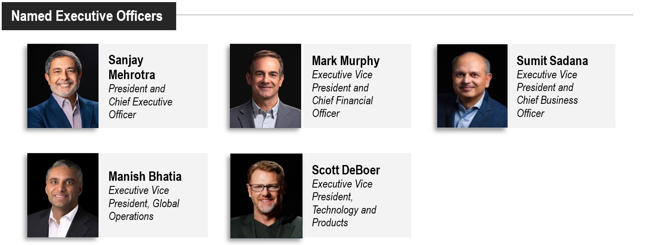

Throughout this discussion and elsewhere in this Proxy Statement, the foregoing individuals are referred to as our “Named Executive Officers.”

Executive Summary

Financial Highlights

Fiscal 2023 was a challenging year for the memory and storage industry and resulted in a significant impact to financial performance. Despite this difficult backdrop, the Micron team stayed focused on our strategy, executed well, accomplished several important milestones, and delivered the following financial results.

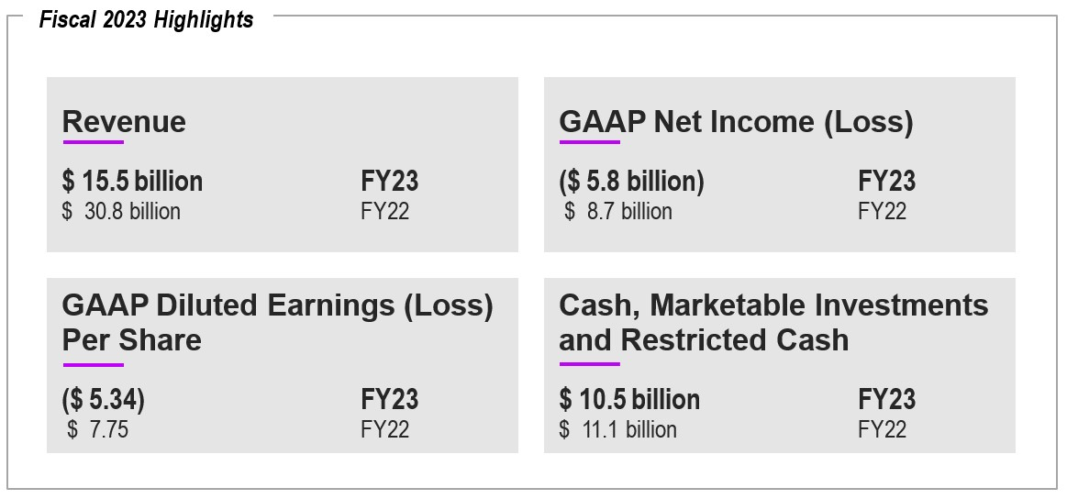
28 | 2023 Proxy Statement
Table of Contents
We sustained our technology leadership and launched a suite of leading-edge products that represent one of the strongest portfolio expansions in Micron’s 45-year history. In addition, our industry-leading DRAM and NAND technology made strong progress in fiscal 2023:

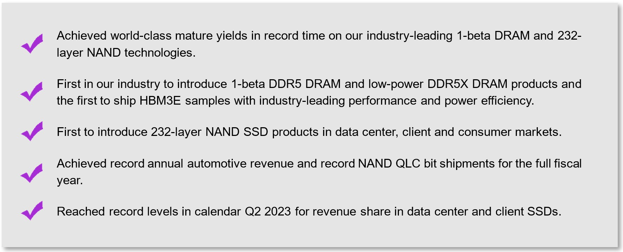

The following chart shows our one- and three-year relative total shareholder return data through the last trading day of fiscal 2023 as compared to the S&P 500 Composite Index, the Philadelphia Semiconductor Index (“SOX”) and the median of our Compensation Peer Group as identified in “Compensation-Setting Process and the Determination of Compensation Levels – ‘Market Data’ Defined” below. Throughout the Executive Compensation and Related Information section of this Proxy Statement, we refer to total shareholder return as “TSR” and relative TSR as “rTSR.”

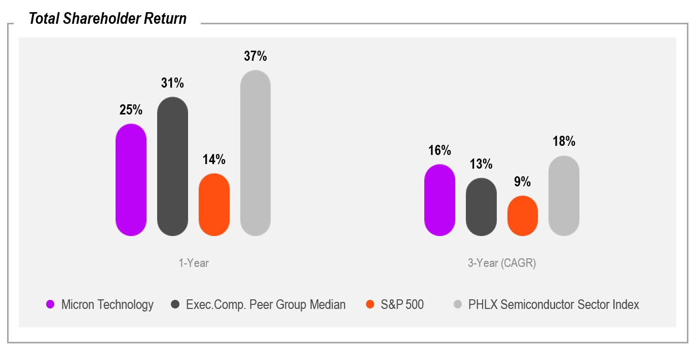
The information presented above is based on closing prices on or nearest to August 31st and represents annualized rates of return reflecting price appreciation plus reinvestment of dividends and the compounding effect of dividends paid, if any, on reinvested dividends.

29
Table of Contents
Executive Compensation Highlights

The pay mix, based on target amounts established in October 2022, for our CEO and other Named Executive Officers (on average) for fiscal 2023, as shown below, was heavily weighted towards variable, at risk compensation opportunities.

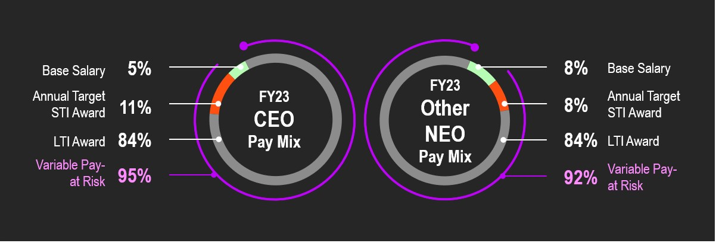

Short-Term Incentive Awards Suspended. Our Named Executive Officers are typically eligible to earn short-term incentive awards pursuant to our Executive Officer Performance Incentive Plan (“EIP”). However, due to the challenging business environment noted above and as part of a significant program to reduce Company costs and operating expenses, the Compensation Committee suspended the Named Executive Officers’ fiscal 2023 EIP participation. Accordingly, no Named Executive Officer received any short-term incentive cash award for fiscal 2023.

Long-Term Incentive Awards Balance Our Drive Towards Continued Technology Leadership and Sustained Value Creation. The metrics for our fiscal 2023 performance-based restricted stock units include the NAND bits shipped or percentage of NAND bits shipped into the data center segment, the DRAM revenue or percentage of revenue from high-growth, stable segments and TSR relative to the semiconductor sector. In addition, the NAND and DRAM operational goals together have two additional earnings opportunities relating to the development of next-generation products like high-bandwidth memory and Compute Express Link.

The following illustration depicts the amount and mix of pay opportunities for our Named Executive Officers for fiscal 2023 after suspension of the EIP, including salaries paid and target long-term incentive opportunities granted for fiscal 2023.

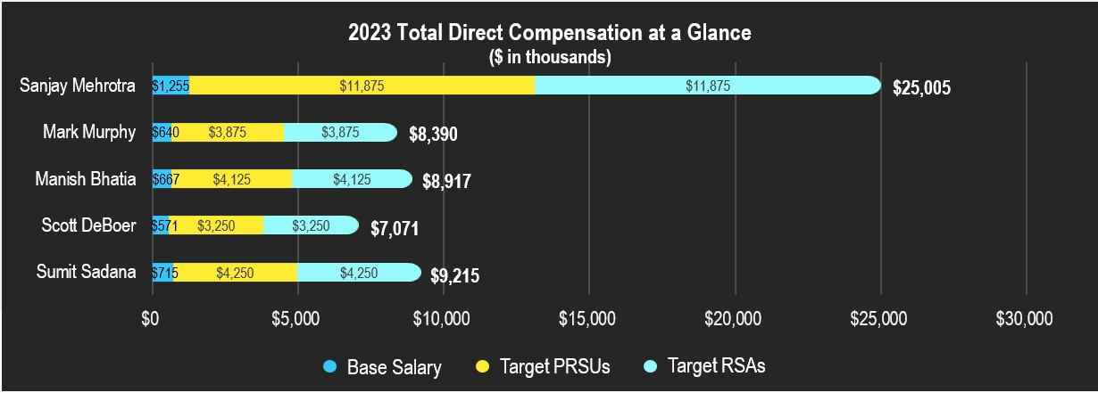

30 | 2023 Proxy Statement
Table of Contents
Shareholder Engagement Shaped Our Response to the Fiscal 2022 Say-on-Pay Vote

At the Fiscal 2022 Annual Meeting of Shareholders on January 12, 2023, 71% of the votes cast were voted in support of our say-on-pay proposal. While we appreciate that a substantial majority of our holders are supportive of our pay practices, the Compensation Committee viewed this say-on-pay vote outcome as unsatisfactory. Accordingly, it developed a deliberate shareholder outreach effort to understand the concerns that drove shareholders’ say-on-pay voting decisions. See “Shareholder Outreach” on page 13 for details regarding our engagement with shareholders. The Compensation Committee greatly appreciates shareholders’ contributions in these meetings and values the constructive feedback received. In response to the compensation-related feedback we received, we enhanced our disclosures in this Proxy Statement regarding our fiscal 2023 compensation program and we made changes to our fiscal 2024 compensation program as explained in this Compensation Discussion and Analysis section.

The Compensation Committee intends to continue our outreach to shareholders on executive compensation and other matters, and to seek the advice and counsel of its compensation advisors. Our shareholders may communicate any concerns or opinions on executive pay directly to the Compensation Committee or the Board. Please refer to “Executive Sessions and Communications with the Board of Directors” on page 23 for information about communicating with the Board.

Fiscal 2024 Compensation Program Changes

After carefully considering the feedback we received from shareholders, we have made several changes to our long-term incentive plan for fiscal 2024. As shown in the infographic below, the changes aim to enhance the pay-for-performance approach of our program and increase the alignment of our executives' incentives with shareholders’ interests. We have also enhanced our disclosures throughout this Compensation Discussion & Analysis to provide greater visibility regarding our short- and long-term incentive programs, and intend to make further enhancements for fiscal 2024 to provide additional details regarding our EIP goals and related results.

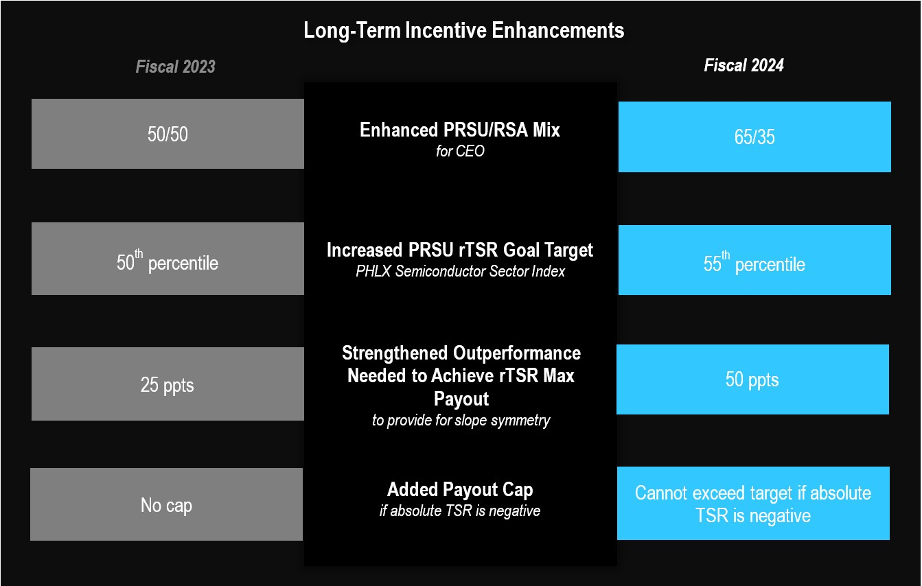

31
Table of Contents
The pay mix for our CEO and other Named Executive Officers (on average) for fiscal 2024 closely mirrors that of 2023.

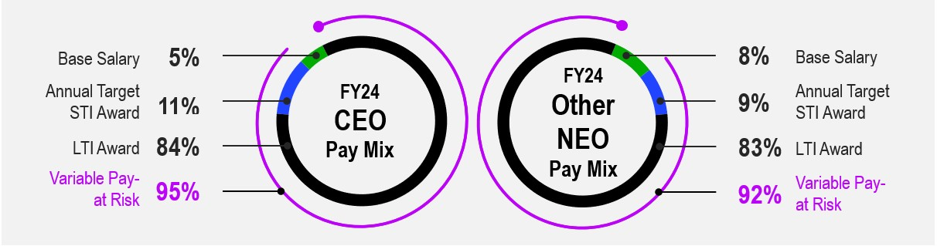

Executive Compensation Practices

We strive to maintain sound executive compensation practices and policies, which include adherence to the following compensation principles.

Our Compensation Principles

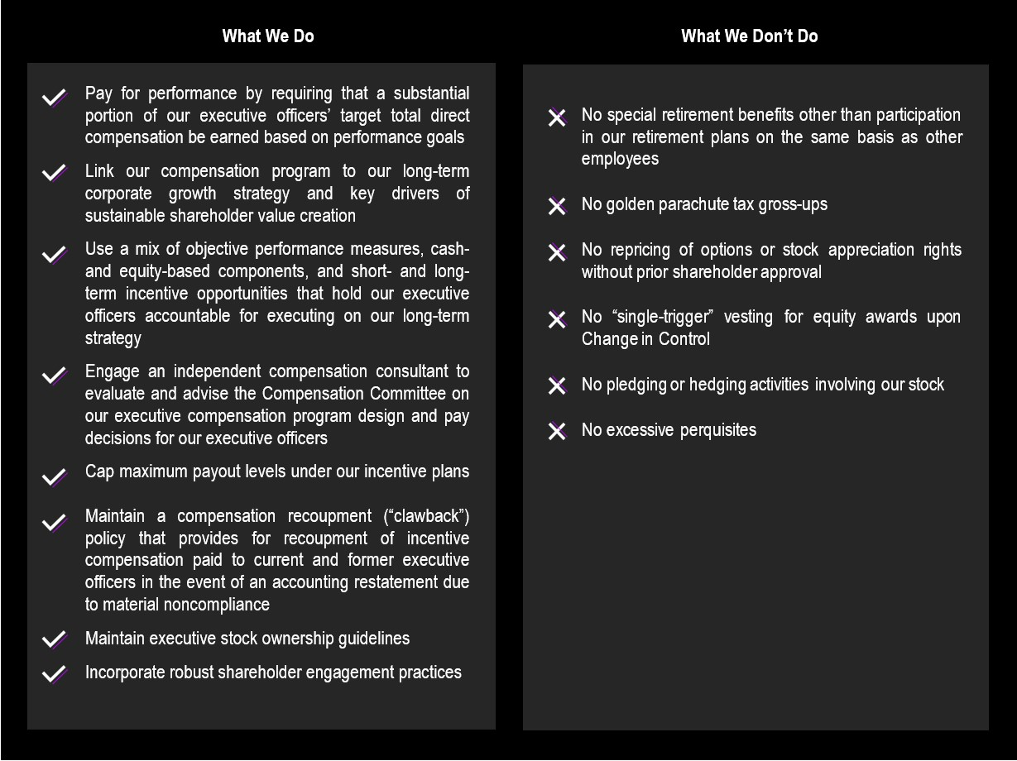

32 | 2023 Proxy Statement
Table of Contents
Oversight of the Executive Compensation Program

Each year, the Compensation Committee, advised by its independent compensation consultant, undertakes a rigorous process to review our executive compensation program and determine executive compensation in the context of our pay-for-performance philosophy. The Compensation Committee believes a substantial portion of our executive compensation should be incentive-based and focused on long-term performance to help ensure that the interests of our executive officers are aligned with those of our shareholders. Our primary long-term objective is to drive sustainable value creation for our shareholders by attracting, retaining, developing, and motivating a diverse group of top executive talent through a comprehensive and market-competitive executive compensation program. The Compensation Committee reviews and approves the goals and objectives used to determine executive compensation, evaluates performance in light of such goals and objectives, and determines and approves compensation levels based on that evaluation.

The Compensation Committee annually engages an external compensation consultant and meets with the compensation consultant at least quarterly. The Compensation Committee also works closely with our CEO with respect to the determination of compensation of other officers. A more complete description of the Compensation Committee’s responsibilities is provided in the Compensation Committee’s Charter approved by the Board, which can be found on our website, www.micron.com. A more complete description of the role of the Compensation Committee’s compensation consultant and our CEO in the compensation process is described later in this Compensation Discussion and Analysis. Additional information regarding the Compensation Committee’s compensation consultant, the specific activities it undertakes for us, and its fees can be found under “Compensation-Setting Process and the Determination of Compensation Levels” on page 51.

33
Table of Contents
Pay-for-Performance Philosophy

Our compensation philosophy for executive officers is based on the belief that the interests of our executives should be closely aligned with our long-term performance and sustainable value creation for our shareholders. To support this philosophy, a large portion of each executive officer’s target total direct compensation is “at risk” and linked to the accomplishment of specific financial and operational performance goals that we expect will lead to increased long-term value creation for our shareholders. The key elements of the compensation that applied to our Named Executive Officers in fiscal 2023 relative to our pay-for-performance philosophy are summarized below.

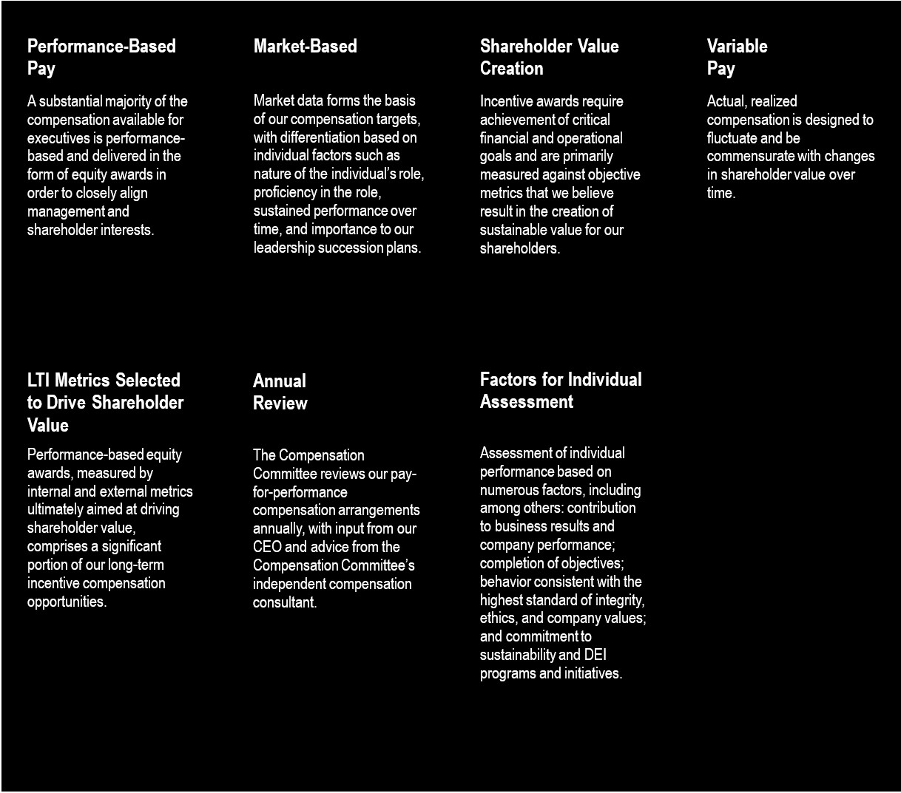

34 | 2023 Proxy Statement
Table of Contents
Targeting “Reasonable” and “Competitive” Pay

We believe that offering a compensation package that is “reasonable” and “competitive” with what our executives could otherwise obtain in the market, and especially from companies within our Compensation Peer Group, enables us to attract, motivate, reward, and retain qualified individuals and to meet our overall objective of increasing shareholder value. Our Compensation Peer Group consists of companies that we believe are especially likely to be our competitors for executive talent and is discussed further in “Market Data Defined” below. The Compensation Committee determines what would be reasonable and competitive compensation based upon an analysis of the Market Data, the recommendations of its compensation consultant, and our historical experience.

Reasonable

The Compensation Committee generally considers the Market Data median to be reasonable. Accordingly, the Market Data median informs the Compensation Committee’s decision-making process, but the Compensation Committee also considers additional factors in establishing each individual’s target compensation levels, including:

•differences in position and level of responsibility among officers, both in absolute terms and relative to our other officers and as compared to similarly situated officers within the Compensation Peer Group;

•past and anticipated contributions;

•technical expertise;

•Company performance;

•applicable business unit performance; and

•length of service and/or experience, both in absolute terms and relative to our other officers and as compared to similarly situated officers within the Compensation Peer Group.

The semiconductor industry is highly volatile. Market Data, which is a compilation of data from many companies provided by the compensation consultant as further described below, may change dramatically from year to year and can evolve as compensation practices change, executives retire or are replaced with less experienced and lower-paid executives, goals are achieved or not achieved resulting in varying payouts, participants in proprietary compensation surveys change, and the completeness or accuracy of compensation data improves or deteriorates. Accordingly, what may have been the median or within a reasonable range of competitiveness in one year, may be higher or lower for the next. For this reason and the factors noted above, even though the Compensation Committee generally uses the Market Data median as its starting point and guiding principle, officer compensation may vary, above or below the median, or a range from the median, year over year.

Competitive

The Compensation Committee believes, including based on advice from its compensation consultant, that a competitive compensation package will address and measure compensation practices for executive positions with respect to three primary elements of compensation:

•base compensation (salary);

•short-term incentive compensation (cash bonus programs); and

•long-term incentive compensation (time-based restricted stock and performance-based restricted stock units).

35
Table of Contents
We do not require that a particular element comprises a set portion of the target total direct compensation mix. We do believe, however, that a significant portion of the compensation should be variable (such as performance-based incentives and incentives tied to the performance of the Company and its Common Stock) as compared to fixed (such as base salary), and that such variable compensation should align executives’ interests with those of our shareholders. Additionally, although the Compensation Committee reviews total direct compensation (which is the sum of base salary, short-term incentive, and long-term incentive compensation) for each of our Named Executive Officers, it does not have a fixed objective with respect to such target total direct compensation. The Compensation Committee’s philosophy is to use incentive pay opportunities rather than base salary as a way to ensure we are able to attract and retain top talent.

Focus on Top Talent

The Compensation Committee places a strong emphasis on developing, motivating, retaining, and attracting top talent. Such talent is key to the execution of our business strategy and the growth of our business.

Mr. Mehrotra, our President and Chief Executive Officer, has earned more than 70 patents during his 42 years in the semiconductor industry, several of which were foundational to enabling high-capacity flash memory. In November 2023, the Semiconductor Industry Association honored Mr. Mehrotra with the Robert N. Noyce Award, recognizing outstanding achievement and leadership supporting the semiconductor industry. In 2022, Mr. Mehrotra was inducted into the National Academy of Engineering, one of the profession’s highest distinctions. He was awarded an honorary degree from Boise State University in 2022 in recognition of his semiconductor industry leadership. In addition, he received the “Spirit of 1868 Volunteer Award” from the University of California, Berkeley in 2021, the Malaysian Order of Loyal Defender of the State medal in 2021, and the 2019 Flash Memory Summit Lifetime Achievement Award for co-founding SanDisk, advancing the architecture that enabled the industry and market for flash memory, and for his leadership of the Company.

Mr. Murphy, our Executive Vice President and Chief Financial Officer, has more than 25 years of experience in executive leadership and finance roles, including roles at companies serving semiconductor materials, semiconductor capital equipment, semiconductor fabrication and assembly and test, and advanced manufacturing for automotive and aerospace. He has successfully led large-scale finance organizations through industry cycles. He is a veteran of the U.S. Marine Corps.

Mr. Bhatia, our Executive Vice President of Global Operations, has more than 25 years of engineering and operations leadership experience with a proven track record of driving semiconductor manufacturing excellence with best-in-class supply chain and quality performance. Mr. Bhatia was awarded the Public Service Medal by the government of Singapore in recognition of his collaborative work on behalf of the Company, which enhanced the country’s economic development.

Dr. DeBoer, our Executive Vice President of Technology and Products, has more than 28 years of experience at the Company where he accumulated extensive technical expertise. Dr. DeBoer’s leadership in delivering memory solutions has been integral to the Company by advancing the scaling of current memory technologies, enabling new memory technologies, and integrating those technologies into memory solutions for all markets. Dr. DeBoer has earned more than 120 patents, many of which were instrumental in today’s DRAM processes and process integration.

Mr. Sadana, our Executive Vice President and Chief Business Officer, has more than 32 years of technology industry experience and currently leads all the Company’s business units as well as overall company strategy, corporate business development and global communications and marketing. Over the course of his career, Mr. Sadana has gained extensive business and technical expertise in roles ranging from chip design, software development, operations management, strategy development and intellectual property licensing, to executive roles such as Chief Technology Officer, Chief Financial Officer and General Manager.

Our Named Executive Officers have been recognized by business, higher education and community-focused organizations for their exceptional leadership, knowledge and contributions to the semiconductor industry.

36 | 2023 Proxy Statement
Table of Contents
Components of our Executive Compensation Program

In October 2022, the Compensation Committee set compensation levels and performance goals for fiscal 2023 based on a review of financial results, projections, individual contributions, strategic objectives, Market Data (as defined below), and market conditions. The table below reflects target total direct compensation as initially established for the year (prior to suspension of the EIP) and illustrates our executive compensation program emphasis on longer-term and performance-based variable award opportunities.
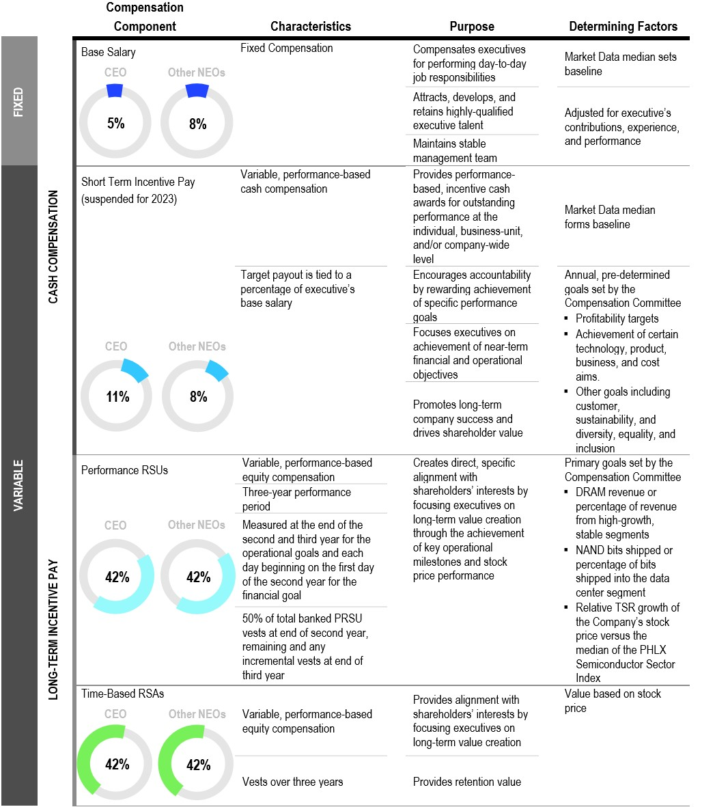
The percentages shown for each of the compensation components in the table above are presented based on base salary, target annual STI award, and the annual LTI awards (at the target award values approved by the Compensation Committee) granted to our CEO (on the left) and averaged for all other Named Executive Officers, excluding our CEO (on the right). Percentages of total compensation may not total 100% due to rounding.
37
Table of Contents
Base Salaries

In October 2022, the Compensation Committee determined to maintain fiscal 2023 base salaries consistent with fiscal 2022 levels. Subsequently, in February 2023, in light of the challenging industry environment, the Compensation Committee determined to reduce salaries for the remainder of fiscal 2023. Specifically, Mr. Mehrotra’s salary was reduced by 20% and other Named Executive Officers’ salaries were reduced by 15%.

Executive Officer |  |  | Fiscal 2023  Base Salary |  |  | Base Salary  % Change From Fiscal 2022 |  |  | Annualized  Fiscal 2023  Reduced  Base Salary |  |  | Annualized Reduced Base Salary  % Change From Fiscal 2022
Sanjay Mehrotra |  |  | $ | 1,418,000 |  | 0% |  |  | $ | 1,255,476 |  | (11) |  | %
Mark Murphy |  |  | 700,000 |  |  | 0% |  |  | 639,827 |  |  | (9) |  | %
Manish Bhatia |  |  | 729,750 |  |  | 0% |  |  | 667,020 |  |  | (9) |  | %
Scott DeBoer |  |  | 624,750 |  |  | 0% |  |  | 571,046 |  |  | (9) |  | %
Sumit Sadana |  |  | 782,250 |  |  | 0% |  |  | 715,007 |  |  | (9) |  | %

As discussed under “Short-Term Incentives” below, the Compensation Committee also suspended the EIP in February 2023. The table below illustrates the percentage reduction in our Named Executive Officers’ actual cash compensation between fiscal 2022 and fiscal 2023 as a result of the reduced base salary and EIP suspension.

Executive Officer |  |  | Fiscal 2022  Actual Cash Compensation ($) |  |  | Fiscal 2023  Target Cash Compensation ($) (Pre-Reduction) |  |  | Fiscal 2023  Actual Cash Compensation ($) |  |  | Actual Cash Compensation Reduction From Fiscal 2022 (%)
Sanjay Mehrotra |  |  | $ | 4,845,168 |  | $ | 4,466,700 |  | $ | 1,255,476 |  | (74%)
Mark Murphy(1) |  |  | 843,093 |  |  | 1,470,000 |  |  | 639,827 |  |  | N/A
Manish Bhatia |  |  | 1,630,118 |  |  | 1,532,475 |  |  | 667,020 |  |  | (59%)
Scott DeBoer |  |  | 1,325,171 |  |  | 1,249,500 |  |  | 571,046 |  |  | (57%)
Sumit Sadana |  |  | 1,835,536 |  |  | 1,720,950 |  |  | 715,007 |  |  | (61%)

(1) No comparison provided for Mr. Murphy whose fiscal 2022 actual total cash compensation reflects partial year salary and EIP payout and includes a $250,000 cash signing bonus.

Short-Term Incentives

Typically, we use the EIP to attract, retain, and reward qualified executives who are important to our success by offering the opportunity to earn cash awards for achieving performance goals set by the Compensation Committee. The Compensation Committee administers the EIP and has the authority to make all decisions and determinations required by the EIP, or as the Compensation Committee deems necessary or advisable to administer the EIP. Due to the challenging nature of the goals set by the Compensation Committee, achievement of EIP goals has historically required significant leadership, effort, and coordination among our leadership team.

Due to the challenging business environment the Company faced in 2023, and as part of a significant program to reduce Company costs and operating expenses, the Compensation Committee suspended the participation of our Named Executive Officers in the EIP for fiscal 2023. Accordingly, no Named Executive Officer received any short-term incentive award for fiscal 2023.

Notwithstanding the suspension of Named Executive Officers’ participation in the EIP during fiscal 2023, in an effort to respond to shareholders’ requests for enhanced disclosure regarding our EIP structure, in this section we discuss both the EIP structure for fiscal 2024 – for which performance will be measured over, and achievement
38 | 2023 Proxy Statement
Table of Contents
results will be determinable upon completion of, fiscal 2024 – as well as the EIP as it was initially established for fiscal 2023.

Fiscal 2024 Short-Term Incentive Awards

In October 2023, the Compensation Committee established fiscal 2024 performance goals and a short-term incentive compensation opportunity (the “Target Awards”) under the EIP for each Named Executive Officer. These Target Awards were made taking into consideration the Market Data median, among other factors, as part of the Compensation Committee’s efforts to make such opportunities reasonable as described above. The Compensation Committee selected Company Performance goals outlined below based on their correlation to the creation of shareholder value and their alignment with our financial and strategic objectives. The EIP awards will be determined following the end of the fiscal 2024 performance period as follows:

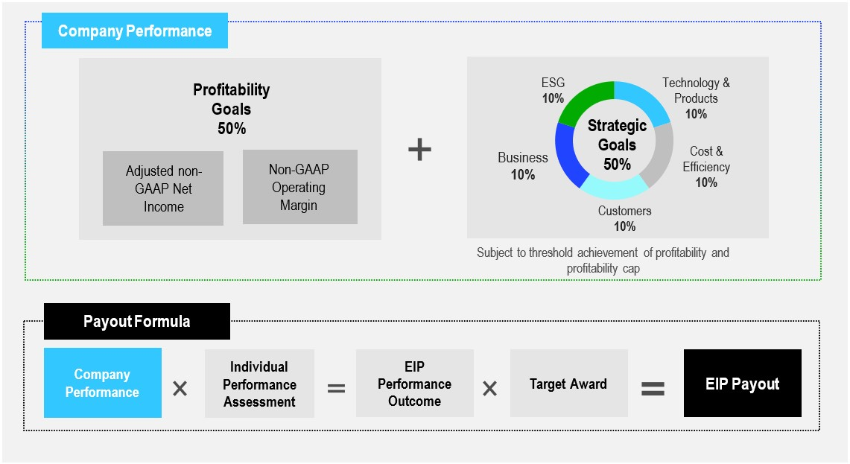

In response to the feedback we have received from shareholders, we are committed to providing full details regarding fiscal 2024 EIP profitability goals, including the threshold - maximum pay opportunities, and detail regarding our actual performance against the profitability and strategic goals, in next year’s proxy statement. See footnote 7 of “Pay Versus Performance” for a description of non-GAAP net income.

Fiscal 2023 Short-Term Incentive Awards

Fiscal 2023 EIP – Establishment and Suspension. In October 2022, the Compensation Committee initially set fiscal 2023 performance goals and Target Awards under the EIP for each Named Executive Officer as follows:

Named Executive Officer |  |  | Target Award  (% of Base Salary) |  |  | % Change from  Fiscal 2022
Sanjay Mehrotra |  |  | 215 |  | % | 0%
Mark Murphy |  |  | 110 |  | % | 0%
Manish Bhatia |  |  | 110 |  | % | 0%
Scott DeBoer |  |  | 100 |  | % | 0%
Sumit Sadana |  |  | 120 |  | % | 0%
39
Table of Contents
Subsequently, in light of the challenging industry environment and as part of a significant program to reduce Company costs and operating expenses, in February 2023, the Compensation Committee suspended the Named Executive Officers’ fiscal 2023 EIP participation. Accordingly, no Named Executive Officer received or was eligible to receive any short-term incentive cash award for fiscal 2023.

The remainder of this discussion provides information regarding the fiscal 2023 short-term incentive profitability and strategic goals that would have provided bonus payout opportunities under a structure similar to the fiscal 2024 EIP illustrated above had the fiscal 2023 EIP not been suspended. In light of the EIP suspension, we have not included details regarding the EIP profitability goals for fiscal 2023, but as noted above we commit to providing the fiscal 2024 profitability threshold, target and maximum goals, together with the actual performance ultimately achieved against those goals, in next year’s proxy statement. Our strategic goals involve highly confidential, competitively sensitive information, including forward-looking targets and product-specific strategies that if disclosed could cause irreparable competitive harm to us by providing competitors with insight into our internal processes, know-how, products and business initiatives, particularly as many of our goals build on multi-year achievements in order to execute on our overall business strategies. Revealing such information would allow competitors to leverage it to their competitive advantage, to our detriment and the detriment of our shareholders. However, we understand shareholders' desire for additional detail regarding our strategic goals, and have strived to provide greater visibility into the strategic goal components where possible, while balancing these competitive concerns.

Profitability and Strategic Performance Goals. Prior to suspending the EIP, the Compensation Committee established a profitability goal (50% weighting) measured based on the performance of adjusted non-GAAP net income and non-GAAP operating margin and five strategic goal categories (each category with a 10% weighting and together accounting for 50% weighting) for evaluating performance in fiscal 2023. See footnote 7 of “Pay Versus Performance” for a description of non-GAAP net income.

The Compensation Committee chose the profitability and strategic goals based on the following criteria:
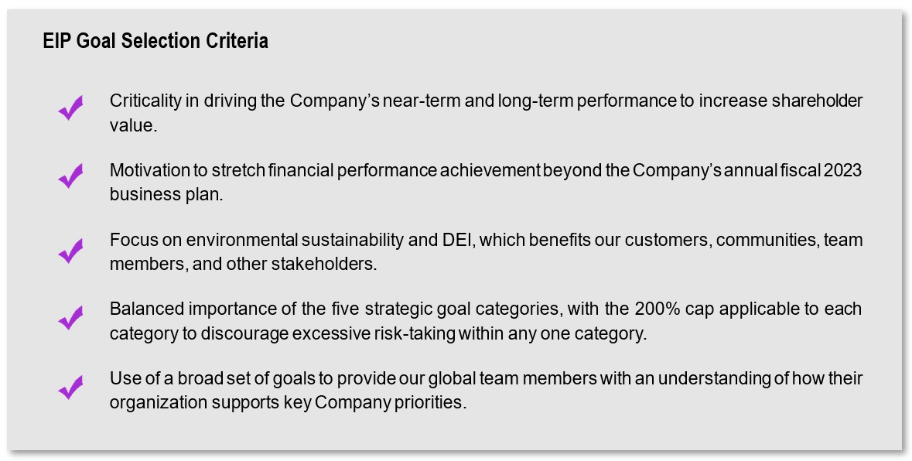
The fiscal 2023 profitability goal would have functioned as a gate with respect to any payout based on achievement of the strategic goals discussed below. Specifically, because actual achievement of the profitability goal was below the threshold performance of 50% of target, no payout could have been earned for the EIP had it not been suspended, regardless of the calculated strategic goal achievement. If the profitability goal achievement had resulted in achievement at or above threshold but below target performance, then the overall strategic goals outcome would have been adjusted to the lesser of the profitability goal results and the pre-adjusted strategic goal results.
40 | 2023 Proxy Statement
Table of Contents

The profitability goal would have required the Company to achieve pre-established fiscal 2023 adjusted non-GAAP net income or non-GAAP operating margin goals. The Compensation Committee intended these goals to be highly rigorous, as even the minimum threshold targets required performance meaningfully above our fiscal year 2023 business plan. Consistent with such approach, based on the Company’s fiscal 2023 adjusted non-GAAP net income and non-GAAP operating margin, the Company would not have achieved the minimum (50% of target) threshold goals. Accordingly, the payout for the profitability goal would have been zero had the Named Executive Officers’ participation in the EIP not been suspended.

The following five strategic goal categories would have accounted for 50% of the overall EIP achievement weighting.

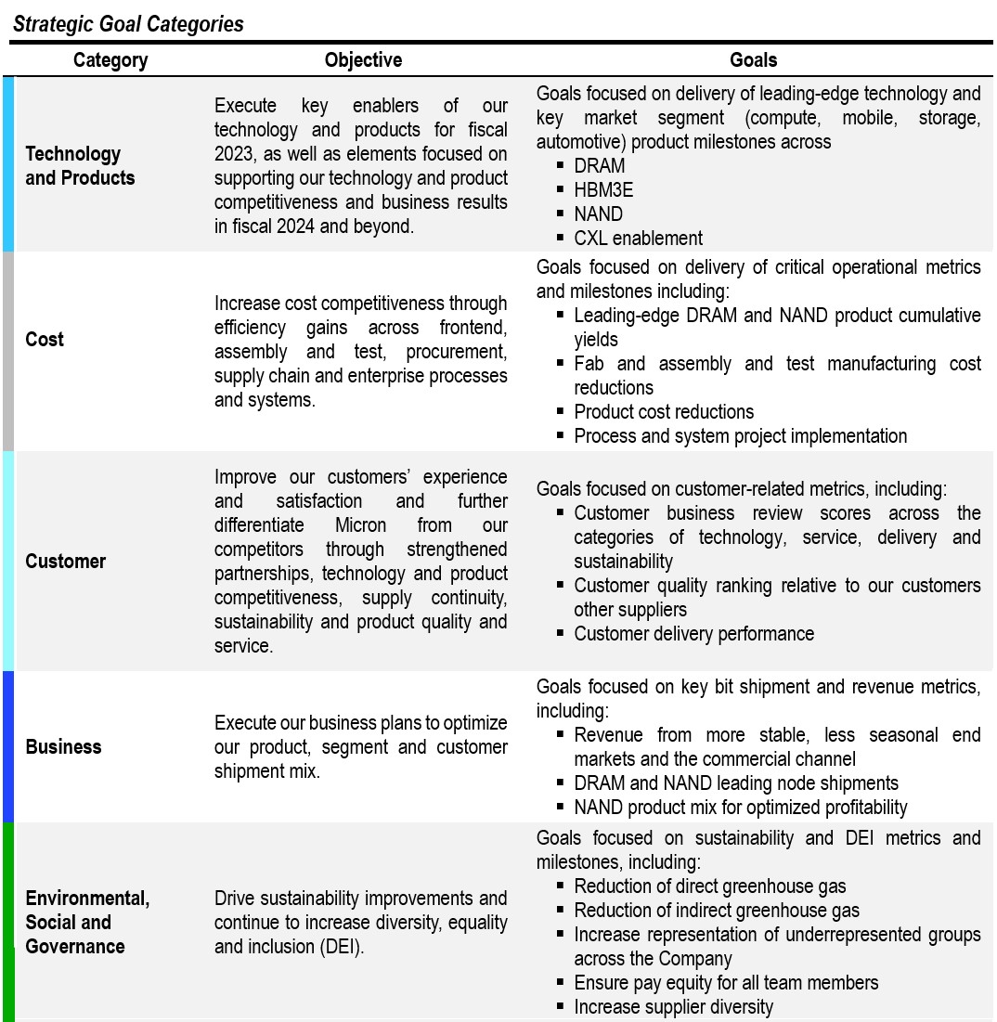

41
Table of Contents
Within each goal category, each strategic goal or group of related strategic goals would have provided an opportunity to achieve performance between the minimum threshold of 50% of target and a maximum of 200% of target.

Achievement of each of the strategic goals included in the five strategic goal categories would have required significant effort and adept execution, and there was no assurance of achievement with respect to any of the metrics or milestones. The Compensation Committee believed that achieving maximum performance for any strategic goal categories would have been challenging and required extraordinary leadership, effort, and coordination as a team. In the past three fiscal years, none of the current strategic goal categories achieved (or would have achieved, for fiscal 2023) maximum performance.

Had the Named Executive Officers’ participation in the EIP for fiscal 2023 not been suspended, the formulaic results of the EIP goals would have been as follows:
Metric |  |  | Performance Level Achieved  (% of Targeted Goal)
Profitability (Adjusted non-GAAP Net Income and non-GAAP Operating Margin) |  |  | 0%
Technology and Products |  |  | 138%
Cost |  |  | 140%
Customer |  |  | 156%
Business |  |  | 132%
Environmental, Social and Governance |  |  | 160%
Total Achievement |  |  | 0%

Notwithstanding that the strategic goals were achieved, because the fiscal 2023 EIP design required achieving threshold performance under the profitability goals in order for Named Executive Officers to earn any award, no payouts would have been earned under the EIP had it not been suspended.

Long-Term Equity Incentives

We believe long-term incentive compensation should be tied to our success and help promote increases in long-term shareholder value. Accordingly, performance-based restricted stock unit awards are a significant component of our executive compensation program. We believe these awards are especially aligned with shareholders’ long-term interests because they vest based on achievement of key financial and operational goals and provide an incentive to increase stockholder value because these awards become more valuable to the grantee if our stock price increases. These awards are also intended to help retain key executives and employees as their efforts greatly affect our success as a company.

In fiscal 2023, consistent with the pay-for-performance philosophy underlying our compensation program, the Compensation Committee set the long-term incentive mix at 50% performance-based restricted stock units (“PRSUs”) and 50% time-based restricted stock awards (“RSAs”) for all Named Executive Officers. The Compensation Committee believes that making PRSUs a significant portion of the long-term incentive mix furthers Micron’s pay-for-performance philosophy. For fiscal 2024, the Compensation Committee increased the performance-based weighting of the CEO’s long-term incentive mix to award 65% of the value in PRSUs and 35% in RSAs.

In determining the amount of the long-term equity incentive awards for our Named Executive Officers, the Compensation Committee took into account various data points including (but not limited to) Market Data and information provided by Mr. Mehrotra related to the other officers’ performance and his recommendation as to the amount of their awards. Although the Market Data and Mr. Mehrotra’s recommendations informed the Compensation Committee’s decision, they were not dispositive. The Compensation Committee also considers the other factors described under the section entitled “Reasonable” above when determining long-term equity incentive awards for our Named Executive Officers.

42 | 2023 Proxy Statement
Table of Contents
The following table shows the intended target value of our Named Executive Officers’ fiscal 2023 long-term equity incentive awards:
Named Executive Officer |  |  | Fiscal 2023 Long-Term Equity Incentives(1)
Sanjay Mehrotra |  |  | $ | 23,750,000
Mark Murphy |  |  | 7,750,000
Manish Bhatia |  |  | 8,250,000
Scott DeBoer |  |  | 6,500,000
Sumit Sadana |  |  | 8,500,000

(1) Reflects target grant-date fair value.

Based on a review of Market Data, taking into consideration the Market Data median, the Compensation Committee determined that it was appropriate to increase the target award amounts by $250,000 for each Named Executive Officer and $750,000 for Mr. Murphy.

We have not, and do not plan to time the grant of long-term incentive awards (or the award or payment of any other compensation) with the release of material, non-public information. Historically, long-term incentive awards have been made in the first quarter of the fiscal year with the exact grant date corresponding with the date of the approval of the Compensation Committee. The Compensation Committee generally approves long-term incentive awards granted to the Named Executive Officers on the same day as the grants to other executive officers. For purposes of our equity plans, fair market value is defined as the closing price of our Common Stock as quoted on Nasdaq for the last market-trading day prior to the date of grant.

Certain Goals Involve Highly Confidential Information

As with the strategic goals under our EIP discussed above, the specific targets for our PRSUs awarded based on operational metrics involve highly confidential information that, if disclosed, could cause us irreparable competitive harm. Accordingly, we do not publicly disclose the specific targets for any PRSU awards that utilize operational metrics. However, in this discussion, we have endeavored to provide shareholders with greater visibility into the details of operational PRSU metrics where possible, while remaining mindful of these competitive concerns.

Performance-based RSUs Granted in Fiscal 2023

For fiscal 2023, the Compensation Committee awarded three types of PRSUs:

Metric Category |  |  | Name |  |  | Performance Metric |  |  | Percentage of 2023 PRSU Award Value
Operational |  |  | 2023 DRAM PRSU Awards |  |  | DRAM revenue or percentage of DRAM revenue from high-growth, stable segments (automotive, industrial multi-market, networking, data center, and graphics applications) |  |  | 25%
Operational |  |  | 2023 NAND PRSU Awards |  |  | NAND bits shipped or percentage of NAND bits shipped into the data center segment, to drive increased NAND profitability and return on investment (ROI) |  |  | 25%
Financial |  |  | 2023 rTSR PRSU Award |  |  | Relative TSR growth of the Company’s stock price versus the median of the PHLX Semiconductor Sector Index. |  |  | 50%

We refer to the 2023 NAND PRSU Awards and the 2023 DRAM PRSU Awards collectively as the “2023 Operational PRSU Awards,” and, together with the 2023 rTSR PRSU Award, as the “2023 PRSU Awards.”

43
Table of Contents
PRSU awards are eligible to be earned (or “banked”) during the second and third years of the three-year period covering fiscal 2023, 2024, and 2025 (the “Performance Period”) based upon results against performance metrics set at the beginning of the Performance Period. The actual number of PRSUs that will be banked and become eligible to vest under the 2023 PRSU Awards is determined by the product of each Named Executive Officer’s target number of PRSUs and the payout factor that results from actual performance versus pre-established performance metrics (the “Payout Factor”) and is subject to the caps discussed below.

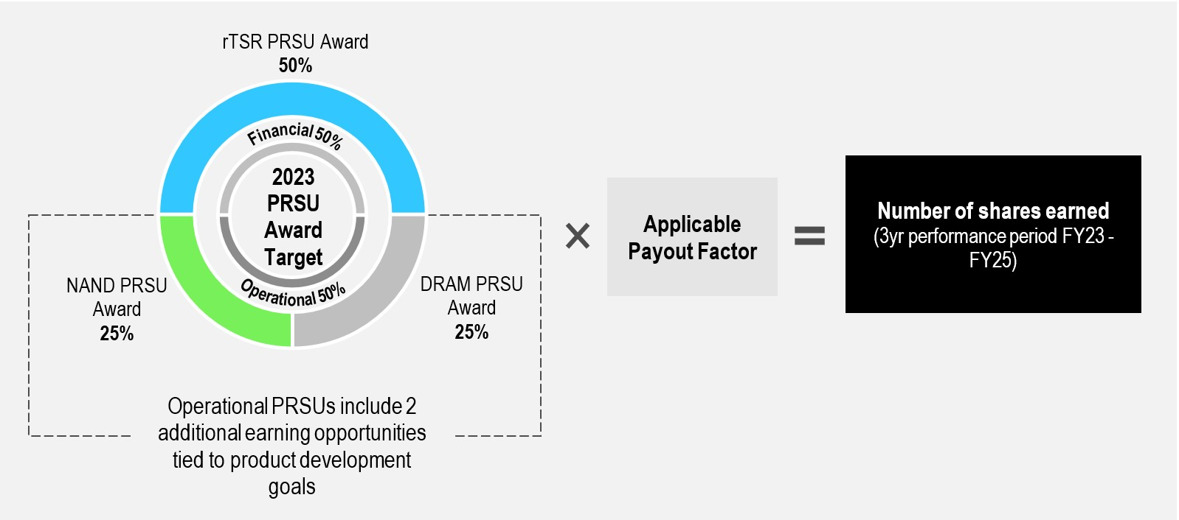

Overall Combined Cap on PRSU Earning and Vesting

The number of PRSUs that each Named Executive Officer may earn under all 2023 PRSU Awards (taken together) during the Performance Period is limited to two times the aggregate target number of PRSUs awarded (the “200% Limit”). As a result, our Named Executive Officers’ ability to earn and vest in the PRSUs is capped at the 200% Limit.

Each of the two Operational PRSU Awards (2023 DRAM PRSU Awards and 2023 NAND PRSU Awards) represents 25% of the total 2023 PRSU Awards. The Operational PRSU Awards thus account for 50% of the total 2023 PRSU Awards. The maximum number of PRSUs that can be earned based on the actual results for the primary components of each of the Operational PRSU Awards is 200% of the target number of PRSUs awarded for each of the Operational PRSU Awards.

The 2023 rTSR PRSU Award represents the remaining 50% of the total 2023 PRSU Awards1. The maximum number of PRSUs that can be earned for the 2023 rTSR PRSU Award is 150% of the target number of PRSUs awarded for the rTSR PRSU Award.

If the primary components of the Operational PRSU Awards achieve the maximum payout of 200% and the rTSR Award achieves the maximum payout level of 150%, the total 2023 PRSUs earned by each Named Executive Officer will be less than1 175% of the total target PRSUs. The Compensation Committee has approved two additional stretch components of the Operational PRSU Awards that increase the earning opportunity for the Operational PRSU Awards. These stretch components are chosen to be ones whose importance is strategic in nature, whose accomplishment is highly uncertain as the targets represent a stretch from an operational and execution perspective, and whose accomplishment would position the Company very well from a competitive standpoint for the future. Delivering on each of these stretch components will allow recipients of the 2023 PRSU Awards to earn an additional 16.5% of the total 2023 PRSU target award for each of the two stretch components, subject to the overall 200% Limit.
1 The actual number of shares granted through the rTSR Award was lower than the number of shares granted for the Operational PRSU Awards due to application of the Monte Carlo valuation approach for the rTSR Award.
44 | 2023 Proxy Statement
Table of Contents

Achievement of one of these stretch components of the Operational PRSU Awards would add 16.5% to the 175% referenced above, bringing the maximum number of overall total 2023 PRSUs earned to less than1 192% of the total 2023 PRSU target. Achievement of both stretch components, would increase the maximum number of 2023 PRSU Awards to 200% of the total 2023 PRSU target, due to the 200% Limit.

2023 Operational PRSU Awards

The 2023 Operational PRSU Awards tie 50% of each Named Executive Officer target performance-based long-term incentive compensation opportunity to the 2023 DRAM PRSU Awards and 2023 NAND PRSU Awards, as noted above. The 2023 Operational PRSU Awards also have two additional earnings opportunities for stretch components based on product development milestones and targeted product revenue.

Performance for the 2023 DRAM PRSU Awards requires DRAM revenue from high-growth, stable segments (automotive, industrial multi-market, networking, data center, and graphics applications) to exceed a specified absolute threshold or percentage of the total Company DRAM revenue for fiscal year 2024 and fiscal 2025, respectively. Achievement below the threshold will result in no payout. As DRAM revenue from the defined high-growth, stable segments or percentage of total Company DRAM revenue achievement increases above the threshold, payout also increases up to a maximum of 200% of the target number of PRSUs.

Performance for the 2023 NAND PRSU Awards is measured by exceeding a threshold for fiscal year shipments of NAND products, including components and SSDs, into the data center segment (“Data Center NAND”) measured as an absolute number of exabytes shipped or as a percentage of total Company NAND shipments for fiscal 2024 and fiscal 2025, respectively. Achievement below the threshold will result in no payout. As Data Center NAND shipments or percentage of the total Company NAND shipments increase above the threshold, payout also increases up to a maximum of 200% of the target number of PRSUs.

For the 2023 Operational PRSU Awards, the maximum payout for achieving these targets is 200% of the target number of PRSUs under each award, subject to any increases for achieving the additional earning opportunities described below, but capped by the 200% Limit described above. 2023 Operational PRSU Awards do not bank unless performance meets or exceeds the established thresholds. When performance results in achievement above the threshold and between performance levels, the applicable Payout Factor will be determined based on interpolation between performance levels.

In addition, the 2023 Operational PRSU Awards also include two additional earning opportunities tied to stretch components that relate to the development of high bandwidth memory products and associated revenue and Compute Express Link-related products that the Compensation Committee believes would represent significant progress that will enhance long-term shareholder value. Achievement of these additional 2023 Operational PRSU performance conditions increases the number of operational 2023 PRSU Awards earned and requires a significant level of execution and effort. Achievement is subject to the 200% Limit noted above.

Operational PRSU Goals Require Strong Performance. In setting the targets for the 2023 Operational PRSU Awards, the Compensation Committee believed that achievement of these goals at target would require a stretch performance and challenging level of execution and effort on the part of our Named Executive Officers. The established target for DRAM revenue from high-growth, stable segments as a percentage of total Company DRAM revenue set by the Compensation Committee requires performance that is superior to prior fiscal years, including fiscal 2022. The Data Center NAND shipment threshold set by the Compensation Committee for number of exabytes shipped into the data center segment is higher than actual shipments achieved in any prior fiscal year. When the Compensation Committee set the 2023 Operational PRSU Award goals, it believed that achievement of even the threshold level of performance was uncertain.

Determination of Payout. Achievement levels with respect to the Payout Factor applicable to the 2023 Operational PRSU Awards will be measured at the end of the second and third fiscal years of the Performance Period. No later than 60 days after the end of the second and third fiscal years in the Performance Period (each, a “Certification Date”), the Compensation Committee determines and certifies the resulting Payout Factors for the applicable fiscal year as set forth above. PRSUs that have achieved the requisite performance will become banked.
45
Table of Contents

2023 rTSR PRSU Award

The 2023 rTSR PRSU Award ties 50% of each Named Executive Officer’s target performance-based long-term incentive compensation opportunity to the Company’s share price growth as compared to the TSR of the companies in the SOX index, which is composed of companies primarily involved in the design, distribution, manufacture, and sale of semiconductors, over the three-year Performance Period. The TSR component is measured in year two and year three of the Performance Period. For fiscal 2023, the Compensation Committee set the target goal at the median of the SOX index calculated based on the difference between the Company’s and the median SOX index company’s 60-day average three-year TSR compounded annual growth rate performance. After taking shareholders’ feedback into consideration, the Compensation Committee has increased the fiscal 2024 target to the 55th percentile of the SOX index.

Payout Factor. The Payout Factor for the 2023 rTSR PRSU Award is based on the average of the Company’s three-year rTSR for each of the 60 days trailing the applicable measurement date (inclusive of the measurement date), expressed as a compounded annual growth rate (the “TSR CAGR”), relative to the TSR CAGR (“rTSR CAGR”) of the median company in the SOX index (the “Median SOX Company”). The rTSR CAGRs of the Company versus the Median SOX Company will be measured on each day starting on the first day of fiscal 2024 through the last day of the Performance Period (each, a “measurement date”).

The following table sets forth the levels of rTSR CAGR required to be achieved under the 2023 rTSR PRSU Award to result in the Payout Factors specified below:

rTSR CAGR Achieved on a Measurement Date |  |  | Payout Factor for the rTSR CAGR
Less than -50 percentage points (“pp”) |  |  | 0%
-50pp (“rTSR Threshold”) |  |  | 50%
0pp (“rTSR Target”) |  |  | 100%
+25pp (“rTSR Maximum”) |  |  | 150%
Greater than +25pp |  |  | 150%

If the rTSR CAGR achieved is between the rTSR Threshold and rTSR Target levels or the rTSR Target and rTSR Maximum levels, the Payout Factor will be determined using interpolation between the applicable levels. For fiscal 2024, the Compensation Committee increased the rTSR Maximum to +50pp so that our payout slope is symmetrical for increases (and decreases) above (and below) the rTSR Target, significantly increasing the level of outperformance required to achieve the rTSR Maximum.
Cap on rTSR PRSUs. The maximum number of rTSR PRSUs that may be earned and vested is equal to 150% of the target number of 2023 rTSR PRSUs granted and is further limited by the total 200% Limit discussed under “Overall Combined Cap on PRSU Earning and Vesting” above. In addition, beginning in fiscal 2024, to further the alignment of the rTSR PRSU Award with shareholders’ experience, payouts will be capped at the rTSR Target in the event that the Company’s absolute TSR is negative, notwithstanding the level of relative performance achieved.

Determination of Payout. As of any measurement date, the number of PRSUs under a 2023 rTSR PRSU Award that are considered banked through such date will equal the product of the Payout Factor determined based on the greatest rTSR CAGR achieved during the Performance Period through such date, and the target number of PRSUs subject to the 2023 rTSR PRSU Award. Accordingly, once PRSUs under a 2023 rTSR PRSU Award become banked on a measurement date (due to achievement of a particular rTSR CAGR level), additional PRSUs can become banked only if a greater rTSR CAGR level is achieved on a later measurement date. Such additional PRSUs banked, if any, will be equal to the excess of the Payout Factor determined using the new, greater rTSR CAGR achieved, over the Payout Factor determined using the next greatest rTSR CAGR previously achieved, multiplied by the target PRSUs subject to the 2023 rTSR PRSU Award. Following completion of each of fiscal 2024 and 2025, the Compensation Committee will certify the extent of achievement of the Payout Factors as set forth above during fiscal 2024 and 2025, respectively.
46 | 2023 Proxy Statement
Table of Contents

PRSU Vesting

PRSUs will not vest under the 2023 PRSU Awards (if at all) until the Certification Date that immediately follows the end of fiscal 2024, when 50% of PRSUs that have been earned will vest. The remaining 50% of PRSUs earned upon the first Certification Date are banked and will vest upon the second Certification Date that immediately follows the end of fiscal 2025. Any incremental PRSUs that become earned during fiscal 2025 will also vest in full on the second Certification Date, as illustrated below.

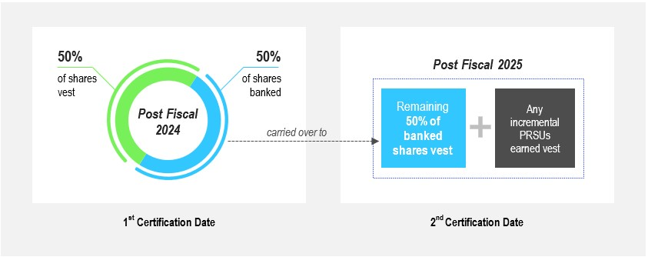

If a Named Executive Officer terminates employment with the Company for any reason other than a termination by the Company for cause, any banked shares will continue to vest on the vesting schedule described above. No further PRSUs under the 2023 PRSU Awards will vest following a Named Executive Officer’s termination for cause. For purposes of the 2023 PRSU Awards, “cause” is as defined in the agreement between a Named Executive Officer and the Company governing the terms of such Named Executive Officer’s employment or termination thereof, or if not so defined, as defined in the equity incentive plan under which the award was granted.

Fiscal 2023 PRSUs Achievement

The measurement periods for the 2023 Operational PRSU Awards and the 2023 rTSR PRSU Award do not begin until fiscal 2024. Accordingly, no shares were earned, vested or banked during fiscal 2023 under the 2023 PRSU Awards.

Fiscal 2022 PRSUs Achievement

For fiscal 2022, the Compensation Committee awarded PRSUs (the “2022 PRSU Awards”) as follows:

47
Table of Contents
Metric Category |  |  | Name |  |  | Performance Metric |  |  | Percentage of 2022 PRSU Award Value
Operational |  |  | 2022 Market Segment NAND PRSU Awards |  |  | Fiscal year shipments of Data Center NAND measured in absolute exabytes and as a percentage of total Company NAND shipments for that fiscal year |  |  | 25%
Operational |  |  | 2022 High-Value NAND PRSU Awards |  |  | Fiscal year shipments of all NAND bit sales minus consumer components and SpecTek components (“High-Value NAND”) measured as a percentage of total Company NAND shipments for that fiscal year |  |  | 25%
Financial |  |  | 2022 rTSR PRSU Award |  |  | Relative TSR growth of the Company’s shares versus the median of the SOX |  |  | 50%

We refer to the 2022 Market Segment NAND PRSU Awards and the 2022 High-Value NAND PRSU Awards collectively as the “2022 Operational PRSU Awards.”

The 2022 rTSR PRSU Award is structured very similarly to the 2023 rTSR PRSU Award except that the applicable performance period is fiscal 2022, 2023 and 2024. Thus, the 2022 rTSR PRSU Award (as with the 2023 awards) provide for the earning and banking or vesting of shares based on the Company’s share price growth as compared to the median TSR of the companies in the SOX index over a three-year performance period. The rTSR goals and potential payout factors are the same as shown above in the table for the 2023 rTSR PRSU Award (with the exception of the applicable performance period).

For the 2022 Market Segment NAND PRSU Awards, separate thresholds apply for each of fiscal year 2023 and 2024 for both absolute exabytes and percentage of total NAND bits shipped. For the 2022 High-Value NAND PRSU Awards, thresholds apply for the percentage of total NAND bits shipped. Achievement below the threshold will result in no payout.

In addition to the Data Center NAND and High-Value NAND performance metrics, the 2022 Operational PRSU Awards also include two additional earning opportunities tied to performance conditions relating to the development of high bandwidth memory products and associated revenue, Compute Express Link-related products, and leading-edge DRAM products that the Compensation Committee believes represent significant progress that will enhance long-term shareholder value. Each of these two additional 2022 Operational PRSU performance conditions may increase the number of the 2022 PRSU Awards earned, although total 2022 PRSU Award payouts may not exceed the 200% Limit noted above. Achievement of the additional performance conditions requires a significant level of execution.

PRSU Payout Formula

For each of the PRSU Awards we granted for fiscal years 2021, 2022 and 2023, a Payout Factor (that varies based on actual performance versus the goals and that may be zero, resulting in no payout) is used to determine the number of shares that are earned and banked (but not necessarily vested).

48 | 2023 Proxy Statement
Table of Contents
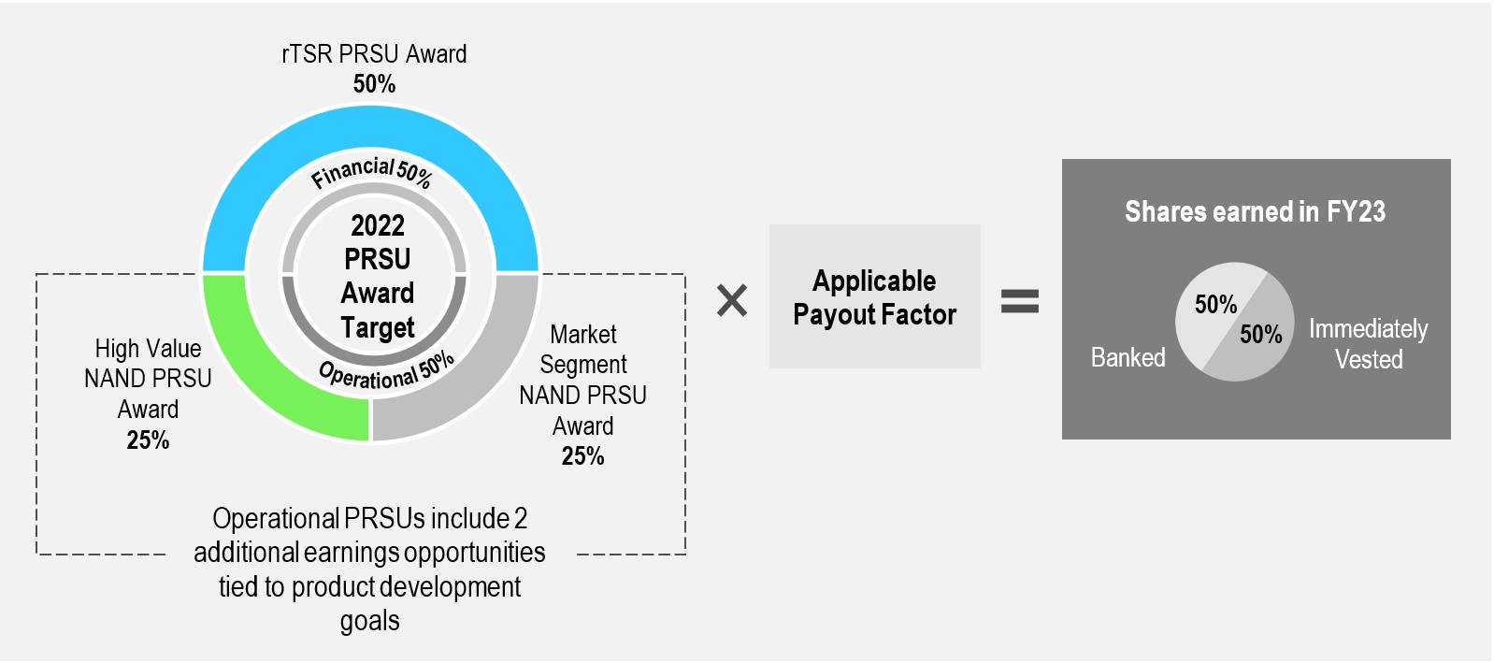

In October 2023, the Compensation Committee reviewed the Company’s performance relative to the 2022 PRSU Award metrics and applied the applicable 2022 Payout Factors. This review was the first measurement year provided under the 2022 PRSU Awards; the final measurement will be performed following fiscal year 2024.
The Compensation Committee determined that the Company’s performance versus the goals as of the end of fiscal year 2023 was as follows:

Fiscal 2022 PRSU Award Payout Factors
 |  |  | Operational - 50% Weight |  |  |  |  |  |  |  |  |  |  |  |  |  |  |  |  |  |  |  |  |  |  |  |  |  |  | Financial - 50% Weight
 |  |  | High-Value NAND |  |  |  |  |  |  |  |  | Market Segment NAND |  |  |  |  |  |  |  |  | Additional  Performance Conditions |  |  |  |  |  |  |  |  | rTSR CAGR
Fiscal Year |  |  | Actual Result |  |  | Payout Factor |  |  |  |  |  | Actual Result |  |  | Payout Factor |  |  |  |  |  | Actual Result |  |  | Payout Factor |  |  |  |  |  | Actual Result |  |  | Payout Factor
2023 |  |  | below threshold |  |  | 0% |  |  |  |  |  | below threshold |  |  | 0% |  |  |  |  |  | Achieved high bandwidth memory revenue goal |  |  | 33% |  |  |  |  |  | -7ppts |  |  | 93%

Performance also will be measured after the end of fiscal 2024 and additional shares may be earned, although there is no guarantee any additional shares will be earned. Following the completion of fiscal year 2024, the Company intends to provide additional information regarding the goals, their achievement, and whether additional shares were earned.

49
Table of Contents
The Compensation Committee certified that the following shares had been earned and vested or banked by our Named Executive Officers under the 2022 PRSU Awards:

 |  |  | FY22  High-Value NAND Shares |  |  |  |  |  |  |  |  |  |  |  | FY22  Market Segment NAND Shares |  |  |  |  |  |  |  |  |  |  |  | FY22  rTSR Shares
Executive |  |  | Earned for FY23 |  |  | Vested |  |  | Banked |  |  |  |  |  | Earned for FY23 |  |  | Vested |  |  | Banked |  |  |  |  |  | Earned for FY23 |  |  | Vested |  |  | Banked
Sanjay Mehrotra |  |  | 14,529 |  |  | 7,264 |  |  | 7,265 |  |  |  |  |  | 14,529 |  |  | 7,264 |  |  | 7,265 |  |  |  |  |  | 68,770 |  |  | 34,385 |  |  | 34,385
Mark Murphy |  |  | 7,430 |  |  | 3,715 |  |  | 3,715 |  |  |  |  |  | 7,430 |  |  | 3,715 |  |  | 3,715 |  |  |  |  |  | 34,765 |  |  | 17,382 |  |  | 17,383
Manish Bhatia |  |  | 4,946 |  |  | 2,473 |  |  | 2,473 |  |  |  |  |  | 4,946 |  |  | 2,473 |  |  | 2,473 |  |  |  |  |  | 23,411 |  |  | 11,705 |  |  | 11,706
Scott DeBoer |  |  | 3,864 |  |  | 1,932 |  |  | 1,932 |  |  |  |  |  | 3,864 |  |  | 1,932 |  |  | 1,932 |  |  |  |  |  | 18,289 |  |  | 9,144 |  |  | 9,145
Sumit Sadana |  |  | 5,100 |  |  | 2,550 |  |  | 2,550 |  |  |  |  |  | 5,100 |  |  | 2,550 |  |  | 2,550 |  |  |  |  |  | 24,143 |  |  | 12,071 |  |  | 12,072

Fiscal 2021 PRSUs Achievement

For fiscal 2021, the Compensation Committee awarded PRSUs under performance metrics that measure relative TSR growth (the “2021 rTSR PRSU Award”) and the percentage of bits shipped as part of certain high-value NAND products (the “2021 High-Value NAND PRSU Award” and, together with the 2021 rTSR PRSU Award, the “2021 PRSU Awards”), each representing 50% of the total target PRSU opportunity for each Named Executive Officer. The 2021 rTSR PRSU Award had the same design as the 2023 rTSR PRSU Award and the 2022 rTSR PRSU Award, except that the performance period for the 2021 rTSR PRSU Award was fiscal 2021, 2022 and 2023.

Performance for the 2021 High-Value NAND PRSU Award required exceeding a threshold with respect to percentage of NAND bits shipped as High-Value NAND, then meeting certain incremental pre-established targets to achieve increased payouts, subject to a maximum payout of 200%.

In addition, the 2021 High-Value NAND PRSU Award also included two additional earnings opportunities tied to performance conditions relating to achievement of targeted high bandwidth memory revenue and 3DXP solutions revenue that the Compensation Committee believed represented significant progress that would enhance long-term shareholder value. Each of the two additional performance conditions could have increased the number of 2021 NAND PRSU Awards earned, although the total 2021 PRSU Award payouts may not have exceeded the 200% Limit. The additional performance conditions were not achieved and therefore did not impact the 2021 High-Value NAND PRSU Award earned.

In October 2022 and October 2023, the Compensation Committee reviewed the Company’s actual performance relative to the 2021 PRSU Award metrics and applied the applicable 2021 Payout Factors. Actual results and the Payout Factors as certified by the Compensation Committee were as follows:

Fiscal 2021 PRSU Award Payout Factors
 |  |  | Operational |  |  |  |  |  |  |  |  | Financial
 |  |  | High-Value NAND |  |  |  |  |  |  |  |  | rTSR CAGR
Fiscal Year |  |  | Actual Result |  |  | Payout Factor |  |  |  |  |  | Actual Result |  |  | Payout Factor
2022 |  |  | above maximum |  |  | 200% |  |  |  |  |  | -8ppts |  |  | 92%
2023 |  |  | N/A |  |  | N/A |  |  |  |  |  | -7ppts |  |  | 93%
Total Combined Payout |  |  |  |  |  | 200% |  |  |  |  |  |  |  |  | 93%

Based on these actual results and Payout Factors, the Compensation Committee certified that a number of incremental shares were earned and vested in fiscal 2023 under the 2021 PRSU Awards, as set forth in the table below. The table also indicates the number of shares previously earned and either vested or banked based on fiscal 2022 performance.

50 | 2023 Proxy Statement
Table of Contents
Executive(1) |  |  | FY21 NAND |  |  |  |  |  |  |  |  |  |  |  |  |  |  | FY21 rTSR
 |  |  | Shares Earned & Vested in FY22 |  |  | Shares Banked in FY22 & Vested in FY23 |  |  | Incremental Shares Earned & Vested for FY23 |  |  | Total Shares Earned & Vested |  |  |  |  |  | Shares Earned & Vested in FY22 |  |  | Shares Banked in FY22 & Vested in FY23 |  |  | Incremental Shares Earned & Vested for FY23 |  |  | Total Shares Earned & Vested
Sanjay Mehrotra |  |  | 89,045 |  |  | 89,045 |  |  | — |  |  | 178,090 |  |  |  |  |  | 34,610 |  |  | 34,611 |  |  | 752 |  |  | 69,973
Manish Bhatia |  |  | 28,879 |  |  | 28,879 |  |  | — |  |  | 57,758 |  |  |  |  |  | 11,225 |  |  | 11,225 |  |  | 244 |  |  | 22,694
Scott DeBoer |  |  | 24,066 |  |  | 24,066 |  |  | — |  |  | 48,132 |  |  |  |  |  | 9,354 |  |  | 9,354 |  |  | 204 |  |  | 18,912
Sumit Sadana |  |  | 31,286 |  |  | 31,286 |  |  | — |  |  | 62,572 |  |  |  |  |  | 12,160 |  |  | 12,161 |  |  | 264 |  |  | 24,585

(1) Mr. Murphy joined the Company in April 2022 and, as a result, did not receive any 2021 PRSU Awards

Time-Based RSAs

Time-based restricted stock awards (“RSAs”) support retention and are linked to shareholder value and ownership. Annual RSAs granted in fiscal 2023 over three years from the date of grant, with one third vesting on the first anniversary date of grant and the remainder vesting ratably in eight quarterly installments, subject to continued employment. In fiscal 2023, RSAs comprised 50% of the target value of the long-term incentive awards granted.

Compensation-Setting Process and the Determination of Compensation Levels

The Compensation Committee reviews the compensation of our executive officers on an annual basis and sets compensation levels at the beginning of each fiscal year. As part of this process, the Compensation Committee reviews our financial results for the year just ended, projections for future periods, our strategic business plan, and the Market Data provided by its compensation consultant. The Compensation Committee also works with our CEO to establish performance goals that further our strategic objectives.

Engagement of Compensation Consultant

The Compensation Committee annually engages a compensation consultant to provide a comprehensive review of executive compensation matters and meets with the compensation consultant at least quarterly. This compensation consultant provided the Compensation Committee with information for our executive officers on cash and non-cash compensation elements and historical and trend payment data.

The Compensation Committee has established procedures intended to keep its compensation consultant’s advice objective and free of influence from our management. These procedures include: a direct reporting relationship to the Compensation Committee; a provision in the Compensation Committee’s engagement letter with the compensation consultant specifying what information, data, and recommendations can be shared with management; and an annual update to the Compensation Committee on the compensation consultant’s relationship with the Company, including a summary of the work performed during the preceding 12 months. For fiscal 2023, the specific activities undertaken by the compensation consultant for the Compensation Committee included:

•review the Compensation Peer Group (as defined in this Compensation Discussion and Analysis) and recommend any changes to its members;

•evaluate target total direct compensation and its components (base salary, target short-term incentives, and target long-term incentives) of our executive officers using several data sources;

•evaluate our historical “pay-for-performance” relationship;

•review the metrics and targets associated with the annual short-term incentives and long-term incentive compensation plans;
51
Table of Contents

•review the proposed equity awards to be granted to our executive officers, along with vesting recommendations;

•assist with a risk assessment of our compensation policies and practices;

•review a draft of the Compensation Discussion and Analysis section of our definitive proxy statement; and

•attend the Compensation Committee meetings in which executive compensation matters are discussed.

Compensia, Inc. (“Compensia") was the Compensation Committee’s compensation consultant in fiscal 2023. Compensia provided services related exclusively to the executive and non-employee director compensation consulting work performed for the Compensation Committee and for the Governance and Sustainability Committee.

The Compensation Committee considered Compensia’s independence in light of SEC rules and Nasdaq Listing Rules. The Compensation Committee received a letter from Compensia addressing its independence, including the following factors: (i) other services provided to us by them; (ii) fees paid by us as a percentage of their total annual revenue; (iii) policies or procedures maintained by them that are designed to prevent a conflict of interest; (iv) any business or personal relationships between the individual consultants involved in the engagement and any member of the Compensation Committee; (v) whether the individual consultants involved in the engagement owned shares of our Common Stock; and (vi) any business or personal relationships between our executive officers and them or the individual consultants involved in the engagement. The Compensation Committee concluded that there were no conflicts of interest with Compensia.

“Market Data” Defined

The Compensation Committee, with the support of Compensia, reviews and approves the Compensation Peer Group annually to ensure that it reflects industry or economic changes and core selection criteria. Our current criteria includes comparable revenue and market capitalization size; industry, with a focus on semiconductor companies and other broad technology industry companies that are market leaders in their space; as well as other talent competitors and companies with similar business strategies.

Our Compensation Peer Group for fiscal 2023 was comprised of the following 16 companies, which we believe are companies with which we are likely to compete for executive talent. In consultation with Compensia, the Compensation Committee did not make any changes to the Compensation Peer Group for fiscal 2023.

52 | 2023 Proxy Statement
Table of Contents
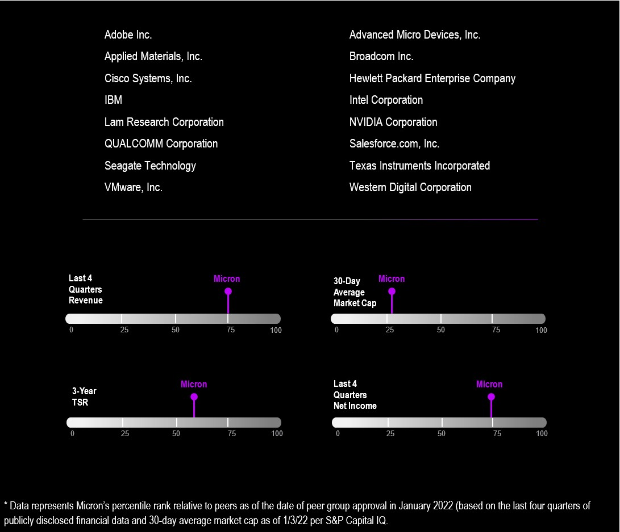

Compensation Peer Group Data

Compensia gathers data from the proxy statements publicly filed by our Compensation Peer Group and from published compensation surveys. The relevant survey and Compensation Peer Group data for fiscal 2023, each as discussed below, were weighted equally by the Compensation Committee and are collectively referred to throughout this Compensation Discussion and Analysis as the “Market Data.”

When collecting and assessing market compensation data, Compensia collects data based on job descriptions first. This permits the Compensation Committee to match positions held by our executives with those of our Compensation Peer Group and, as described more fully below, deviate from the Market Data based on the factors described earlier. If the Compensation Committee is not able to match positions to a reasonable number of companies within the Compensation Peer Group, it looks to the rank of the person involved and matches ranks, e.g., our third-highest paid executive officer could be compared to the third-highest paid executive officer at each company within the Compensation Peer Group.

53
Table of Contents
Compensation Survey Data

Compensation survey data may vary from year to year. For fiscal 2023, the compensation consultant used the Radford Global Technology Survey and information obtained from public filings by the Compensation Peer Group. We believe this survey is particularly relevant for technology companies given the high level of participation by such companies in the survey.

Compensation-Setting Process

Compensia reviews the most recent available data and identifies the Market Data values for the 25th, 50th (i.e., median), and 75th percentile with respect to each position or rank, then compares our compensation data, both as to elements and amounts to be paid or potential value to be delivered, with that of the Market Data and reports its findings to the CEO and the Compensation Committee. The CEO works with Compensia by providing our financial data with respect to the most-recently completed fiscal year. The CEO also reviews projected financial results for the current fiscal year and our strategic business plan. For all Named Executive Officers other than himself, the CEO makes suggestions as to base salary, recommends a potential set of company-wide and/or business unit metrics and targets for the current fiscal year with respect to short-term incentives, and offers suggestions as to long-term incentive compensation. He makes no recommendations as to his own level of compensation. The Compensation Committee reviews the Market Data, discusses the Market Data with the CEO and with Compensia, discusses individual executive officer performance based on input from the CEO and, without the CEO present, discusses the CEO’s own performance for the most-recently completed fiscal year and anticipated performance for the current year. The Compensation Committee uses the Market Data and the deliberations to determine whether our compensation is competitive and reasonable as described above and whether, and to what extent, the Compensation Committee believes it would be appropriate to deviate from the Market Data and competitive practices. Following these deliberations, the Compensation Committee exercises its business judgment to certify the payment of compensation based on the financial results for the most-recently completed fiscal year, and approves the compensation for the current fiscal year, including the metrics and targets for the current fiscal year.

Consideration of Tax Consequences when Making Compensation Decisions

Code Section 162(m) generally disallows a tax deduction to public companies such as Micron for annual compensation over $1,000,000 per person paid to our Named Executive Officers and certain other current or former executive officers. Although the Compensation Committee considers the deductibility of compensation under Section 162(m), it reserves the right to grant or approve compensation or awards that may be non-deductible when it believes such compensation or awards are in our and our shareholders’ best interests.

Stock Ownership Guidelines

We have established stock ownership guidelines for our executive officers. The Compensation Committee believes that our executive officers will more effectively manage the Company in the best interests of the shareholders if they are also shareholders. The minimum ownership guideline for our CEO is to hold shares with a value equal to five times his base salary. Messrs. Murphy, Bhatia, DeBoer, and Sadana are required to hold shares with a value equal to three times their base salary. Executive officers are given five years to meet the ownership guidelines. The Governance and Sustainability Committee reviews the stock ownership guidelines periodically and monitors each covered executive’s progress toward, and continued compliance with, the guidelines. Stock sales restrictions may be imposed upon executive officers if the stock ownership guidelines are not met. All our executive officers are in compliance with the guidelines.

54 | 2023 Proxy Statement
Table of Contents
The following table shows compliance with the guidelines as of fiscal 2023 year-end:

Executive Officer |  |  | Guideline Multiplier |  |  | Guideline  Amount(1) |  |  | Compliance with Guideline
Sanjay Mehrotra |  |  | 5 |  |  | $ | 5,672,000 |  | Yes
Mark Murphy |  |  | 3 |  |  | 1,785,000 |  |  | Yes
Manish Bhatia |  |  | 3 |  |  | 1,860,863 |  |  | Yes
Scott DeBoer |  |  | 3 |  |  | 1,593,113 |  |  | Yes
Sumit Sadana |  |  | 3 |  |  | 1,994,738 |  |  | Yes

(1) Based on the reduced base salary amounts as of the fiscal 2023 year-end.

Compliance is based on ownership (either directly in their name or jointly or separately by a spouse, children or trusts) of fully vested shares obtained through previous equity awards, unvested time-based equity awards and shares purchased on the open market.

Please see page 26 for information on stock ownership guidelines for our directors.

Compensation Recoupment (Clawback) Policy

We maintain a compensation recoupment (clawback) policy, which we recently amended and restated effective in September 2023 for compliance with the listing standards of Nasdaq. In the event that the Company is required to prepare an accounting restatement due to its material noncompliance with any financial reporting requirement under U.S. securities law, the policy provides that the Company will recoup compensation from each current or former executive officer who, during the three-year period preceding the date on which a restatement is required, received compensation from incentive awards based on the erroneous financial data that exceeds the amount of incentive-based compensation the executive would have received based on the restatement. The Compensation Committee has sole discretion to determine how to seek recovery under the policy and may forgo recovery if it determines that recovery would be impracticable and either the cost of recovery would exceed the amount sought to be recovered, or that recovery would violate a home-country law that was adopted prior to November 28, 2022 or would cause an otherwise tax-qualified retirement plan broadly available to our employees to fail to meet applicable tax qualification requirements.

Other Fiscal 2023 Employee Benefits

We provide a competitive level of time-off, health, life, disability, and retirement benefits to substantially all employees. The Named Executive Officers are eligible to participate in the same such plans as our other employees.

In addition, we also pay for personal security arrangements for Mr. Mehrotra. We do not consider personal security measures to be a personal benefit to Mr. Mehrotra, but instead appropriate expenses for the benefit of the Company that arise out of his employment responsibilities and that are necessary to his job performance and to ensure the safety of Mr. Mehrotra and his family. In determining to authorize these security arrangements, the Compensation Committee evaluated the need to respond to specific incidents and threats, and reviewed recommendations from a leading independent security firm. In addition, the Compensation Committee has established a policy to review personal security costs quarterly. The Security Committee also has an annual process for oversight of the nature of security measures and will discontinue, adjust, or enhance security as appropriate.

In the interests of safety, security, and efficiency, the Compensation Committee has authorized Mr. Mehrotra to use the Company's aircraft for personal travel. The Compensation Committee also has established a policy to review costs for use of Company aircraft for personal travel on a quarterly basis.

See footnote 6 to the Summary Compensation Table for additional information.
55
Table of Contents

Severance and Change in Control Arrangements

Severance Agreements

President and Chief Executive Officer

At the time of his hire, we entered into an executive agreement with Mr. Mehrotra (the “Executive Agreement”) providing for severance benefits in certain circumstances. The Executive Agreement provides that if Mr. Mehrotra’s employment is terminated (i) as result of his death or “disability,” (ii) by us without “cause” or (iii) as a result of Mr. Mehrotra’s resignation for “good reason,” then in addition to receiving his accrued base salary, accrued vacation pay, and other earned and vested employee benefits, Mr. Mehrotra will receive the following severance benefits:

•salary continuation equal to two times Mr. Mehrotra’s salary in effect upon the date of termination paid in installments during the one-year period following termination (or paid in a lump sum if Mr. Mehrotra’s termination of employment occurs on, or within 12 months after, a “Change in Control”);

•a pro-rated annual bonus under the EIP for the year of termination, subject to achievement of applicable performance criteria, paid in accordance with the terms of the EIP;

•an additional bonus of two times Mr. Mehrotra’s target annual bonus under the EIP for the year of termination paid on the one-year anniversary of Mr. Mehrotra’s termination;

•continued vesting (and exercisability) of any options, restricted stock or other time-based, and, subject to achievement of applicable performance criteria, performance-based equity awards for the one-year period following Mr. Mehrotra’s termination of employment; and

•a cash payment equal to the additional cost of COBRA for continuation of benefits Mr. Mehrotra would have incurred and the employer qualified plan matching contributions Mr. Mehrotra would have received had Mr. Mehrotra remained a participant for an additional two years, paid in a lump sum following termination.

If Mr. Mehrotra’s severance benefits become payable on account of his “good reason” resignation prior to a “Change in Control” and Mr. Mehrotra becomes employed within one year of his termination of employment, the unpaid portion of his salary continuation benefit will be forfeited. The Executive Agreement also includes a “cut-back” provision, which provides that Mr. Mehrotra’s benefits under the Executive Agreement will be reduced so that no excise tax will apply under Section 280G of the Internal Revenue Code of 1986, as amended from time to time (the “Code”), if such reduction will result in a higher net after-tax benefit to Mr. Mehrotra. The Executive Agreement does not provide a tax gross-up for any such tax. Mr. Mehrotra’s entitlement to the benefits provided under the Executive Agreement are conditioned on Mr. Mehrotra signing a release of claims in favor of Micron and on Mr. Mehrotra’s compliance with terms of our non-competition, non-solicitation, and non-disclosure agreement.

Other Named Executive Officers

Each of our other Named Executive Officers has a severance agreement (together, the “Named Executive Officer Severance Agreements”). The Named Executive Officer Severance Agreements provide for severance benefits upon certain terminations of employment. These benefits begin upon a “separation of service” as defined in Section 409A of the Code, regardless of when a termination of employment or loss of officer status occurs, and ends after one year (or 18 months if termination occurs on or within 12 months following a Change in Control). We believe severance agreements for certain of our officers are in the best interests of us and our shareholders, in that they help us attract and retain qualified executive talent, promote candid discussion among our officers, help provide for a smooth transition when there is a change in management, provide the officer with benefits in consideration of a promise not to compete with us after termination of employment, and release us, and our officers, directors, employees, and agents from any and all claims.

56 | 2023 Proxy Statement
Table of Contents
Provided a Named Executive Officer complies with post-employment obligations and restrictions described below and all other terms of the Named Executive Officer Severance Agreement, the Named Executive Officer is entitled to receive compensation during the 12- or 18-month period following termination of employment equivalent to the compensation and benefits customarily provided to such Named Executive Officer while employed including, but not limited to, salary, executive bonus, and in certain cases, continued vesting of outstanding stock options and restricted equity awards, and amounts with respect to 401(k) plan matching contributions and COBRA premiums. With respect to cash and equity awards that are performance-based, the Named Executive Officer is entitled to receive such awards only if the goals are achieved before or during the 12- or 18-month period following termination of employment. Terminated Named Executive Officers are not entitled to receive any new awards under our equity plans or the EIP or to the payment of any compensation that would be deferred past the 12- or 18-month period following termination of employment due to payment criteria of an incentive program, as those criteria exist as of the date of termination. Notwithstanding the discussion above, the Named Executive Officer Severance Agreement for Dr. DeBoer that was in place for fiscal 2023 did not provide for enhanced benefits upon separation in connection with a Change in Control. The Named Executive Officer Severance Agreements for Messrs. Murphy, Bhatia and Sadana provide that upon certain terminations of employment on or within 12 months following a Change in Control, all of the Named Executive Officer’s outstanding stock options and restricted equity awards will be treated as vested and earned. Mr. Murphy’s Named Executive Officer Severance Agreement also provides that in connection with certain terminations of employment any unvested shares granted as part of his new hire equity award will continue to vest at the same time and in the same amounts as if he had remained an employee through the applicable vesting date.

Terminated Named Executive Officers are subject to the following post-termination obligations and restrictions:

•a one-year non-competition obligation;
•confidentiality obligations related to our proprietary and confidential information that last indefinitely;
•a non-disparagement and confidentiality obligation surrounding the reasons for, and circumstances of, the Named Executive Officer’s termination of employment or change in officer status that lasts indefinitely. However, we may disclose such information if we determine, in our sole discretion, it is either required by law to be disclosed or necessary to be disclosed to serve a valid business purpose; and
•non-solicitation and non-interference provisions relating to our employees and business partners that last at least one year.

Upon receipt of all benefits under the Named Executive Officer Severance Agreement, we and the Named Executive Officer are considered to have settled, waived, and voluntarily released any and all claims each has or may have against the other, inclusive of any of our affiliates, officers, directors, employees or agents, both individually and in their official capacities, which claims are accruing prior to the end of the 12- or 18-month period following termination of employment.

57
Table of Contents
We entered into an amended and restated Severance Agreement with Dr. DeBoer after the close of our fiscal 2023. In contrast to the agreement with Dr. DeBoer in effect during fiscal 2023, which is described above, the amended and restated Severance Agreement:

•clarifies that a qualifying termination that entitles Dr. DeBoer to severance is limited to a termination by us without “cause” or a resignation by Dr. DeBoer for “good reason”;
•caps at fiscal 2023 levels (prior to reduction) the salary and target bonus used to determine the compensation payable to Dr. DeBoer during the 12-month period following termination of employment in the event of a qualifying termination in the absence of a “Change in Control”;
•provides that, in the event of Dr. DeBoer’s retirement, any such severance payments will be pursuant to a consulting agreement that will terminate upon Dr. DeBoer’s return from retirement;
•provides that, in the event of Dr. DeBoer’s qualifying termination upon or within 12 months following a “Change in Control”, Dr. DeBoer will vest in full in his outstanding unvested options, with any unresolved performance conditions deemed to be met at target levels.

Estimated Severance Payments

See “Potential Payments Upon Termination or Change in Control” on page 69 for a description of the estimated severance amounts as of the end of fiscal 2023 for Messrs. Mehrotra, Murphy, Bhatia, DeBoer, and Sadana. Any cash severance amounts that would be payable to our executive officers are subject to the Executive Officer Cash Severance Policy described below.

Executive Officer Cash Severance Policy

In October 2023, we adopted an Executive Officer Cash Severance Policy that does not allow the Company to enter into any new employment agreement, severance agreement or separation agreement with any executive officer – or establish any new severance plan or policy covering any executive officer – that provides for cash severance benefits exceeding 2.99 times the sum of the executive officer’s base salary plus target annual bonus opportunity, without seeking shareholder ratification of such arrangement. In addition, the Executive Officer Cash Severance Policy provides that any cash payments that may be owed under any existing agreement, plan or policy with an executive officer that was in place prior to adoption of the policy will be reduced as necessary to not exceed the 2.99 times limit unless shareholder ratification is obtained. The Executive Officer Cash Severance Policy is administered by the Compensation Committee, including full authority to interpret and enforce such policy.

Change in Control Arrangements

We do not have separate Change in Control agreements for our Named Executive Officers and directors. The Executive Agreement and the Named Executive Officer Severance Agreements referenced above provide for transitional benefits in the event of termination of employment, including following a Change in Control. In addition, under the terms of our EIP and our equity compensation plans, awards may be substituted, assumed, or accelerated upon a Change in Control, depending upon the circumstances. Our equity plans provide for “double-trigger” vesting provisions in the event of a Change in Control. As a result, if awards are assumed by a successor in connection with a Change in Control, such awards will not automatically vest and pay out solely as a result of the Change in Control. Instead, vesting for such awards will accelerate if within one year after the effective date of the Change in Control, the participant’s employment is terminated without cause or, in the case of certain participants including our Named Executive Officers, if the participant resigns for good reason. The compensation that Named Executive Officers could receive if a Change in Control occurs is intended to enable them to objectively evaluate whether a potential Change in Control is in the best interest of us and our shareholders. The estimated value that the Named Executive Officers could receive from our Change in Control provisions can be found in “Potential Payments Upon Termination or Change in Control” on page 69.
58 | 2023 Proxy Statement
Table of Contents

COMPENSATION COMMITTEE REPORT

The material in this report is not “soliciting material,” is not deemed “filed” with the SEC, and is not to be incorporated by reference into any filing by Micron under the Securities Act of 1933 or the Exchange Act.

The Compensation Committee has reviewed and discussed with management the disclosures contained in the Compensation Discussion and Analysis section of this Proxy Statement. Based upon this review and our discussions, the Compensation Committee has recommended to our Board that the Compensation Discussion and Analysis be included in this Proxy Statement.

The Compensation Committee
Richard M. Beyer (Chair)
Robert E. Switz
MaryAnn Wright

Compensation Committee Interlocks and Insider Participation

No member of the Compensation Committee is or has been one of our officers or employees or an officer or employee of any of our subsidiaries during fiscal 2023. During fiscal 2023, none of our executive officers served on the compensation committee (or equivalent) or the board of directors of another entity whose executive officer(s) served on our Compensation Committee or Board.

59
Table of Contents
FISCAL 2023 SUMMARY COMPENSATION TABLE

The following table details the total compensation earned by our Named Executive Officers in fiscal 2023, 2022, and 2021.
Name and Principal Position |  |  | Year |  |  | Salary(1) |  |  | Bonus (2) |  |  | Stock Awards(3)(4) |  |  |  | Non-Equity Incentive Plan Compensation(5) |  |  | All Other Compensation(6) |  |  | Total
Sanjay Mehrotra |  |  | 2023 |  |  | $ | 1,255,476 |  | $ | — |  | $ | 23,750,005 |  |  | $ | — |  | $ | 271,472 |  | $ | 25,276,953
President and Chief |  |  | 2022 |  |  | 1,409,893 |  |  | — |  |  | 23,499,965 |  |  |  | 3,435,275 |  |  | 495,676 |  |  | 28,840,809
Executive Officer |  |  | 2021 |  |  | 1,350,000 |  |  | — |  |  | 18,499,995 |  |  |  | 4,800,600 |  |  | 666,114 |  |  | 25,316,709
Mark Murphy |  |  | 2023 |  |  | 639,827 |  |  | — |  |  | 7,749,991 |  |  |  | — |  |  | 14,284 |  |  | 8,404,102
Executive Vice President and |  |  | 2022 |  |  | 266,538 |  |  | 250,000 |  |  | 12,631,963 |  |  |  | 326,555 |  |  | 99,986 |  |  | 13,575,042
Chief Financial Officer
Manish Bhatia |  |  | 2023 |  |  | 667,020 |  |  | — |  |  | 8,250,009 |  |  |  | — |  |  | 17,118 |  |  | 8,934,147
Executive Vice President, |  |  | 2022 |  |  | 725,607 |  |  | — |  |  | 7,999,991 |  |  |  | 904,511 |  |  | 8,887,720 |  |  | 18,517,829
Global Operations |  |  | 2021 |  |  | 695,000 |  |  | — |  |  | 5,999,969 |  |  |  | 1,235,710 |  |  | 622,194 |  |  | 8,552,873
Scott DeBoer |  |  | 2023 |  |  | 571,046 |  |  | — |  |  | 6,500,022 |  |  |  | — |  |  | 18,352 |  |  | 7,089,420
Executive Vice President, |  |  | 2022 |  |  | 621,203 |  |  | — |  |  | 6,249,944 |  |  |  | 703,968 |  |  | 17,450 |  |  | 7,592,565
Technology and Products |  |  | 2021 |  |  | 595,000 |  |  | — |  |  | 4,999,957 |  |  |  | 1,057,910 |  |  | 15,700 |  |  | 6,668,567
Sumit Sadana |  |  | 2023 |  |  | 715,007 |  |  | — |  |  | 8,500,024 |  |  |  | — |  |  | 16,500 |  |  | 9,231,531
Executive Vice President |  |  | 2022 |  |  | 777,809 |  |  | — |  |  | 8,250,001 |  |  |  | 1,057,727 |  |  | 15,893 |  |  | 10,101,430
and Chief Business Officer |  |  | 2021 |  |  | 745,000 |  |  | — |  |  | 6,500,005 |  |  |  | 1,457,071 |  |  | 14,500 |  |  | 8,716,576

(1)Our fiscal year is the 52-week period ending on the Thursday closest to August 31. Fiscal 2023, 2022, and 2021 each contained 52 weeks.

(2)Mr. Murphy received a cash signing bonus in fiscal 2022 upon joining the Company.

(3)The grant date fair values for the stock awards are based on the closing price on the last market trading day prior to the date of grant. The grant date fair value of the performance-based awards granted in fiscal 2023, 2022, and 2021 was computed by multiplying (i) the target number of restricted shares or units awarded to each Named Executive Officer, which was the assumed probable outcome as of the grant date, by (ii) either (a) the closing price of our Common Stock on the last market trading day prior to the date of grant; or (b) the fair value per share as calculated by the use of a Monte Carlo simulation, which represents the most likely value, if the award had a market condition performance goal. Although the assumed probable outcome as of the grant date was achievement at the target level, the terms of the awards for performance-based restricted stock unit awards granted in fiscal 2023, 2022, and 2021 also provide for achievement of up to 200% of the target amount (“maximum”).
60 | 2023 Proxy Statement
Table of Contents
The table below presents the aggregate grant date fair value of stock awards for the periods presented assuming achievement at the maximum level for such performance-based awards. Grant date fair values for both the target and maximum levels are consistent with the amounts used to determine compensation cost under Accounting Standards Codification 718.
 |  |  | 2023 |  |  |  |  |  |  |  |  | 2022 |  |  |  |  |  |  |  |  | 2021
Executive Officer |  |  | Time-based Stock Award |  |  | Performance-based Stock Award at Maximum Level |  |  | Total Stock Awards |  |  | Time-based Stock Award |  |  | Performance-based Stock Award at Maximum Level |  |  | Total Stock Awards |  |  | Time-based Stock Award |  |  | Performance-based Stock Award at Maximum Level |  |  | Total Stock Awards
Sanjay Mehrotra |  |  | $ | 11,874,975 |  | $ | 21,731,347 |  | $ | 33,606,322 |  | $ | 11,749,992 |  | $ | 21,502,435 |  | $ | 33,252,427 |  | $ | 9,249,995 |  | $ | 16,927,511 |  | $ | 26,177,506
Mark Murphy |  |  | 3,875,015 |  |  | 7,091,239 |  |  | 10,966,254 |  |  | 6,315,978 |  |  | 11,558,203 |  |  | 17,874,181
Manish Bhatia |  |  | 4,124,997 |  |  | 7,548,803 |  |  | 11,673,800 |  |  | 3,999,997 |  |  | 7,319,981 |  |  | 11,319,978 |  |  | 3,000,002 |  |  | 5,489,918 |  |  | 8,489,920
Scott DeBoer |  |  | 3,249,980 |  |  | 5,947,570 |  |  | 9,197,550 |  |  | 3,125,031 |  |  | 5,718,586 |  |  | 8,843,617 |  |  | 2,499,976 |  |  | 4,574,983 |  |  | 7,074,959
Sumit Sadana |  |  | 4,250,015 |  |  | 7,777,478 |  |  | 12,027,493 |  |  | 4,125,031 |  |  | 7,548,641 |  |  | 11,673,672 |  |  | 3,249,990 |  |  | 5,947,520 |  |  | 9,197,510

(4)Amount shown for Mr. Murphy for fiscal 2022 includes $9,999,999 in respect of his new hire equity awards, in the form of both time-based restricted stock and performance-based restricted units.

(5)The EIP for fiscal 2023 for all Named Executive Officers was suspended in February 2023 and no amounts were paid.

(6)Includes matching contributions paid by us pursuant to our 401(k) plan. For fiscal 2023, $16,500 was contributed for each of Messrs. Mehrotra, Bhatia, DeBoer, and Sadana, and $12,746 for Mr. Murphy. Includes matching contributions paid by us for health savings accounts in fiscal 2023 for Messrs. Murphy, and DeBoer and de minimis non-cash benefits and related tax gross-ups paid by us for each of Messrs. Mehrotra, Murphy, Bhatia, and DeBoer.

All Other Compensation also includes the following for the Named Executive Officers mentioned below:

•Amount for Mr. Mehrotra’s fiscal 2023 compensation includes $71,567 for the use of Company aircraft for personal travel and $183,065 for personal security arrangements paid by us. While we do not consider personal security measures to be a personal benefit, but instead appropriate expenses for the benefit of the Company that arise out of our executive’s employment responsibilities and that are necessary to his or her job performance and to ensure the safety of our executives and their families, SEC regulations require the costs of certain personal security arrangements to be reported as personal benefits. In determining to authorize these security arrangements, the Compensation Committee evaluated the need to respond to specific incidents and threats, and reviewed recommendations from a leading security firm. In addition, the Compensation Committee has established a policy to review personal security costs quarterly. The Security Committee also has an annual process for oversight of the nature of security measures and will discontinue, adjust, or enhance security as appropriate.
•Amount for Mr. Bhatia’s fiscal 2022 compensation includes a tax equalization of $8,388,304 to be paid by us for him and we expect to recover $6,783,325 for fiscal 2023 and all or a portion of the remaining $1,604,979 over the next few years with foreign tax credits or Singapore tax refund.

Employees who participate in our expatriate programs are responsible for substantially the same income tax liability as they would have been had they worked exclusively in the United States. Each expatriate employee is responsible for a hypothetical U.S. income tax liability based on an estimate of their anticipated U.S. income tax liability on their stay-at-home income, and we are responsible for income tax liabilities associated with the assignment or host country taxes, as applicable, and any additional taxes attributed to the international assignment. To the extent that tax years differ from the fiscal year in which the compensation was earned that gave rise to the expatriates’ income tax liability, or in the case that we have not reached the end of the tax year, the amount of tax equalization has been estimated. Mr. Bhatia received no net benefit from tax equalization (when considered together with the impact of his overseas assignment) in 2021 because his hypothetical U.S. tax exceeded his actual and/or estimated global (U.S. and international) taxes in each year.
61
Table of Contents

Mr. Bhatia completed his expatriate assignment in Singapore in fiscal 2022. As a result, he is subject to the deemed exercise rule upon exit with respect to his unvested restricted equity awards granted during his Singapore expatriate assignment and is required to pay Singapore taxes as if gains were realized. All or most of the taxes paid on his unvested awards are expected to be recovered when those restricted equity awards granted during his Singapore expatriate assignment vest or forfeit.

62 | 2023 Proxy Statement
Table of Contents
GRANTS OF PLAN-BASED AWARDS IN FISCAL 2023

The table below sets forth the plan-based award grants to our Named Executive Officers in fiscal 2023.
Name |  |  | Grant Date |  |  | Estimated Future Payouts  under Non-Equity Incentive  Plan Awards(1) |  |  |  |  |  |  |  |  | Estimated Future Payouts under Equity Incentive Plan Awards(2) |  |  |  |  |  |  |  |  | All Other Stock Awards: Number of Shares of Stock or Units(3) |  |  | Grant Date Fair Value of Stock (or Units)(4)
 |  |  |  |  |  | Threshold |  |  | Target |  |  | Max |  |  | Threshold |  |  | Target |  |  | Max
Sanjay Mehrotra |  |  | NA |  |  | $ | 1,524,350 |  | $ | 3,048,700 |  | $ | 6,097,400
 |  |  | 10/13/22 |  |  |  |  |  |  |  |  |  |  |  | 44,383 |  |  | 201,325 |  |  | 402,650 |  |  |  |  |  | $ | 11,875,031
 |  |  | 10/13/22 |  |  |  |  |  |  |  |  |  |  |  |  |  |  |  |  |  |  |  |  | 225,118 |  |  | 11,874,975
Mark Murphy |  |  | NA |  |  | 385,000 |  |  | 770,000 |  |  | 1,540,000
 |  |  | 10/13/22 |  |  |  |  |  |  |  |  |  |  |  | 14,483 |  |  | 65,695 |  |  | 131,390 |  |  |  |  |  | 3,874,976
 |  |  | 10/13/22 |  |  |  |  |  |  |  |  |  |  |  |  |  |  |  |  |  |  |  |  | 73,460 |  |  | 3,875,015
Manish Bhatia |  |  | NA |  |  | 401,363 |  |  | 802,725 |  |  | 1,605,450
 |  |  | 10/13/22 |  |  |  |  |  |  |  |  |  |  |  | 15,417 |  |  | 69,934 |  |  | 139,868 |  |  |  |  |  | 4,125,011
 |  |  | 10/13/22 |  |  |  |  |  |  |  |  |  |  |  |  |  |  |  |  |  |  |  |  | 78,199 |  |  | 4,124,997
Scott DeBoer |  |  | NA |  |  | 312,375 |  |  | 624,750 |  |  | 1,249,500
 |  |  | 10/13/22 |  |  |  |  |  |  |  |  |  |  |  | 12,147 |  |  | 55,100 |  |  | 110,200 |  |  |  |  |  | 3,250,042
 |  |  | 10/13/22 |  |  |  |  |  |  |  |  |  |  |  |  |  |  |  |  |  |  |  |  | 61,611 |  |  | 3,249,980
Sumit Sadana |  |  | NA |  |  | 469,350 |  |  | 938,700 |  |  | 1,877,400
 |  |  | 10/13/22 |  |  |  |  |  |  |  |  |  |  |  | 15,885 |  |  | 72,053 |  |  | 144,106 |  |  |  |  |  | 4,250,009
 |  |  | 10/13/22 |  |  |  |  |  |  |  |  |  |  |  |  |  |  |  |  |  |  |  |  | 80,569 |  |  | 4,250,015

(1)The EIP for fiscal 2023 was suspended in February 2023 and no bonuses were paid. As required by SEC rules, the amounts shown in the table represent estimated possible payouts for fiscal 2023 under the EIP prior to its suspension. Payment of bonuses under the EIP would have been dependent upon meeting specified performance goals. A description of the performance milestones associated with such bonuses is included in the “Compensation Discussion and Analysis.”

(2)Represents restricted stock units awarded in fiscal 2023 under the 2007 Plan with performance-based and market-based restrictions. The threshold amounts shown relate solely to the 2023 rTSR PRSU Award. For the 2023 DRAM Market Segment PRSU Awards and the 2023 NAND Market Segment PRSU Awards, achievement at the relevant threshold level results in no payout. For all PRSU awards, achievement between the threshold level and the maximum level is paid out based on interpolation between performance levels. Information related to the performance-based and market-based restrictions associated with these shares is contained in “Compensation Discussion and Analysis.” All of the PRSUs include the potential to receive dividends at the same rate as other holders of Common Stock. Any such dividends initially will be unvested and will accumulate and pay out in cash only if and when the underlying PRSUs vest.

(3)Represents restricted stock awarded in fiscal 2023 under the 2007 Plan with time-based restrictions. Time-based restrictions on these awards lapse in three equal installments over a three-year period from the date of the award. The restricted stock includes the potential to receive dividends at the same rate as other holders of Common Stock. Any such dividends initially will be unvested and will accumulate and pay out in cash only if and when the underlying shares of restricted stock vest.

(4)The value shown is based on the fair value as of the date of grant and was computed by multiplying (i) the target number of restricted shares or units awarded to each Named Executive Officer by (ii) either (a) the closing price of our Common Stock on the last market-trading day prior to the date of grant; or (b) the fair value per share as calculated by the use of a Monte-Carlo simulation, which represents the most likely value if the award had a market condition performance goal.
63
Table of Contents
Plan Information

The purpose of the 2007 Plan is to promote our success by linking the personal interests of our employees and officers to those of our shareholders, and by providing participants with an incentive for outstanding performance. Permissible awards under the 2007 Plan include: options, restricted stock, restricted stock units, stock appreciation rights, deferred stock units, and dividend equivalent rights. We have issued options, restricted stock, restricted stock units, and dividend equivalent rights under the 2007 Plan. Options granted under the 2007 Plan have an exercise price equal to the fair market value (as defined by the 2007 Plan) on the date of grant and, since March 2014, a term of eight years. For purposes of share counting, each restricted stock unit or share of restricted stock issued under the 2007 Plan reduces the number of shares available for issuance by two.

Historically, we have provided annual bonuses to our executive officers pursuant to the EIP. As discussed above, the Compensation Committee suspended the EIP for fiscal 2023.

Lapsing of Restrictions Associated with Restricted Stock and Restricted Stock Unit Awards

The restrictions associated with the restricted stock and restricted stock units granted to the Named Executive Officers include both time-based restrictions and performance-based restrictions. Time-based restrictions lapse in three equal installments over a three-year period. The restrictions associated with performance-based awards are described below.

Issuance and Vesting of Performance-based Awards

Restricted Stock Units

Our executive officers received awards related to three performance goals: a DRAM market segment metric, a NAND market segment metric and a rTSR metric. Please see “Fiscal 2023 Executive Compensation – Fiscal 2023 Long-Term Equity Incentives” section of the “Compensation Discussion and Analysis.” The number of shares that will be received at the end of the three years varies between 0% and 200% of the targeted share amount and is dependent upon the level of achievement. All threshold, target, and maximum amounts require significant execution and effort with no assurance of achievement guaranteed. Unless the threshold targets are achieved or exceeded, the restrictions will not lapse and the shares will be forfeited.

Cash Awards

No bonuses were paid to the Named Executive Officers for fiscal 2023 as a result of our suspension of the EIP for fiscal 2023 in February 2023 regardless of the achievement of certain goals. Please see the “Fiscal 2023 Executive Compensation – Fiscal 2023 Short-Term Incentive Awards” section of the “Compensation Discussion and Analysis.”

64 | 2023 Proxy Statement
Table of Contents
OUTSTANDING EQUITY AWARDS AT FISCAL 2023 YEAR-END

The following table provides information with respect to outstanding stock options, restricted stock, and restricted stock units held as of August 31, 2023, by our Named Executive Officers.
 |  |  | Option Awards |  |  |  |  |  |  |  |  |  |  |  |  |  |  |  |  |  | Stock Awards
 |  |  | Number of Securities Underlying Unexercised Options |  |  |  |  |  |  |  |  | Option Exercise Price  ($) |  |  | Option Expiration Date |  |  |  |  |  | Shares or Units of Stock That Have Not Vested |  |  |  |  |  |  |  |  | Equity Incentive Plan Awards: Number of Unearned Shares, Units or Other Rights That Have Not Vested(#) |  |  |  |  |  | Equity Incentive Plan Awards: Market or Payout Value of Unearned Shares, Units or Other Rights That Have Not Vested($)(1)
Name |  |  | Exercisable  (#) |  |  | Unexercisable  (#) |  |  |  |  |  |  |  |  |  |  |  |  |  |  | Number  (#) |  |  |  |  |  | Market Value($)(1)
Sanjay Mehrotra |  |  | 471,976 |  |  |  |  |  |  |  |  | $ | 28.20 |  | 5/8/2025 |  |  |  |  |  | 59,363 |  |  | (2) |  |  | $ | 4,151,848 |  | 34,611 |  |  | (3) |  |  | $ | 2,420,693
 |  |  | 59,308 |  |  |  |  |  |  |  |  | 41.56 |  |  | 10/24/2025 |  |  |  |  |  | 117,406 |  |  | (4) |  |  | 8,211,376 |  |  | 89,045 |  |  | (5) |  |  | 6,227,807
 |  |  |  |  |  |  |  |  |  |  |  |  |  |  |  |  |  |  |  |  | 225,118 |  |  | (6) |  |  | 15,744,753 |  |  | 44,027 |  |  | (7) |  |  | 3,079,248
 |  |  |  |  |  |  |  |  |  |  |  |  |  |  |  |  |  |  |  |  |  |  |  |  |  |  |  |  |  | 44,027 |  |  | (8) |  |  | 3,079,248
 |  |  |  |  |  |  |  |  |  |  |  |  |  |  |  |  |  |  |  |  |  |  |  |  |  |  |  |  |  | 73,946 |  |  | (9) |  |  | 5,171,783
 |  |  |  |  |  |  |  |  |  |  |  |  |  |  |  |  |  |  |  |  |  |  |  |  |  |  |  |  |  | 56,280 |  |  | (10) |  |  | 3,936,223
 |  |  |  |  |  |  |  |  |  |  |  |  |  |  |  |  |  |  |  |  |  |  |  |  |  |  |  |  |  | 56,280 |  |  | (11) |  |  | 3,936,223
 |  |  |  |  |  |  |  |  |  |  |  |  |  |  |  |  |  |  |  |  |  |  |  |  |  |  |  |  |  | 88,765 |  |  | (12) |  |  | 6,208,224
Mark Murphy |  |  |  |  |  |  |  |  |  |  |  |  |  |  |  |  |  |  |  |  | 60,041 |  |  | (13) |  |  | 4,199,268 |  |  | 22,515 |  |  | (7) |  |  | 1,574,699
 |  |  |  |  |  |  |  |  |  |  |  |  |  |  |  |  |  |  |  |  | 73,460 |  |  | (6) |  |  | 5,137,792 |  |  | 22,515 |  |  | (8) |  |  | 1,574,699
 |  |  |  |  |  |  |  |  |  |  |  |  |  |  |  |  |  |  |  |  |  |  |  |  |  |  |  |  |  | 37,382 |  |  | (9) |  |  | 2,614,497
 |  |  |  |  |  |  |  |  |  |  |  |  |  |  |  |  |  |  |  |  |  |  |  |  |  |  |  |  |  | 18,365 |  |  | (10) |  |  | 1,284,448
 |  |  |  |  |  |  |  |  |  |  |  |  |  |  |  |  |  |  |  |  |  |  |  |  |  |  |  |  |  | 18,365 |  |  | (11) |  |  | 1,284,448
 |  |  |  |  |  |  |  |  |  |  |  |  |  |  |  |  |  |  |  |  |  |  |  |  |  |  |  |  |  | 28,965 |  |  | (12) |  |  | 2,025,812
Manish Bhatia |  |  | 53,317 |  |  |  |  |  |  |  |  | 41.56 |  |  | 10/24/2025 |  |  |  |  |  | 19,253 |  |  | (2) |  |  | 1,346,555 |  |  | 11,225 |  |  | (3) |  |  | 785,077
 |  |  |  |  |  |  |  |  |  |  |  |  |  |  |  |  |  |  |  |  | 39,968 |  |  | (4) |  |  | 2,795,362 |  |  | 28,879 |  |  | (5) |  |  | 2,019,797
 |  |  |  |  |  |  |  |  |  |  |  |  |  |  |  |  |  |  |  |  | 78,199 |  |  | (6) |  |  | 5,469,238 |  |  | 14,988 |  |  | (7) |  |  | 1,048,261
 |  |  |  |  |  |  |  |  |  |  |  |  |  |  |  |  |  |  |  |  |  |  |  |  |  |  |  |  |  | 14,988 |  |  | (8) |  |  | 1,048,261
 |  |  |  |  |  |  |  |  |  |  |  |  |  |  |  |  |  |  |  |  |  |  |  |  |  |  |  |  |  | 25,173 |  |  | (9) |  |  | 1,760,600
 |  |  |  |  |  |  |  |  |  |  |  |  |  |  |  |  |  |  |  |  |  |  |  |  |  |  |  |  |  | 19,550 |  |  | (10) |  |  | 1,367,327
 |  |  |  |  |  |  |  |  |  |  |  |  |  |  |  |  |  |  |  |  |  |  |  |  |  |  |  |  |  | 19,550 |  |  | (11) |  |  | 1,367,327
 |  |  |  |  |  |  |  |  |  |  |  |  |  |  |  |  |  |  |  |  |  |  |  |  |  |  |  |  |  | 30,834 |  |  | (12) |  |  | 2,156,530
Scott DeBoer |  |  | 8,770 |  |  |  |  |  |  |  |  | 41.56 |  |  | 10/24/2025 |  |  |  |  |  | 16,044 |  |  | (2) |  |  | 1,122,117 |  |  | 9,354 |  |  | (3) |  |  | 654,219
 |  |  |  |  |  |  |  |  |  |  |  |  |  |  |  |  |  |  |  |  | 31,225 |  |  | (4) |  |  | 2,183,877 |  |  | 24,066 |  |  | (5) |  |  | 1,683,176
 |  |  |  |  |  |  |  |  |  |  |  |  |  |  |  |  |  |  |  |  | 61,611 |  |  | (6) |  |  | 4,309,073 |  |  | 11,709 |  |  | (7) |  |  | 818,927
 |  |  |  |  |  |  |  |  |  |  |  |  |  |  |  |  |  |  |  |  |  |  |  |  |  |  |  |  |  | 11,709 |  |  | (8) |  |  | 818,927
 |  |  |  |  |  |  |  |  |  |  |  |  |  |  |  |  |  |  |  |  |  |  |  |  |  |  |  |  |  | 19,666 |  |  | (9) |  |  | 1,375,440
 |  |  |  |  |  |  |  |  |  |  |  |  |  |  |  |  |  |  |  |  |  |  |  |  |  |  |  |  |  | 15,403 |  |  | (10) |  |  | 1,077,286
 |  |  |  |  |  |  |  |  |  |  |  |  |  |  |  |  |  |  |  |  |  |  |  |  |  |  |  |  |  | 15,403 |  |  | (11) |  |  | 1,077,286
 |  |  |  |  |  |  |  |  |  |  |  |  |  |  |  |  |  |  |  |  |  |  |  |  |  |  |  |  |  | 24,294 |  |  | (12) |  |  | 1,699,122
Sumit Sadana |  |  | 14,031 |  |  |  |  |  |  |  |  | 41.56 |  |  | 10/24/2025 |  |  |  |  |  | 20,857 |  |  | (2) |  |  | 1,458,739 |  |  | 12,161 |  |  | (3) |  |  | 850,540
 |  |  |  |  |  |  |  |  |  |  |  |  |  |  |  |  |  |  |  |  | 41,217 |  |  | (4) |  |  | 2,882,717 |  |  | 31,286 |  |  | (5) |  |  | 2,188,143
 |  |  |  |  |  |  |  |  |  |  |  |  |  |  |  |  |  |  |  |  | 80,569 |  |  | (6) |  |  | 5,634,996 |  |  | 15,456 |  |  | (7) |  |  | 1,080,993
 |  |  |  |  |  |  |  |  |  |  |  |  |  |  |  |  |  |  |  |  |  |  |  |  |  |  |  |  |  | 15,456 |  |  | (8) |  |  | 1,080,993
 |  |  |  |  |  |  |  |  |  |  |  |  |  |  |  |  |  |  |  |  |  |  |  |  |  |  |  |  |  | 25,960 |  |  | (9) |  |  | 1,815,642
 |  |  |  |  |  |  |  |  |  |  |  |  |  |  |  |  |  |  |  |  |  |  |  |  |  |  |  |  |  | 20,142 |  |  | (10) |  |  | 1,408,731
 |  |  |  |  |  |  |  |  |  |  |  |  |  |  |  |  |  |  |  |  |  |  |  |  |  |  |  |  |  | 20,142 |  |  | (11) |  |  | 1,408,731
 |  |  |  |  |  |  |  |  |  |  |  |  |  |  |  |  |  |  |  |  |  |  |  |  |  |  |  |  |  | 31,769 |  |  | (12) |  |  | 2,221,924

65
Table of Contents
(1)Calculated by multiplying the number of shares of restricted stock or restricted stock units by $69.94, the closing price of our Common Stock on August 31, 2023.
(2)Restrictions on shares lapsed on October 16, 2023.
(3)Represents the banked number of 2021 rTSR PRSU Awards. Performance-based restrictions on stock units lapsed in October 2023 based on the achievement of an rTSR goal through fiscal 2023.
(4)Restrictions on shares lapsed or will lapse, as applicable, in equal installments on October 13, 2023 and October 13, 2024.
(5)Represents the banked number of 2021 High-Value NAND PRSU Awards. Performance-based restrictions on stock units lapsed in October 2023 based on the achievement of a high-value NAND shipment goal through fiscal 2022.
(6)Restrictions on shares lapsed or will lapse, as applicable, on 33.33% of the units on October 15, 2023 and on 8.33% each quarter thereafter over the remaining two years.
(7)Represents the target number of 2022 High-Value NAND PRSU Awards. Performance-based restrictions on stock units lapsed or will lapse, as applicable, in October 2023 and October 2024 based on the achievement of a high-value NAND shipment goal through fiscal 2023 and 2024.
(8)Represents the target number of 2022 Market Segment NAND PRSU Awards. Performance-based restrictions on stock units lapsed or will lapse, as applicable, in October 2023 and October 2024 based on the achievement of a NAND market segment goal through fiscal 2023 and 2024.
(9)Represents the target number of 2022 rTSR PRSU Awards. Performance-based restrictions on stock units lapsed or will lapse, as applicable, in October 2023 and October 2024 based on the achievement of a rTSR goal through fiscal 2023 and 2024.
(10)Represents the target number of 2023 DRAM PRSU Awards. Performance-based restrictions on stock units lapse in October 2024 and October 2025 based on the achievement of a DRAM market segment goal through fiscal 2024 and 2025.
(11)Represents the target number of 2023 NAND PRSU Awards. Performance-based restrictions on stock units lapse in October 2024 and October 2025 based on the achievement of a NAND market segment goal through fiscal 2024 and 2025.
(12)Represents the target number of 2023 rTSR PRSU Awards. Performance-based restrictions on stock units lapse in October 2024 and October 2025 based on the achievement of a rTSR goal through fiscal 2024 and 2025.
(13)Restrictions on shares will lapse, as applicable, in equal installments on April 18, 2024 and April 18, 2025.

66 | 2023 Proxy Statement
Table of Contents
OPTION EXERCISES AND STOCK VESTED IN FISCAL 2023

The following table sets forth information related to the number of options and restricted awards held by each of the Named Executive Officers that were exercised or vested in fiscal 2023 and the value realized.
 |  |  | Option Awards |  |  |  |  |  |  |  |  | Stock Awards
Name |  |  | Number of Shares Acquired on Exercise |  |  | Value Realized on Exercise(1) |  |  |  |  |  | Number of Shares Acquired on Vesting(2) |  |  | Value Realized on Vesting(3)
Sanjay Mehrotra |  |  | 81,000 |  |  | $ | 2,132,730 |  |  |  |  | 345,198 |  |  | $ | 21,152,256
Mark Murphy |  |  | — |  |  | — |  |  |  |  |  | 54,832 |  |  | 3,608,088
Manish Bhatia |  |  | — |  |  | — |  |  |  |  |  | 114,173 |  |  | 6,990,493
Scott DeBoer |  |  | — |  |  | — |  |  |  |  |  | 91,741 |  |  | 5,631,197
Sumit Sadana |  |  | — |  |  | — |  |  |  |  |  | 122,079 |  |  | 7,473,444

(1)Calculated as the aggregate value of the number of options exercised multiplied by the difference between the fair market value per share at the time of the exercise and the exercise price of the option.

(2)Includes performance-based restricted units vested in October 2023 based on performance completed by the end of fiscal 2023 and performance-based restricted units for which time-based restrictions lapsed in fiscal 2023 but for which the performance condition had been met in prior years. Excludes performance-based restricted units vested in October 2022 based on performance completed by the end of fiscal 2022 and performance-based restricted units with time-based restrictions that had met the performance-based condition but for which the time-based restriction had not lapsed by the end of fiscal 2023.

(3)Value calculated by multiplying number of shares by the market value per share on the vesting date.

2023 NONQUALIFIED DEFERRED COMPENSATION

Mr. Mehrotra is the only Named Executive Officer who has participated in the Micron Technology, Inc. Deferred Compensation Plan (the “Deferred Compensation Plan”) through the end of fiscal 2023.
Name |  |  | Executive Contributions in Last Fiscal Year ($) |  |  |  |  |  | Registrant Contributions in Last Fiscal Year ($) |  |  | Aggregate Earnings (Losses) in Last Fiscal Year ($) |  |  | Aggregate Withdrawals/Distributions ($) |  |  | Aggregate Balance at Last Fiscal Year-End ($)
Sanjay Mehrotra |  |  | $ | 1,788,922 |  | (1) |  |  | $ | — |  | $ | 1,185,320 |  | $ | (2,103,225) |  | $ | 8,064,548 |  | (2)

(1)$357,558 included in the Summary Compensation table in the “Salary” column for fiscal 2023 and $1,431,364 included in the “Non-Equity Incentive Plan Compensation” column for fiscal 2022.

(2)Balance as of the beginning of fiscal 2023 was $7,193,531.
67
Table of Contents
Summary of Material Terms of Deferred Compensation Plan

The Deferred Compensation Plan is a nonqualified deferred compensation plan under which designated eligible participants may elect to defer compensation. Eligible participants include a select group of management and other employees of the Company that meet certain compensation requirements, including each of the Company’s Named Executive Officers. Pursuant to the Deferred Compensation Plan and subject to applicable tax laws, participants may elect to defer up to 75% of their base salary and up to 100% of their bonus compensation. The Company may, in its sole discretion, provide matching and/or discretionary contributions to the Deferred Compensation Plan. Participants will be 100% vested at all times in their deferral accounts; provided, however, that matching and/or discretionary contributions by the Company, if any, may be subject to a vesting schedule as provided by the Company. Participants may elect to receive payment of their account balances upon a fixed date, or their separation from service with the Company, or the earlier of a fixed date or their separation from service. Participants may elect to receive payment of their account balances in a single sum cash payment or in substantially equal annual cash installments over not less than two years and not more than ten years. Account balances will become payable immediately in a single sum cash payment upon a participant’s death or disability, or upon a Change in Control. Account balances under the Deferred Compensation Plan earn or lose value based on the investment performance of one or more of the various investment funds offered under the Deferred Compensation Plan and selected by the participants. Incentive compensation that is subject to our Recoupment Policy remains subject to that policy when deferred under the Deferred Compensation Plan. Compensation deferred under the Deferred Compensation Plan represents an unsecured obligation of the Company. Amounts deferred under the Deferred Compensation Plan are held in a separate rabbi trust established to pay Plan benefits.

CHIEF EXECUTIVE OFFICER PAY RATIO

In accordance with Item 402(u) of Regulation S-K, we are providing the ratio of the annual total compensation of our CEO to the annual total compensation of our median compensated employee.

•The annual total compensation of our median compensated employee for fiscal 2023 was $54,570.
•The annual total compensation of our CEO for fiscal 2023 was $25,276,953.
•The ratio of the annual total compensation of our CEO to that of our median employee for fiscal 2023 was estimated to be 463 to 1.

The median compensated employee generally is the employee whose annual total compensation is at the midpoint of our employees (excluding our CEO), ranked in order of their compensation amounts. As permitted by the SEC rules, we used base salary, bonuses, and grant date fair value of equity awards granted to employees in fiscal 2023, as reported in our payroll data, to identify our median employee. When calculating our median compensation for fiscal 2023, we utilized our global employee population and exchange rates as of August 31, 2023. As of August 31, 2023, our employee population was approximately 43,000. This includes all regular, part-time, and temporary employees. No exclusions were made for countries, employee types, or acquisitions.

The median compensated employee for fiscal 2023 was a Manufacturing Engineer in Taiwan. We determined actual annual total compensation in accordance with Item 402(c)(2)(x) of Regulation S-K and in the same manner as our CEO in the Summary Compensation Table using the daily average Taiwan dollar exchange rates for compensation paid to the median compensated employee during fiscal 2023. We compared this value to the annual total compensation of our CEO for purposes of the ratio set forth above. We did not make any cost of living adjustments.

The SEC rules for identifying the median compensated employee and calculating the pay ratio based on that employee’s annual total compensation allow companies to adopt a variety of methodologies, to apply certain exclusions, and to make reasonable estimates and assumptions that reflect their compensation practices. As such, the pay ratio reported by other companies may not be comparable to the pay ratio reported above, as other companies may have different employment and compensation practices and may utilize different methodologies, exclusions, estimates, and assumptions in calculating their own pay ratios. Based on the above, the ratio shown of the annual total compensation of our CEO to the annual total compensation of the median compensated employee for fiscal 2023 is a reasonable estimate calculated in a manner consistent with Item 402(u) of Regulation S-K.

68 | 2023 Proxy Statement
Table of Contents
POTENTIAL PAYMENTS UPON TERMINATION OR CHANGE IN CONTROL

The following tables quantify the estimated payments and benefits for each of the continuing Named Executive Officers pursuant to the Executive Agreement and NEO Severance Agreements and in the event of a Change in Control as described in the “Severance and Change in Control Arrangements” section of the “Compensation Discussion and Analysis.” The amounts listed for the continuing Named Executive Officers are estimated amounts that were calculated as if a Change in Control occurred on August 31, 2023, or the Named Executive Officers separated from service on August 31, 2023, the last day of fiscal 2023.

Potential Payment upon Termination without Change in Control

All the continuing Named Executive Officers have severance agreements. Payments and benefits upon termination for Messrs. Mehrotra, Murphy, Bhatia and Sadana are payable only if their employment with the Company terminates as a result of death or disability, the Company terminates their employment without cause, or they resign for good reason.

The “Salary” portion of severance payments is paid on our regular bi-weekly payroll schedule during the officer’s one-year Transition Period subject to the possibility of a six-month delay that may be required by Section 409A of the Code (“Section 409A”). If Section 409A imposes a six-month delay, payments subject to the delay would be accumulated and paid to the officer on the first day of the seventh month following the Named Executive Officer’s separation from service. The remaining payments would then be paid according to our regular payroll schedule.

The “Bonus” portion of the severance payments includes a component that is paid only if the applicable performance goals are achieved before or during the applicable Transition Period. Such payments are made at the same time that the other officers participating in the applicable bonus plan receive their payments, if any, and typically would occur during our first fiscal quarter. Mr. Mehrotra would receive a separate bonus severance payment equal to two times his target annual bonus under the EIP for the year of termination paid on the anniversary of his termination.

The “Cash In Lieu of Benefits” portion of the severance payments is calculated based on the difference between the amount of premiums the Named Executive Officer paid each month for benefits coverage as our employee and the estimated premiums the Named Executive Officer would need to pay each month for the same or similar coverage as a former employee. This monthly amount is multiplied by the number of months in the Named Executive Officer’s Transition Period and is grossed-up for taxes, with the exception of Mr. Mehrotra, who would receive two times this amount. All gross-up calculations and payments are based on the standard supplemental withholding rates provided by federal and state guidelines. We do not use the Named Executive Officer’s actual tax rate for these calculations. These “Cash in Lieu of Benefits” payments will be made in a lump sum within 30 or 60 days after the Named Executive Officer’s separation from service for Dr. DeBoer or Mr. Mehrotra, respectively, and in roughly equal installments over the Transition Period for our other Named Executive Officers, subject to the possibility of a six-month delay that may be required by Section 409A. If Section 409A imposes a six-month delay, the payment would be made to the Named Executive Officer (or commence, for our Named Executive Officers other than Dr. DeBoer and Mr. Mehrotra) on the first day of the seventh month following the officer’s separation from service.
Name |  |  | Salary(1) |  |  | Bonus(2) |  |  | Cash in Lieu of Benefits Payment(3) |  |  | Value of Extended Option Exercise Term (4) |  |  | Value of Extended Restricted Stock Vesting(5) |  |  | Value of Unearned Performance -Based Stock Awards(6) |  |  | Total
Sanjay Mehrotra |  |  | $ | 2,836,000 |  | $ | 5,398,547 |  | $ | 389,026 |  | $ | 1,053,556 |  | $ | 17,441,917 |  | $ | 12,122,071 |  | $ | 39,241,117
Mark Murphy |  |  | 700,000 |  |  | — |  |  | 113,036 |  |  | — |  |  | 5,096,668 |  |  | 1,735,351 |  |  | 7,645,055
Manish Bhatia |  |  | 729,750 |  |  | — |  |  | 93,209 |  |  | 173,083 |  |  | 5,934,619 |  |  | 3,986,510 |  |  | 10,917,171
Scott DeBoer |  |  | 624,750 |  |  | — |  |  | 117,676 |  |  | 28,470 |  |  | 4,727,594 |  |  | 3,261,442 |  |  | 8,759,932
Sumit Sadana |  |  | 782,250 |  |  | — |  |  | 86,676 |  |  | 45,549 |  |  | 6,187,102 |  |  | 4,258,087 |  |  | 11,359,664
69
Table of Contents
(1)Represents one year of the Named Executive Officer’s salary as of August 31, 2023, except for Mr. Mehrotra, which represents two years of salary as of August 31, 2023. As agreed with the Named Executive Officers at the time of their salary reductions for fiscal 2023, upon a termination in fiscal 2023, salary severance benefits would be based on salaries in effect for fiscal 2023 prior to reduction.

(2)Represents for Mr. Mehrotra a bonus severance payment equal to two times his target annual bonus, subject to the maximum award limit imposed by the EIP. This column also includes the actual EIP bonus paid for fiscal 2023 for each Named Executive Officer. As discussed above, the EIP for fiscal 2023 was suspended in February 2023, so none of our Named Executive Officers received a bonus for fiscal 2023.

(3)Represents a cash payment in an amount estimated to allow the Named Executive Officer to purchase during the Transition Period benefits similar to those received while an employee, except for Mr. Mehrotra, which represents twice that amount. The amount listed includes a gross-up calculation for the tax impact of the payment.

(4)Represents the value resulting from an extension of the exercise period for stock options through the 12-month Transition Period plus thirty days, or, if shorter, the remaining life of the options, for options that were outstanding as of August 31, 2023. The incremental fair value of each option award is estimated as of August 31, 2023 using the Black-Scholes option valuation model. The expected volatilities utilized are based on implied volatility from traded options on our stock. The expected lives are based on the shorter of the length of the Transition Period plus thirty days or the remaining life of the option. The risk-free interest rates utilized are based on the U.S. Treasury yield as of August 31, 2023.

(5)Represents the value resulting from the additional vesting of restricted shares during the Named Executive Officer’s Transition Period. The amount shown is calculated as the number of additional shares that would vest during the Transition Period multiplied by $69.94, our closing stock price on August 31, 2023.

(6)Represents the value resulting from the vesting of performance based restricted awards during the Named Executive Officer’s Transition Period. The amount shown is calculated as the number of additional shares that would vest during the Transition Period based on actual attainment of performance goals through August 31, 2023, multiplied by $69.94, our closing stock price on August 31, 2023.

Potential Payment under Termination with Change in Control

For purposes of the Named Executive Officers’ Severance Agreements, a Change in Control is generally defined as a change in the majority of the members of the Board within a specified time period, the acquisition of 35% or more of our outstanding Common Stock, or a reorganization or sale of assets after which the holders of the Company stock before the transaction do not hold a majority of the stock of the surviving entity.

Our equity plans, grant agreements, and EIP have Change in Control provisions, including “double-trigger” vesting provisions in the event of a Change in Control. As a result, if awards are assumed by a successor in connection with a Change in Control, such awards will not automatically vest and pay out solely as a result of the Change in Control. Instead, such awards will only vest if within one year after the effective date of the Change in Control, the participant’s employment is terminated without cause or, in the case of certain participants including our Named Executive Officers, if the participant resigns for good reason. For equity awards, the impact of a Change in Control differs for outstanding time-based and performance-based awards. Outstanding time-based awards would automatically become fully vested or the applicable restrictions would lapse upon occurrence of the double-trigger event. For our Named Executive Officers, upon the occurrence of a double-trigger event, outstanding performance-based awards are treated as if all required performance goals were satisfied at the target level, and the awards vested, on the date of the double-trigger event, except that if applicable performance goals have been exceeded, or the applicable performance period has been completed, at the time of a double-trigger event, performance-based awards will be treated as if relevant performance goals were satisfied at the actual level instead of the target level, subject to any applicable caps.

Under the EIP, a Change in Control results in an early payout of awards, to the extent earned. Upon a Change in Control, performance achievement is measured as of the last day of the month preceding the Change in Control.
70 | 2023 Proxy Statement
Table of Contents
We do not have separate Change in Control agreements for our Named Executive Officers. The Severance Agreements for Messrs. Mehrotra, Murphy, Bhatia, and Sadana provide for transitional benefits for Change in Control separation. Change in Control separation means a qualifying separation from service that occurs on or within 12 months following a Change in Control. In the event of a Change in Control separation, the payments for “Salary,” “Bonus,” and “Cash in Lieu of Benefit” for these Named Executive Officers on a Change in Control separation are paid in a lump sum within 60 days from the date of separation, subject to the possibility of a six-month delay that may be required by Section 409A. All outstanding time-based and performance-based awards would become fully vested.

The compensation that executive officers could receive if a Change in Control occurs is intended to enable them to objectively evaluate whether a potential Change in Control is in the best interest of us and our shareholders.
The following table sets forth the estimated benefits payable to the Named Executive Officers pursuant to Change in Control agreements or provisions, assuming a Change in Control separation occurred on August 31, 2023.
Name |  |  | Salary(1) |  |  | Bonus(2) |  |  | Cash in Lieu of Benefits Payment(3) |  |  | Value of Options(4) |  |  | Value of Stock Awards(5) |  |  | Total
Sanjay Mehrotra |  |  | $ | 2,836,000 |  | $ | 5,398,547 |  | $ | 389,026 |  | $ | — |  | $ | 62,220,023 |  | $ | 70,843,596
Mark Murphy |  |  | 1,050,000 |  |  | 703,810 |  |  | 169,553 |  |  | — |  |  | 19,695,664 |  |  | $ | 21,619,027
Manish Bhatia |  |  | 1,094,625 |  |  | 733,722 |  |  | 139,813 |  |  | — |  |  | 21,181,399 |  |  | 23,149,559
Scott DeBoer |  |  | 624,750 |  |  | — |  |  | 117,676 |  |  | — |  |  | 13,260,158 |  |  | 14,002,584
Sumit Sadana |  |  | 1,173,375 |  |  | 858,008 |  |  | 130,014 |  |  | — |  |  | 22,050,613 |  |  | 24,212,010

(1)Represents one-and-a-half years of the Named Executive Officer’s salary as of August 31, 2023, except for Mr. Mehrotra, which represents two years of his salary as of August 31, 2023, and for Dr. DeBoer, which represents one year of his salary as of August 31, 2023. As agreed with the Named Executive Officers at the time of their salary reductions for fiscal 2023, upon a termination in fiscal 2023, salary severance benefits would be based on salaries in effect for fiscal 2023 prior to reduction.

(2)Represents the target EIP bonus opportunity for fiscal 2023, except for Mr. Mehrotra, which also includes two times his target annual bonus, subject to the maximum award limit imposed by the EIP, and for Dr. DeBoer, which includes his actual EIP bonus paid for fiscal 2023. These bonus severance figures factor in the base salary reduction for our Named Executive Officers for fiscal 2023.

(3)Represents a cash payment in an amount estimated to allow the Named Executive Officer to purchase 18 months of benefits similar to those received while an employee, except for Mr. Mehrotra, which represents 24 months of such benefits, and for Dr. DeBoer, which represents 12 months of such benefits. The severance agreement for Dr. DeBoer does not provide for enhanced benefits upon separation in connection with a Change in Control. The amounts listed include gross-ups for the tax impact of these payments.

(4)All outstanding options are exercisable on August 31, 2023 and no options are subject to accelerated vesting due to a Change in Control.

(5)All outstanding time-based and performance-based restricted stock awards would have fully vested at target or actual achievement level on August 31, 2023, except for Dr. DeBoer, whose separation agreement in effect as of August 31, 2023 did not include a Change in Control provision. Fiscal 2022 and 2023 performance-based restricted stock awards for Dr. DeBoer each have a performance period of three years, and two-thirds of their respective fiscal 2022 and one-third of their respective fiscal 2023 performance-based awards would have vested on August 31, 2023. The amount shown is calculated as the number of shares upon which restrictions would lapse, multiplied by $69.94, the closing price of our Common Stock on August 31, 2023.

71
Table of Contents
Dr. DeBoer’s Amended and Restated Severance Agreement

In October 2023 we entered into an amended and restated severance agreement with Dr. DeBoer. Details on this amendment and restatement are described in the “Severance and Change in Control Arrangements” section of the “Compensation Discussion and Analysis.” The following table sets forth the estimated benefits that would have been payable to Dr. DeBoer upon a qualifying termination of employment on August 31, 2023 in the absence of a Change in Control, under his amended and restated severance agreement if it had been in effect as of August 31, 2023.

Name |  |  | Salary(1) |  |  | Bonus(2) |  |  | Cash in Lieu of Benefits Payment(3) |  |  | Value of Extended Option Exercise Term (4) |  |  | Value of Extended Restricted Stock Vesting(5) |  |  | Value of Unearned Performance -Based Stock Awards(6) |  |  | Total
Scott DeBoer |  |  | $ | 624,750 |  | $ | 624,750 |  | $ | 74,665 |  | $ | 28,470 |  | $ | 4,727,594 |  | $ | 3,261,442 |  | $ | 9,341,671

(1)Represents one year of Dr. DeBoer’s salary for fiscal 2023 (prior to the February 2023 reduction).

(2)Represents an estimate of the bonus severance payable to Dr. DeBoer, which would have included Dr. DeBoer’s actual bonus for fiscal 2023, if earned, and a bonus based on the Company’s performance against performance goals for fiscal 2024, calculated based on Dr. DeBoer’s salary (prior to the February 2023 reduction) and bonus opportunity for fiscal 2023. No amount is included here for any bonus payable for fiscal 2023, because, as discussed above, the EIP for fiscal 2023 was suspended in February 2023, so none of our Named Executive Officers received a bonus for fiscal 2023. The amount included reflects an estimate of the bonus severance payable to Dr. DeBoer for Company performance against performance goals for fiscal 2024, assuming that these goals are met at target levels, which amount is not guaranteed.

(3)Represents a cash payment in an amount estimated to allow Dr. DeBoer to purchase during the Transition Period benefits similar to those received while an employee, without any gross-up for taxes.

(4)Represents the value resulting from an extension of the exercise period for stock options through the Transition Period plus thirty days, or, if shorter, the remaining life of the options, for options that were outstanding as of August 31, 2023. The incremental fair value of each option award is estimated as of August 31, 2023 using the Black-Scholes option valuation model. The expected volatilities utilized are based on implied volatility from traded options on our stock. The expected lives are based on the shorter of the length of the Transition Period plus thirty days or the remaining life of the option. The risk-free interest rates utilized are based on the U.S. Treasury yield as of August 31, 2023.

(5)Represents the value resulting from the additional vesting of restricted shares during the Named Executive Officer’s Transition Period. The amount shown is calculated as the number of additional shares that would vest during the Transition Period multiplied by $69.94, our closing stock price on August 31, 2023.

(6)Represents the value resulting from the vesting of performance based restricted awards during the Named Executive Officer’s Transition Period. The amount shown is calculated as the number of additional shares that would vest during the Transition Period based on actual attainment of performance goals through August 31, 2023, multiplied by $69.94, our closing stock price on August 31, 2023.

The following table sets forth the estimated benefits that would have been payable to Dr. DeBoer upon a termination of employment on August 31, 2023 in connection with a Change in Control occurring on that date, under his amended and restated severance agreement if it had been in effect as of August 31, 2023.

Name |  |  | Salary(1) |  |  | Bonus(2) |  |  | Cash in Lieu of Benefits Payment(3) |  |  | Value of Options(4) |  |  | Value of Stock Awards(5) |  |  | Total
Scott DeBoer |  |  | $ | 624,750 |  | $ | 624,750 |  | $ | 74,665 |  | $ | — |  | $ | 16,833,719 |  | $ | 18,157,884

(1)Represents one year of Dr. DeBoer’s salary for fiscal 2023 (prior to the February 2023 reduction).
72 | 2023 Proxy Statement
Table of Contents

(2)Represents an estimate of the bonus severance payable to Dr. DeBoer, which would have included Dr. DeBoer’s actual bonus for fiscal 2023, if earned, and a bonus based on the Company’s performance against performance goals for fiscal 2024, calculated based on Dr. DeBoer’s salary (prior to the February 2023 reduction) and bonus opportunity for fiscal 2023. No amount is included here for any bonus payable for fiscal 2023, because, as discussed above, the EIP for fiscal 2023 was suspended in February 2023, so none of our Named Executive Officers received a bonus for fiscal 2023. The amount included reflects an estimate of the bonus severance payable to Dr. DeBoer for Company performance against performance goals for fiscal 2024, assuming that these goals are met at target levels, which amount is not guaranteed.

(3)Represents a cash payment in an amount estimated to allow Dr. DeBoer to purchase during the Transition Period benefits similar to those received while an employee, without any gross-up for taxes.

(4)All outstanding options are exercisable on August 31, 2023 and no options are subject to accelerated vesting due to a Change in Control.

(5)Represents the value of all outstanding time-based and performance-based restricted stock awards as of August 31, 2023 that would vest in connection with Dr. DeBoer’s termination of employment in connection with a Change in Control, with any performance conditions deemed achieved at target. The amount shown is calculated as the number of shares upon which restrictions would lapse, multiplied by $69.94, the closing price of our Common Stock on August 31, 2023.

73
Table of Contents
EQUITY COMPENSATION PLAN INFORMATION

The following table provides information as of August 31, 2023 and, in certain cases, the Record Date, November 20, 2023, regarding shares of Common Stock that may be issued pursuant to our equity compensation plans:
 |  |  | (a) Number of Securities to be Issued Upon Exercise of Outstanding Options, Warrants and Rights |  |  | (b) Weighted Average Exercise Price of Outstanding Options, Warrants and Rights(1) |  |  | (c) Number of Securities Remaining Available for Future Issuance Under Equity Compensation Plans (Excluding Securities Reflected in Column (a))
Equity Compensation Plans Approved by Shareholders(2) |  |  | 30,703,596 |  |  | $ | 28.01 |  | 91,802,460 |  |  | (3)
Equity Compensation Plans Not Approved by Shareholders(4) |  |  | 590,613 |  |  | 25.74 |  |  | 3,253,144 |  |  | (5)
Totals(6) |  |  | 31,294,209 |  |  | 27.20 |  |  | 95,055,604

(1)Excludes restricted stock that is issued for no consideration and upon vesting, all restrictions lapse without payment of consideration, and excludes ESPP shares for which the exercise price will not be fixed until the purchase date.

(2)Includes shares issuable or available pursuant to our 2004 Equity Incentive Plan (the “2004 Plan”), 2007 Plan, and Employee Stock Purchase Plan (the “ESPP”). The 2004 Plan and the 2007 Plan provide for a maximum term for options and Stock Appreciation Rights (“SARs”) of eight years. The 2004 Plan and 2007 Plan are our only plans that permit granting of awards other than stock options. The 2004 Plan and the 2007 Plan provide that awards other than stock options or SARs reduce the number of available shares under the plan by two shares for each one share covered by the award. In addition, none of our equity plans contain provisions that are commonly known as “liberal share counting provisions” or permit the grant of discounted options or SARs.

(3)If issuing full-value awards, the number of available shares is 52,864,189. The 2007 Plan permits granting options and full-value awards. The 2004 Plan expired in January 2023.

(4)Includes shares issuable or available pursuant to our Nonstatutory Stock Option Plan (the “NSOP”). Options granted under the NSOP have terms ranging from six to ten years. The exercise price and the vesting schedule of the options granted under this plan are determined by the administrators of the plan or our Board. Executive officers and directors do not participate in the NSOP.

(5)None of these shares are available to grant as full-value awards.

(6)The following table contains further information as to awards outstanding and available for issuance under each of our equity plans as of August 31, 2023:
Equity Plan |  |  | (a)  Number of Securities To Be Issued Upon Exercise of Outstanding Options, Warrants and Rights |  |  |  |  |  | (b)  Number of Securities Available for Issuance (Excluding Securities Reflected in Column (a))
Plans Approved by Shareholders
2004 Plan |  |  | 2,182,318 |  |  | (1) |  |  | — |  |  | (3)
2007 Plan |  |  | 26,297,521 |  |  | (2) |  |  | 77,876,542
ESPP |  |  | 2,223,757 |  |  |  |  |  | 13,925,918
Approved Plan Total |  |  | 30,703,596 |  |  |  |  |  | 91,802,460
Plans Not Approved by Shareholders
NSOP |  |  | 590,613 |  |  |  |  |  | 3,253,144
Not Approved Plan Total |  |  | 590,613 |  |  |  |  |  | 3,253,144
Grand Total |  |  | 31,294,209 |  |  |  |  |  | 95,055,604
74 | 2023 Proxy Statement
Table of Contents
(1)Includes 1,493,668 restricted stock units.

(2)Includes 25,930,961 restricted stock units and excludes 1,158,028 shares of restricted stock.

(3)2004 Plan expired in January 2023.

The following table contains further information as to awards outstanding and available for issuance under each of our equity plans as of the Record Date, November 20, 2023:

Equity Plan |  |  | (a)  Number of Securities To Be Issued Upon Exercise of Outstanding Options, Warrants and Rights |  |  |  |  |  | (b)  Number of Securities Available for Issuance (Excluding Securities Reflected in Column (a))
Plans Approved by Shareholders
2004 Plan |  |  | 1,436,657 |  |  | (1) |  |  | — |  |  | (2)
2007 Plan |  |  | 30,356,089 |  |  | (3) |  |  | 56,583,034
ESPP |  |  | 2,178,590 |  |  |  |  |  | 13,971,084
Approved Plan Total |  |  | 33,971,336 |  |  |  |  |  | 70,554,118
Plans Not Approved by Shareholders
NSOP |  |  | 509,590 |  |  | (4) |  |  | 3,253,144
Not Approved Plan Total |  |  | 509,590 |  |  |  |  |  | 3,253,144
Grand Total |  |  | 34,480,926 |  |  |  |  |  | 73,807,262

(1)Includes 836,422 restricted stock units and 600,235 stock options with a $32.65 weighted average exercise price and an average remaining contractual life of 1.6 years.

(2)2004 Plan expired in January 2023.

(3)Includes 30,133,147 restricted stock units and 1,153 deferred stock units, and excludes 1,108,073 shares of restricted stock. Also includes 221,789 stock options with a $19.42 weighted average exercise price and an average remaining contractual life of 0.81 year.

(4)The stock options granted under the NSOP have a $26.80 weighted average exercise price and an average remaining contractual life of 1.35 years.

75
Table of Contents
PAY VERSUS PERFORMANCE

 |  |  |  |  |  |  |  |  |  |  |  |  |  |  | Value of Initial Fixed $100 Investment Based on:(4) |  |  |  |  |  |  |  |  | Company Selected Measure: Non-GAAP Net Income (Loss)(7)  (in millions)
Fiscal Year |  |  | Summary Compensation Table for PEO(1) |  |  | Compensation Actually Paid to PEO(2) |  |  | Average Summary Compensation Table Total for Non-PEO NEOs(3) |  |  | Average Compensation Actually Paid to Non-PEO NEOs(2) |  |  | Company Total Shareholder Return (“TSR”) |  |  | Peer Group TSR(5) |  |  | Net Income (Loss)(6)  (in millions)
2023 |  |  | $ | 25,276,953 |  | $ | 42,535,802 |  | $ | 8,414,800 |  | $ | 13,652,768 |  | $ | 153.10 |  | $ | 164.30 |  | $ | (5,833) |  | $ | (4,862)
2022 |  |  | 28,840,809 |  |  | 13,451,732 |  |  | 10,446,440 |  |  | 4,217,817 |  |  | 124.42 |  |  | 117.53 |  |  | 8,687 |  |  | 9,475
2021 |  |  | 25,316,709 |  |  | 68,023,777 |  |  | 7,697,877 |  |  | 19,558,088 |  |  | 159.70 |  |  | 152.68 |  |  | 5,861 |  |  | 6,976

(1)Our Principal Executive Officer (“PEO”) for each of the fiscal years shown in the table is Sanjay Mehrotra. Amounts reflect the compensation reported in the “Total” column of the Summary Compensation Table for our PEO for the corresponding fiscal year.

(2)Amounts reflect the Compensation Actually Paid (“CAP”) of our PEO, or the average of the CAP of our Non-PEO Named Executive Officers (“Non-PEO NEOs”), for each fiscal year. CAP does not necessarily reflect amounts of compensation actually earned, realized, or received in each fiscal year. Rather, CAP is calculated starting with the amount of compensation reported in the “Total” column of the Summary Compensation Table for our PEO or Non-PEO NEOs, as applicable, for each fiscal year (and averaged for our Non-PEO NEOs), as adjusted in accordance with the requirements of Item 402(v) of Regulation S-K. The following adjustments were made to the amount of compensation reported in the “Total” column of the Summary Compensation Table for our PEO and the average of the amounts of compensation reported in the “Total” column of the Summary Compensation Table for our Non-PEO NEOs:
76 | 2023 Proxy Statement
Table of Contents
 |  |  | Fiscal 2023 |  |  |  |  |  |  |  |  | Fiscal 2022 |  |  |  |  |  |  |  |  | Fiscal 2021
 |  |  | PEO |  |  | Average Non-PEO NEOs |  |  |  |  |  | PEO |  |  | Average Non-PEO NEOs |  |  |  |  |  | PEO |  |  | Average Non-PEO NEOs
Summary Compensation Table Total |  |  | $ | 25,276,953 |  | $ | 8,414,800 |  |  |  |  | $ | 28,840,809 |  | $ | 10,446,440 |  |  |  |  | $ | 25,316,709 |  | $ | 7,697,877
- grant date fair value of awards granted in fiscal year |  |  | (23,750,005) |  |  | (7,750,012) |  |  |  |  |  | (23,499,965) |  |  | (7,771,995) |  |  |  |  |  | (18,499,995) |  |  | (5,624,972)
+ fair value of outstanding and unvested awards at fiscal year end that were granted in fiscal year |  |  | 30,945,387 |  |  | 10,097,981 |  |  |  |  |  | 19,866,074 |  |  | 5,492,754 |  |  |  |  |  | 26,043,233 |  |  | 7,918,513
+/- change, from prior fiscal year end, in fair value of awards granted in any prior fiscal year outstanding and unvested |  |  | 8,473,475 |  |  | 2,455,380 |  |  |  |  |  | (9,033,074) |  |  | (2,077,206) |  |  |  |  |  | 26,370,283 |  |  | 8,310,020
+ fair value as of vesting date of equity awards granted and vested in the year |  |  | — |  |  | — |  |  |  |  |  | — |  |  | — |  |  |  |  |  | — |  |  | —
+/- change, from prior fiscal year end, in fair value at vesting date of any awards granted in any prior fiscal year for which all applicable vesting conditions were satisfied at end of or during fiscal year |  |  | 1,168,408 |  |  | 309,198 |  |  |  |  |  | (3,060,411) |  |  | (761,113) |  |  |  |  |  | 8,793,547 |  |  | 1,256,650
- fair value at end of prior fiscal year of any awards granted in any prior fiscal year that failed to meet applicable vesting conditions during fiscal year |  |  | — |  |  | — |  |  |  |  |  | — |  |  | (1,170,912) |  |  |  |  |  | — |  |  | —
+ value of dividends or other earnings paid on stock or option awards not otherwise reflected in fair value or total compensation |  |  | 421,584 |  |  | 125,421 |  |  |  |  |  | 338,299 |  |  | 59,849 |  |  |  |  |  | — |  |  | —
Total Equity Award Adjustments |  |  | 17,258,849 |  |  | 5,237,968 |  |  |  |  |  | (15,389,077) |  |  | (6,228,623) |  |  |  |  |  | 42,707,068 |  |  | 11,860,211
Compensation Actually Paid |  |  | $ | 42,535,802 |  | $ | 13,652,768 |  |  |  |  | $ | 13,451,732 |  | $ | 4,217,817 |  |  |  |  | $ | 68,023,777 |  | $ | 19,558,088

(3)Amounts reflect the average of the amounts of compensation reported in the “Total” column of the Summary Compensation Table for our Non-PEO NEOs for the corresponding fiscal year. Our Non-PEO NEOs for each of the fiscal years shown in the Pay Versus Performance Table are:
2023: |  |  | M. Murphy, M. Bhatia, S. DeBoer, and S. Sadana
2022: |  |  | M. Murphy, M. Bhatia, M. Bokan, S. DeBoer, S. Sadana, and D. Zinsner (former CFO)
2021: |  |  | M. Bhatia, S. DeBoer, S. Sadana, and D. Zinsner

(4)The total shareholder return, or TSR, of each of the Company and the Peer Group is calculated by assuming that an investment of $100 is made in our common stock and in the Peer Group, respectively, starting from the market close on Sept. 3, 2020, which is the last trading day before the end of the fiscal year shown. Total shareholder return includes reinvestment of dividends into shares of common stock of the applicable company. Historical stock performance is not necessarily indicative of future stock performance. Disclosure of the TSRs is required by Item 402(v) of Regulation S-K and is not intended to forecast or be indicative of possible future performance of our common stock or the Peer Group.

(5)The Peer Group is based on the Philadelphia Semiconductor Index, one of the indices identified in the Stock Price Performance Graph included in our Annual Report on Form 10-K for our fiscal year 2023.

(6)Amounts reflect the Company’s net income as reflected in the audited financial statements for each covered fiscal year.

77
Table of Contents
(7)Amounts reflect the Company’s non-GAAP net income (loss) which is the audited net income (loss) plus adjustments for stock-based compensation, restructure and asset impairments, goodwill impairment, gains and losses from settlements and patent license charges, gains and losses on debt repurchases and conversions, initial impact of inventory accounting policy change to FIFO and change in inventory cost absorption, and estimated tax effects of the above and other tax adjustments.

Relationship between CAP vs. Cumulative TSR of Company and the Peer Group

The following chart illustrates the relationship between CAP for our PEO and the average CAP for our Non-PEO NEOs against our TSR, as well as the relationship between our TSR and the TSR of our peer group:

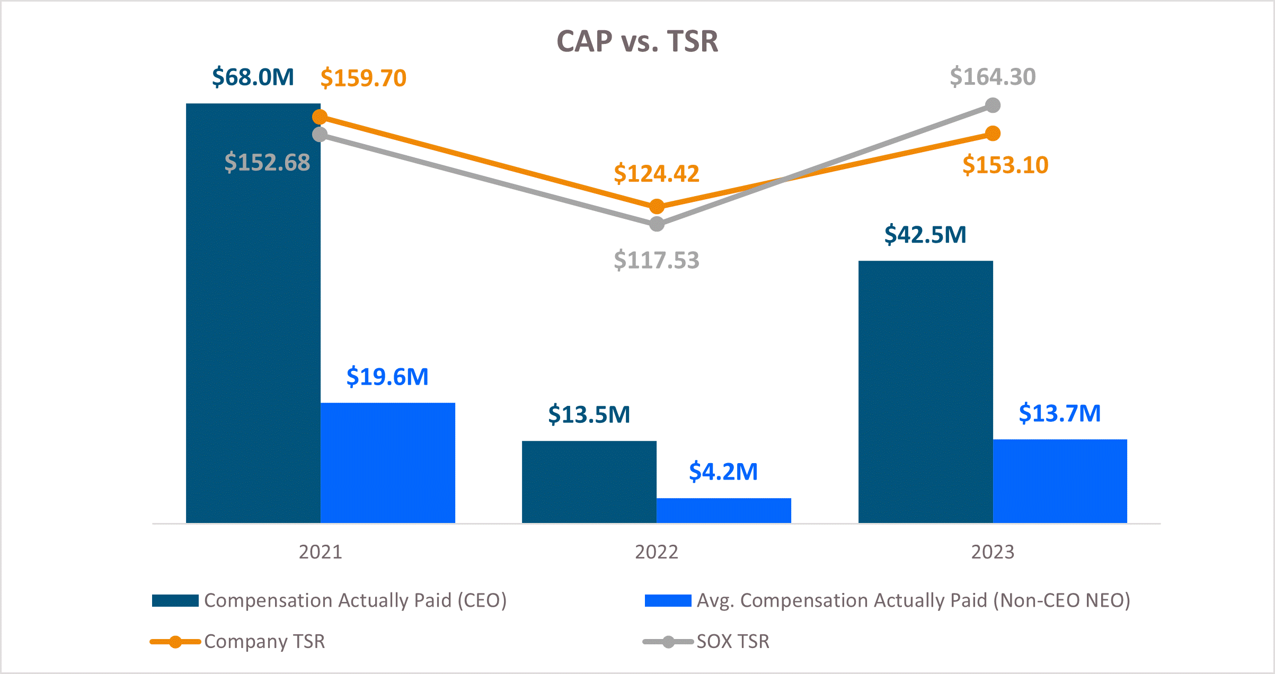

78 | 2023 Proxy Statement
Table of Contents
Relationship between CAP vs. Net Income (Loss) & Non-GAAP Net Income (Loss)

The following chart illustrates the CAP for our PEO and the average CAP for our Non-PEO NEOs against our net income (loss) and non-GAAP net income (loss):

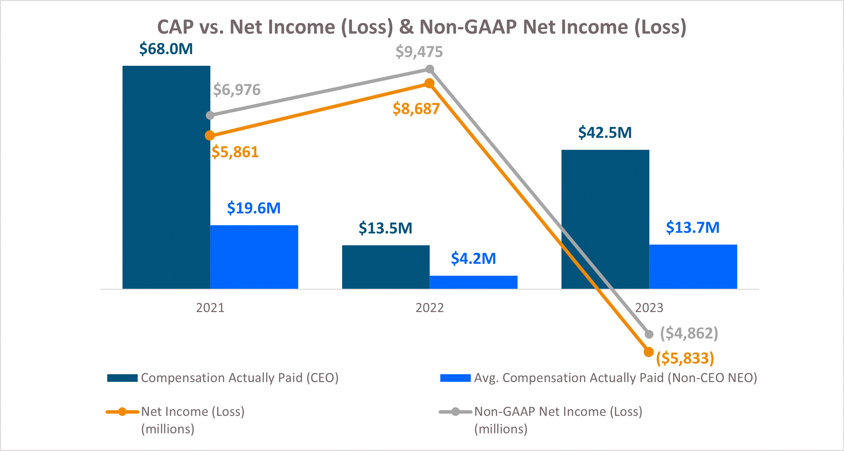

Most Important Performance Measures

The following is an unranked list of the performance measures we consider most important in linking company performance and compensation actually paid to our Named Executive Officers for the most recently completed fiscal year:

•Non-GAAP net income (loss)
•Non-GAAP operating margin
•Relative TSR growth of the Company’s stock price versus the median of the SOX index
•DRAM revenue or percentage of revenue from high-growth, stable segments
•NAND bits shipped or percentage of bits shipped into the data center segment

79
Table of Contents
PROPOSAL 3 – ADVISORY VOTE ON THE FREQUENCY WITH WHICH SHAREHOLDERS WILL VOTE ON SAY-ON-PAY PROPOSALS IN FUTURE YEARS
PROPOSAL DETAILS

The Dodd-Frank Act provides an opportunity for our shareholders to indicate how frequently we should hold an advisory say-on-pay vote on the compensation of our Named Executive Officers, such as Proposal 2 included on page 27 of this Proxy Statement. By voting on this Proposal 3, shareholders may indicate whether they would prefer an advisory say-on-pay vote on Named Executive Officer compensation once every one, two, or three years. Alternatively, stockholders may abstain from voting on this proposal.

The Board of Directors has determined that holding an advisory say-on-pay vote on Named Executive Officer compensation every year is the most appropriate alternative for us, and therefore the Board recommends that you vote for a one-year interval for future advisory say-on-pay votes.

Shareholders who have concerns about executive compensation during the interval between say-on-pay votes are welcome to bring their specific concerns to the attention of the Board. Please refer to "Executive Sessions and Communications with the Board of Directors" on page 23 of this Proxy Statement for information about communicating with the Board.

A “say on frequency” vote similar to this Proposal 3 will occur at least once every six years.

BOARD RECOMMENDATION

The Board recommends a vote for every “ONE Year" on this proposal.

VOTE REQUIRED FOR APPROVAL

We will treat the option of one year, two years or three years that receives the highest number of votes cast by shareholders as being the frequency for the advisory vote on executive compensation that has been selected by shareholders, even if such frequency does not receive the affirmative vote of a majority of the voting power of our Common Stock present in person or represented by proxy at the Annual Meeting. The Board will take the results of the vote into account when deciding when to call for the next advisory vote on Named Executive Officer compensation.

This say-on-frequency vote is required by Section 14A of the Exchange Act (15 U.S.C. 78n-1) and is advisory and therefore not binding on us, the Compensation Committee, or the Board and will not be construed as overruling a decision by our Company or our Board or creating or implying any additional fiduciary duty for our Company or our Board. The Board may decide that it is in our and our shareholders’ best interests to hold an advisory vote on executive compensation more or less frequently than the option approved by our shareholders. However, the Board and the Compensation Committee value the opinions of our shareholders and will consider the outcome of the vote when determining the frequency of holding shareholder advisory votes on executive compensation.

80 | 2023 Proxy Statement
Table of Contents
AUDIT COMMITTEE MATTERS
PROPOSAL 4 – RATIFICATION OF APPOINTMENT OF PRICEWATERHOUSECOOPERS LLP

The Audit Committee of the Board has retained PricewaterhouseCoopers LLP (“PwC”) as our Independent Registered Public Accounting Firm to audit our consolidated financial statements for the fiscal year ending August 29, 2024. PwC has been our Independent Registered Public Accounting Firm since 1984. Although ratification is not required, the Board is submitting a proposal to ratify PwC’s appointment to our shareholders because we value our shareholders’ views and as a matter of good corporate practice. If PwC’s appointment is not ratified by our shareholders, the Audit Committee may reconsider its decision to appoint PwC as our Independent Registered Public Accounting Firm. Even if the appointment is ratified, the Audit Committee may in its discretion select a different independent registered public accounting firm at any time during the fiscal year if it determines that such a change would be in the best interests of the Company and our shareholders. Representatives of PwC are expected to be present at the Annual Meeting, will have the opportunity to make a statement if they so desire, and are expected to be available to respond following the Annual Meeting to appropriate questions submitted before or during the Annual Meeting.

Fees Paid

Fees charged for services performed by PwC for fiscal 2023 and 2022 were as follows:
 |  |  | 2023 |  |  | 2022
 |  |  | (amounts in millions)
Audit fees(1) |  |  | $ | 9.4 |  | $ | 8.7
Audit-related fees(2) |  |  | 0.1 |  |  | —
Tax fees(3) |  |  | 1.6 |  |  | 1.5
All other fees(4) |  |  | — |  |  | —
 |  |  | $ | 11.1 |  | $ | 10.2

(1)Includes fees related to the audit of our financial statements, fees for services provided in connection with statutory and regulatory filings, and fees for attestation services related to our securities offerings and internal control over financial reporting as required by the Sarbanes-Oxley Act of 2002.

(2)Fees not included in audit fees that are billed by the auditor for assurance and related services that are reasonably related to the performance of the audit of the financial statements.

(3)Primarily reflects fees for services in connection with tax planning, tax consulting, tax compliance, and tax audit defense.

(4)Reflects fees for services not included in the categories above, including a subscription to accounting research software.

PRE-APPROVAL POLICY

The Audit Committee Charter provides that the Audit Committee will pre-approve all audit and non-audit services provided to us by the independent auditors, except for such de minimis non-audit services for which the pre-approved requirements are waived in accordance with the rules and regulations of the SEC. In fiscal 2023 and 2022, all audit, non-audit, tax services, and all other fees for services provided by PwC were approved by the Audit Committee in advance of services being provided.

81
Table of Contents
BOARD RECOMMENDATION

The Board recommends voting “FOR” the ratification of the appointment of PricewaterhouseCoopers LLP.

VOTE REQUIRED FOR APPROVAL

The “FOR” vote of the holders of a majority of the voting power of the shares of our Common Stock attending online in person or represented by proxy at the Annual Meeting is required to ratify the appointment of PricewaterhouseCoopers LLP as our independent registered public accounting firm for the fiscal year ending August 29, 2024.

REPORT OF THE AUDIT COMMITTEE OF THE BOARD OF DIRECTORS

This report has been prepared by members of the Audit Committee of the Board. The Board determined that each Audit Committee member qualified as an “audit committee financial expert” for purposes of the rules and regulations of the SEC. The Board also determined that during their period of service on the Audit Committee, each member satisfied the independence requirements of applicable federal laws and the Listing Rules of Nasdaq.

The purpose of the Audit Committee is to assist the Board in overseeing and monitoring (i) the integrity of our financial statements, (ii) the adequacy of our internal controls and procedures, (iii) the performance of our internal audit function, (iv) the qualifications, performance, and independence of our Independent Registered Public Accounting Firm, and (v) our compliance with legal and regulatory requirements.

The Audit Committee has reviewed and discussed our audited financial statements with our management, which has primary responsibility for such financial statements. PwC, our Independent Registered Public Accounting Firm for fiscal 2023, has expressed in our Annual Report on Form 10-K its opinion as to the conformity of our consolidated financial statements with accounting principles generally accepted in the United States. The Audit Committee has discussed with PwC the matters that are required to be discussed by the applicable requirements of the Public Company Accounting Oversight Board (the “PCAOB”) and the SEC. PwC has provided to the Audit Committee the written disclosures and the letter required by the applicable requirements of the PCAOB. The Audit Committee and PwC also discussed PwC’s independence, including the non-audit services PwC provided to us as described above, and concluded that PwC was independent for fiscal 2023.

On the basis of the reviews and discussions referred to above, the Audit Committee recommended to the Board that they include our audited consolidated financial statements in our Annual Report on Form 10-K for fiscal 2023, appointed PwC as our Independent Registered Public Accounting Firm for the fiscal year ending August 29, 2024, and approved and authorized PwC to carry out and perform certain specified non-audit services for us in fiscal 2024.

While the Audit Committee has performed the above functions, management, and not the Audit Committee, has the primary responsibility for (i) preparing our consolidated financial statements and for the reporting process in general and (ii) establishing and maintaining internal controls. Similarly, it is the responsibility of the Independent Registered Public Accounting Firm, and not the Audit Committee, to conduct the audit of our consolidated financial statements and express an opinion as to the conformity of the financial statements with accounting principles generally accepted in the United States.

The Audit Committee
Lynn A. Dugle
Steven J. Gomo
Mary Pat McCarthy (Chair)

82 | 2023 Proxy Statement
Table of Contents
PROPOSAL 5 – SHAREHOLDER PROPOSAL – SHAREHOLDER RATIFICATION OF EXCESSIVE TERMINATION PAY
The following shareholder proposal has been submitted to us for action at the Annual Meeting by John Chevedden, 2215 Nelson Avenue, No. 205, Redondo Beach, CA 90278. Mr. Chevedden has submitted documentation indicating that he is the beneficial owner of at least 100 shares of our Common Stock and he intends to continue to hold the requisite amount of shares through the date of the Annual Meeting. In accordance with proxy regulations, the following is the complete text of the proposal, which is reproduced as submitted to us other than minor formatting changes. All statements contained in the shareholder proposal and supporting statement are the sole responsibility of the proponent.

Proposal 5 - Shareholder Ratification of Excessive Termination Pay



Shareholders request that the Board adopt a policy to seek shareholder approval of the top 10 senior managers’ new or renewed pay package that provides for termination payments with an estimated value exceeding 2.99 times the sum of the executive’s base salary plus target short-term bonus.

The Board shall retain the option to seek shareholder approval at an annual meeting after material terms are agreed upon.

Generous performance-based pay can sometimes be justified but shareholder ratification of “golden parachute” severance packages with a total cost exceeding 2.99 times base salary plus target short-term bonus better aligns management pay with shareholder interests.

This proposal is relevant even if there are current golden parachute limits. A limit on golden parachutes is like a speed limit. A speed limit by itself does not guarantee that the speed limit will never be exceeded. Like this proposal the rules associated with a speed limit provide consequences if the limit is exceeded. With this proposal the consequences are a non-binding shareholder vote is required for unreasonably high golden parachutes.

This proposal places no limit on long-term equity pay or any other type pay. This proposal thus has no impact on the ability to attract executive talent or discourage the use of long-term equity pay because it places no limit on golden parachutes. It simply requires that extra large golden parachutes be subject to a non binding shareholder vote at a shareholder meeting already scheduled for other matters.

This proposal is relevant because the annual say on executive pay vote does not have a separate section for approving or rejecting golden parachutes.

This proposal is more important at Micron Technology because executive pay was rejected by 28% of shares at the 2023 annual meeting when a 5% rejection is often the norm at well performing companies.

The topic of this proposal, received between 51% and 65% support at:
FedEx
Spirit AeroSystems
Alaska Air
Fiserv

Please vote yes:
Shareholder Ratification of Excessive Termination Pay – Proposal 5

83
Table of Contents
THE COMPANY’S OPPOSITION STATEMENT TO PROPOSAL

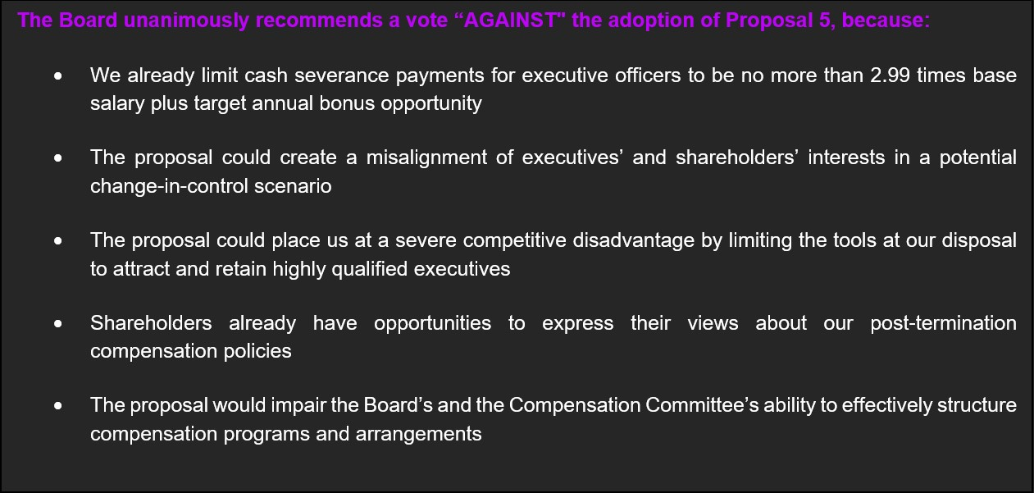

We already limit cash severance payments for executive officers to be no more than 2.99 times base salary plus target annual bonus opportunity

We have recently adopted an Executive Officer Cash Severance Policy that already addresses the proposal’s request with regard to salary and annual bonus. This policy does not allow the Company to enter into any new employment agreement, severance agreement, or separation agreement with any executive officer – or establish any new severance plan or policy covering any executive officer – that provides for cash severance benefits exceeding 2.99 times the sum of the executive officer’s base salary plus target bonus opportunity, without seeking shareholder ratification of such arrangement. In addition, the Executive Officer Cash Severance Policy provides that any cash payments that may be owed under any existing agreement, plan or policy with an executive officer that was in place prior to adoption of the policy will be reduced as necessary to not exceed the 2.99 times limit unless shareholder ratification is obtained. The Executive Officer Cash Severance Policy is administered by the Compensation Committee, including full authority to interpret and enforce such policy. Our existing severance arrangements are described in detail within the Compensation Discussion & Analysis section entitled “Severance and Change in Control Arrangements.”

The proposal could create a misalignment of executives’ and shareholders’ interests in a potential Change in Control scenario

The Board and Compensation Committee believes that the proposal could create misalignment between our executives and shareholders during a Change in Control transition, leading to increased risk for shareholders.

As described in further detail in the Compensation Discussion & Analysis, in the context of a Change in Control, our equity plans and executive officer severance agreements provide for “double-trigger” vesting provisions that would accelerate the vesting of equity awards if an executive officer were terminated in a qualifying termination of employment (generally, other than for cause or with good reason, as defined) in connection with a Change in Control transaction. Without this incentive, our ability to deliver maximum stockholder value in a Change in Control transaction could be impaired. We may struggle to retain our executive officers, or our executive officers may be unnecessarily distracted by the risk of job loss coupled with a limit on the value realizable from previously granted equity awards. The Board believes that in the context of a Change in Control transaction that it has determined to be in the best interests of our shareholders, our executive officers should be incentivized and motivated to fully focus on the transaction, with the assurance that they will be adequately compensated even if they are terminated
84 | 2023 Proxy Statement
Table of Contents
other than for cause or with good reason. We believe this is a responsible pay practice and aligns the interests of our executives with our shareholders.

The proposal could place us at a severe competitive disadvantage by limiting the tools at our disposal to attract and retain highly qualified executives

We operate in a highly competitive market and industry, and in geographic regions that are exceptionally competitive for executive talent. We believe our ability to attract and retain highly qualified executives is key to maximizing the value we create for our shareholders. Many public companies, including our peers, provide double-trigger severance benefits to their executives. In our experience, executive-level candidates expect these protections as part of their compensation packages, and we would jeopardize our ability to attract qualified executives if we were restricted in our ability to offer them. Even if offers of employment contained severance protections that were contingent upon shareholder approval – as would be required by the proposal – they may be viewed as too uncertain and could discourage competitive candidates from accepting our offer. Therefore, the Board believes the proposal would prevent Micron from effectively using equity acceleration as a significant component of severance packages used to attract and retain executives, which in turn could compromise our recruiting efforts and ability to attract top-level talent.

The Board and Compensation Committee believe that the Executive Officer Cash Severance Policy is better suited for the Company to balance shareholder concerns regarding outsized severance payments while remaining competitive for top-level talent, which it believes to be in the best interest of our shareholders.

Shareholders already have opportunities to express their views about our post-termination compensation policies

In addition to the shareholder ratification required under our Executive Officer Cash Severance Policy, we hold an annual say-on-pay advisory vote each year giving our shareholders the ability to vote on our executive compensation program – including our post-termination compensation practices – and shareholders regularly have the opportunity to vote to approve our equity compensation plans. We further supplement these votes with our robust shareholder outreach program, which is outlined in the section of this Proxy Statement entitled “The Board’s Role and Responsibilities – Shareholder Outreach”. Importantly, across the 13 meetings we had with shareholders representing 31% of shares outstanding over the course of fiscal 2023, no shareholder raised the topic of our severance practices as an area of concern. We believe our long track record of shareholder support of our compensation programs since the introduction of say-on-pay advisory votes, together with our demonstrated responsiveness to shareholders when they do raise concerns, as detailed in the Compensation Discussion & Analysis, speaks to the effectiveness of these existing opportunities.

Further, SEC rules also require separate shareholder approval, on an advisory basis, of golden parachute compensation payable to named executive officers in connection with change-in-control transactions. If we were to undergo a change-in-control transaction, shareholders would have the opportunity to vote, on an advisory basis, on any golden parachute arrangements with our executives at that time.

Requiring an intermittent additional shareholder approval of specific elements of compensation, as this proposal requests, is therefore both unnecessary and potentially jeopardizing to our ability to executive on our strategic priorities.

85
Table of Contents
The proposal would impair the Board’s and the Compensation Committee’s ability to effectively structure compensation programs and arrangements

The Compensation Committee is responsible for assisting the Board in overseeing the compensation of Micron’s executives and other employees, including with respect to severance and termination payments. The Compensation Committee is comprised solely of independent, non-employee directors and regularly consults with its independent compensation consultant, Compensia. The proposed requirement that Micron secure shareholder approval of certain severance arrangements could constrain the Compensation Committee’s ability to exercise its judgment in structuring compensation arrangements in a timely manner and that it believes are in shareholders’ best interests.

The Board believes the Compensation Committee is well qualified to oversee post-termination compensation and should retain the responsibility and flexibility to tailor, assess, and approve compensation structures based on its insights into the Company’s needs and its strategic and operational goals, its access to market information and the independent advice from its compensation consultant.

BOARD RECOMMENDATION

The Board recommends a vote “AGAINST” Proposal 5.

VOTE REQUIRED FOR APPROVAL

The “FOR” vote of the holders of a majority of the voting power of the shares of our Common Stock attending online in person or represented by proxy at the Annual Meeting.

86 | 2023 Proxy Statement
Table of Contents
PRINCIPAL SHAREHOLDERS

Security Ownership of Certain Beneficial Owners and Management

The following table sets forth security beneficial ownership information of our Common Stock as of November 3, 2023, calculated in accordance with the rules of the SEC based on the most current information provided to us by the beneficial owners, available to us from our own records or provided in SEC filings made by the beneficial owners, for (i) persons known by us to own beneficially more than 5% of our Common Stock, (ii) each director, (iii) each Named Executive Officer listed in the “Summary Compensation Table” set forth herein, and (iv) all directors and executive officers as a group. We have based our calculation of the percentage of beneficial ownership on 1,103,445,199 shares of our Common Stock outstanding as of November 3, 2023. Unless otherwise indicated, the address of each beneficial owner listed in the table below is c/o Micron Technology, Inc., 8000 South Federal Way, Boise, Idaho, 83716-9632.
Name of Beneficial Owner |  |  | Number of  Shares Owned(1) |  |  | Right to Acquire(2) |  |  | Total  Beneficial  Ownership |  |  | Percent of  Class(3)
The Vanguard Group, Inc.(4) |  |  | 91,568,443 |  |  | — |  |  | 91,568,443 |  |  | 8.3 |  | %
BlackRock, Inc.(5) |  |  | 86,062,636 |  |  | — |  |  | 86,062,636 |  |  | 7.8 |  | %
Capital Research Global Investors(6) |  |  | 64,749,634 |  |  | — |  |  | 64,749,634 |  |  | 5.9 |  | %
Richard M. Beyer |  |  | 99,245 |  |  | — |  |  | 99,245 |  |  | *
Manish Bhatia |  |  | 323,921 |  |  | 53,317 |  |  | 377,238 |  |  | *
Scott J. DeBoer |  |  | 222,800 |  |  | 8,770 |  |  | 231,570 |  |  | *
Lynn A. Dugle |  |  | 17,651 |  |  | — |  |  | 17,651 |  |  | *
Steven J. Gomo |  |  | 27,424 |  |  | — |  |  | 27,424 |  |  | *
Linnie M. Haynesworth |  |  | 13,632 |  |  | — |  |  | 13,632 |  |  | *
Mary Pat McCarthy |  |  | 27,424 |  |  | — |  |  | 27,424 |  |  | *
Sanjay Mehrotra(7) |  |  | 1,296,694 |  |  | 468,284 |  |  | 1,764,978 |  |  | *
Mark J. Murphy |  |  | 215,267 |  |  | — |  |  | 215,267 |  |  | *
Sumit Sadana |  |  | 270,939 |  |  | 14,031 |  |  | 284,970 |  |  | *
Robert E. Switz |  |  | 73,427 |  |  | — |  |  | 73,427 |  |  | *
MaryAnn Wright |  |  | 23,333 |  |  | — |  |  | 23,333 |  |  | *
All directors and executive officers as a group (15 persons) |  |  | 3,004,054 |  |  | 544,402 |  |  | 3,548,456 |  |  | *

* Represents less than 1% of shares outstanding
(1)Includes unvested shares of restricted stock and excludes shares that may be acquired through the exercise of outstanding stock options.

(2)Represents shares that an individual has a right to acquire within 60 days from November 3, 2023.

(3)For purposes of calculating the Percent of Class, shares that the person or entity had a Right to Acquire are deemed to be outstanding when calculating the Percent of Class of such person or entity.

(4)Based upon information contained in the Schedule 13G/A filed by The Vanguard Group, Inc. (“Vanguard”) on February 9, 2023, as of December 30, 2022, Vanguard had sole dispositive power as to 87,021,583 shares, shared voting power as to 1,595,802 shares, and shared dispositive power as to 4,546,860 shares. Vanguard’s business address is 100 Vanguard Blvd., Malvern, PA 19355.

(5)Based upon information contained in the Schedule 13G/A filed by BlackRock, Inc. (“BlackRock”) on February 3, 2023, as of December 31, 2022, BlackRock had sole voting power as to 78,778,143 shares and sole dispositive power as to 86,062,636 shares. BlackRock’s business address is 55 East 52nd Street, New York, NY 10055.
87
Table of Contents

(6)Based upon information contained in the Schedule 13G filed by Capital Research Global Investors. (“CRGI”) on February 13, 2023, as of December 30, 2022, CRGI had sole voting power as to 64,731,679 shares and sole dispositive power as to 64,749,634 shares. CRGI’s business address is 333 South Hope Street, 55th Fl, Los Angeles, CA 90071. CRGI is a division of Capital Research and Management Company ("CRMC"), as well as its investment management subsidiaries and affiliates Capital Bank and Trust Company, Capital International, Inc., Capital International Limited, Capital International Sarl, Capital International K.K., Capital Group Private Client Services, Inc., and Capital Group Investment Management Private Limited (together with CRMC, the "investment management entities"). CRGI's divisions of each of the investment management entities collectively provide investment management services under the name "Capital Research Global Investors."

(7)Includes 68,322 shares held by the Sangeeta Mehrotra 2021 Grantor Retained Annuity Trust V, 32,935 shares held by the Sangeeta Mehrotra 2022 Grantor Retained Annuity Trust II, and 500,000 shares held by The Sangeeta Mehrotra 2023 Grantor Retained Annuity Trust I.

NOTICE OF ELECTRONIC AVAILABILITY OF PROXY MATERIALS

Important Notice Regarding the Availability of Proxy Materials for the Shareholder Meeting to Be Held on January 18, 2024. The Proxy Statement and Annual Report on Form 10-K are available at www.proxyvote.com.

As permitted by the SEC, we are making our proxy materials available to our shareholders electronically via the Internet. We have mailed many of our shareholders a Notice containing instructions on how to access this Proxy Statement and our Annual Report on Form 10-K and vote online. If you received a Notice by mail, you will not receive a printed copy of the proxy materials in the mail. Instead, the Notice instructs you on how to access and review all of the important information contained in the Proxy Statement and Annual Report on Form 10-K. The Notice also instructs you on how you may submit your voting instructions over the Internet. If you received a Notice by mail and would like to receive a printed copy of our proxy materials, you should follow the instructions for requesting such materials included in the Notice. In addition, shareholders may request to receive proxy materials in printed form by mail or electronically by email on an ongoing basis.

INCORPORATION BY REFERENCE OF CERTAIN FINANCIAL INFORMATION

We incorporate by reference in this Proxy Statement the “Equity Plans” note to our Consolidated Financial Statements included in our Annual Report on Form 10-K for fiscal 2023. The Annual Report on Form 10-K for fiscal 2023 accompanies this Proxy Statement. Copies of the Annual Report on Form 10-K for fiscal 2023 may be obtained without charge by sending a written request to: Micron Technology, Inc., Attn.: Corporate Secretary, 8000 South Federal Way, Boise, Idaho 83716. Our Annual Report on Form 10-K also is available in the “Investor Relations” section of our website at www.micron.com.

HOUSEHOLDING OF PROXY STATEMENTS AND ANNUAL REPORTS

We are allowed and intend to deliver only one copy of the Notice regarding the Internet availability of proxy materials or one set of printed proxy materials (i.e., our 2023 Annual Report on Form 10-K and Proxy Statement) to multiple registered shareholders sharing an address who have received prior notice of our intent to deliver only one such notice or set of materials, so long as we have not received contrary instructions from such shareholders. This practice is commonly referred to as “householding.” Householding reduces the volume of duplicate information received at your household and our costs of preparing and mailing duplicate materials.

88 | 2023 Proxy Statement
Table of Contents
If you share an address with other registered shareholders and your household receives one copy of the Notice or of the proxy materials and you decide you want a separate copy through the date of the Annual Meeting, we will promptly deliver your separate copy if you contact us at Micron Technology, Inc., Attn.: Corporate Secretary, 8000 South Federal Way, Boise, Idaho 83716-9632 or corporatesecretary@micron.com or (208) 368-4000. Additionally, for registered shareholders to resume the mailing of individual copies of future annual reports, proxy statements, proxy statements combined with a prospectus, and information statements to a particular shareholder, you may contact EQ Shareowner Services, Attn.: Householding, P.O. Box 64854, St. Paul, Minnesota 55164-0874 and your request will be effective within 30 days after receipt. After the Annual Meeting, you may request householding of these documents, including notices, by providing EQ Shareowner Services at the address provided directly above with a written request to eliminate multiple mailings. The written request must include names and account numbers of all shareholders consenting to householding for a given address and must be signed by those shareholders.

Additionally, we have been notified that certain banks, brokers, and other nominees will household our annual reports and proxy statements for shareholders who hold in street names and have consented to householding. In this case, you may request an individual copy of the proxy materials by contacting your bank, broker, or other nominee.

CAUTIONARY NOTE ON FORWARD-LOOKING STATEMENTS

This Proxy Statement contains forward-looking statements that involve a number of risks and uncertainties. Such forward-looking statements may be identified by words such as “anticipate,” “expect,” “intend,” “pledge,” “committed,” “plans,” “opportunities,” “future,” “believe,” “target,” “on track,” “estimate,” “continue,” “likely,” “may,” “will,” “would,” “should,” “could,” and variations of such words and similar expressions. However, the absence of these words or similar expressions does not mean that a statement is not forward-looking. Specific forward-looking statements include, but are not limited to, statements such as those made regarding our plans for expected production ramp of certain products; our expected results for fiscal 2024; our DEI, sustainability and compensation plans, expectations and commitments; our goals, and expected improvements; the outlook for our industry; our restructuring plans and expected savings therefrom; expected market demand for our products; the timing for construction and ramping of production for new memory manufacturing fabs in the United States; our plans for our investments and planned expansions in our fabs; the receipt of government grants and investment tax credits; market conditions and profitability in our industry; spending in 2024, the sufficiency of our cash and investments; and estimated payments to our Named Executive Officers upon termination or Change in Control. These forward-looking statements are subject to a number of risks and uncertainties that could cause actual events to differ materially. Please refer to the documents we file with the SEC, including our most recent Annual Report on Form 10-K and our annual report provided as part of the proxy materials. These documents contain and identify important factors that could cause our actual results to differ materially from those contained in the forward-looking statements. Although we believe that the expectations reflected in the forward-looking statements are reasonable, we cannot guarantee future results, levels of activity, performance, or achievements. We are under no duty to update any of the forward-looking statements, except as required by applicable law.

DEADLINE FOR RECEIPT OF SHAREHOLDER PROPOSALS FOR FISCAL 2024 ANNUAL MEETING

Shareholders may present proper proposals for inclusion in our proxy statement and for consideration at the next annual meeting of shareholders by submitting their proposals in writing to our Corporate Secretary in a timely manner. For a shareholder proposal to be considered for inclusion in our proxy statement for our fiscal 2024 annual meeting of shareholders, our Corporate Secretary must receive the written proposal at our principal executive offices located at 8000 South Federal Way, Boise, Idaho 83716-9632, Attention: Corporate Secretary, no later than August 1, 2024. In addition, such shareholders proposals must comply with the other requirements of Rule 14a-8 regarding the inclusion of stockholder proposals in Company-sponsored proxy materials. Submission of a proposal before the deadline does not guarantee its inclusion in our proxy materials.

Under our Bylaws, director nominations and other business may be brought before an annual meeting of shareholders only by or at the direction of the Board or by a shareholder entitled to vote who has submitted a proposal in accordance with the requirements of our Bylaws. To nominate a candidate or submit a proposal for
89
Table of Contents
consideration at our fiscal 2024 annual meeting pursuant to our advance notice bylaw provisions, shareholders must deliver or mail their nomination submission or other stockholder notice of a proposal so that it is received by our Corporate Secretary, at the address above no later than August 1, 2024. In addition to the requirements set forth in our Bylaws, to comply with Rule 14a-19 under the Exchange Act, shareholders must provide notice of intent to solicit proxies in support of director nominees (other than the Company’s nominees) for the fiscal 2024 annual meeting when providing notice of nomination to the Company no later than the dates set forth above. Please note that the notice requirement under Rule 14a-19 is in addition to the applicable notice requirements in our Bylaws.

Shareholders wishing to nominate a director candidate through our proxy access Bylaw provisions for inclusion in our proxy statement must comply with the eligibility, procedural, and disclosure requirements set forth in our Bylaws. To be timely for our fiscal 2024 annual meeting of shareholders, our Corporate Secretary must receive a shareholder’s notice of proxy access nomination at our principal executive offices, not earlier than July 2, 2024 or later than August 1, 2024.

November 29, 2023
THE BOARD OF DIRECTORS

90 | 2023 Proxy Statement

Micron’s Global Presence

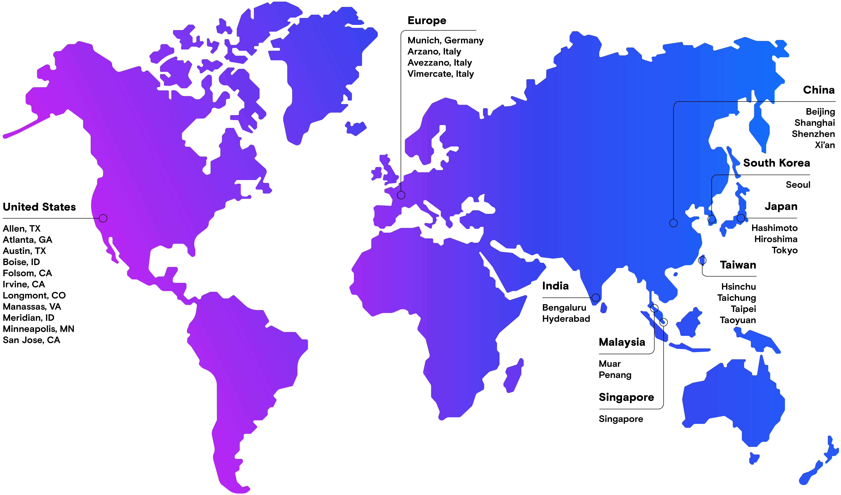
Micron’s global presence map highlights locations that include our manufacturing sites, centers of excellence, customer labs, and large offices.
Not all Micron locations are represented on this map.







