UNITED STATES

SECURITIES AND EXCHANGE COMMISSION

Washington, D.C. 20549

FORM 8-K

CURRENT REPORT

Pursuant to Section 13 OR 15(d) of The Securities Exchange Act of 1934

January 31, 2014

Date of Report (date of earliest event reported)

MICRON TECHNOLOGY, INC.

(Exact name of registrant as specified in its charter)

Delaware

(State or other jurisdiction of

1-10658

(Commission File Number)

75-1618004

(I.R.S. Employer Identification No.)

incorporation)

8000 South Federal Way

Boise, Idaho 83716-9632

(Address of principal executive offices)

(208) 368-4000

(Registrant’s telephone number, including area code)

Check the appropriate box below if the Form 8-K filing is intended to simultaneously satisfy the filing obligation of the registrant under any of the following provisions (see General Instruction A.2. below):

- Written communications pursuant to Rule 425 under the Securities Act (17 CFR 230.425)

- Soliciting material pursuant to Rule 14a-12 under the Exchange Act (17 CFR 240.14a-12)

- Pre-commencement communications pursuant to Rule 14d-2(b) under the Exchange Act (17 CFR 240.14d-2(b))

- Pre-commencement communications pursuant to Rule 13e-4(c) under the Exchange Act (17 CFR 240.13e-4c))

Item 7.01. Regulation FD Disclosure.

The information set forth in this Item 7.01 is intended to be furnished under Item 7.01 of Form 8-K (Regulation FD Disclosure). This information shall not be deemed “filed” for purposes of Section 18 of the Securities Exchange Act of 1934, as amended (the “Exchange Act”), or otherwise subject to the liabilities of that section. In addition, this information shall not be incorporated by reference into any registration statement filing under the Securities Act of 1933, as amended, or the Exchange Act, regardless of any general incorporation language in such filing, unless it is specifically incorporated by reference in such filing.

Micron Technology, Inc. (“Micron”) is furnishing certain information regarding its business on Exhibit 99.1 to this report.

Item 8.01. Other Events.

On January 31, 2014, Micron issued a press release announcing the proposed private placement of senior notes due 2022 and its delivery of notice to holders of its outstanding 1.875% convertible senior notes due 2014 that their notes will be redeemed on March 3, 2014, except to the extent such notes are converted or repurchased by Micron prior to such date. A copy of this press release is filed as Exhibit 99.2 to this report and is incorporated herein by reference.

Item 9.01. Financial Statement and Exhibits.

(d) Exhibits

The following exhibits are attached herewith:

 | Exhibit |  | Description
 | 99.1 |  | Disclosure regarding Micron Technology Inc.’s business.
 | 99.2 |  | Press Release of Micron Technology, Inc., dated January 31, 2014, announcing offering of senior notes.
 |  |  | 2

SIGNATURE

Pursuant to the requirements of the Securities Exchange Act of 1934, the Registrant has duly caused this report to be signed on its behalf by the undersigned hereunto duly authorized.

 | MICRON TECHNOLOGY, INC.
Date: January 31, 2014 | By: | /s/ Ronald C. Foster
 | Name: | Ronald C. Foster
 | Title: | Chief Financial Officer and
 |  | Vice President of Finance
 | 3

 |  |  | INDEX TO EXHIBITS FILED WITH
 |  |  | THE CURRENT REPORT ON FORM 8-K DATED JANUARY 31, 2014
Exhibit |  |  | Description
 | 99.1 |  | Disclosure regarding Micron Technology Inc.’s business.
99.2 |  | Press Release of Micron Technology, Inc., dated January 31, 2014, announcing offering of senior notes.
 |  | 4

Exhibit 99.1
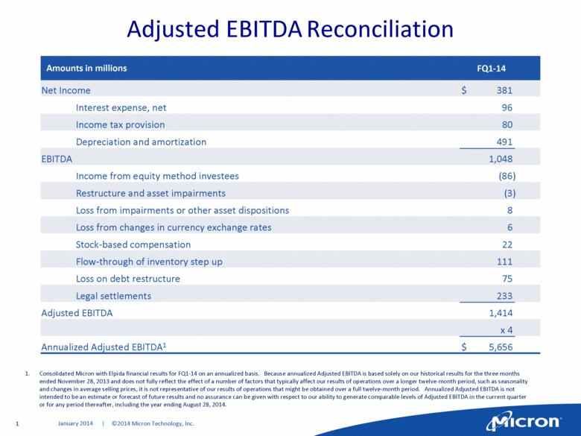

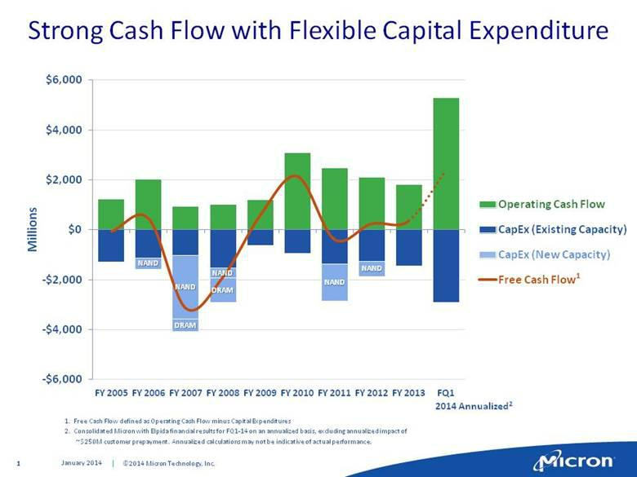

Exhibit 99.2

FOR IMMEDIATE RELEASE
Contacts: | Kipp A. Bedard | Daniel Francisco
 | Investor Relations | Media Relations
 | kbedard@micron.com | dfrancisco@micron.com
 | (208) 368-4465 | (208) 368-5584

MICRON ANNOUNCES PROPOSED $500 MILLION OFFERING OF SENIOR NOTES

BOISE, Idaho, January 31, 2014 — Micron Technology, Inc., (NASDAQ: MU) today announced that it intends to offer, subject to market and other considerations, $500 million aggregate principal amount of senior notes due 2022 (the “Notes”) through an offering to qualified institutional buyers pursuant to Rule 144A under the Securities Act of 1933, as amended (the “Securities Act”), and outside the United States to non-U.S. persons pursuant to Regulation S under the Securities Act.

The interest rate, redemption provisions and other terms of the Notes will be determined by negotiations between Micron and the initial purchasers.

Micron intends to use the net proceeds from this offering to pay a portion of the costs of extinguishing its obligations with respect to its outstanding 1.875% convertible senior notes due 2014 (the “2014 Notes”), which may include payments in settlement of conversions of, or to repurchase or redeem, the 2014 Notes. Earlier today, Micron gave notice to holders of the 2014 Notes that their notes will be redeemed on March 3, 2014, except to the extent such notes are converted or repurchased by Micron prior to such date.

This announcement does not constitute an offer to sell or a solicitation of an offer to buy any of the foregoing securities, nor shall there be any offer, solicitation or sale in any state or jurisdiction in which such an offer, solicitation or sale would be unlawful.

The Notes have not been registered under the Securities Act or any state securities laws and may not be offered or sold in the United States absent registration or an applicable exemption from such registration requirements.

