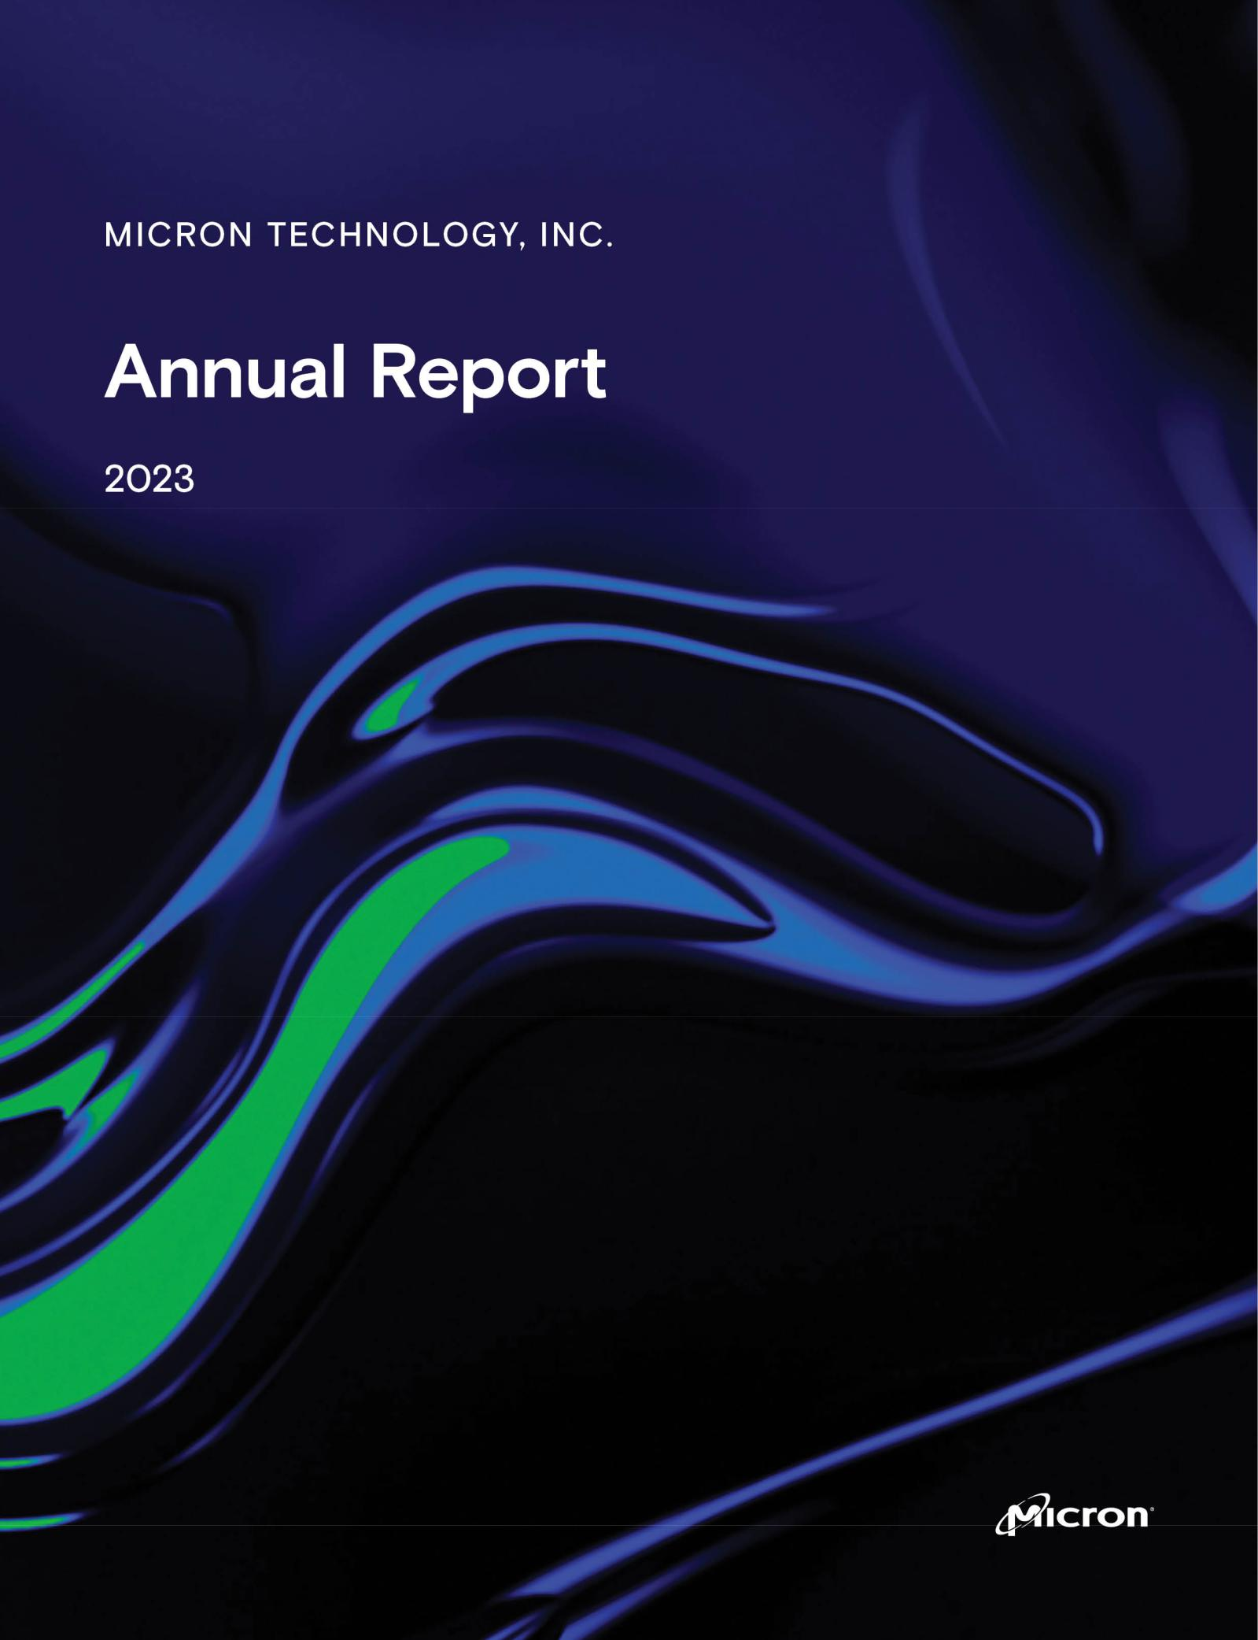

UNITED STATES

SECURITIES AND EXCHANGE COMMISSION

Washington, D.C. 20549

FORM 10-K

(Mark One)

- ANNUAL REPORT PURSUANT TO SECTION 13 OR 15(d) OF THE SECURITIES EXCHANGE ACT OF 1934

For the fiscal year ended August 31, 2023

OR
- TRANSITION REPORT PURSUANT TO SECTION 13 OR 15(d) OF THE SECURITIES EXCHANGE ACT OF 1934

For the transition period from |  |  |  |  | to
Commission file number 1-10658
Micron Technology, Inc.
(Exact name of registrant as specified in its charter)
Delaware |  |  |  |  | 75-1618004
(State or other jurisdiction of incorporation or organization) |  |  |  |  | (IRS Employer Identification No.)
Address of principal executive offices, including zip code |  |  |  |  | 8000 S. Federal Way, Boise, Idaho 83716-9632
Registrant’s telephone number, including area code |  |  |  |  | (208) 368-4000
Securities registered pursuant to Section 12(b) of the Act:
Title of each class |  | Trading Symbol |  |  | Name of each exchange on which registered
Common Stock, par value $0.10 per share |  | MU |  |  | Nasdaq Global Select Market
Securities registered pursuant to Section 12(g) of the Act: None
Indicate by check mark if the registrant is a well-known seasoned issuer, as defined in Rule 405 of the Securities Act. |  |  |  |  |  | Yes ☒ | No ☐
Indicate by check mark if the registrant is not required to file reports pursuant to Section 13 or Section 15(d) of the Act. |  |  |  |  |  | Yes ☐ | No ☒
Indicate by check mark whether the registrant (1) has filed all reports required to be filed by Section 13 or 15(d) of the Securities
Exchange Act of 1934 during the preceding 12 months (or for such shorter period that the registrant was required to file such reports), |  |  |  |  |  | Yes ☒ | No ☐
and (2) has been subject to such filing requirements for the past 90 days. |  |  |  |  |  | Yes ☒ | No ☐
Indicate by check mark whether the registrant has submitted electronically every Interactive Data File required to be submitted
pursuant to Rule 405 of Regulation S-T (§ 232.405 of this chapter) during the preceding 12 months (or for such shorter period that the |  |  |  |  |  | Yes ☒ | No ☐
registrant was required to submit such files). |  |  |  |  |  | Yes ☒ | No ☐
Indicate by check mark whether the registrant is a large accelerated filer, an accelerated filer, a non-accelerated filer, a smaller reporting company, or an emerging growth company. See the definitions of “large accelerated filer,” “accelerated filer,” “smaller reporting company,” and “emerging growth company” in Rule 12b-2 of the Exchange Act.

Large Accelerated Filer Accelerated Filer Non-Accelerated Filer Smaller Reporting Company Emerging Growth Company

☒ ☐ ☐ ☐ ☐

If an emerging growth company, indicate by check mark if the registrant has elected not to use the extended transition period for complying with any new or revised financial accounting standards provided pursuant to Section 13(a) of the Exchange Act.
Indicate by check mark whether the registrant has filed a report on and attestation to its management’s assessment of the effectiveness of its internal control over financial reporting under Section 404(b) of the Sarbanes-Oxley Act (15 U.S.C. 7262(b)) by the registered public accounting firm that prepared or issued its audit report.

If securities are registered pursuant to Section 12(b) of the Act, indicate by check mark whether the financial statements of the registrant included in the filing reflect the correction of an error to previously issued financial statements.

Indicate by check mark whether any of those error corrections are restatements that required a recovery analysis of incentive-based compensation received by any of the registrant’s executive officers during the relevant recovery period pursuant to §240.10D-1(b).

Indicate by check mark whether the registrant is a shell company (as defined in Rule 12b-2 of the Exchange Act). Yes ☐ No

☐

☒

☐

☐

☒

The aggregate market value of the voting and non-voting common equity held by non-affiliates was $47.9 billion based on the closing price reported on the Nasdaq Global Select Market on March 2, 2023. Shares of common stock held by each executive officer and director and by each person who owns 5% or more of the outstanding common stock were excluded as they may be deemed to be affiliates. This determination of affiliate status is not necessarily a conclusive determination for other purposes.

The number of outstanding shares of the registrant’s common stock as of September 29, 2023 was 1,098,034,471.

DOCUMENTS INCORPORATED BY REFERENCE

Portions of the Proxy Statement for the registrant’s Fiscal 2023 Annual Meeting of Shareholders to be held on January 18, 2024 are incorporated by reference into Part II and Part III of this Annual Report on Form 10-K.

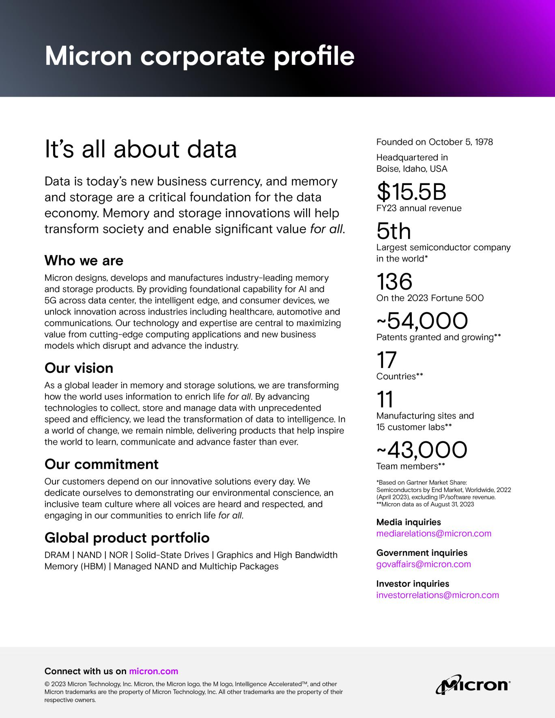

Micron’s Global Presence
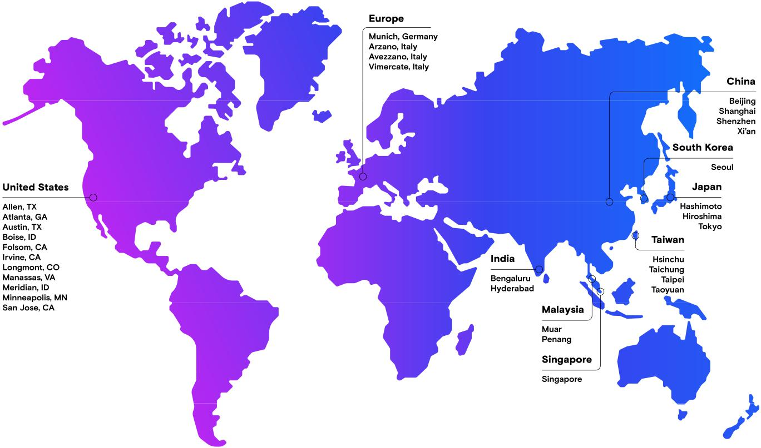

Micron’s global presence map highlights locations that include our manufacturing sites, centers of excellence, customer labs, and large offices.

Not all Micron locations are represented on this map.
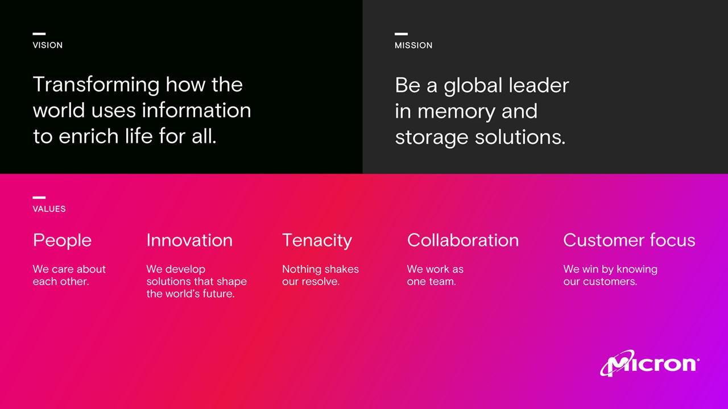

Table of Contents
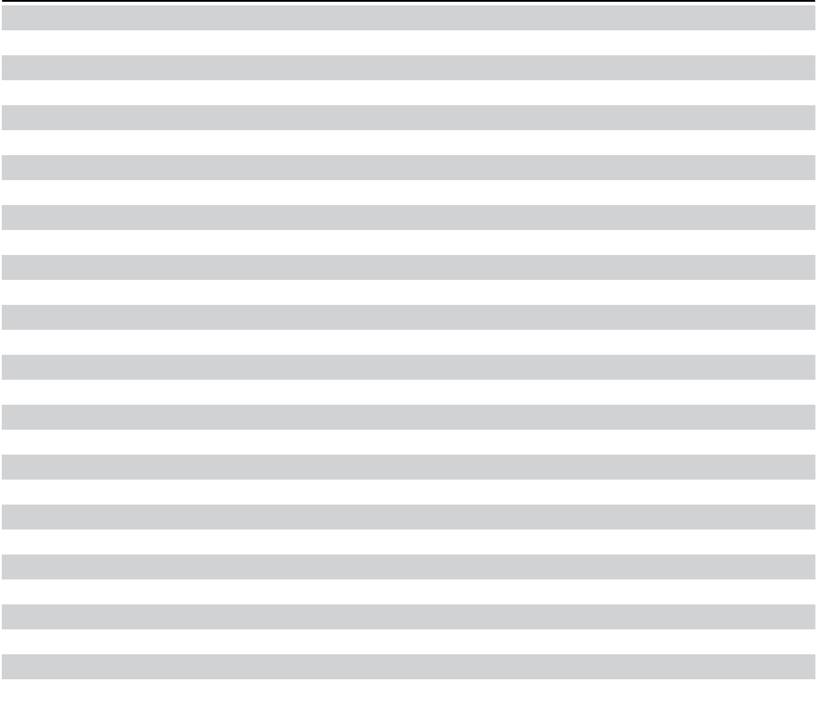

Introduction |  | 2
PART I
Item 1. | Business | 4
Item 1A. | Risk Factors | 18
Item 1B. | Unresolved Staff Comments | 37
Item 2. | Properties | 37
Item 3. | Legal Proceedings | 38
Item 4. | Mine Safety Disclosures | 38
PART II
Item 5. | Market for Registrant’s Common Equity, Related Stockholder Matters, and Issuer Purchases of Equity Securities | 38
Item 6. | [Reserved] | 40
Item 7. | Management’s Discussion and Analysis of Financial Condition and Results of Operations | 41
Item 7A. | Quantitative and Qualitative Disclosures About Market Risk | 51
Item 8. | Financial Statements and Supplementary Data | 53
Item 9. | Changes in and Disagreements With Accountants on Accounting and Financial Disclosure | 91
Item 9A. | Controls and Procedures | 91
Item 9B. | Other Information | 92
Item 9C. | Disclosure Regarding Foreign Jurisdictions that Prevent Inspections | 92
PART III
Item 10. | Directors, Executive Officers, and Corporate Governance | 92
Item 11. | Executive Compensation | 92
Item 12. | Security Ownership of Certain Beneficial Owners and Management and Related Stockholder Matters | 92
Item 13. | Certain Relationships and Related Transactions, and Director Independence | 92
Item 14. | Principal Accountant Fees and Services | 92
PART IV
Item 15. | Exhibits and Financial Statement Schedule | 93
Item 16. | Form 10-K Summary | 97
Signatures |  | 98


1

Definitions of Commonly Used Terms

As used herein, “we,” “our,” “us,” and similar terms include Micron Technology, Inc. and its consolidated subsidiaries, unless the context indicates otherwise. Abbreviations, terms, or acronyms are commonly used or found in multiple locations throughout this report and include the following:

 | Term | Definition |  | Term | Definition
2023 | Notes | 2.497% Senior Notes due April 2023, repaid |  | GDDR
2023 | Notes | 2.497% Senior Notes due April 2023, repaid |  | GDDR | Graphics double data rate
 |  | November 2021
2024 | Notes | 4.640% Senior Notes due February 2024, |  | HBM | High-bandwidth memory, a stacked DRAM
 |  | repaid November 2021 |  |  | technology optimized for memory-bandwidth
 |  |  |  |  | intensive applications
2024 | Term Loan A | Senior Term Loan A due October 2024 |  | Inotera
2024 | Term Loan A | Senior Term Loan A due October 2024 |  | Inotera | Inotera Memories, Inc.
2025 | Term Loan A | Senior Term Loan A due November 2025 |  | LIBOR | London Interbank Offered Rate
2026 Term Loan A |  | Senior Term Loan A due November 2026 |  | LPDDR | Low-power double data rate DRAM
2027 Term Loan A |  | Senior Term Loan A due November 2027 |  | LPDRAM | Low-power DRAM
2026 | Notes | 4.975% Senior Notes due February 2026 |  | MCP | Multichip packaged solutions with managed
 |  |  |  |  | NAND and LPDRAM
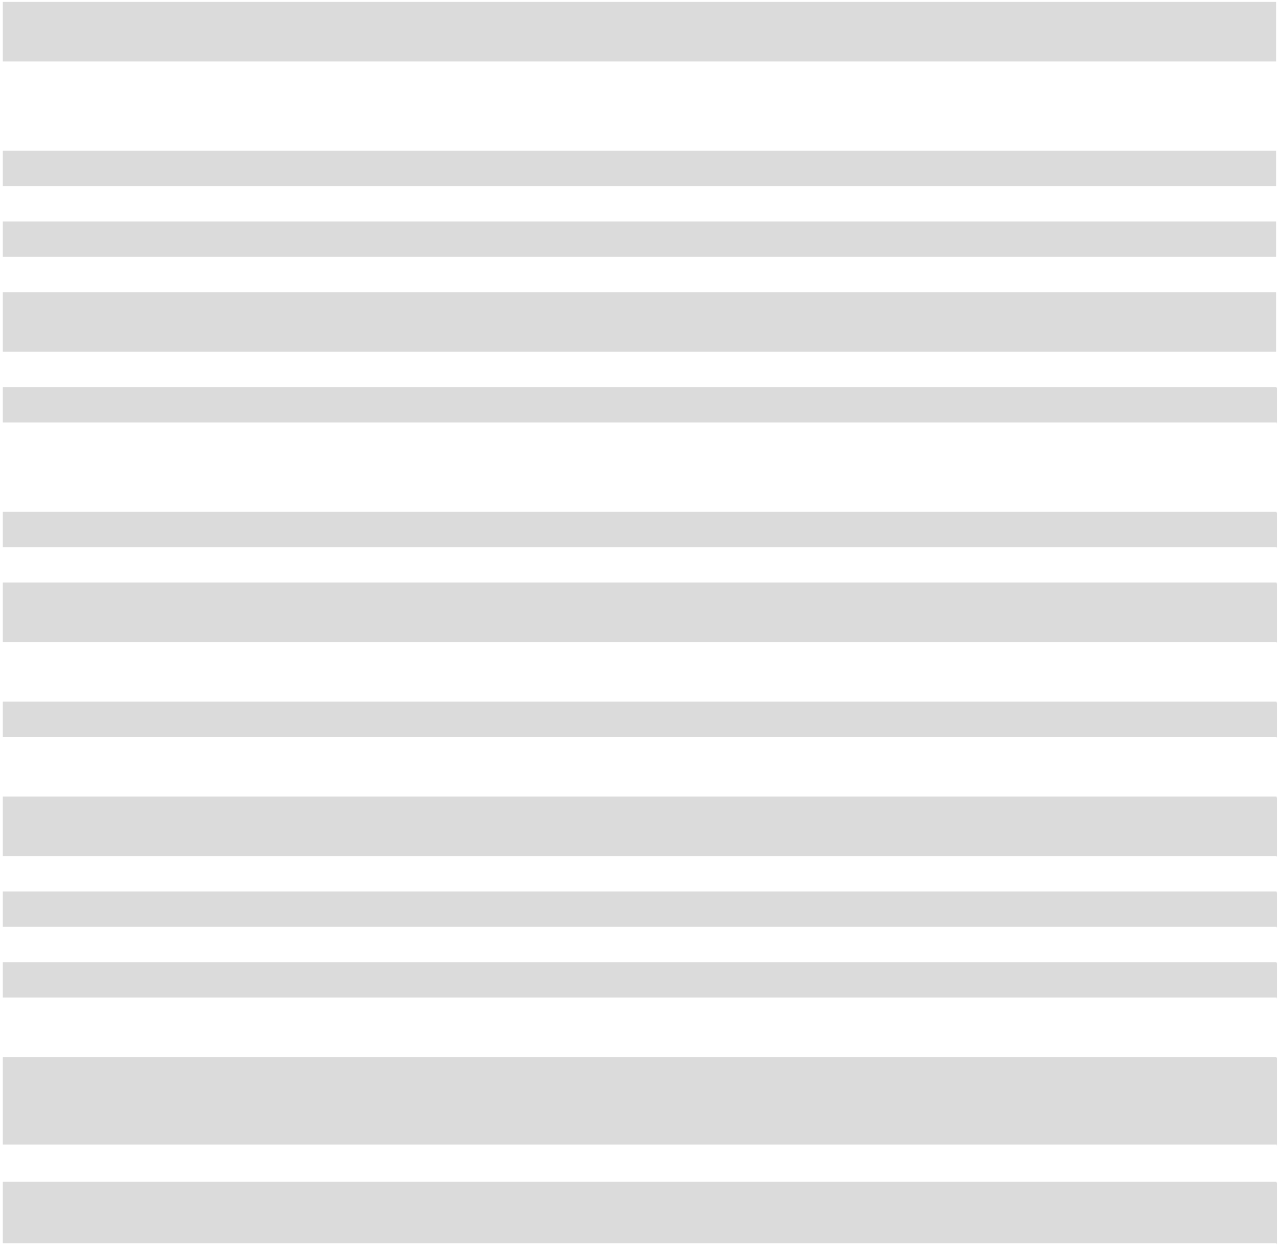

2027 | Notes | 4.185% | Senior Notes due February 2027 | Micron
2028 | Notes | 5.375% | Senior Notes due April 2028 | MTU
2029 | A Notes | 5.327% | Senior Notes due February 2029 | Multi-Tranche Term
 |  |  |  | Loan Agreement

Micron Technology, Inc. (Parent Company) Micron Technology Utah, LLC

Borrowing agreement executed November 3, 2022 that governs the 2025 Term Loan A, 2026 Term Loan A, and 2027 Term Loan A

2029 | B Notes | 6.750% | Senior Notes due November 2029 | NRV | Net realizable value
2030 | Notes | 4.663% | Senior Notes due February 2030 | OEM | Original equipment manufacturer
2032 | Green Bonds | 2.703% | Senior Notes due April 2032 | PCIe | High-speed motherboard connection for
 |  |  |  |  | peripheral devices such as storage drives
2032D Notes |  | 3.125% | Convertible Senior Notes due May | Qimonda | Qimonda AG
 |  | 2032, settled August 2021
2033 | A Notes | 5.875% | Senior Notes due February 2033 | QLC | Quad-level cell (four bits per cell)
2033 | B Notes | 5.875% | Senior Notes due September 2033 | Revolving Credit | $2.5 billion Revolving Credit Facility due May
 |  |  |  | Facility | 2026
2041 | Notes | 3.366% | Senior Notes due November 2041 | SATA | Hardware interface for connecting to storage
 |  |  |  |  | devices such as hard disk drives and SSDs
2051 | Notes | 3.477% | Senior Notes due November 2051 | SLC | Single-level cell (one bit per cell)
AI |  | Artificial intelligence |  | SOFR | Secured Overnight Financing Rate
CAC |  | China’s Cyberspace Administration |  | SSD | Solid state drive
DDR |  | Double data rate DRAM |  | TI | Texas Instruments Incorporated
EBITDA |  | Earnings before interest, taxes, depreciation, |  | TLC | Triple-level cell (three bits per cell)
 |  | and amortization
eMCP |  | Embedded multichip packaged solutions with |  | UFS | Universal flash storage
 |  | embedded multimedia card storage and
 |  | LPDDR
EUV |  | Extreme ultraviolet lithography |  | uMCP | UFS-based MCP
Extinguished 2024 |  | Senior Term Loan A due October 2024,
Term Loan A |  | repaid May 2021

Micron, Crucial, any associated logos, and all other Micron trademarks are the property of Micron. 3D XPoint is a trademark of Intel Corporation or its subsidiaries. Other product names or trademarks that are not owned by Micron are for identification purposes only and may be the trademarks of their respective owners.

All period references are to our fiscal periods unless otherwise indicated. Our fiscal year is the 52 or 53-week period ending on the Thursday closest to August 31. Fiscal 2023, 2022, and 2021 each contained 52 weeks.

2 | 2023 10-K

Forward-Looking Statements

This Form 10-K contains trend information and other forward-looking statements that involve a number of risks and uncertainties. Such forward-looking statements may be identified by words such as "anticipate," "expect," "intend," "pledge," "committed," "plan," "opportunities," "future," "believe," "target," "on track," "estimate," "continue," "likely,"

"may," "will," "would," "should," "could," and variations of such words and similar expressions. However, the absence of these words or similar expressions does not mean that a statement is not forward-looking. Specific forward-looking statements include, but are not limited to, statements such as those made regarding expected production ramp of certain products; plans to implement EUV lithography; restructure plans and expected related savings; potential increases in our effective tax rate; the timing for construction and ramping of production for new memory manufacturing fabs in the United States; intent to make investments at our backend facility in Xi’an, China and build a new assembly and test facility in Gujarat, India; the receipt of government grants and investment tax credits; estimates of tax expense for 2024; the payment of future cash dividends; market conditions and profitability in our industry; potential write-downs of inventories in future quarters; the impact of the Cyberspace Administration of China decision; capital spending in 2024; the sufficiency of our cash and investments; allocation and dispersal of the net proceeds of our 2032 Green Bonds; and results of tax return examinations. Our actual results could differ materially from our historical results and those discussed in the forward-looking statements. Factors that could cause actual results to differ materially include, but are not limited to, those identified in “Part I – Item 1A. Risk Factors.”

3

PART I

ITEM 1. BUSINESS

Overview

We are an industry leader in innovative memory and storage solutions transforming how the world uses information to enrich life for all. With a relentless focus on our customers, technology leadership, and manufacturing and operational excellence, Micron delivers a rich portfolio of high-performance DRAM, NAND, and NOR memory and storage products through our Micron® and Crucial® brands. Every day, the innovations that our people create fuel the data economy, enabling advances in artificial intelligence and 5G applications that unleash opportunities — from the data center to the intelligent edge and across the client and mobile user experience.

We manufacture our products at wholly-owned facilities and also utilize subcontractors for certain manufacturing processes. Our global network of manufacturing centers of excellence not only allows us to benefit from scale while streamlining processes and operations, but it also brings together some of the world’s brightest talent to work on the most advanced memory technology. Centers of excellence bring expertise together in one location, providing an efficient support structure for end-to-end manufacturing, with quicker cycle times, in partnership with teams such as research and development (“R&D”), product engineering, human resources, procurement, and supply chain. For our locations in Singapore and Taiwan, this is also a combination of bringing fabrication and back-end manufacturing together. We make significant investments to develop proprietary product and process technology, which generally increases bit density per wafer and reduces per-bit manufacturing costs of each generation of product. We continue to introduce new generations of products that offer improved performance characteristics, including higher data transfer rates, advanced packaging solutions, lower power consumption, improved read/write reliability, and increased memory density.

We face intense competition in the semiconductor memory and storage markets and to remain competitive we must continuously develop and implement new products and technologies and decrease manufacturing costs in spite of ongoing inflationary cost pressures. Our success is largely dependent on obtaining returns on our R&D investments, efficient utilization of our manufacturing infrastructure, development and integration of advanced product and process technologies, market acceptance of our diversified portfolio of semiconductor-based memory and storage solutions, and efficient capital spending.

Sales, Markets, and Products

Product Technologies

Our product portfolio of memory and storage solutions, advanced solutions, and storage platforms is based on our high-performance semiconductor memory and storage technologies, including DRAM, NAND, and NOR. We sell our products into various markets through our business units in numerous forms, including components, modules, SSDs, managed NAND, MCPs, and wafers. Our system-level solutions, including SSDs and managed NAND, combine NAND, a controller, firmware, and in some cases DRAM.

DRAM: DRAM products are dynamic random access memory semiconductor devices with low latency that provide high-speed data retrieval with a variety of performance characteristics. DRAM products lose content when power is turned off (“volatile”) and are most commonly used in client, cloud server, enterprise, networking, graphics, industrial, and automotive markets. LPDRAM products, which are engineered to meet standards for performance and power consumption, are sold into smartphone and other mobile-device markets (including client markets for Chromebooks and notebook PCs), as well as into the automotive, industrial, and consumer markets.

4 | 2023 10-K

NAND: NAND products are non-volatile, re-writeable semiconductor storage devices that provide high-capacity, low-cost storage with a variety of performance characteristics. NAND is used in SSDs for the enterprise and cloud, client, and consumer markets and in removable storage markets. Managed NAND is used in smartphones and other mobile devices, and in consumer, automotive, and embedded markets. Low-density NAND is ideal for applications like automotive, surveillance, machine-to-machine, automation, printer, and home networking.

NOR: NOR products are non-volatile re-writable semiconductor memory devices that provide fast read speeds. NOR is most commonly used for reliable code storage (e.g., boot, application, operating system, and execute-in-place code in an embedded system) and for frequently changing small data storage and is ideal for automotive, industrial, and consumer applications.

Products by Business Unit and Market

Compute and Networking Business Unit (“CNBU”)

CNBU includes memory products and solutions sold into client, cloud server, enterprise, graphics, and networking markets. CNBU reported revenue of $5.71 billion in 2023, $13.69 billion in 2022, and $12.28 billion in 2021. CNBU sales in 2023 consisted primarily of DRAM products produced on 1x, 1y, 1z, and 1α (1-alpha) technology nodes. In 2023, we achieved several important product qualifications on our industry-leading 1ß (1-beta) DRAM node and are well positioned to ramp manufacturing of CNBU products in 2024.

Client: CNBU sales to the client market in 2023 consisted primarily of DDR4, DDR5, LPDDR5, and LPDDR4 DRAM products. Our products sold to the client market support both commercial and consumer PC unit growth.

Cloud Server: CNBU sales to the cloud market in 2023 consisted primarily of our DDR4 and DDR5 DRAM products. Overall cloud growth continues to be driven by the shift of both infrastructure and workloads from on-premises to the cloud. Cloud-native workloads are drivers of growth through use-cases like intelligent edge devices capable of AI and augmented reality that store and access data in the cloud or rely on the cloud for compute capability. Cloud servers supporting AI and data-centric workloads require significantly increasing quantities of DRAM, HBM, and NAND as the task of turning data into insight becomes increasingly memory-centric. As modern servers pack more processing cores into CPUs, the memory bandwidth per CPU core has been decreasing. Our DDR5 alleviates this bottleneck by providing higher bandwidth compared to previous generations, enabling improved performance and scaling. We expect that our new server DDR5 memory will be a key enabler of CPU core count growth and the bandwidth that DDR5 delivers will be central to unlocking overall server system performance gains for data-intensive workloads like AI and high-performance computing. HBM, used in high performance computing, had very strong demand this year, driven by demand for generative AI. We are working closely with our customers and have begun sampling our industry-leading HBM3E product offering. We expect to begin a mass production ramp for HBM3E in early calendar 2024. In 2023, we announced the introduction of 128GB and 256GB Compute Express Link (“CXL”) 2.0 memory expansion modules. By leveraging a unique dual-channel memory architecture, we are able to deliver higher module capacity and increased bandwidth.

Enterprise: CNBU sales to the enterprise market in 2023 consisted primarily of our DDR4 and DDR5 DRAM products. In 2023, we announced volume shipments of our 96GB DDR5 high-density module built on 1α technology, using 24Gb die, which delivers equivalent performance for the majority of workloads versus the more expensive through-silicon via (“TSV”) dual-die package-based 128GB modules. The enterprise market continues to grow beyond the mature OEM-sourced server consumption model with the further maturing of hybrid cloud and edge solutions as part of the digital transformation.

Graphics: CNBU sales to the graphics market in 2023 consisted primarily of GDDR6 graphics products. The graphics market is driven by the need for high-performance and HBM solutions. Our GDDR6 and GDDR6X DRAM graphics products are incorporated into gaming consoles, PC graphics cards, and graphics processing unit-based data center solutions, which are the driving force behind applications such as AI, virtual and augmented reality, 4K and 8K gaming, and professional design.

Networking: CNBU sales to the networking market in 2023 consisted primarily of DDR4 and DDR5 DRAM products. In 2023, demand was driven by 5G infrastructure deployments, data center networking growth, and increasing data transfer requirements across multiple industries.

5

Mobile Business Unit (“MBU”)

MBU includes memory and storage products sold into the mobile market including discrete NAND, DRAM, and managed NAND products. MBU managed NAND includes embedded multi-media controller (“e.MMC”) and universal flash storage (“UFS”) solutions, each of which combine high-capacity NAND with a high-speed controller and firmware, and eMCP/uMCP products, which combine an e.MMC/UFS solution with LPDRAM. MBU reported revenue of $3.63 billion in 2023, $7.26 billion in 2022, and $7.20 billion in 2021. In 2023, we achieved key mobile customer qualifications on our 1ß based LPDDR5X and started high-volume revenue shipments to tier-1 OEMs. In addition, we achieved significant milestones in UFS with the qualification and ramp of a high-capacity uMCP5 featuring 16GB of DRAM and 512GB of NAND. We also started to sample a new UFS 4.0 product based on our latest 232-layer NAND technology, which enables industry-leading performance for flagship handsets.

Mobile: MBU sales to the mobile market in 2023 consisted primarily of LPDDR4 and LPDDR5 DRAM and managed NAND solutions. 5G-enabled products require higher DRAM and NAND content per device and the market penetration rate for 5G continued to increase. Our smartphone, tablet, and mobile PC products are utilized by OEMs to enable AI, augmented reality, and life-like virtual reality capabilities into high-end phones, including facial and voice recognition, real-time translation, fast image search, and scene detection.

Embedded Business Unit (“EBU”)

EBU includes memory and storage products and solutions sold into automotive, industrial, and consumer markets and includes discrete and module DRAM, discrete NAND, managed NAND, SSDs, and NOR. EBU reported revenue of $3.64 billion in 2023, $5.24 billion in 2022, and $4.21 billion in 2021. The embedded market has traditionally been characterized by long life-cycle DRAM and non-volatile products manufactured on mature process technologies. Strong trends of digitization, connectivity, and intelligence in every device, are driving increasing demand in embedded markets for memory and storage products that incorporate leading process technologies. Our embedded products enable edge devices to store, connect, and transform information in the internet of things (“IoT”) market and are utilized in a diverse set of applications in the automotive, industrial, and consumer markets.

Automotive: EBU sales to the automotive market in 2023 consisted primarily of LPDDR4 and LPDDR5 DRAM, DDR3 and DDR4 DRAM, and e.MMC managed NAND. Advancements in autonomous driving, advanced driver-assistance systems, and in-vehicle infotainment systems continue to increase the requirements for high-performing memory and storage products, with higher reliability requirements for leading-edge products. Automotive memory and storage products enable connected, advanced infotainment systems with increasingly larger and higher definition displays and support improved voice and gesture control. In addition, our products enable increasingly advanced vision and sensor based automated systems to support driver assistance solutions and vehicle safety. Our comprehensive and expanding portfolio of DRAM, NAND, and NOR solutions to the automotive market, as well as our extensive customer support network, enable us to maintain our strong leadership position in this market.

Industrial: EBU sales to the industrial market in 2023 consisted primarily of DDR3 and DDR4 DRAM, LPDDR4 DRAM, NAND MCPs, and SLC NAND. Our products enable applications in the growing industrial IoT market, including machine-to-machine communication, factory automation, transportation, surveillance, retail, and smart infrastructure.

Consumer: EBU sales to the consumer market in 2023 consisted primarily of our LPDDR4 and LPDDR5 DRAM, DDR4 and DDR3 DRAM, and SLC NAND. These embedded memory and storage solutions are used in a diverse set of consumer products, including service provider and IP set-top boxes, digital home assistants, digital still and video cameras, home networking, ultra-high definition televisions, augmented reality and virtual reality (“AR/VR”) headsets, and many more applications. Our embedded memory and storage solutions enable edge devices in the consumer products market to store, connect, and transform information in the IoT.

6 | 2023 10-K

Storage Business Unit (“SBU”)

SBU includes SSDs and component-level solutions sold into enterprise and cloud, client, and consumer storage markets. SBU reported revenue of $2.55 billion in 2023, $4.55 billion in 2022, and $3.97 billion in 2021. In 2023, 176-layer NAND comprised the largest portion of SBU’s NAND bit shipments. In 2023, we also began shipping client, consumer, and data center SSDs featuring 232-layer NAND technology. It features higher areal density and delivers higher capacity and improved energy efficiency over previous generations of our NAND, to enable best-in-class support of the most data-intensive use cases from client to cloud.

SSDs: SSD storage products incorporate NAND, a controller, and firmware and offer significant performance and features over hard disk drives, including smaller form factors, faster read and write speeds, higher reliability, and lower power consumption. We offer SSD solutions utilizing our NAND technology to the enterprise and cloud, client, and consumer markets.

Enterprise and Cloud SSDs: SBU sales to the enterprise and cloud SSD markets in 2023 consisted primarily of our 5300, 7450, 5400, 9400, and 6500 series SSDs. In data center SSDs, our entire portfolio is now on 176-layer or 232-layer NAND, demonstrating our product and technology leadership. We are in a strong position to serve AI demand for fast storage as these data-intensive applications proliferate. In 2023, we launched our first 200+ layer NAND data center SSD, and qualification has completed at some customers and is in progress at other customers largely to support AI cluster installations. The enterprise and cloud storage markets are driven by the growth of applications that store, access, and analyze data in the cloud. Applications such as machine learning servers require fast access to data with low latency, predictable performance, and high storage capacities.

Client SSDs: SBU sales to the client SSD market in 2023 consisted primarily of our 2450, 2400, and 3400 series client SSDs. Our client SSDs, targeted for leading personal computer OEMs, have mostly replaced hard disk drives used in notebooks, desktops, workstations, and other consumer applications, and deliver high performance, power efficiency, security, and capacity.

Consumer SSDs: SBU sales to the consumer SSD market in 2023 consisted primarily of our Crucial-branded MX500 and BX500 SATA SSDs and our P3, P3 Plus, and P5 Plus PCIe SSDs, which utilize our NAND QLC and TLC technologies. In 2023, we began production shipments of Crucial T700, a Gen5 PCIe consumer SSD built with our 232-layer NAND. Our consumer SSD solutions have mostly replaced hard disk drives as end users and system builders and integrators seek the higher performance, power savings, and reliability of SSDs.

Components: SBU sales of components in 2023 consisted primarily of our 96-layer, 176-layer, and 232-layer TLC and QLC NAND products.

Marketing and Customers

We seek to build collaborative relationships with our customers to understand their unique opportunities and challenges. By engaging with our customers early in the product life-cycle to identify and design features and performance characteristics into our products, we are able to manufacture products that anticipate and address our customers’ changing needs. Collaborating with our customers on their design needs in changing end markets and meeting their timelines for qualifying new products allows us to differentiate our memory and storage solutions, which provides greater value to our customers.

Our semiconductor memory and storage products are offered under our Micron and Crucial brand names and through private labels. We market our semiconductor memory and storage products primarily through our own direct sales force and maintain sales or representative offices to support our worldwide customer base. Our products are also offered through distributors, retailers, and independent sales representatives. Our distributors carry our products in inventory and typically sell a variety of other semiconductor products, including our competitors’ products. Our independent sales representatives obtain orders, subject to final acceptance by us, and we then make shipments against these orders directly to customers or through our distributors. We sell our Crucial-branded products through a web-based customer-direct sales channel as well as through channel and distribution partners. We maintain inventory at locations in close proximity to certain key customers to facilitate rapid delivery of products.

7

Due to volatile industry conditions, our customers are generally reluctant to enter into long-term, fixed-price purchase contracts. We typically enter into long-term agreements with our customers with acknowledgment that pricing, quantity, and other terms will be periodically negotiated to reflect market conditions and our customer’s demand for our products.

In each of the last three years, approximately one-half of our total revenue was from our top ten customers. For other information regarding our concentrations and customers, see “Part II – Item 8. Financial Statements and Supplementary Data – Notes to Consolidated Financial Statements – Certain Concentrations.”

Competitive Conditions

We face intense competition in the semiconductor memory and storage markets from a number of companies, including Kioxia Holdings Corporation; Samsung Electronics Co., Ltd.; SK hynix Inc.; and Western Digital Corporation. Our competitors may use aggressive pricing to obtain market share. Some of our competitors are large corporations or conglomerates that may have a larger market share and greater resources to invest in technology, capitalize on growth opportunities, and withstand downturns in the semiconductor markets in which we compete. Consolidation of industry competitors could put us at a competitive disadvantage as our competitors may benefit from increased manufacturing scale and a stronger product portfolio. We operate in different jurisdictions than our competitors and may be impacted by unfavorable changes in currency exchange rates.

In addition, some governments may provide, or have provided and may continue to provide, significant assistance, financial or otherwise, to some of our competitors or to new entrants and may intervene in support of national industries and/or competitors. In particular, we face the threat of increasing competition as a result of significant investment in the semiconductor industry by the Chinese government and various state-owned or affiliated entities, in companies such as Yangtze Memory Technologies Co., Ltd. (“YMTC”) and ChangXin Memory Technologies, Inc. (“CXMT”). In addition, the May 21, 2023 decision by China’s Cyberspace Administration (the “CAC”) that critical information infrastructure operators in China may not purchase Micron products had an impact on our ability to compete effectively in China and elsewhere.

We and our competitors generally seek to increase wafer output, improve yields, and reduce die size, which could result in significant increases in worldwide supply and downward pressure on prices. During periods of supply overcapacity, the industry may experience a temporary interruption in increased wafer output due to curtailed capital expenditures. Increases in worldwide supply of semiconductor memory and storage also result from fabrication capacity expansions, either by way of new facilities, increased capacity utilization, or reallocation of other semiconductor production to semiconductor memory and storage production. Our competitors may increase capital expenditures resulting in future increases in worldwide supply. We, and some of our competitors, have plans to ramp, or are constructing or ramping, production at new fabrication facilities. Increases in worldwide supply of semiconductor memory and storage, if not accompanied by commensurate increases in demand, could lead to declines in average selling prices for our products and could materially adversely affect our business, results of operations, or financial condition. If competitors are more successful at developing or implementing new product or process technology, their products could have cost or performance advantages.

Manufacturing

We manufacture our products within our own facilities located in Taiwan, Singapore, Japan, the United States, Malaysia, and China, and also utilize subcontractors to perform certain manufacturing processes. Our products are manufactured on 300mm wafers in facilities that generally operate 24 hours per day, seven days per week. Semiconductor manufacturing is capital intensive, requiring large investments in sophisticated facilities and equipment. Our DRAM, NAND, and NOR products share a number of common manufacturing processes, enabling us to leverage our product and process technology and certain resources and manufacturing infrastructure across these product lines.

8 | 2023 10-K

Our process for manufacturing semiconductor products is complex and involves numerous precise steps, including wafer fabrication, post fabrication processing, assembly, and test. Efficient production of semiconductor products requires utilization of advanced semiconductor manufacturing techniques and effectively deploying those techniques across multiple facilities. The primary determinants of manufacturing cost are process line-width, 3D non-volatile layers, NAND cell levels, process complexity (including the number of mask layers and fabrication steps), and manufacturing yield. Other factors include the cost and sophistication of manufacturing equipment, equipment utilization, cost of raw materials, labor productivity, package type, cleanliness of our manufacturing environment, and utilization of subcontractors to perform certain manufacturing processes. As we continue to increase our production of high value products and solutions, manufacturing costs are increasingly affected by the costs of application-specific integrated circuit (“ASIC”) controllers and other semiconductors, advanced and complex packaging configurations, and testing at progressively higher performance speeds and quality levels. We continuously enhance our production processes, increase bits per wafer, transition to higher density products, and utilize advanced testing and assembly processes.

Wafer fabrication occurs in a highly-controlled clean environment to minimize yield loss from contaminants. Despite stringent manufacturing controls, individual circuits may be nonfunctional or wafers may be scrapped due to equipment errors, minute impurities in materials, defects in photomasks, circuit design marginalities or defects, or contamination from airborne particles, among other factors. Success of our manufacturing operations depends largely on minimizing defects and improving process margin to maximize yield of high-quality circuits. In this regard, we employ rigorous quality controls throughout the manufacturing, screening, and testing processes. We continue to heighten quality control as our product offerings expand into higher-end segments that require increasing performance targets.

Our products are manufactured and sold in both packaged form and as unpackaged bare die. Our packaged products include packaged die, memory modules, and system-level solutions, such as SSDs, managed NAND, and MCPs. We assemble many products in-house and, in some cases, outsource assembly services for certain packaged die, memory modules, SSDs, and MCPs. We test our products at various stages in the manufacturing process, conduct numerous quality control inspections throughout the entire production flow, and perform high temperature burn-in on finished products. In addition, we use our proprietary AMBYX™ line of intelligent test and burn-in systems to perform simultaneous circuit tests of semiconductor die, capturing quality and reliability data and reducing testing time and cost.

In recent years, we have produced an increasingly broad portfolio of products and system solutions, which enhances our ability to allocate resources to our most profitable products but also increases the complexity of our manufacturing and supply chain operations. Although our product lines generally use similar manufacturing processes, our costs can be affected by frequent conversions to new products; the allocation of manufacturing capacity to more complex, smaller-volume products; and the reallocation of manufacturing capacity across various product lines.

Resources

Supply Chain, Materials, and Third-Party Service Providers

Our supply chain and operations are dependent on the availability of materials that meet exacting standards and the use of third parties to provide us with components and services. We generally have multiple sources of supply for our materials and services. However, only a limited number of suppliers are capable of delivering certain materials, components, and services that meet our standards and, in some cases, materials, components, or services are provided by a single or sole source, and we may be unable to qualify new suppliers on a timely basis. The availability of materials or components such as chemicals, silicon wafers, gases, photoresist, controllers, substrates, lead frames, printed circuit boards, targets, and reticle glass blanks is impacted by various factors. These factors could include a shortage of raw materials or a disruption in the processing or purification of those raw materials into finished goods. Shortages or increases in lead times have occurred in the past, are currently occurring with respect to some materials and components, and may occur from time to time in the future. Constraints within our supply chain for certain materials and integrated circuit components could limit our bit shipments, which could have a material adverse effect on our business, results of operations, or financial condition.

9

Our manufacturing processes are also dependent on our relationships with third-party manufacturers of controllers, analog integrated circuits, and other components used in some of our products and with outsourced semiconductor foundries, assembly and test providers, contract manufacturers, logistics carriers, and other service providers, including providers of electricity and other utilities. Although we have certain long-term contracts with some of our suppliers, many of these contracts do not provide for long-term capacity or pricing commitments. To the extent we do not have firm commitments from our third-party suppliers over a specific time period or for any specific capacity, quantity, and/or pricing, our suppliers may allocate capacity to their other customers and capacity and/or materials may not be available when needed or at reasonable prices. Inflationary pressures have increased, and may continue to increase costs for materials, supplies, and services. Regardless of contract structure, large swings in demand may exceed our contracted supply and/or our suppliers’ capacity to meet those demand changes resulting in a shortage of parts, materials, or capacity needed to manufacture our products. In addition, if any of our suppliers was to cease operations or become insolvent, this could impact their ability to provide us with necessary supplies, and we may not be able to obtain the needed supply in a timely way or at all from other providers.

Certain materials are primarily available in a limited number of countries, including rare earth elements, minerals, and metals. Trade disputes, geopolitical tensions, economic circumstances, political conditions, or public health issues may limit our ability to obtain such materials. Although these rare earth and other materials are generally available from multiple suppliers, China is the predominant producer of certain of these materials. If China were to restrict or stop exporting these materials, our suppliers’ ability to obtain such supply may be constrained and we may be unable to obtain sufficient quantities, or obtain supply in a timely manner, or at a commercially reasonable cost. Constrained supply of rare earth elements, minerals, and metals may restrict our ability to manufacture certain of our products and make it difficult or impossible to compete with other semiconductor memory and storage manufacturers who are able to obtain sufficient quantities of these materials from China.

We and/or our suppliers and service providers could be affected by regional conflicts, civil unrest, labor disruptions, sanctions, tariffs, embargoes, or other trade restrictions, as well as laws and regulations enacted in response to concerns regarding climate change, conflict minerals, responsible sourcing practices, public health crises, or other matters, which could limit the supply of our materials and/or increase the cost. Environmental regulations could limit our ability to procure or use certain chemicals or materials in our operations or products. In addition, disruptions in transportation lines could delay our receipt of materials. Our ability to procure components to repair equipment essential for our manufacturing processes could also be negatively impacted by various restrictions or disruptions in supply chains, among other items. The disruption of our supply of materials, components, or services, or the extension of our lead times could have a material adverse effect on our business, results of operations, or financial condition.

Our inability to source materials, supplies, capital equipment, or third-party services could affect our overall production output and our ability to fulfill customer demand. Significant or prolonged shortages of our products could halt customer manufacturing and damage our relationships with these customers. Any damage to our customer relationships as a result of a shortage of our products could have a material adverse effect on our business, results of operations, or financial condition.

Similarly, if our customers experience disruptions to their supplies, materials, components, or services, or the extension of their lead times, they may reduce, cancel, or alter the timing of their purchases with us, which could have a material adverse effect on our business, results of operations, or financial condition.

Patents and Licenses

As of August 31, 2023, we owned approximately 13,100 active U.S. patents and 6,300 active foreign patents. In addition, we have thousands of U.S. and foreign patent applications pending. Our patents have various terms expiring through 2042.

From time to time, we sell and/or license our technology to other parties and continue to pursue opportunities to monetize our investments in our intellectual property through partnering and other arrangements. We have also jointly developed memory and storage product and process technology with third parties on a limited basis.

10 | 2023 10-K

We have a number of patent and intellectual property license agreements and have, from time to time, licensed or sold our intellectual property to third parties. Some of these license agreements require us to make one-time or periodic payments while others have resulted in us receiving payments. We may need to obtain additional licenses or renew existing license agreements in the future, and we may enter into additional sales or licenses of intellectual property and partnering arrangements. We are unable to predict whether these license agreements can be obtained or renewed on terms acceptable to us.

Research and Development

Our R&D efforts are focused primarily on development of memory and storage solutions, including our industry-leading DRAM and NAND technology, that enable continuous improvement in performance and cost structure for our products. In DRAM, our 1ß node was introduced ahead of the industry and we ramped our manufacturing of it during 2023. We plan to implement EUV lithography on the DRAM node after 1ß. In NAND, the introduction of our 232-layer node was also ahead of the industry and we ramped our manufacturing of it during 2023. We are also focused on developing new fundamentally different memory structures, materials, and packages designed to facilitate our transition to next generation products. Additional R&D efforts are concentrated on the enablement of advanced computing, storage, and mobile memory architectures and the investigation of new opportunities that leverage our core semiconductor expertise. Product design and development efforts include high-density DDR5, LPDDR5, HBM, CXL based products, and advanced graphics DRAM; 3D NAND (including TLC and QLC technologies); mobile and storage solutions (including firmware and controllers); managed NAND; SSDs; and other memory technologies and systems.

To compete in the semiconductor memory and storage markets, we must continue to develop technologically advanced products and processes. The continued evolution of our semiconductor product offerings is necessary to meet expected customer requirements for memory and storage products and solutions. Our process, design, firmware, controller, package, and system development efforts occur at multiple locations across the world. Our primary R&D centers are located in Boise, Idaho; India; Japan; Taiwan; China; Italy; Singapore; Germany; Malaysia; and other sites in the United States.

R&D expenses vary primarily with the number of development and pre-qualification wafers processed and end-product solutions developed, personnel costs, and the cost of advanced equipment dedicated to new product and process development, such as investments in EUV lithography equipment. Because of the lead times necessary to manufacture our products, we typically begin to process wafers before completion of performance and reliability testing. Development of a product is deemed complete when it is qualified through internal reviews and tests for performance, functionality, and reliability. R&D expenses can vary significantly depending on the timing of product qualification.

Human Capital

We depend on a highly educated and experienced workforce to design, develop, and manufacture high-quality, cutting-edge memory and storage solutions. As of August 31, 2023, we had approximately 43,000 employees located in the following regions:

Region | Percent All | Percent Women
Asia | 78 % | 34 %
Americas | 20 % | 20 %
Europe, Middle East, and Africa | 2 % | 21 %
Total | 100 % | 31 %
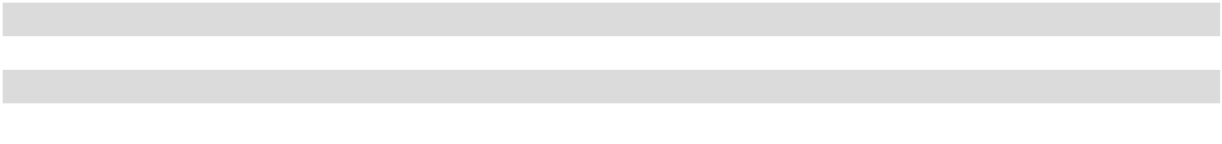

As of August 31, 2023 and September 1, 2022, 31% of our global workforce were women. As of August 31, 2023, 25% of our technical or engineering roles were held by women, as compared to 24% as of September 1, 2022. Women comprised 17% of our senior leaders as of August 31, 2023 and September 1, 2022.

11

Our Board of Directors was comprised of four men and four women as of August 31, 2023. In addition, as of August 31, 2023, based on self-identification, one member of our Board of Directors is Asian, one member is African-American, and six members are White. One member of our Board of Directors is a veteran of the U.S. military.

Talent Acquisition, Development, and Engagement

Finding and retaining the best and brightest people in an extremely competitive industry environment is a strategic imperative for our business. We partner with our communities, institutions, governments, and associations to expand the pipeline of diverse, highly skilled STEM talent globally. Our partnerships with K-12 and post-secondary education systems are key to training and inspiring the next generation to consider STEM careers in the semiconductor industry. We use AI to reduce or eliminate the potential for bias from resumes, allowing us to focus on individual merit over personal characteristics. We are committed to developing team members at all stages of their careers, including on-the-job training, continuing education, a robust mentoring program, and numerous internal certifications and training. In addition, we develop and accelerate our leaders’ careers through targeted learning that helps them move to higher-level positions or across functions.

We use a research-based, people-centric approach to understanding and improving team member engagement. Periodically, we invite all team members to participate in our internal engagement survey, which covers questions that measure and provide insight into three driving factors: meaningfulness, availability, and psychological safety. In April 2023, 82% of our team members participated in the survey. The results of the survey are shared with all team members and management uses feedback from the survey to identify and implement continuous improvements to our culture and workplace practices.

Compensation and Benefits

Our compensation programs are designed to support our team members’ financial and personal wellbeing by providing a valuable return for their contributions to the company. Our total compensation strategy includes base salary, annual bonuses, equity awards, a discounted stock purchase plan, and a comprehensive benefits package.

Diversity, Equality, and Inclusion

We have five diversity, equality, and inclusion (“DEI”) commitments that serve as the roadmap of our DEI work internally, within our industry, and in the community at large. To hold ourselves accountable, each commitment is assigned an executive sponsor who is responsible for its strategy and execution. Our five DEI commitments are summarized as follows:

- Increase representation of underrepresented groups

- Drive equitable pay and inclusive benefits

- Champion advocacy and strengthen our culture of inclusion

- Engage with diverse financial institutions for cash management

- Increase diverse supplier representation and spending

We have a regular review of pay globally, including base pay and stock awards, to drive compensation equitably. In 2023, due to challenging industry conditions, base pay increases were suspended, however we achieved global pay equity for all underrepresented employees in compensation across bonuses and stock rewards. In 2022 and 2021, we achieved comprehensive global pay equity for all employees in total compensation across base pay, bonuses, and stock rewards. A pay equity analysis will be conducted in 2024 with our base pay merit review. We also continually assess our global leave, medical, and financial benefits to ensure inclusiveness. In addition, a portion of our company-wide annual bonus program is based on the achievement of DEI-related goals.

12 | 2023 10-K

Health, Safety, and Wellbeing

Proactive efforts to prevent occupational illnesses and injuries allow us to maintain a safe, healthy, and secure workplace. Each of our sites have health and safety committees, which are designed to promote overall operations and communications regarding safety and to help lead and implement secure and compliant work areas. Our safety program creates a unified corporate safety culture by establishing a formal training structure and common safety practices across our global facilities.

In addition to our proactive efforts on safety, our team member wellness program offers resources across our five pillars of wellbeing (physical, mental, social, career, and financial). We provide services to our team members including free mental health and counseling support, on-site and near-site fitness centers, wellness spaces and health clinics at certain Micron sites, money management and other financial education tools, and encouraging team members to form healthy habits, reduce stress and reinforce mindfulness solutions by participating in wellbeing challenges and measuring their personal progress. We also provide exclusive access to near-site, company-sponsored childcare centers, financial subsidies to help families with cost, and partnerships with community centers.

We are a member of the Responsible Business Alliance (“RBA”), a group of leading companies focused on promoting responsible working conditions, ethical business practices, and environmental stewardship throughout our global supply chain. We strive to adhere to both our Code of Business Conduct and Ethics (available on our website, www.micron.com) and the RBA code of conduct, which is a demonstration of our commitment to integrity and responsible practices.

Additional information about our human capital is included in our 2023 Sustainability Report and our 2022 DEI Annual Report, each available on our website. Information contained or referenced on our website is not incorporated by reference and does not form a part of this Annual Report on Form 10-K.

Government Regulations

Our worldwide business activities are subject to various federal, state, local, and foreign laws and our products are governed by a number of rules and regulations and customer expectations. The efforts and expenditures needed to comply with these laws, rules, and regulations do not presently have a material impact on our results of operations, capital expenditures, or competitive position. Nevertheless, compliance with existing or future government laws, including, but not limited to, our operations, products, global trade, business acquisitions, employee health and safety, and taxes could have a material adverse effect on our future results of operations, capital expenditures, or competitive position. See “Item 1A. Risk Factors” for a discussion of these potential impacts.

Environmental Compliance

Manufacturing of our products is subject to complex and evolving federal, state, local, and foreign environmental, health, safety and product laws and regulations and expectations. We approach environmental compliance and sustainability proactively to ensure we meet applicable government regulations regarding use of raw materials and chemicals, discharges, emissions, climate change and energy use, and waste disposal and management from our manufacturing processes. Our approach also considers the expectations of our investors, customers, team members, community members, and other stakeholders. Compliance with the law and other obligations is a minimum environmental expectation at Micron. Our wafer fabrication facilities continued to conform to the requirements of the ISO 14001:2015 environmental management systems standard to ensure we are continuously improving our performance. As part of the ISO 14001 framework, we have established a global environmental policy and meet requirements, such as environmental aspects evaluation and control, compliance obligations, commitment, training, communication, document control, operational control, emergency preparedness and response, and management review. While we have not experienced any material adverse effects to our operations from environmental regulations, changes in regulations could necessitate additional capital expenditures, modification of our operations or chemical usage, or other compliance actions.

13

Trade Regulations

Sales of our memory and storage products, and the transfer of related technical information and know-how, including support, are subject to laws and regulations governing international trade, including, but not limited to, export control, customs, and sanctions regulations administered by U.S. government agencies such as the Bureau of Industry and Security (“BIS”) of the U.S. Department of Commerce and the Office of Foreign Asset Control of the U.S. Department of the Treasury. Other jurisdictions, such as the European Union or China, also maintain, or may implement, similar laws and regulations with which we must comply. Any such laws or regulations may require that we either obtain licenses or other authorizations to export certain of our products or sell them to certain countries, companies, or individuals, or, in the absence of such licenses or authorizations, not export or sell the applicable products or transfer the related technical information and know-how to the affected countries, companies, or individuals. In addition, increased tariffs imposed by the countries in which our products are sold can increase the cost of our product to our customers. The laws and regulations that govern international trade change frequently, sometimes without advance notice. See “Item 1A. Risk Factors – Risks Related to Laws and Regulations – Government actions and regulations, such as export restrictions, tariffs and trade protection measures, may limit our ability to sell our products to certain customers or markets, or could otherwise restrict our ability to conduct operations” and “ – Risks Related to Our Business, Operations, and Industry – We face geopolitical and other risks associated with our international operations that could materially adversely affect our business, results of operations, or financial condition.”

We and/or our suppliers and service providers could be affected by tariffs, embargoes, or other trade restrictions, as well as laws and regulations enacted in response to concerns regarding climate change, conflict minerals, responsible sourcing practices, public health crises, or other matters, which could limit the supply of our materials and/or increase the cost. Environmental regulations could limit our ability to procure or use certain chemicals or materials in our operations or products. In addition, disruptions in transportation lines could delay our receipt of materials. Lead times for the supply of materials have been extended in the past. Our ability to procure components to repair equipment essential for our manufacturing processes could also be negatively impacted by various restrictions or disruptions in supply chains, among other items. The disruption of our supply of materials, components, or services, or the extension of our lead times could have a material adverse effect on our business, results of operations, or financial condition. Similarly, if our customers experience disruptions to their supplies, materials, components, or services, or the extension of their lead times, they may reduce, cancel, or alter the timing of their purchases with us, which could have a material adverse effect on our business, results of operations, or financial condition.

14 | 2023 10-K

Information About Our Executive Officers

Our executive officers are appointed annually by our Board of Directors and our directors are elected annually by our shareholders. All officers serve until their successors are duly chosen or elected and qualified, except in the case of earlier death, resignation, or removal.

The following presents information, as of August 31, 2023, about our executive officers:


Scott R. Allen



Corporate Vice President and Chief Accounting Officer

Mr. Allen, 55, joined us in September 2020 as Corporate Vice President of Accounting. Mr. Allen was named Corporate Vice President and Chief Accounting Officer in October 2020. From August 2016 to September 2020, Mr. Allen held several executive roles at NetApp, Inc. including Senior Vice President, Chief Accounting Officer. Mr. Allen holds a Bachelor of Business Administration in Accounting from Siena College.

April S. Arnzen



Senior Vice President and Chief People Officer

Ms. Arnzen, 52, joined us in December 1996 and has served in various leadership positions since that time. Ms. Arnzen was named Senior Vice President, Human Resources in June 2017 and named Senior Vice President and Chief People Officer in October 2020. Ms. Arnzen holds a BS in Human Resource Management and Marketing from the University of Idaho and is a graduate of the Stanford Graduate School of Business Executive Program.

Manish Bhatia



Executive Vice President, Global Operations

Mr. Bhatia, 51, joined us in October 2017 as our Executive Vice President, Global Operations. From May 2016 to October 2017, Mr. Bhatia served as the Executive Vice President of Silicon Operations at Western Digital Corporation. From March 2010 to May 2016, Mr. Bhatia held several executive roles at SanDisk Corporation including Executive Vice President of Worldwide Operations until it was acquired by Western Digital in May 2016. Mr. Bhatia holds a BS and MS in Mechanical Engineering and an MBA, each from the Massachusetts Institute of Technology.

Michael W. Bokan



Senior Vice President, Worldwide Sales

Mr. Bokan, 62, joined us in 1996 and has served in various leadership positions since that time. Mr. Bokan was named Senior Vice President, Worldwide Sales in October 2018. Mr. Bokan holds a BS in Business Administration from Colorado State University.

Scott J. DeBoer



Executive Vice President, Technology & Products

Dr. DeBoer, 57, joined us in February 1995 and has served in various leadership positions since that time. Dr. DeBoer was named Executive Vice President, Technology Development in June 2017 and named Executive Vice President, Technology & Products in September 2019. Dr. DeBoer holds a PhD in Electrical Engineering and an MS in Physics from Iowa State University. He completed his undergraduate degree at Hastings College.

15


Sanjay Mehrotra


President, Chief Executive Officer, and Director

Mr. Mehrotra, 65, joined us in May 2017 as our President, Chief Executive Officer, and Director. Mr. Mehrotra co-founded and led SanDisk Corporation as a start-up in 1988 until its eventual sale in May 2016, serving as its President and Chief Executive Officer from January 2011 to May 2016, and as a member of its Board of Directors from July 2010 to May 2016. Mr. Mehrotra served as a member of the Board of Directors for Cavium, Inc. from July 2009 until July 2018 and for Western Digital Corp. from May 2016 to February 2017 and has served since March 2021 as a member of the Board of Directors of CDW Corporation. Mr. Mehrotra holds a BS and an MS in Electrical Engineering and Computer Science from the University of California, Berkeley and is a graduate of the Stanford Graduate School of Business Executive Program.

Mark J. Murphy



Executive Vice President and Chief Financial Officer

Mr. Murphy, 55, joined us in April 2022 as Executive Vice President and Chief Financial Officer. From June 2016 to April 2022, Mr. Murphy served as the Chief Financial Officer of Qorvo, Inc. Prior to Qorvo, Mr. Murphy served as Executive Vice President and Chief Financial Officer of Delphi Automotive PLC, and prior to Delphi, held executive roles at Praxair, Inc. and MEMC Electronic Materials, Inc. Mr. Murphy currently serves on the Board of Directors of Albany International Corp. Mr. Murphy is a veteran of the U.S. Marine Corps and holds an MBA from Harvard University and BS in Business from Marquette University.

Sumit Sadana



Executive Vice President and Chief Business Officer

Mr. Sadana, 54, joined us in June 2017 as our Executive Vice President and Chief Business Officer. From April 2010 to May 2016, Mr. Sadana served in various roles at SanDisk Corporation, including Executive Vice President, Chief Strategy Officer, and General Manager, Enterprise Solutions until it was acquired by Western Digital in May 2016. Mr. Sadana currently serves on the Board of Directors of Silicon Laboratories, Inc. Mr. Sadana holds a B.Tech. in Electrical Engineering from the Indian Institute of Technology, Kharagpur, India and an MS in Electrical Engineering from Stanford University.

There are no family relationships between any of our directors or executive officers.

16 | 2023 10-K

Available Information

Our executive offices are located at 8000 South Federal Way, Boise, Idaho 83716-9632 and our telephone number is (208) 368-4000. Information about us is available on our website, www.micron.com. Also available on our website are our Corporate Governance Guidelines, Governance and Sustainability Committee Charter, Compensation Committee Charter, Audit Committee Charter, Finance Committee Charter, Security Committee Charter, and Code of Business Conduct and Ethics. We intend to satisfy the disclosure requirement under Item 5.05 of Form 8-K regarding any amendments to, or waivers from, our Code of Business Conduct and Ethics by posting such information on our website within four business days of the amendment or waiver. Copies of these documents are available to shareholders upon request. Information contained or referenced on our website is not incorporated by reference and does not form a part of this Annual Report on Form 10-K.

Investors and others should note that we announce material financial information about our business and products through a variety of means, including our investor relations website (investors.micron.com), filings with the U.S. Securities and Exchange Commission (“SEC”), press releases, public conference calls, blog posts (micron.com/ about/blog), and webcasts. We use these channels to achieve broad, non-exclusionary distribution of information to the public and for complying with our disclosure obligations under Regulation FD. Therefore, we encourage investors, the media, and others interested in our company to review the information we post on such channels.

Our filings are available free of charge on our website as soon as reasonably practicable after they are electronically filed with, or furnished to, the SEC, including our annual and quarterly reports on Forms 10-K and 10-Q and current reports on Form 8-K, our proxy statements, and any amendments to those reports or statements. The SEC’s website, www.sec.gov, contains reports, proxy and information statements, and other information regarding issuers that file electronically with the SEC. The content on any website referred to in this Form 10-K is not incorporated by reference in this Form 10-K unless expressly noted.

17

ITEM 1A. RISK FACTORS

In addition to the factors discussed elsewhere in this Form 10-K, this section discusses important factors which could cause actual results or events to differ materially from those contained in any forward-looking statements made by us. The order of presentation is not necessarily indicative of the level of risk that each factor poses to us. Any of these factors could have a material adverse effect on our business, results of operations, financial condition, or stock price. Our operations could also be affected by other factors that are presently unknown to us or not considered significant.

Risk Factor Summary

Risks Related to Our Business, Operations, and Industry

- volatility in average selling prices of our products;

- a range of factors that may adversely affect our gross margins;

- our international operations, including geopolitical risks;

- the highly competitive nature of our industry;

- our ability to develop and produce new and competitive memory and storage technologies and products;

- realizing expected returns from capacity expansions;

- achieving or maintaining certain performance or other obligations associated with incentives from various governments;
- availability and quality of materials, supplies, and capital equipment and dependency on third-party service providers;
- a downturn in regional or worldwide economies;

- disruptions to our manufacturing process from operational issues, natural disasters, or other events;

- dependency on a select number of key customers, including international customers;

- products that fail to meet specifications, are defective, or are incompatible with end uses;

- breaches of our security systems or products, or those of our customers, suppliers, or business partners;

- attracting, retaining, and motivating highly skilled employees;

- responsible sourcing requirements and related regulations;

- environmental, social, and governance considerations;

- acquisitions and/or alliances; and

- restructure plans may not realize expected savings or other benefits.

Risks Related to Intellectual Property and Litigation

- protecting our intellectual property and retaining key employees who are knowledgeable of and develop our intellectual property;
- legal proceedings and claims; and

- claims that our products or manufacturing processes infringe or otherwise violate the intellectual property rights of others or failure to obtain or renew license agreements covering such intellectual property.

Risks Related to Laws and Regulations

- impacts of government actions and compliance with tariffs, trade restrictions, and/or trade regulations;

- tax expense and tax laws in key jurisdictions; and

- compliance with laws, regulations, or industry standards, including environmental considerations.

Risks Related to Capitalization and Financial Markets

- our ability to generate sufficient cash flows or obtain access to external financing;

- our debt obligations;

- changes in foreign currency exchange rates;

- counterparty default risk;

- volatility in the trading price of our common stock; and

- fluctuations in the amount and frequency of our common stock repurchases and payment of cash dividends and resulting impacts.

18 | 2023 10-K

Risks Related to Our Business, Operations, and Industry

Volatility in average selling prices for our semiconductor memory and storage products may adversely affect our business.

We have experienced significant volatility in our average selling prices and may continue to experience such volatility in the future. For example, average selling prices for DRAM declined in the high-40s percent range and NAND declined in the low-50s percent range for 2023 as compared to 2022. Since 2017, annual percentage changes in DRAM average selling prices have ranged from approximately plus 35% to a minus high-40s percent range. Since 2017, annual percentage changes in NAND average selling prices have ranged from nearly flat to a minus low-50s percent range. In current and recent periods, average selling prices for our products have been below our manufacturing costs and we may experience such circumstances in the future. Average selling prices for our products that decline faster than our costs have recently had an adverse effect on our business and results of operations, and in future periods could have a material adverse effect on our business, results of operations, or financial condition.

Our gross margins may be adversely affected by a range of factors.

Our gross margins are dependent, in part, upon continuing decreases in per gigabit manufacturing costs achieved through improvements in our manufacturing processes and product designs. Factors that may limit our ability to reduce our per gigabit manufacturing costs at sufficient levels to prevent deterioration of or improve gross margins include, but are not limited to:

- strategic product diversification decisions affecting product mix;

- increasing complexity of manufacturing processes;

- difficulties in transitioning to smaller line-width process technologies or additional 3D memory layers or NAND cell levels;
- process complexity including number of mask layers and fabrication steps;

- manufacturing yield;

- technological barriers;

- changes in process technologies;

- new products that may require relatively larger die sizes;

- start-up or other costs associated with capacity expansions;

- higher costs of goods and services due to inflationary pressures or market conditions; and

- higher manufacturing costs per gigabit due to fabrication facility underutilization, lower wafer output, and insufficient volume to run new technology nodes to achieve cost optimization.

Many factors may result in a reduction of our output or a delay in ramping production, which could lead to underutilization of our production assets. These factors may include, among others, a weak demand environment, industry oversupply, inventory surpluses, difficulties in ramping emerging technologies, supply chain disruptions, and delays from equipment suppliers. See “Part II – Item 7. Management’s Discussion and Analysis of Financial Condition and Results of Operations – Overview – Industry Conditions” for information regarding our current underutilization. A significant portion of our manufacturing costs are fixed and do not vary proportionally with changes in production output. As a result, lower utilization, lower wafer output, and corresponding increases in our per gigabit manufacturing costs have resulted in higher inventory carrying costs, and have had, and may continue to have, an adverse effect on our gross margins, business, results of operations, or financial condition.

19

We have a broad portfolio of products to address our customers’ needs, which span multiple market segments and are subject to rapid technological changes. Our manufacturing costs on a per gigabit basis vary across our portfolio as they are largely influenced by the technology node in which the solution was developed. We strive to balance our demand and supply for each technology node, but the dynamics of our markets and our customers can create periods of imbalance, which can lead us to carry elevated inventory levels. Consequently, we may incur charges in connection with obsolete or excess inventories, or we may not fully recover our costs, which would reduce our gross margins. For example, in 2023, we recorded aggregate charges of $1.83 billion to write down the carrying value of our inventories to their estimated net realizable value. In addition, due to the customized nature of certain products we manufacture, we may be unable to sell certain finished goods inventories to alternative customers or manufacture in-process inventory to different specifications, which may result in excess and obsolescence charges in future periods.

In addition, if we are unable to supply products that meet customer design and performance specifications, we may be required to sell such products at lower average selling prices, which may reduce our gross margins. Our gross margins may also be impacted by shifts in product mix, driven by our strategy to optimize our portfolio to best respond to changing market dynamics.

Our inability to prevent deterioration of or improve gross margins could have a material adverse effect on our business, results of operations, or financial condition.

We face geopolitical and other risks associated with our international operations that could materially adversely affect our business, results of operations, or financial condition.

In addition to our U.S. operations, a substantial portion of our operations are conducted in Taiwan, Singapore, Japan, Malaysia, China, and India, and many of our customers, suppliers, and vendors also operate internationally. In 2023, nearly half of our revenue was from sales to customers who have headquarters located outside the United States, while over 80% of our revenue in 2023 was from products shipped to customer locations outside the United States.

Our international operations are subject to a number of risks, including:

- restrictions on sales of goods or services to one or more of our significant foreign customers;

- export and import duties, changes to import and export regulations, customs regulations and processes, and restrictions on the transfer of funds, including currency controls in China, which could negatively affect the amount and timing of payments from certain of our customers and, as a result, our cash flows;
- compliance with U.S. and international laws involving international operations, including the Foreign Corrupt Practices Act of 1977, as amended, sanctions and anti-corruption laws, export and import laws, and similar rules and regulations;

- theft of intellectual property;

- political and economic instability, including instability resulting from domestic and international conflicts;

- government actions or civil unrest preventing the flow of products and materials, including delays in shipping and obtaining products and materials, cancellation of orders, or loss or damage of products;
- problems with the transportation or delivery of products and materials;

- issues arising from cultural or language differences and labor unrest;

- longer payment cycles and greater difficulty in collecting accounts receivable;

- compliance with trade, technical standards, and other laws in a variety of jurisdictions;

- contractual and regulatory limitations on the ability to maintain flexibility with staffing levels;

- disruptions to manufacturing or R&D activities as a result of actions imposed by foreign governments;

- changes in economic policies of foreign governments;

- difficulties in staffing and managing international operations; and

- public health issues.

If we or our customers, suppliers, or vendors are impacted by any of these risks, it could have a material adverse effect on our business, results of operations, or financial condition.

20 | 2023 10-K

Following the May 21, 2023 decision of its cybersecurity review of our products sold in China, the CAC determined that critical information infrastructure operators in China may not purchase Micron products, impacting our revenue with companies headquartered in mainland China and Hong Kong, including direct sales as well as indirect sales through distributors. Some revenue with customers headquartered outside of China has also been impacted. As we try to mitigate possible impacts due to the CAC decision, revenue may come at lower prices or gross margins due to product or customer mix changes, which may impact our business results. Further actions by the Chinese government could impact additional revenue inside or outside China, or our operations in China, or our ability to ship products to our customers, any of which could have a material adverse effect on our business, results of operations, or financial condition.

Political, economic, or other actions may adversely affect our operations in Taiwan. A majority of our DRAM production output in 2023 was from our fabrication facilities in Taiwan and any loss of output could have a material adverse effect on us. Any political, economic, or other actions may also adversely affect our customers and the technology industry supply chain, for which Taiwan is a central hub, and as a result, could have a material adverse impact on us.

In addition, the U.S. government has in the past restricted American firms from selling products and software to certain of our customers and may in the future impose similar restrictions on one or more of our significant customers. These restrictions may not prohibit our competitors from selling similar products to our customers, which may result in our loss of sales and market share. Even as such restrictions are lifted, financial or other penalties or continuing export restrictions imposed with respect to our customers could have a continuing negative impact on our future revenue and results of operations, and we may not be able to recover any customers or market share we lose, or make such recoveries at acceptable average selling prices, while complying with such restrictions.

The semiconductor memory and storage markets are highly competitive.

We face intense competition in the semiconductor memory and storage markets from a number of companies, including Kioxia Holdings Corporation; Samsung Electronics Co., Ltd.; SK hynix Inc.; and Western Digital Corporation. Our competitors may use aggressive pricing to obtain market share. Some of our competitors are large corporations or conglomerates that may have a larger market share and greater resources to invest in technology, capitalize on growth opportunities, and withstand downturns in the semiconductor markets in which we compete. Consolidation of industry competitors could put us at a competitive disadvantage as our competitors may benefit from increased manufacturing scale and a stronger product portfolio. We operate in different jurisdictions than our competitors and may be impacted by unfavorable changes in currency exchange rates.

In addition, some governments may provide, or have provided and may continue to provide, significant assistance, financial or otherwise, to some of our competitors or to new entrants and may intervene in support of national industries and/or competitors. In particular, we face the threat of increasing competition as a result of significant investment in the semiconductor industry by the Chinese government and various state-owned or affiliated entities, in companies such as Yangtze Memory Technologies Co., Ltd. (“YMTC”) and ChangXin Memory Technologies, Inc. (“CXMT”). In addition, the CAC’s decision that critical information infrastructure operators in China may not purchase Micron products had an impact on our ability to compete effectively in China and elsewhere.

We and our competitors generally seek to increase wafer output, improve yields, and reduce die size, which could result in significant increases in worldwide supply and downward pressure on prices. Increases in worldwide supply of semiconductor memory and storage also result from fabrication capacity expansions, either by way of new facilities, increased capacity utilization, or reallocation of other semiconductor production to semiconductor memory and storage production. Our competitors may increase capital expenditures resulting in future increases in worldwide supply. We, and some of our competitors, have plans to ramp, or are constructing or ramping, production at new fabrication facilities. Increases in worldwide supply of semiconductor memory and storage, if not accompanied by commensurate increases in demand, could lead to declines in average selling prices for our products and could materially adversely affect our business, results of operations, or financial condition. If competitors are more successful at developing or implementing new product or process technology, their products could have cost or performance advantages.

The competitive nature of our industry could have a material adverse effect on our business, results of operations, or financial condition.

21

Our future success depends on our ability to develop and produce new and competitive memory and storage technologies and products.

Our key semiconductor memory and storage technologies face technological barriers to continue to meet long-term customer needs. These barriers include potential limitations on stacking additional 3D memory layers, increasing bits per cell (i.e., cell levels), meeting higher density requirements, improving power consumption and reliability, and delivering advanced features and higher performance. We may face technological barriers to continue to shrink our products at our current or historical rate, which has generally reduced per gigabit cost. We have invested and expect to continue to invest in R&D for new and existing products and process technologies, such as EUV lithography, to continue to deliver advanced product requirements. Such new technologies can add complexity and risk to our schedule and may affect our costs and production output. We may be unable to recover our investment in R&D or otherwise realize the economic benefits of reducing die size or increasing memory and storage densities. Our competitors are working to develop new memory and storage technologies that may offer performance and/or cost advantages to existing technologies and render existing technologies obsolete. Accordingly, our future success may depend on our ability to develop and produce viable and competitive new memory and storage technologies.

We are developing new products, including system-level memory and storage products and solutions, which complement our traditional products or leverage their underlying design or process technology. We have invested and expect to continue to invest in new semiconductor product and system-level solution development. We are increasingly differentiating our products and solutions to meet the specific demands of our customers, which increases our reliance on our customers’ ability to accurately forecast the needs and preferences of their customers. As a result, our product demand forecasts may be impacted significantly by the strategic actions of our customers. In addition, our ability to successfully introduce new products often requires us to make product specification decisions multiple years in advance of when new products enter the market.

It is important that we deliver products in a timely manner with increasingly advanced performance characteristics at the time our customers are designing and evaluating samples for their products. If we do not meet their product design schedules, our customers may exclude us from further consideration as a supplier for those products. The process to develop new products requires us to demonstrate advanced functionality, performance, and reliability, often well in advance of a planned ramp of production, in order to secure design wins with our customers. Many factors may negatively impact our ability to meet anticipated timelines and/or expected or required quality standards with respect to the development of certain of our products. In addition, some of our components have long lead-times, requiring us to place orders up to a year in advance of anticipated demand. Such long lead-times increase the risk of excess inventory or loss of sales in the event our forecasts vary substantially from actual demand.

There can be no assurance of the following:

- we will be successful in developing competitive new semiconductor memory and storage technologies and products;

- we will be able to cost-effectively manufacture new products;

- we will be able to successfully market these technologies;

- margins generated from sales of these products will allow us to recover costs of development efforts;

- we will be able to establish or maintain key relationships with customers, or that we will not be prohibited from working with certain customers, for specific chip set or design requirements;
- we will accurately predict and design products that meet our customers' specifications; or

- we will be able to introduce new products into the market and qualify them with our customers on a timely basis.

Unsuccessful efforts to develop new memory and storage technologies and products could have a material adverse effect on our business, results of operations, or financial condition.

22 | 2023 10-K

We may not be able to achieve expected returns from capacity expansions.

We have announced our intent to expand our production capacity and/or make capital investments in the United States and in other regions where we operate.

These expansions involve several risks including the following:

- capital expenditure requirements for capacity expansions during periods of relatively low free cash flow generation, resulting from challenging memory and storage industry conditions;

- availability of necessary funding, which may include external sources;

- ability to realize expected grants, investment tax credits, and other government incentives, including through the U.S. CHIPS and Science Act of 2022 (“CHIPS Act”) and other national, international, state, and local grants;

- potential changes in laws or provisions of grants, investment tax credits, and other government incentives;

- potential restrictions on expanding in certain geographies;

- availability of equipment and construction materials;

- ability to complete construction as scheduled and within budget;

- availability of the necessary workforce;

- ability to timely ramp production in a cost-effective manner;

- increases to our cost structure until new production is ramped to adequate scale; and

- sufficient customer demand to utilize our increased capacity.

We invest our capital in areas that we believe best align with our business strategy and optimize future returns. Investments in capital expenditures may not generate expected returns or cash flows. Significant judgment is required to determine which capital investments will result in optimal returns, and we could invest in projects that are ultimately less profitable than those projects we do not select. Delays in completion and ramping of new production facilities, or failure to optimize our investment choices, could significantly impact our ability to realize expected returns on our capital expenditures.

Any of the above factors could have a material adverse effect on our business, results of operations, or financial condition.

Our incentives from various governments are conditional upon achieving or maintaining certain performance or other obligations and are subject to reduction, termination, clawback, or could impose certain limitations on our business.

We have received, and may in the future continue to receive, benefits and incentives from national, state, and local governments in various regions of the world designed to encourage us to establish, maintain, or increase investment, workforce, or production in those regions. These incentives may take various forms, including grants, loan subsidies, and tax arrangements, and typically require us to achieve or maintain certain levels of investment, capital spending, employment, technology deployment, or research and development activities to qualify for such incentives or could restrict us from undertaking certain activities. We may be unable to obtain significant future incentives to continue to fund a portion of our capital expenditures and operating costs, without which our cost structure would be adversely impacted. We also cannot guarantee that we will successfully achieve performance or other obligations required to qualify for these incentives or that the granting agencies will provide such funding. These incentive arrangements typically provide the granting agencies with rights to audit our compliance with their terms and obligations. Such audits could result in modifications to, or termination of, the applicable incentive program. The incentives we receive could be subject to reduction, termination, or clawback, and any decrease or clawback of government incentives could have a material adverse effect on our business, results of operations, or financial condition.

23

Our business, results of operations, or financial condition could be adversely affected by the availability and quality of materials, supplies, and capital equipment, or dependency on third-party service providers.

Our supply chain and operations are dependent on the availability of materials that meet exacting standards and the use of third parties to provide us with components and services. We generally have multiple sources of supply for our materials and services. However, only a limited number of suppliers are capable of delivering certain materials, components, and services that meet our standards and, in some cases, materials, components, or services are provided by a single or sole source, and we may be unable to qualify new suppliers on a timely basis. The availability of materials or components such as chemicals, silicon wafers, gases, photoresist, controllers, substrates, lead frames, printed circuit boards, targets, and reticle glass blanks is impacted by various factors. These factors could include a shortage of raw materials or a disruption in the processing or purification of those raw materials into finished goods. Shortages or increases in lead times have occurred in the past, are currently occurring with respect to some materials and components, and may occur from time to time in the future. Constraints within our supply chain for certain materials and integrated circuit components could limit our bit shipments, which could have a material adverse effect on our business, results of operations, or financial condition.

Our manufacturing processes are also dependent on our relationships with third-party manufacturers of controllers, analog integrated circuits, and other components used in some of our products and with outsourced semiconductor foundries, assembly and test providers, contract manufacturers, logistics carriers, and other service providers, including providers of electricity and other utilities. Although we have certain long-term contracts with some of our suppliers, many of these contracts do not provide for long-term capacity or pricing commitments. To the extent we do not have firm commitments from our third-party suppliers over a specific time period or for any specific capacity, quantity, and/or pricing, our suppliers may allocate capacity to their other customers and capacity and/or materials may not be available when needed or at reasonable prices. Inflationary pressures have increased, and may continue to increase costs for materials, supplies, and services. Regardless of contract structure, large swings in demand may exceed our contracted supply and/or our suppliers’ capacity to meet those demand changes resulting in a shortage of parts, materials, or capacity needed to manufacture our products. In addition, if any of our suppliers was to cease operations or become insolvent, this could impact their ability to provide us with necessary supplies, and we may not be able to obtain the needed supply in a timely way or at all from other providers.

Certain materials are primarily available in a limited number of countries, including rare earth elements, minerals, and metals. Trade disputes, geopolitical tensions, economic circumstances, political conditions, or public health issues may limit our ability to obtain such materials. Although these rare earth and other materials are generally available from multiple suppliers, China is the predominant producer of certain of these materials. If China were to restrict or stop exporting these materials, our suppliers’ ability to obtain such supply may be constrained and we may be unable to obtain sufficient quantities, or obtain supply in a timely manner, or at a commercially reasonable cost. Constrained supply of rare earth elements, minerals, and metals may restrict our ability to manufacture certain of our products and make it difficult or impossible to compete with other semiconductor memory and storage manufacturers who are able to obtain sufficient quantities of these materials from China.

We and/or our suppliers and service providers could be affected by regional conflicts, civil unrest, labor disruptions, sanctions, tariffs, embargoes, or other trade restrictions, as well as laws and regulations enacted in response to concerns regarding climate change, conflict minerals, responsible sourcing practices, public health crises, or other matters, which could limit the supply of our materials and/or increase the cost. Environmental regulations could limit our ability to procure or use certain chemicals or materials in our operations or products. In addition, disruptions in transportation lines could delay our receipt of materials. Our ability to procure components to repair equipment essential for our manufacturing processes could also be negatively impacted by various restrictions or disruptions in supply chains, among other items. The disruption of our supply of materials, components, or services, or the extension of our lead times could have a material adverse effect on our business, results of operations, or financial condition.

24 | 2023 10-K

Our operations are dependent on our ability to procure advanced semiconductor manufacturing equipment that enables the transition to lower cost manufacturing processes. For certain key types of equipment, including photolithography tools, we are sometimes dependent on a single supplier. From time to time, we have experienced difficulties in obtaining some equipment on a timely basis due to suppliers’ limited capacity. Our inability to obtain equipment on a timely basis could adversely affect our ability to transition to next generation manufacturing processes and reduce our costs. Delays in obtaining equipment could also impede our ability to ramp production and could increase our overall costs of a ramp. Our inability to obtain advanced semiconductor manufacturing equipment in a timely manner could have a material adverse effect on our business, results of operations, or financial condition.

Our construction projects to expand production and R&D capacity are highly dependent on available sources of labor, materials, equipment, and services. Increasing demand, supply constraints, inflation, and other market conditions could result in increasing shortages and higher costs for these items. Difficulties in obtaining these resources could result in significant delays in completion of our construction projects and cost increases, which could have a material adverse effect on our business, results of operations, or financial condition.

Our inability to source materials, supplies, capital equipment, or third-party services could affect our overall production output and our ability to fulfill customer demand. Significant or prolonged shortages of our products could halt customer manufacturing and damage our relationships with these customers. Any damage to our customer relationships as a result of a shortage of our products could have a material adverse effect on our business, results of operations, or financial condition.

Similarly, if our customers experience disruptions to their supplies, materials, components, or services, or the extension of their lead times, they may reduce, cancel, or alter the timing of their purchases with us, which could have a material adverse effect on our business, results of operations, or financial condition.

Downturns in regional or worldwide economies may harm our business.

Downturns in regional or worldwide economies, due to inflation, geopolitics, major central bank policy actions including interest rate increases, public health crises, or other factors, have harmed our business in the past and current and future downturns could also adversely affect our business. Adverse economic conditions affect demand for devices that incorporate our products, such as personal computers, smartphones, automobiles, and servers. Reduced demand for these or other products could result in significant decreases in our average selling prices and product sales. In addition, to the extent our customers or distributors have elevated inventory levels or are impacted by a deterioration in credit markets, we may experience a decrease in short-term and/or long-term demand resulting in industry oversupply and declines in pricing for our products.

A deterioration of conditions in regional or worldwide credit markets could limit our ability to obtain external financing to fund our operations and capital expenditures. In addition, we may experience losses on our holdings of cash and investments due to failures of financial institutions and other parties. Difficult economic conditions may also result in a higher rate of losses on our accounts receivable due to credit defaults. As a result, downturns in regional or worldwide economies could have a material adverse effect on our business, results of operations, or financial condition.

If our manufacturing process is disrupted by operational issues, natural disasters, or other events, our business, results of operations, or financial condition could be materially adversely affected.

We and our subcontractors manufacture products using highly complex processes that require technologically advanced equipment and continuous modification to improve yields and performance. Difficulties in the manufacturing process or the effects from a shift in product mix can reduce yields or disrupt production and may increase our per gigabit manufacturing costs. We and our subcontractors maintain operations and continuously implement new product and process technology at manufacturing facilities, which are widely dispersed in multiple locations in several countries including the United States, Singapore, Taiwan, Japan, Malaysia, and China. As a result of the necessary interdependence within our network of manufacturing facilities, an operational disruption at one of our or a subcontractor’s facilities may have a disproportionate impact on our ability to produce many of our products.

25

From time to time, there have been disruptions in our manufacturing operations as a result of power outages, improperly functioning equipment, disruptions in supply of raw materials or components, or equipment failures. We have manufacturing and other operations in locations subject to natural occurrences and possible climate changes, such as severe and variable weather and geological events resulting in increased costs, or disruptions to our manufacturing operations or those of our suppliers or customers. In addition, climate change may pose physical risks to our manufacturing facilities or our suppliers’ facilities, including increased extreme weather events that could result in supply delays or disruptions. Other events, including political or public health crises, such as an outbreak of contagious diseases, may also affect our production capabilities or that of our suppliers, including as a result of quarantines, closures of production facilities, lack of supplies, or delays caused by restrictions on travel or shipping. Events of the types noted above have occurred from time to time and may occur in the future. As a result, in addition to disruptions to operations, our insurance premiums may increase or we may not be able to fully recover any sustained losses through insurance.

If production is disrupted for any reason, manufacturing yields may be adversely affected, or we may be unable to meet our customers’ requirements and they may purchase products from other suppliers. This could result in a significant increase in manufacturing costs, loss of revenue, or damage to customer relationships, any of which could have a material adverse effect on our business, results of operations, or financial condition.

A significant portion of our revenue is concentrated with a select number of customers.

In each of the last three years, approximately one-half of our total revenue was from our top ten customers. A disruption in our relationship with any of these customers could adversely affect our business. We could experience fluctuations in our customer base or the mix of revenue by customer as markets and strategies evolve. Our customers’ demand for our products may fluctuate due to factors beyond our control. In addition, any consolidation of our customers could reduce the number of customers to whom our products may be sold. Our inability to meet our customers’ requirements or to qualify our products with them could adversely impact our revenue. A meaningful change in the inventory strategy of our customers could impact our industry bit demand growth outlook. The loss of, or restrictions on our ability to sell to, one or more of our major customers, or any significant reduction in orders from, or a shift in product mix by, customers could have a material adverse effect on our business, results of operations, or financial condition.

Increases in sales of system solutions may increase our dependency upon specific customers and our costs to develop, qualify, and manufacture our system solutions.

Our development of system-level memory and storage products is dependent, in part, upon successfully identifying and meeting our customers’ specifications for those products. Developing and manufacturing system-level products with specifications unique to a customer increases our reliance upon that customer for purchasing our products at sufficient volumes and prices in a timely manner. Even if our products meet customer specifications, our sales of system-level solutions are dependent upon our customers choosing our products over those of our competitors and purchasing our products at sufficient volumes and prices. Our competitors’ products may be less costly, provide better performance, or include additional features when compared to our products. Our long-term ability to sell system-level memory and storage products is reliant upon our customers’ ability to create, market, and sell their products containing our system-level solutions at sufficient volumes and prices in a timely manner. If we fail to successfully develop and market system-level products, our business, results of operations, or financial condition may be materially adversely affected.

26 | 2023 10-K

Manufacturing system-level solutions, such as SSDs, managed NAND, and HBM, typically results in higher per-unit manufacturing costs as compared to other products. Even if we are successful in selling system-level solutions to our customers in sufficient volume, we may be unable to generate sufficient profit if our per-unit manufacturing costs are not offset by higher per-unit selling prices. Manufacturing system-level solutions to customer specifications requires a longer development cycle, as compared to discrete products, to design, test, and qualify, which may increase our costs. Some of our system solutions are increasingly dependent on sophisticated firmware that may require significant customization to meet customer specifications, which increases our costs and time to market. Additionally, we may need to update our controller and hardware design as well as our firmware or develop new firmware as a result of new product introductions or changes in customer specifications and/or industry standards, which increases our costs. System complexities and extended warranties for system-level products could also increase our warranty costs. Our failure to cost-effectively manufacture system-level solutions and/or controller, hardware design, and firmware in a timely manner may result in reduced demand for our system-level products and could have a material adverse effect on our business, results of operations, or financial condition.

Products that fail to meet specifications, are defective, or are otherwise incompatible with end uses could impose significant costs on us.

Products that do not meet specifications or that contain, or are perceived by our customers to contain, defects or that are otherwise incompatible with end uses could impose significant costs on us or otherwise materially adversely affect our business, results of operations, or financial condition. From time to time, we experience problems with nonconforming, defective, or incompatible products after we have shipped such products. In recent periods, we have further diversified and expanded our product offerings, which could potentially increase the chance that one or more of our products could fail to meet specifications in a particular application. Our products and solutions may be deemed fully or partially responsible for functionality in our customers’ products and may result in sharing or shifting of product or financial liability from our customers to us for costs incurred by the end user as a result of our customers’ products failing to perform as specified. In addition, if our products and solutions perform critical functions in our customers’ products or are used in high-risk consumer end products, such as autonomous driver assistance programs, home and enterprise security, smoke and noxious gas detectors, medical monitoring equipment, or wearables for child and elderly safety, our potential liability may increase. We could be adversely affected in several ways, including the following:

- we may be required or agree to compensate customers for costs incurred or damages caused by defective or incompatible products and to replace products;
- we could incur a decrease in revenue or adjustment to pricing commensurate with the reimbursement of such costs or alleged damages; and

- we may encounter adverse publicity, which could cause a decrease in sales of our products or harm our reputation or relationships with existing or potential customers.

Any of the foregoing items could have a material adverse effect on our business, results of operations, or financial condition.

27

Breaches of our security systems or products, or those of our customers, suppliers, or business partners, could expose us to losses.

We maintain a system of controls over the physical security of our facilities. We also manage and store various proprietary information and sensitive or confidential data relating to our operations. In addition, we process, store, and transmit large amounts of data relating to our customers and employees, including sensitive personal information. Unauthorized persons, employees, former employees, nation states, or other parties may gain access to our facilities or technology infrastructure and systems to steal trade secrets or other proprietary information, compromise confidential information, create system disruptions, or cause shutdowns. This risk is exacerbated as competitors for talent, particularly engineering talent, attempt to hire our employees. Through cyberattacks on technology infrastructure and systems, unauthorized parties may obtain access to computer systems, networks, and data, including cloud-based platforms. The technology infrastructure and systems of our suppliers, vendors, service providers, cloud solution providers, and partners have in the past experienced, and may in the future experience, such attacks, which could impact our operations. Cyberattacks can include ransomware, computer denial-of-service attacks, worms, supply chain attacks, social engineering, open source vulnerabilities, and other malicious software programs or other attacks, including those using techniques that change frequently or may be disguised or difficult to detect, or designed to remain dormant until a triggering event, impersonation of authorized users, and efforts to discover and exploit any design flaws, “bugs,” security vulnerabilities, as well as intentional or unintentional acts by employees or other insiders with access privileges. Additionally, some actors are using artificial intelligence technology to launch more automated, targeted and coordinated attacks. Globally, cyberattacks are increasing in number and the attackers are increasingly organized and well-financed, or supported by state actors, and are developing increasingly sophisticated systems to not only attack, but also to evade detection. In addition, geopolitical tensions or conflicts may create a heightened risk of cyberattacks. Breaches of our physical security, attacks on our technology infrastructure and systems, or breaches or attacks on our customers, suppliers, or business partners who have confidential or sensitive information regarding us and our customers and suppliers, could result in significant losses and damage our reputation with customers and suppliers and may expose us to litigation if the confidential information of our customers, suppliers, or employees is compromised.

Our products are also targets for cyberattacks, including those products utilized in cloud-based environments. While some of our products contain encryption or security algorithms to protect third-party content or user-generated data stored on our products, these products could still be hacked or the encryption schemes could be compromised, breached, or circumvented by motivated and sophisticated attackers. Further, our products contain sophisticated hardware and firmware and applications that may contain security vulnerabilities or defects in design or manufacture, including “bugs” and other problems that could interfere with the intended operation of our products. To the extent our products are hacked, or the encryption schemes are compromised or breached, this could harm our business by requiring us to employ additional resources to fix the errors or defects, exposing us to litigation, claims, and harm to our reputation.

Any of the foregoing security risks could have a material adverse effect on our business, results of operations, or financial condition.

We must attract, retain, and motivate highly skilled employees.

To remain competitive, we must attract, retain, and motivate executives and other highly skilled, diverse employees, as well as effectively manage succession for key employees. Competition for experienced employees in our industry can be intense. Hiring and retaining qualified executives and other employees is critical to our business. If our total compensation programs, employment benefits, and workplace culture are not viewed as competitive and inclusive, our ability to attract, retain, and motivate employees could be compromised.

At times, we experience higher levels of attrition, increasing compensation costs, and more intense competition for talent across our industry. To the extent we experience significant attrition and are unable to timely replace employees, we could experience a loss of critical skills and reduced employee morale, potentially resulting in business disruptions or increased expenses to address any disruptions. Additionally, changes to immigration policies in the countries in which we operate, as well as restrictions on travel due to public health crises or other causes, may limit our ability to hire and/or retain talent in, or transfer talent to, specific locations.

Our inability to attract, retain, and motivate executives and other employees or effectively manage succession of key roles may inhibit our ability to maintain or expand our business operations.

28 | 2023 10-K

Compliance with responsible sourcing requirements and any related regulations could increase our operating costs, or limit the supply and increase the cost of certain materials, supplies, and services, and if we fail to comply, customers may reduce purchases from us or disqualify us as a supplier.

We and many of our customers have adopted responsible sourcing programs that require us to meet certain environmental, social and governance criteria, and to periodically report on our performance against these requirements, including that we source the materials, supplies, and services we use and incorporate into the products we sell as prescribed by these programs. Many customer programs require us to remove a supplier within a prescribed period if such supplier ceases to comply with prescribed criteria, and our supply chain may at any time contain suppliers at risk of being removed due to non-compliance with responsible sourcing requirements. Some of our customers may elect to disqualify us as a supplier (resulting in a permanent or temporary loss of sales to such customer) or reduce purchases from us if we are unable to verify that our performance or products (including the underlying supply chain) meet the specifications of our customers’ responsible sourcing programs on a continuous basis. Meeting responsible sourcing requirements may increase operating requirements and costs or limit the sourcing and availability of some of the materials, supplies, and services we use, particularly when the availability of such materials, supplies, and services is concentrated to a limited number of suppliers. From time to time, we remove suppliers or require our suppliers to remove suppliers from their supply chains based on our responsible sourcing requirements or customer requirements, and we or our suppliers may be unable to replace such removed suppliers in a timely or cost-effective manner. Any inability to replace removed suppliers in a timely or cost effective manner may affect our ability and/or the cost to obtain sufficient quantities of materials, supplies, and services necessary for the manufacture of our products. Our inability to replace suppliers we have removed in a timely or cost-effective manner or comply with customers’ responsible sourcing requirements or with any related regulations could have a material adverse effect on our business, results of operations, or financial condition.

Failure to meet environmental, social, and governance expectations or standards or achieve our related goals could adversely affect our business, results of operations, financial condition, or stock price.

In recent years, there has been an increased focus from stakeholders on environmental, social, and governance matters, including greenhouse gas emissions and climate-related risks, sustainability, renewable energy, water stewardship, waste management, diversity, equality and inclusion, responsible sourcing and supply chain, human rights, and social responsibility. Given our commitment to relevant social and environmental issues as it relates to our business, we actively manage these issues and have established and publicly announced certain goals, commitments, and targets which we may refine or even expand further in the future. These goals, commitments, and targets reflect our current plans and aspirations and are not guarantees that we will be able to achieve them. Achieving these goals may entail significant costs, for example we have entered into several virtual power purchase agreements to obtain renewable energy credits at a cost that will vary based on future prices for electrical power. Evolving stakeholder expectations and our efforts to manage these issues, report on them, and accomplish our goals present numerous operational, regulatory, reputational, financial, legal, and other risks, any of which could have a material adverse impact, including on our reputation and stock price.

Such risks and uncertainties include:

- reputational harm, including damage to our relationships with customers, suppliers, investors, governments, or other stakeholders;

- adverse impacts on our ability to manufacture and sell products and maintain our market share;

- the success of our collaborations with third parties;

- increased risk of litigation, investigations, or regulatory enforcement action;

- unfavorable environmental, social, and governance ratings or investor sentiment;

- diversion of resources and increased costs to control, assess, and report on environmental, social, and governance metrics;
- our ability to achieve our goals, commitments, and targets within timeframes announced;

- increased costs to achieve our goals, commitments, and targets;

- unforeseen operational and technological difficulties;

- access to and increased cost of capital; and

- adverse impacts on our stock price.

29

Any failure, or perceived failure, to meet evolving stakeholder expectations and industry standards or achieve our environmental, social, and governance goals, commitments, and targets could have an adverse effect on our business, results of operations, financial condition, or stock price.

Acquisitions and/or alliances involve numerous risks.

Acquisitions and the formation or operation of alliances, such as joint ventures and other partnering arrangements, involve numerous risks, including the following:

- integrating the operations, technologies, and products of acquired or newly formed entities into our operations;

- increasing capital expenditures to upgrade and maintain facilities;

- increased debt levels;

- the assumption of unknown or underestimated liabilities;

- the use of cash to finance a transaction, which may reduce the availability of cash to fund working capital, capital expenditures, R&D expenditures, and other business activities;
- diverting management’s attention from daily operations;

- managing larger or more complex operations and facilities and employees in separate and diverse geographic areas;
- hiring and retaining key employees;

- requirements imposed by government authorities in connection with the regulatory review of a transaction, which may include, among other things, divestitures or restrictions on the conduct of our business or the acquired business;

- underestimating the costs or overestimating the benefits, including product, revenue, cost and other synergies and growth opportunities that we expect to realize, and we may not achieve those benefits;
- failure to maintain customer, vendor, and other relationships;

- inadequacy or ineffectiveness of an acquired company’s internal financial controls, disclosure controls and procedures, compliance programs, and/or environmental, health and safety, anti-corruption, human resource, or other policies or practices; and

- impairment of acquired intangible assets, goodwill, or other assets as a result of changing business conditions or technological advancements.

The global memory and storage industry has experienced consolidation and may continue to consolidate. We engage, from time to time, in discussions regarding potential acquisitions and similar opportunities. To the extent we are successful in completing any such transactions, we could be subject to some or all of the risks described above. Acquisitions of, or alliances with, technology companies are inherently risky and may not be successful and could have a material adverse effect on our business, results of operations, or financial condition.

We have incurred restructure charges and may incur restructure charges in future periods and may not realize expected savings or other benefits from restructure plans.

In 2023, we initiated a restructure plan in response to current market conditions. See “Part II – Item 8. Financial Statements and Supplementary Data – Notes to Consolidated Financial Statements – Restructure and Asset Impairments” and “Part II – Item 7. Management’s Discussion and Analysis of Financial Condition and Results of Operations – Overview.” In addition, we may in the future enter into other restructure initiatives in order to, among other items, streamline our operations, respond to changes in business conditions, our markets, or product offerings, or to centralize certain key functions.

We may not realize expected savings or other benefits from our current or future restructure activities and may incur additional restructure charges or other losses in future periods associated with other initiatives. In connection with any restructure initiatives, we could incur restructure charges, loss of production output, loss of key personnel, disruptions in our operations, and difficulties in the timely delivery of products, which could have a material adverse effect on our business, results of operations, or financial condition.

30 | 2023 10-K

Risks Related to Intellectual Property and Litigation

We may be unable to protect our intellectual property or retain key employees who are knowledgeable of and develop our intellectual property.

We maintain a system of controls over our intellectual property, including U.S. and foreign patents, trademarks, copyrights, trade secrets, licensing arrangements, confidentiality procedures, non-disclosure agreements with employees, consultants, and vendors, and a general system of internal controls. Despite our system of controls over our intellectual property, it may be possible for our current or future competitors to obtain, copy, use, or disclose, illegally or otherwise, our product and process technology or other proprietary information. The laws of some foreign countries may not protect our intellectual property to the same degree as do U.S. laws, and our confidentiality, non-disclosure, and non-compete agreements may be unenforceable or difficult and costly to enforce.

Additionally, our ability to maintain and develop intellectual property is dependent upon our ability to attract, develop, and retain highly skilled employees. If our competitors or future entrants into our industry are successful in hiring our employees, they may directly benefit from the knowledge these employees gained while they were under our employment, and this may also negatively impact our ability to maintain and develop intellectual property.

Our inability to protect our intellectual property or retain key employees who are knowledgeable of and develop our intellectual property could have a material adverse effect on our business, results of operations, or financial condition.

Legal proceedings and claims could have a material adverse effect on our business, results of operations, or financial condition.

From time to time, we are subject to various legal proceedings and claims that arise out of the ordinary conduct of our business or otherwise, both domestically and internationally. Such claims include, but are not limited to, allegations of anticompetitive conduct and infringement of intellectual property. See “Part II – Item 8. Financial Statements and Supplementary Data – Notes to Consolidated Financial Statements – Contingencies.”

Any claim, with or without merit, could result in significant legal fees that could negatively impact our financial results, disrupt our operations, and require significant attention from our management. We may be associated with and subject to litigation, claims, or arbitration disputes arising from, or as a result of:

- our relationships with vendors or customers, supply agreements, or contractual obligations with our subcontractors or business partners;

- the actions of our vendors, subcontractors, or business partners;

- our indemnification obligations, including obligations to defend our customers against third-party claims asserting infringement of certain intellectual property rights, which may include patents, trademarks, copyrights, or trade secrets; and

- the terms of our product warranties or from product liability claims.

As we continue to focus on developing system solutions with manufacturers of consumer products, including autonomous driving, augmented reality, and others, we may be exposed to greater potential for personal liability claims against us as a result of consumers’ use of those products. We, our officers, or our directors could also be subject to claims of alleged violations of securities laws. There can be no assurance that we are adequately insured to protect against all claims and potential liabilities, and we may elect to self-insure with respect to certain matters. Exposures to various legal proceedings and claims could lead to significant costs and expenses as we defend claims, are required to pay damage awards, or enter into settlement agreements, any of which could have a material adverse effect on our business, results of operations, or financial condition.

31

Claims that our products or manufacturing processes infringe or otherwise violate the intellectual property rights of others, or failure to obtain or renew license agreements covering such intellectual property, could materially adversely affect our business, results of operations, or financial condition.

As is typical in the semiconductor and other high technology industries, from time to time others have asserted, and may in the future assert, that our products or manufacturing processes infringe upon, misappropriate, misuse, or otherwise violate their intellectual property rights. We are unable to predict the outcome of these assertions made against us. Any of these types of claims, regardless of the merits, could subject us to significant costs to defend or resolve such claims and may consume a substantial portion of management’s time and attention. As a result of these claims, we may be required to:

- pay significant monetary damages, fines, royalties, or penalties;

- enter into license or settlement agreements covering such intellectual property rights;

- make material changes to or redesign our products and/or manufacturing processes; and/or

- cease manufacturing, having made, selling, offering for sale, importing, marketing, or using products and/or manufacturing processes in certain jurisdictions.

We may not be able to take any of the actions described above on commercially reasonable terms and any of the foregoing results could have a material adverse effect on our business, results of operations, or financial condition. See “Part II – Item 8. Financial Statements and Supplementary Data – Notes to Consolidated Financial Statements – Contingencies.”

We have a number of intellectual property license agreements. Some of these license agreements require us to make one-time or periodic payments. We may need to obtain additional licenses or renew existing license agreements in the future. We are unable to predict whether these license agreements can be obtained or renewed on terms acceptable to us. The failure to obtain or renew licenses as necessary could have a material adverse effect on our business, results of operations, or financial condition.

Risks Related to Laws and Regulations

Government actions and regulations, such as export restrictions, tariffs, and trade protection measures, may limit our ability to sell our products to certain customers or markets, or could otherwise restrict our ability to conduct operations.

International trade disputes, geopolitical tensions, and military conflicts have led, and continue to lead, to new and increasing export restrictions, trade barriers, tariffs, and other trade measures that can increase our manufacturing costs, make our products less competitive, reduce demand for our products, limit our ability to sell to certain customers or markets, limit our ability to procure, or increase our costs for, components or raw materials, impede or slow the movement of our goods across borders, impede our ability to perform R&D activities, or otherwise restrict our ability to conduct operations. Increasing protectionism, economic nationalism, and national security concerns may lead to further changes in trade policy, domestic sourcing initiatives, or other formal and informal measures that could make it more difficult to sell our products in, or restrict our access to, some markets and/or customers. For example, following the May 21, 2023 decision of its cybersecurity review of our products sold in China, the CAC determined that critical information infrastructure operators in China may not purchase Micron products, impacting our revenue with companies headquartered in mainland China and Hong Kong, including direct sales as well as indirect sales through distributors. Some revenue with customers headquartered outside of China has also been impacted. Further actions by the Chinese government could impact additional revenue inside or outside China, or our operations in China, or our ability to ship products to our customers, any of which could have a material adverse effect on our business, results of operations, or financial condition.

32 | 2023 10-K

We cannot predict what further actions may ultimately be taken with respect to export regulations, tariffs, or other trade regulations between the United States and other countries, what products or companies may be subject to such actions, or what actions may be taken by other countries in retaliation. Further changes in trade policy, tariffs, restrictions on exports or other trade barriers, or restrictions on supplies, equipment, and raw materials including rare earth minerals, may limit our ability to produce products, increase our selling and/or manufacturing costs, decrease margins, reduce the competitiveness of our products, or inhibit our ability to sell products or purchase necessary equipment and supplies. Such changes may also result in reputational harm to us, the development or adoption of technologies that compete with our products, long-term changes in global trade and technology supply chains, or negative impacts on our customers’ products which incorporate our solutions. Any of the effects described in this risk factor could have a material adverse effect on our business, results of operations, or financial condition.

The technology industry is subject to intense media, political, and regulatory scrutiny, which can increase our exposure to government investigations, legal actions, and penalties. Although we have policies, controls, and procedures designed to help ensure compliance with applicable laws, there can be no assurance that our employees, contractors, suppliers, or agents will not violate such laws or our policies. Violations of trade laws, restrictions, or regulations can result in fines; criminal sanctions against us or our officers, directors, or employees; prohibitions on the conduct of our business; and damage to our reputation.

Tax-related matters could have a material adverse effect on our business, results of operations, or financial condition.

We are subject to income taxes in the United States and many foreign jurisdictions. Our provision for income taxes and cash tax liabilities in the future could be adversely affected by numerous factors, including changes in the geographic mix of our earnings among jurisdictions, challenges by tax authorities to our tax positions and intercompany transfer pricing arrangements, failure to meet performance obligations with respect to tax incentive agreements, expanding our operations in various countries, fluctuations in foreign currency exchange rates, adverse resolution of audits and examinations of previously filed tax returns, and changes in tax laws and regulations.

Changes to income tax laws and regulations, or the interpretation of such laws, in any of the jurisdictions in which we operate could significantly increase our effective tax rate and ultimately reduce our cash flows from operating activities and otherwise have a material adverse effect on our financial condition. Beginning in 2024, the Inflation Reduction Act of 2022 imposes a 15% book minimum tax on corporations with three-year average annual adjusted financial statement income exceeding $1 billion. The impact of this tax will depend on our facts in each year, anticipated guidance from the U.S. Department of the Treasury, and other developing global tax legislation. Further changes in the tax laws of foreign jurisdictions could arise as a result of the base erosion and profit shifting project undertaken by the Organisation for Economic Co-operation and Development (“OECD”). In December 2022, the European Union (“EU”) member states reached an agreement to implement the minimum tax component (“Pillar Two”) of the OECD’s tax reform initiative. The directive is expected to be enacted into the national law of the EU member states by December 31, 2023. If similar directives under Pillar Two are adopted by taxing authorities in other countries where we do business, such changes could have a material adverse effect on our business, results of operations, or financial condition.

We and others are subject to a variety of complex and evolving laws, regulations, or industry standards, including with respect to environmental, health, safety, and product considerations, which may have a material adverse effect on our business, results of operations, or financial condition.

The manufacture of our products requires the use of facilities, equipment, chemicals, and materials that are subject to a broad array of laws and regulations in numerous jurisdictions in which we operate. Additionally, we are subject to a variety of other laws and regulations relative to the construction, maintenance, and operations of our facilities. Any changes in laws, regulations, or industry standards could cause us to incur additional direct costs, as well as increased indirect costs related to our relationships with our customers and suppliers, and otherwise harm our operations and financial condition. Any failure to comply with laws, regulations, or industry standards could adversely impact our reputation and our financial results. Additionally, we engage various third parties as sales channel partners or to represent us or otherwise act on our behalf who are also subject to a broad array of laws, regulations, and industry standards. Our engagement with these third parties may also expose us to risks associated with their respective compliance with laws and regulations.

33

New and evolving environmental health, safety, and product considerations, including those related to greenhouse gas emissions and climate change, the purchase, use and disposal of regulated and/or hazardous chemicals, and the potential resulting environmental, health or safety impacts, may result in new laws, regulations, or industry standards that may affect us, our suppliers, and our customers. Such laws, regulations, or industry standards could cause us to incur additional direct costs for compliance, as well as increased indirect costs resulting from our customers, suppliers, or both incurring additional compliance costs that are passed on to us. These costs may adversely impact our results of operations and financial condition.

As a result of the considerations detailed in this risk factor, we could experience the following:

- suspension of production or sales of our products;

- limited supplies of chemicals or materials used to make our products;

- remediation costs;

- increased compliance costs;

- alteration of our manufacturing processes;

- regulatory penalties, fines, civil or criminal sanctions, and other legal liabilities; and

- reputational challenges.

Compliance with, or our failure, or the failure of our third-party sales channel partners or agents, to comply with, laws, regulations, or industry standards could have a material adverse effect on our business, results of operations, or financial condition.

Risks Related to Capitalization and Financial Markets

We may be unable to generate sufficient cash flows or obtain access to external financing necessary to fund our operations, make scheduled debt payments, pay our dividend, and make adequate capital investments.

Our cash flows from operations depend primarily on the volume of semiconductor memory and storage products sold, average selling prices, and manufacturing costs. To develop new product and process technology, support future growth, achieve operating efficiencies, and maintain product quality, we must make significant capital investments in manufacturing technology, capital equipment, facilities, R&D, and product and process technology. We estimate capital expenditures in 2024 for property, plant, and equipment, net of partner contributions, to be slightly above $7 billion.

In the past, we have utilized external sources of financing when needed. As a result of our debt levels, expected debt amortization, prevailing interest rates, and general capital market and other economic conditions, it may be difficult for us to obtain financing on terms acceptable to us or at all. We have experienced volatility in our cash flows and operating results and we expect to continue to experience such volatility in the future, which may negatively affect our credit rating. Our credit rating may also be affected by our liquidity, financial results, economic risk, or other factors, which may increase the cost of borrowings and make it difficult for us to obtain financing on terms acceptable to us or at all. There can be no assurance that we will be able to generate sufficient cash flows, access capital or credit markets, or find other sources of financing to fund our operations, make debt payments, refinance our debt, pay our quarterly dividend, and make adequate capital investments to remain competitive in terms of technology development and cost efficiency. Our inability to do any of the foregoing could have a material adverse effect on our business, results of operations, or financial condition.

34 | 2023 10-K

Debt obligations could adversely affect our financial condition.

We have incurred in the past, and expect to incur in the future, debt to finance our capital investments, business acquisitions, and to realign our capital structure. As of August 31, 2023, we had debt with a carrying value of $13.33 billion and may incur additional debt, including under our $2.50 billion Revolving Credit Facility. Our debt obligations could adversely impact us as follows:

- require us to use a large portion of our cash flow to pay principal and interest on debt, which will reduce the amount of cash flow available to fund our business activities;

- adversely impact our credit rating, which could increase borrowing costs;

- limit our future ability to raise funds for capital expenditures, strategic acquisitions or business opportunities, R&D, and other general corporate requirements;
- restrict our ability to incur specified indebtedness, create or incur certain liens, and enter into sale-leaseback financing transactions;
- increase our vulnerability to adverse economic and industry conditions;

- increase our exposure to rising interest rates from variable rate indebtedness; and

- result in certain of our debt instruments becoming immediately due and payable or being deemed to be in default if applicable cross default, cross-acceleration and/or similar provisions are triggered.

Our ability to meet our payment obligations under our debt instruments depends on our ability to generate significant cash flows or obtain external financing in the future. This, to some extent, is subject to market, economic, financial, competitive, legislative, and regulatory factors as well as other factors that are beyond our control. There can be no assurance that our business will generate cash flow from operations, or that additional capital will be available to us, in amounts sufficient to enable us to meet our debt payment obligations and to fund other liquidity needs. Additionally, events and circumstances may occur which would cause us to not be able to satisfy applicable draw-down conditions and utilize our Revolving Credit Facility. In light of industry conditions, in 2023, we amended the financial covenants in our Revolving Credit Facility and term loan agreements. See “Part II – Item 7. Management’s Discussion and Analysis of Financial Condition and Results of Operations – Overview – Industry Conditions” and “Part II - Item 8. Financial Statements and Supplementary Data – Notes to Consolidated Financial Statements – Debt.” If we are unable to generate sufficient cash flows to service our debt payment obligations or satisfy our debt covenants, we may need to refinance, restructure, or amend the terms of our debt, sell assets, reduce or delay capital investments, or seek to raise additional capital. If we are unable to implement one or more of these alternatives, we may be unable to meet our debt payment obligations, which could have a material adverse effect on our business, results of operations, or financial condition.

Changes in foreign currency exchange rates could materially adversely affect our business, results of operations, or financial condition.

Across our global operations, significant transactions and balances are denominated in currencies other than the U.S. dollar (our reporting currency), primarily the Chinese yuan, euro, Indian rupee, Japanese yen, Malaysian ringgit, New Taiwan dollar, and Singapore dollar. In addition, a significant portion of our manufacturing costs are denominated in foreign currencies. Exchange rates for some of these currencies against the U.S. dollar have been volatile and may be volatile in future periods. If these currencies strengthen against the U.S. dollar, our manufacturing costs could significantly increase. Exchange rates for the U.S. dollar that adversely change against our foreign currency exposures could have a material adverse effect on our business, results of operations, or financial condition.

35

We are subject to counterparty default risks.

We have numerous arrangements with financial institutions that subject us to counterparty default risks, including cash deposits, investments, and derivative instruments. Additionally, we are subject to counterparty default risk from our customers for amounts receivable from them. As a result, we are subject to the risk that the counterparty will default on its performance obligations. A counterparty may not comply with its contractual commitments which could then lead to its defaulting on its obligations with little or no notice to us, which could limit our ability to mitigate our exposure. Additionally, our ability to mitigate our exposures may be constrained by the terms of our contractual arrangements or because market conditions prevent us from taking effective action. If one of our counterparties becomes insolvent or files for bankruptcy, our ability to recover any losses suffered as a result of that counterparty’s default may be limited by the liquidity of the counterparty or the applicable laws governing the bankruptcy proceedings. In the event of such default, we could incur significant losses, which could have a material adverse effect on our business, results of operations, or financial condition.

The trading price of our common stock has been and may continue to be volatile.

Our common stock has experienced substantial price volatility in the past and may continue to do so in the future. Additionally, we, the technology industry, and the stock market as a whole have on occasion experienced extreme stock price and volume fluctuations that have affected stock prices in ways that may have been unrelated to the specific operating performance of individual companies. The trading price of our common stock may fluctuate widely due to various factors, including, but not limited to, actual or anticipated fluctuations in our financial condition and operating results, changes in financial forecasts or estimates by us or financial or other market estimates and ratings by securities and other analysts, changes in our capital structure, including issuance of additional debt or equity to the public, interest rate changes, regulatory changes, news regarding our products or products of our competitors, and broad market and industry fluctuations.

For these reasons, investors should not rely on recent or historical trends to predict future trading prices of our common stock, financial condition, results of operations, or cash flows. Investors in our common stock may not realize any return on their investment in us and may lose some or all of their investment. Volatility in the trading price of our common stock could also result in the filing of securities class action litigation matters, which could result in substantial costs and the diversion of management time and resources.

The amount and frequency of our share repurchases may fluctuate, and we cannot guarantee that we will fully consummate our share repurchase authorization, or that it will enhance long-term shareholder value. Share repurchases could also increase the volatility of the trading price of our stock and will diminish our cash reserves.

The amount, frequency, and execution of our share repurchases pursuant to our share repurchase authorization may fluctuate based on our operating results, cash flows, and priorities for the use of cash for other purposes. Our expenditures for share repurchases were $425 million in 2023, $2.43 billion in 2022, $1.20 billion in 2021. These other purposes include, but are not limited to, operational spending, capital spending, acquisitions, and repayment of debt. Other factors, including changes in tax laws, could also impact our share repurchases. Although our Board of Directors has authorized share repurchases of up to $10 billion of our outstanding common stock, the authorization does not obligate us to repurchase any common stock.

We cannot guarantee that our share repurchase authorization will be fully consummated or that it will enhance long-term shareholder value. The repurchase authorization could affect the trading price of our stock and increase volatility, and any announcement of a pause in, or termination of, this program may result in a decrease in the trading price of our stock. In addition, this program will diminish our cash reserves.

There can be no assurance that we will continue to declare cash dividends in any particular amounts or at all.

Our Board of Directors has adopted a dividend policy pursuant to which we currently pay a cash dividend on our common shares on a quarterly basis. The declaration and payment of any dividend is subject to the approval of our Board of Directors and our dividend may be discontinued or reduced at any time. There can be no assurance that we will declare cash dividends in the future in any particular amounts, or at all.

36 | 2023 10-K

Future dividends, if any, and their timing and amount, may be affected by, among other factors: our financial condition, results of operations, capital requirements, business conditions, debt service obligations, contractual restrictions, industry practice, legal requirements, regulatory constraints, and other factors that our Board of Directors may deem relevant. A reduction in or elimination of our dividend payments could have a negative effect on the trading price of our stock.

ITEM 1B. UNRESOLVED STAFF COMMENTS

None.

ITEM 2. PROPERTIES

Our corporate headquarters are located in Boise, Idaho. In addition to our principal facilities described below, we own or lease numerous other facilities in locations throughout the world used for design, R&D, and sales and marketing activities. The following is a summary of our principal facilities as of August 31, 2023:
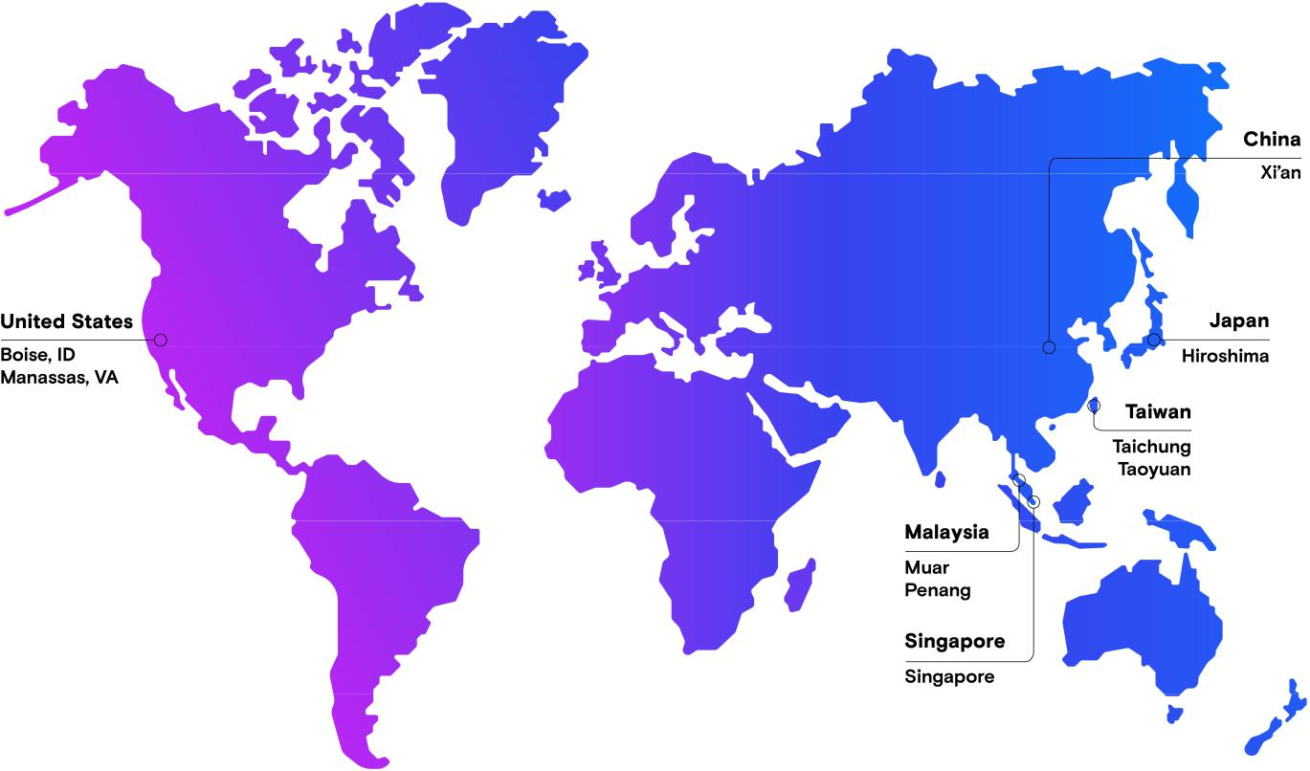

Location | Principal Operations
Taiwan | R&D, wafer fabrication, component assembly and test, module assembly and test
Singapore | R&D, wafer fabrication, component assembly and test, module assembly and test
Japan | R&D, wafer fabrication
United States | R&D, wafer fabrication, reticle manufacturing
Malaysia | Component assembly and test, module assembly and test
China | Component assembly and test, module assembly and test
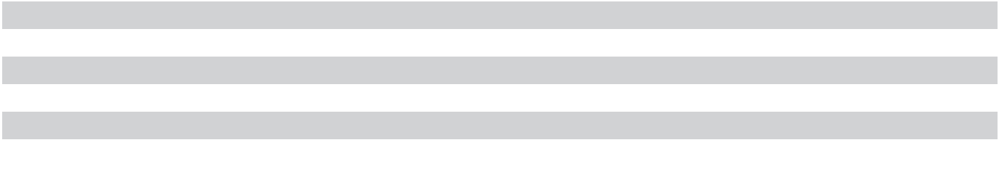

37

We believe that our existing facilities are suitable and adequate for our present purposes. We generally utilize all of our manufacturing capacity; however, a portion of our facilities were underutilized for 2023 due to industry conditions. See “Part II – Item 7. Management’s Discussion and Analysis of Financial Condition and Results of Operations – Overview – Industry Conditions” for information regarding our current underutilization.

To support expected memory demand in the second half of the decade, we will need to add new DRAM wafer capacity. Following the enactment of the CHIPS Act in 2022, we announced plans to invest in two leading-edge memory manufacturing fabs in the United States, contingent on CHIPS Act support through grants and investment tax credits. As part of this plan, in September 2022, we broke ground on a leading-edge memory manufacturing fab in Boise, Idaho. Construction of the fab began in October 2023 with DRAM production targeted to start in calendar 2025 and first output in early calendar 2026. In addition, in October 2022, we announced plans to build a second leading-edge DRAM manufacturing fab in Clay, New York. We expect construction to begin in calendar 2024, with production anticipated to ramp in the latter half of the decade. We expect these new fabs to fulfill our requirements for additional wafer capacity starting in the second half of the decade and beyond, in line with industry demand trends. On August 21, 2023 we announced that two of our subsidiaries had each submitted full applications on August 18, 2023 for federal funding in the form of grants under the CHIPS Act for both of these projects.

We are also advancing our global back-end assembly and test network in order to support our product portfolio and extend our ability to deliver on global customer demand in the future. We intend to make investments at our backend facility in Xi’an, China, including a new building to provide space to add more product capability, to allow us over time to serve more of the demand from our customers in China from the Xi’an facility. We also intend to build a new assembly and test facility in Gujarat, India to address demand in the latter half of this decade.

We do not identify or allocate assets by operating segment, other than goodwill. For a breakout of the carrying value of our long-lived assets by geographic area see “Part II – Item 8. Financial Statements and Supplementary Data – Notes to Consolidated Financial Statements – Geographic Information.”

ITEM 3. LEGAL PROCEEDINGS

For a discussion of legal proceedings, see “Part II – Item 8. Financial Statements and Supplementary Data – Notes to Consolidated Financial Statements – Contingencies” and “Item 1A. Risk Factors” of this Annual Report on Form 10-K.

SEC regulations require disclosure of certain proceedings related to environmental matters unless we reasonably believe that the related monetary sanctions, if any, will be less than a specified threshold. We use a threshold of $1 million for this purpose.

ITEM 4. MINE SAFETY DISCLOSURES

Not applicable.

PART II

ITEM 5. MARKET FOR REGISTRANT’S COMMON EQUITY, RELATED STOCKHOLDER MATTERS, AND ISSUER PURCHASES OF EQUITY SECURITIES

Market Information

Our common stock is listed on The Nasdaq Global Select Market under the trading symbol “MU.”

38 | 2023 10-K

Holders of Record

As of September 29, 2023, there were approximately 1,719 shareholders of record of our common stock. A substantially greater number of holders of our common stock are "street name" or beneficial holders, whose shares are held of record by banks, brokers, and other financial institutions.

Dividends

On September 27, 2023, our Board of Directors declared a quarterly dividend of $0.115 per share, payable in cash on October 25, 2023, to shareholders of record as of the close of business on October 10, 2023.

We currently expect quarterly dividends to continue in future periods and aim to grow our dividend payments over time. However, the declaration and payment of any future cash dividends are at the discretion and subject to the approval of our Board of Directors. Our Board of Directors' decisions regarding the amount and payment of dividends will depend on many factors, such as our financial condition, results of operations, capital requirements, business conditions, debt service obligations, contractual restrictions, industry practice, legal requirements, regulatory constraints, and other factors that our Board of Directors may deem relevant. We cannot guarantee that we will continue to pay a dividend in any future period.

Equity Compensation Plan Information

The information required by this item is incorporated by reference from the information to be included in our 2023 Proxy Statement under the section entitled “Equity Compensation Plan Information,” which will be filed with the SEC within 120 days after August 31, 2023.

Issuer Purchase of Equity Securities

Common Stock Repurchase Authorization

In 2018, we announced that our Board of Directors authorized the discretionary repurchase of up to $10 billion of our outstanding common stock through open-market purchases, block trades, privately-negotiated transactions, derivative transactions, and/or pursuant to Rule 10b5-1 trading plans. The repurchase authorization has no expiration date, does not obligate us to acquire any common stock, and is subject to market conditions and our ongoing determination of the best use of available cash. During the quarter ended August 31, 2023, we did not repurchase any common stock under the authorization and as of August 31, 2023, $3.11 billion of the authorization remained available for the repurchase of our common stock.

Shares of common stock withheld as payment of withholding taxes and exercise prices in connection with the vesting or exercise of equity awards are also treated as common stock repurchases. Those withheld shares of common stock are not required to be disclosed under Item 703 of Regulation S-K and accordingly are excluded from this Item 5.

39

Performance Graph

The following graph illustrates a five-year comparison of cumulative total returns for our common stock, the S&P 500 Composite Index, and the Philadelphia Semiconductor Index (SOX) from August 31, 2018, through August 31, 2023. We operate on a 52 or 53-week fiscal year which ends on the Thursday closest to August 31. Accordingly, the last day of our fiscal year varies. For consistent presentation and comparison to the industry indices shown herein, we have calculated our stock performance graph assuming an August 31 year end.

300
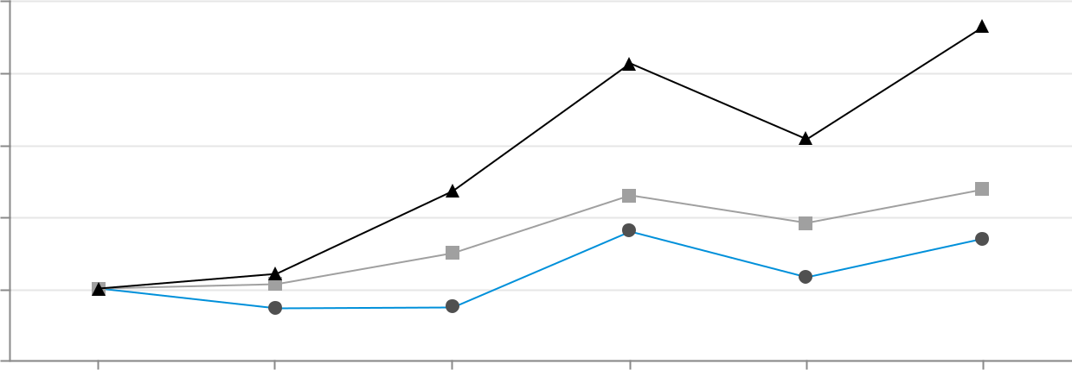

250

200

150

100

50

2018 | 2019 | 2020 | 2021 | 2022 | 2023
 | Micron Technology, Inc |  | S&P 500 Composite Index
 | Philadelphia Semiconductor Index (SOX)

Note: Management cautions that the stock price performance information shown in the graph above may not be indicative of current stock price levels or future stock price performance.

The performance graph above assumes $100 was invested on August 31, 2018 in common stock of Micron Technology, Inc., the S&P 500 Composite Index, and the Philadelphia Semiconductor Index (SOX). Any dividends paid during the period presented were assumed to be reinvested. The performance was plotted using the following data:

 |  | 2018 |  | 2019 |  | 2020 |  | 2021 |  | 2022 |  | 2023
Micron Technology, Inc. | $ | 100 | $ | 86 | $ | 87 | $ | 140 | $ | 108 | $ | 135
S&P 500 Composite Index |  | 100 |  | 103 |  | 125 |  | 165 |  | 146 |  | 169
Philadelphia Semiconductor Index (SOX) |  | 100 |  | 110 |  | 168 |  | 257 |  | 204 |  | 283

ITEM 6. [RESERVED]

40 | 2023 10-K

ITEM 7. MANAGEMENT’S DISCUSSION AND ANALYSIS OF FINANCIAL CONDITION AND RESULTS OF OPERATIONS

This discussion should be read in conjunction with the consolidated financial statements and accompanying notes for the year ended August 31, 2023. All period references are to our fiscal periods unless otherwise indicated. Our fiscal year is the 52 or 53-week period ending on the Thursday closest to August 31. Fiscal 2023, 2022, and 2021 each contained 52 weeks. All tabular dollar amounts are in millions, except per share amounts.

Overview

For an overview of our business, see “Part I – Item 1. Business – Overview.”

Industry Conditions

The memory and storage industry environment deteriorated sharply in the fourth quarter of 2022 and throughout 2023 due to weak demand in many end markets combined with global and macroeconomic challenges and lower demand resulting from customer actions to reduce inventory levels. This led to significant reductions in average selling prices for both DRAM and NAND and bit shipments for DRAM, resulting in declines in revenue across all our business segments and nearly all our end markets. Due to the challenging pricing environment, we recognized charges of $1.83 billion in 2023 to write down inventories to their estimated net realizable value. Ongoing demand growth, customer inventory normalization, and industry-wide supply discipline have set the stage for increased revenue, and improved pricing and profitability throughout fiscal 2024. As a result, pricing trends have started to improve and there were no write downs of inventories to net realizable value in the fourth quarter of 2023. However, further write-downs of inventories in future quarters could occur if pricing expectations deteriorate. Given the challenging pricing environment, elevated levels of inventories for suppliers and customers, and significant supply-demand mismatch, we expect industry profitability will remain challenged into 2024.

As a result of these conditions and increases in our inventory levels, we have reduced capital expenditures and also significantly reduced wafer starts in 2023 for both DRAM and NAND. We expect wafer starts will remain significantly below peak capacity levels for the foreseeable future as we remain focused on managing down our inventories and controlling our supply. We recognized period costs from fabrication facility underutilization of $382 million in 2023 due to wafer start reductions. We estimate that we will recognize approximately $200 million of period costs from underutilization due to wafer start reductions in the first quarter of 2024. We have also taken significant steps to reduce our costs and operating expenses. These actions include the 2023 Restructure Plan discussed below and additional reductions in external spending, including implementing productivity programs across the business, suspension of our 2023 bonus company-wide, reductions in select product programs, lower discretionary spending, and cuts to 2023 executive salaries across the company.

Impact of China Cyberspace Administration Decision

On March 31, 2023, China’s Cyberspace Administration (the “CAC”) notified us that it was conducting a cybersecurity review of our products sold in China. On May 21, 2023, we received notice that the CAC had concluded its review and decided that our products presented a cybersecurity risk. As such, the CAC determined that critical information infrastructure operators in China may not purchase Micron products. There is no list of the companies that have been designated as critical information infrastructure operators published by the Chinese government or otherwise available to us. Therefore, the full impact of the CAC decision on our business remains uncertain.

41

The CAC decision has impacted our business, particularly in the domestic data center and networking markets in China. In addition, although demand for DRAM and NAND is improving as customer inventory levels continue to normalize and secular growth drivers remain intact, the CAC decision continues to impact our revenue opportunity in China. This significant headwind is impacting our outlook and slowing our recovery. We are working to mitigate this impact over time and expect quarter-to-quarter revenue variability. Our revenue with companies headquartered in mainland China and Hong Kong, including direct sales as well as indirect sales through distributors, is approximately a quarter of our worldwide revenue and remains our principal exposure to the CAC decision. Although the impact of the CAC decision remains uncertain, we believe that approximately half of that China-headquartered customer revenue, which equates to a low-double-digit percentage of our worldwide revenue, is at risk of being impacted. Despite the near-term impact to our demand as a result of the CAC decision, our long-term goal is to retain our worldwide DRAM and NAND market share.

2023 Restructure Plan

We initiated a restructure plan in response to challenging industry conditions (the “2023 Restructure Plan”). Under

the plan, we expect our headcount reduction to approach 15% by the end of calendar 2023, through a combination

of voluntary attrition and personnel reductions. In connection with the plan, we incurred restructure charges of $171

million in 2023 primarily related to employee severance costs. The 2023 Restructure Plan was substantially

completed in 2023. As a result of the 2023 Restructure Plan, we expect to realize cost savings of approximately

$130 million per quarter (approximately 60% in cost of goods sold, 30% in R&D, and 10% in SG&A) subsequent to

2023. Further information on restructure activities can be found in “Item 8. Financial Statements and Supplementary

Data – Notes to Consolidated Financial Statements – Restructure and Asset Impairments.”

Lehi, Utah Fab and 3D XPoint

In 2021, we updated our portfolio strategy to further strengthen our focus on memory and storage innovations for the data center market. In connection therewith, we determined that there was insufficient market validation to justify the ongoing investments required to commercialize 3D XPoint at scale. Accordingly, we ceased development of 3D XPoint technology and engaged in discussions for the sale of our facility located in Lehi, Utah that was dedicated to 3D XPoint production. As a result, we classified the property, plant, and equipment as held for sale in 2021, ceased depreciating the assets, and recognized a $435 million restructure and asset impairment charge and a $104 million tax benefit.

We closed the sale of our Lehi facility to TI in 2022 for $893 million and disposed of $918 million of net assets, consisting primarily of property, plant, and equipment, resulting in a $23 million loss, net of selling expenses and other adjustments.

42 | 2023 10-K

Results of Operations

Consolidated Results

For the year ended |  | 2023 |  |  |  | 2022 |  |  |  | 2021
Revenue | $ | 15,540 |  | 100 % $ |  | 30,758 |  | 100 % $ |  | 27,705 |  | 100 %
Cost of goods sold |  | 16,956 |  | 109 % |  | 16,860 |  | 55 % |  | 17,282 |  | 62 %
Gross margin |  | (1,416) |  | (9)% |  | 13,898 |  | 45 % |  | 10,423 |  | 38 %
Research and development |  | 3,114 |  | 20 % |  | 3,116 |  | 10 % |  | 2,663 |  | 10 %
Selling, general, and administrative |  | 920 |  | 6 % |  | 1,066 |  | 3 % |  | 894 |  | 3 %
Restructure and asset impairments |  | 171 |  | 1 % |  | 48 |  | — % |  | 488 |  | 2 %
Other operating (income) expense, net |  | 124 |  | 1 % |  | (34) |  | — % |  | 95 |  | — %
Operating income (loss) |  | (5,745) |  | (37)% |  | 9,702 |  | 32 % |  | 6,283 |  | 23 %
Interest income (expense), net |  | 80 |  | 1 % |  | (93) |  | — % |  | (146) |  | (1)%
Other non-operating income (expense), net |  | 7 |  | — % |  | (38) |  | — % |  | 81 |  | — %
Income tax (provision) benefit |  | (177) |  | (1)% |  | (888) |  | (3)% |  | (394) |  | (1)%
Equity in net income (loss) of equity method investees |  | 2 |  | — % |  | 4 |  | — % |  | 37 |  | — %
Net income (loss) | $ | (5,833) |  | (38)% | $ | 8,687 |  | 28 % | $ | 5,861 |  | 21 %
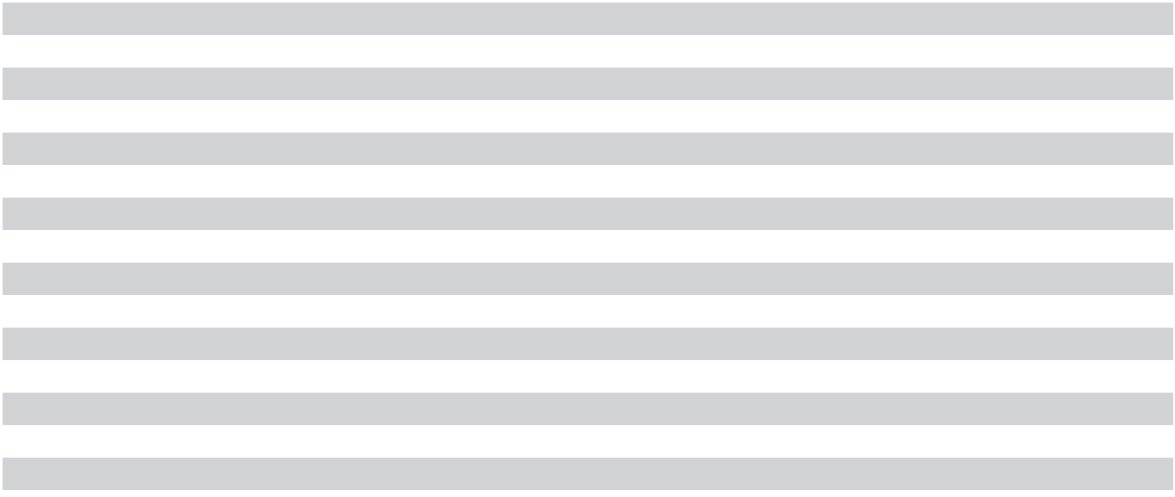

Total Revenue: Total revenue for 2023 was adversely impacted by the factors described in the section titled “Industry Conditions” above. Total revenue for 2023 decreased 49% as compared to 2022 primarily due to decreases in sales of both DRAM and NAND products.

- Sales of DRAM products decreased 51% primarily due to a high-40s percent range decline in average selling prices and decreases in bit shipments in the high-single-digit percent range.

- Sales of NAND products decreased 46% primarily due to a low-50s percent range decline in average selling prices partially offset by increases in bit shipments in the high-single-digit percent range.

Total revenue for 2022 increased 11% as compared to 2021 primarily due to increases in sales of both DRAM and NAND products.

- Sales of DRAM products increased 12% primarily due to increases in bit shipments of slightly over 10%.

- Sales of NAND products increased 11% primarily due to a high-single-digit percent increase in bit shipments and a low-single-digit percent increase in average selling prices.

Consolidated Gross Margin: Our consolidated gross margin has been adversely impacted by the factors described in the section titled “Industry Conditions” above. Our consolidated gross margin percentage decreased to negative 9% for 2023 from 45% for 2022 primarily due to declines in average selling prices for both DRAM and NAND and charges to write down inventories (as detailed in “Inventory NRV write-downs” below), and $382 million of facility underutilization costs in 2023.

Inventory NRV write-downs: Our consolidated gross margin was impacted by charges to write down inventories to their estimated net realizable value as a result of declines in average selling prices for both DRAM and NAND. As charges to write down inventories are recorded in advance of when inventories are sold, costs of goods sold in subsequent periods are lower than they otherwise would be. The impact of inventory NRV write-downs for each period reflects (1) inventory write-downs in that period, offset by (2) lower costs in that period on the sale of inventory written down in prior periods. The impacts of inventory NRV write-downs are summarized below:

43

For the year ended |  | 2023 |  | 2022 |  | 2021
Provision to write down inventory to NRV | $ | (1,831) | $ | — | $ | —
Lower costs from sale of inventory written down in prior periods |  | 844 |  | — |  | —
 | $ | (987) | $ | — | $ | —

Our consolidated gross margin percentage increased to 45% for 2022 from 38% for 2021, as a result of improvements in margins for both DRAM and NAND products, primarily due to reductions in manufacturing costs. Manufacturing cost reductions were driven by strong execution in ramping our 1α DRAM and 176-layer NAND technology nodes. For 2021, our gross margins included the impact of underutilization costs at MTU of $335 million. See “Item 8. Financial Statements and Supplementary Data – Notes to Consolidated Financial Statements – Lehi, Utah Fab and 3D XPoint.” Also, effective as of the beginning of the second quarter of 2021, we changed our method of inventory costing from average cost to first-in, first-out (“FIFO”). Concurrently, as of the beginning of the second quarter of 2021, we modified our inventory cost absorption processes used to estimate inventory values, which affects the timing of when costs are recognized. These changes resulted in a one-time increase to cost of goods sold of approximately $293 million in 2021.

Revenue by Business Unit

For the year ended |  | 2023 |  |  | 2022 |  |  | 2021
CNBU | $ | 5,710 |  | 37 % $ 13,693 |  |  | 45 % $ 12,280 |  |  | 44 %
MBU |  | 3,630 |  | 23 % | 7,260 |  | 24 % | 7,203 |  | 26 %
EBU |  | 3,637 |  | 23 % | 5,235 |  | 17 % | 4,209 |  | 15 %
SBU |  | 2,553 |  | 16 % | 4,553 |  | 15 % | 3,973 |  | 14 %
All Other |  | 10 |  | — % | 17 |  | — % | 40 |  | — %
 | $ | 15,540 |  |  | $ 30,758 |  |  | $ 27,705
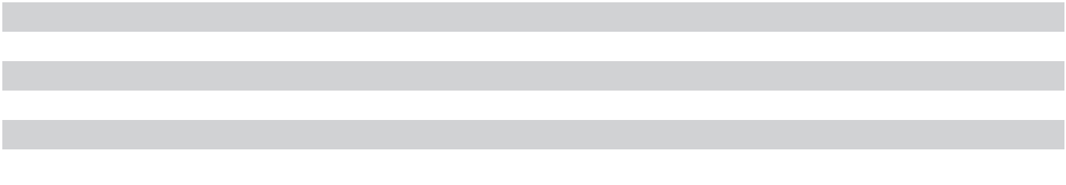
Percentages of total revenue may not total 100% due to rounding.

Changes in revenue for each business unit for 2023 as compared to 2022 were as follows:

- CNBU revenue decreased 58% primarily due to declines in average selling prices for DRAM and decreases in bit shipments.

- MBU revenue decreased 50% primarily due to declines in average selling prices for both DRAM and NAND and decreases in NAND bit shipments.
- EBU revenue decreased 31% primarily due to declines in average selling prices for both DRAM and NAND and decreases in bit shipments.
- SBU revenue decreased 44% primarily due to declines in average selling prices for NAND partially offset by increases in bit shipments.

Changes in revenue for each business unit for 2022 as compared to 2021 were as follows:

- CNBU revenue increased 12% primarily due to increases in bit shipments to cloud, enterprise, and networking markets.

- MBU revenue was relatively unchanged as both DRAM and NAND revenue was relatively flat.

- EBU revenue increased 24% primarily due to strong demand growth in industrial and automotive markets.

- SBU revenue increased 15% primarily due to higher average selling prices and increases in shipments of SSD products.

44 | 2023 10-K

Operating Income (Loss) by Business Unit

For the year ended |  | 2023 |  |  |  | 2022 |  |  |  | 2021
CNBU | $ | (585) |  | (10)% | $ | 5,844 |  | 43 % $ |  | 4,295 |  | 35 %
MBU |  | (1,750) |  | (48)% |  | 2,160 |  | 30 % |  | 2,173 |  | 30 %
EBU |  | 382 |  | 11 % |  | 1,752 |  | 33 % |  | 1,006 |  | 24 %
SBU |  | (1,887) |  | (74)% |  | 513 |  | 11 % |  | 173 |  | 4 %
All Other |  | 8 |  | 80 % |  | 12 |  | 71 % |  | 20 |  | 50 %
 | $ | (3,832) |  |  | $ | 10,281 |  |  | $ | 7,667
Percentages reflect operating income (loss) as a percentage of revenue for each business unit.

Changes in operating income or loss for each business unit for 2023 as compared to 2022 were as follows:

- CNBU operating income (loss) deteriorated primarily due to declines in average selling prices and lower bit shipments.

- MBU operating income (loss) deteriorated primarily due to declines in average selling prices and lower NAND bit shipments.
- EBU operating income decreased primarily due to declines in average selling prices and lower bit shipments.
- SBU operating income (loss) deteriorated primarily due to declines in average selling prices.

Changes in operating income or loss for each business unit for 2022 as compared to 2021 were as follows:

- CNBU operating income increased primarily due to higher bit shipments and manufacturing cost reductions.

- MBU operating income was relatively unchanged as slight increases in gross margins were offset by higher operating expenses.
- EBU operating income increased primarily due to manufacturing cost reductions from an increasing mix of leading-edge bits, higher bit shipments, and improved DRAM pricing in industrial and consumer markets, partially offset by higher R&D expenses.

- SBU operating income increased primarily due to improved product mix driving increases in average selling prices, increases in SSD shipments, and manufacturing cost reductions, partially offset by higher R&D expenses.

Operating Expenses and Other

Research and Development: R&D expenses vary primarily with the number of development and pre-qualification wafers processed, the cost of advanced equipment dedicated to new product and process development, and personnel costs. Because of the lead times necessary to manufacture our products, we typically begin to process wafers before completion of performance and reliability testing. Development of a product is deemed complete when it is qualified through internal reviews and tests for performance and reliability. R&D expenses can vary significantly depending on the timing of product qualification.

R&D expenses for 2023 were relatively unchanged as compared to 2022 as decreases in employee compensation were offset by higher depreciation expense. R&D expenses for 2022 increased 17% as compared to 2021 primarily due to higher employee compensation from increases in headcount, higher volumes of development and prequalification wafers, and higher depreciation expense.

Selling, General, and Administrative: SG&A expenses for 2023 were 14% lower as compared to 2022 primarily due to decreases in employee compensation, legal fees, advertising, and professional services. SG&A expenses for 2022 were 19% higher as compared to 2021 primarily due to increases in employee compensation, professional services, and legal fees.

Restructure and Asset Impairments: For a discussion of restructure and asset impairments, see the Overview sections above titled “2023 Restructure Plan” and “Lehi, Utah Fab and 3D XPoint.”

45

Interest Income (Expense), Net: Interest income (expense) improved for 2023 as compared to 2022 primarily as a result of increases in interest income due to higher interest rates on our cash and investments, partially offset by increases in interest expense due to higher debt balances and interest rates. Interest income (expense) improved for 2022 as compared to 2021 primarily due to an increase of $59 million in interest income as a result of increases in interest rates on our cash and investments.

Income Taxes: Our income tax (provision) benefit consisted of the following:

For the year ended |  | 2023 |  | 2022 |  | 2021
Income (loss) before taxes | $ | (5,658) | $ | 9,571 | $ | 6,218
Income tax (provision) benefit |  | (177) |  | (888) |  | (394)
Effective tax rate |  | (3.1)% |  | 9.3 % |  | 6.3 %

The change in our effective tax rate for 2023 as compared to 2022 was primarily due to a pre-tax loss in 2023. Despite a consolidated pre-tax loss on a worldwide basis, we have taxes payable in certain geographies due to minimum taxable income reportable in those geographies. Our effective tax rate increased in 2022 as compared to 2021 primarily due to the geographic mix of our earnings and a valuation allowance recorded against our Idaho deferred tax assets of $189 million, partially offset by tax impacts of changes in foreign currency exchange rates.

We operate in a number of jurisdictions outside the United States, including Singapore, where we have tax incentive arrangements. These incentives expire, in whole or in part, at various dates through 2034 and are conditional, in part, upon meeting certain business operations and employment thresholds. As a result of a loss before taxes and geographical mix of income, the benefit from tax incentive arrangements was not material for 2023. The effect of tax incentive arrangements reduced our tax provision by $1.12 billion (benefiting our diluted earnings per share by $1.00) for 2022 and by $758 million ($0.66 per diluted share) for 2021.

Beginning in 2024, the Inflation Reduction Act of 2022 imposes a 15% book minimum tax on corporations with three-year average annual adjusted financial statement income exceeding $1 billion. The impact of this tax will depend on our facts in each year, anticipated guidance from the U.S. Department of the Treasury, and other developing global tax legislation.

Various tax reforms are being considered in multiple jurisdictions that, if enacted, contain provisions that could materially impact our tax expense. We continue to monitor the potential impact of these various tax reform proposals to our overall global effective tax rate and financial statements.

Other: Further information can be found in the following notes contained in “Item 8. Financial Statements and

Supplementary Data – Notes to Consolidated Financial Statements”:

- Lehi, Utah Fab and 3D XPoint

- Goodwill

- Equity Plans

- Restructure and Asset Impairments

- Other Operating (Income) Expense, Net

- Other Non-Operating Income (Expense), Net

- Income Taxes

46 | 2023 10-K

Liquidity and Capital Resources

Our primary sources of liquidity are cash generated from operations and financing obtained from capital markets and financial institutions. Cash generated from operations is highly dependent on selling prices for our products, which can vary significantly from period to period. Cash and marketable investments totaled $10.44 billion as of August 31, 2023, and $10.98 billion as of September 1, 2022. Our cash and investments consist primarily of bank deposits, money market funds, and liquid investment-grade, fixed-income securities, which are diversified among industries and individual issuers. To mitigate credit risk, we invest through high-credit-quality financial institutions and by policy generally limit the concentration of credit exposure by restricting the amount of investments with any single obligor. As of August 31, 2023, $2.45 billion of our cash and marketable investments was held by our foreign subsidiaries.

We continuously evaluate alternatives for efficiently funding our capital expenditures and ongoing operations. We expect, from time to time, to engage in a variety of financing transactions for such purposes, including the issuance of securities. As of August 31, 2023, $2.50 billion was available to draw under our Revolving Credit Facility. On March 27, 2023, we entered into amendments to the Multi-Tranche Term Loan Agreement and the agreements governing the Revolving Credit Facility and the 2024 Term Loan A to revise the leverage ratio covenant in each such agreement, as further described in “Item 8. Financial Statements and Supplementary Data – Notes to Consolidated Financial Statements – Debt.” Funding of certain significant capital projects is also dependent on the receipt of government incentives, which are subject to conditions and may not be obtained.

To develop new product and process technology, support future growth, achieve operating efficiencies, and maintain product quality, we must continue to invest in manufacturing technologies, facilities and equipment, and R&D. We estimate capital expenditures in 2024 for property, plant, and equipment, net of partner contributions, to be slightly above $7 billion. Actual amounts for 2024 will vary depending on market conditions. As of August 31, 2023, we had purchase obligations of approximately $915 million for the acquisition of property, plant, and equipment, of which approximately $812 million is expected to be paid within one year. For a description of other contractual obligations, such as leases, debt, and commitments, see “Item 8. Financial Statements and Supplementary Data – Notes to Consolidated Financial Statements – Leases,” “ – Debt,” and “ – Commitments.”

To support expected memory demand in the second half of the decade, we will need to add new DRAM wafer capacity. Following the enactment of the CHIPS Act in 2022, we announced plans to invest in two leading-edge memory manufacturing fabs in the United States, contingent on CHIPS Act support through grants and investment tax credits. As part of this plan, in September 2022, we broke ground on a leading-edge memory manufacturing fab in Boise, Idaho. Construction of the fab began in October 2023 with DRAM production targeted to start in calendar 2025 and first output in early calendar 2026. In addition, in October 2022, we announced plans to build a second leading-edge DRAM manufacturing fab in Clay, New York. We expect construction to begin in calendar 2024, with production anticipated to ramp in the latter half of the decade. We expect these new fabs to fulfill our requirements for additional wafer capacity starting in the second half of the decade and beyond, in line with industry demand trends. On August 21, 2023 we announced that two of our subsidiaries had each submitted full applications on August 18, 2023 for federal funding in the form of grants under the CHIPS Act for both of these projects.

We are also advancing our global back-end assembly and test network in order to support our product portfolio and extend our ability to deliver on global customer demand in the future. We intend to make investments at our backend facility in Xi’an, China, including a new building to provide space to add more product capability, to allow us over time to serve more of the demand from our customers in China from the Xi’an facility. We also intend to build a new assembly and test facility in Gujarat, India to address demand in the latter half of this decade.

Our Board of Directors has authorized the discretionary repurchase of up to $10 billion of our outstanding common stock through open-market purchases, block trades, privately-negotiated transactions, derivative transactions, and/ or pursuant to Rule 10b5-1 trading plans. The repurchase authorization has no expiration date, does not obligate us to acquire any common stock, and is subject to market conditions and our ongoing determination of the best use of available cash. Through August 31, 2023, we had repurchased an aggregate of $6.89 billion of the authorized amount. See “Item 8. Financial Statements and Supplementary Data – Notes to Consolidated Financial Statements – Equity.”

47

On September 27, 2023, our Board of Directors declared a quarterly dividend of $0.115 per share, payable in cash on October 25, 2023, to shareholders of record as of the close of business on October 10, 2023. The declaration and payment of any future cash dividends are at the discretion and subject to the approval of our Board of Directors. Our Board of Directors' decisions regarding the amount and payment of dividends will depend on many factors, including, but not limited to, our financial condition, results of operations, capital requirements, business conditions, debt service obligations, contractual restrictions, industry practice, legal requirements, regulatory constraints, and other factors that our Board of Directors may deem relevant.

We expect that our cash and investments, cash flows from operations, and available financing will be sufficient to meet our requirements at least through the next 12 months and thereafter for the foreseeable future.

Cash Flows

For the year ended |  | 2023 |  | 2022 |  | 2021
Net cash provided by operating activities | $ | 1,559 | $ | 15,181 | $ | 12,468
Net cash provided by (used for) investing activities |  | (6,191) |  | (11,585) |  | (10,589)
Net cash provided by (used for) financing activities |  | 4,983 |  | (2,980) |  | (1,781)
Effect of changes in currency exchange rates on cash, cash equivalents, and |  | (34) |  | (106) |  | 41
restricted cash |  | (34) |  | (106) |  | 41
Net increase (decrease) in cash, cash equivalents, and restricted cash | $ | 317 | $ | 510 | $ | 139


Operating Activities: Cash provided by operating activities reflects net income (loss) adjusted for certain non-cash items, including depreciation expense, amortization of intangible assets, inventory write-downs, asset impairments, and stock-based compensation, and the effects of changes in operating assets and liabilities. The decrease in cash provided by operating activities for 2023 as compared to 2022 was primarily due to a net loss in the current year adjusted for non-cash items and the effect of an increase in inventories and a decline in accounts payable and accrued expenses, partially offset by a decrease in receivables.

The increase in cash provided by operating activities for 2022 as compared to 2021 was primarily due to higher net income adjusted for non-cash items and the effect of lower receivables, partially offset by an increase in inventories.

Investing Activities: For 2023, net cash used for investing activities consisted primarily of $7.68 billion of expenditures for property, plant, and equipment; contributions of $710 million received from partners to offset capital expenditures; and $868 million of net inflows from maturities, sales, and purchases of available-for-sale securities.

For 2022, net cash used for investing activities consisted primarily of $12.07 billion of expenditures for property, plant, and equipment; contributions of $115 million received from partners to offset capital expenditures; $888 million of net inflows from the sale of the Lehi, Utah fab; and $155 million of net outflows from purchases, sales, and maturities of available-for-sale securities.

For 2021, net cash used for investing activities consisted primarily of $10.03 billion of expenditures for property, plant, and equipment, partially offset by contributions of $502 million received from partners to offset capital expenditures, and $1.06 billion of net outflows from purchases, sales, and maturities of available-for-sale securities.

Financing Activities: For 2023, net cash provided by financing activities consisted primarily of $3.20 billion of proceeds from our 2025, 2026, and 2027 Term Loan A borrowings, $1.27 billion from the issuance of the 2029 B Notes, $896 million from the issuance of the 2033 B Notes, $749 million from the issuance of the 2033 A Notes, and $599 million from the issuance of the 2028 Notes. Cash used for financing activities included $761 million for repayments of debt, $504 million for payments of dividends to shareholders, $425 million for the acquisition of 8.6 million shares of our common stock under our share repurchase authorization, and $138 million of payments on equipment purchase contracts.

48 | 2023 10-K

For 2022, net cash used for financing activities included $2.43 billion for the acquisition of 35.4 million shares of our common stock under our share repurchase authorization, $2.03 billion of repayments of debt primarily to redeem the 2023 Notes and 2024 Notes, $461 million of cash payments of dividends to shareholders, and $141 million of payments on equipment purchase contracts. Cash used for financing activities was partially offset by aggregate proceeds of $2.00 billion from the issuance of the unsecured 2032 Green Bonds, 2041 Notes, and 2051 Notes.

For 2021, net cash used for financing activities consisted primarily of $1.20 billion for the acquisition of 15.6 million shares of our common stock under our share repurchase authorization, $295 million of payments on equipment purchase contracts, $185 million of cash payments to settle conversions of our 2032D Notes, and $147 million of repayments of finance leases and other debt. In addition, we received proceeds of $1.19 billion under an unsecured 2024 Term Loan A and used the proceeds to repay the $1.19 billion Extinguished 2024 Term Loan A.

See “Item 8. Financial Statements and Supplementary Data – Notes to Consolidated Financial Statements – Debt.”

Critical Accounting Estimates

The preparation of financial statements and related disclosures in conformity with U.S. GAAP requires management to make estimates and judgments that affect the reported amounts of assets, liabilities, revenues, expenses, and related disclosures. Estimates and judgments are based on historical experience, forecasted events, and various other assumptions that we believe to be reasonable under the circumstances. Estimates and judgments may vary under different assumptions or conditions and involve a significant level of uncertainty. We evaluate our estimates and judgments on an ongoing basis. Our management believes the accounting policies below are critical in the portrayal of our financial condition and results of operations and require management’s most difficult, subjective, or complex judgments.

Contingencies: We are subject to the possibility of losses from various contingencies. Significant judgment is necessary to estimate the probability and amount of a loss, if any, from such contingencies. An accrual is made when it is probable that a liability has been incurred or an asset has been impaired, and the amount of loss can be reasonably estimated. In accounting for the resolution of contingencies, significant judgment may be necessary to estimate amounts pertaining to periods prior to the resolution that are charged to operations in the period of resolution and amounts related to future periods.

Goodwill: We test goodwill for impairment in our fourth quarter each year, or more frequently if indicators of an impairment exist, to determine whether it is more likely than not that the fair value of the reporting unit with goodwill is less than its carrying value. For reporting units for which this assessment concludes that it is more likely than not that the fair value is more than its carrying value, goodwill is considered not impaired, and we are not required to perform the goodwill impairment test. Qualitative factors considered in this assessment include industry and market considerations, overall financial performance, and other relevant events and factors affecting the fair value of the reporting unit. For reporting units for which this assessment concludes that it is more likely than not that the fair value is below the carrying value, goodwill is tested for impairment by determining the fair value of each reporting unit and comparing it to the carrying value of the net assets assigned to the reporting unit. If the fair value of the reporting unit exceeds its carrying value, goodwill is considered not impaired. If the carrying value of the reporting unit exceeds its fair value, we recognize an impairment loss up to the difference between the carrying value and implied fair value. We recognized a charge of $101 million in 2023 to impair all of the goodwill assigned to our SBU reporting unit based on our quantitative assessment for impairment in the current year. The quantitative assessment indicated that the fair value for all of our other reporting units substantially exceeded their carrying value.

49

Determining when to test for impairment, the reporting units, the assets and liabilities of the reporting unit, and the fair value of the reporting unit requires significant judgment and involves the use of significant estimates and assumptions. These estimates and assumptions include revenue growth rates, forecasted manufacturing costs, and other expenses and are developed as part of our long-range planning process. The same estimates are used in business planning, forecasting, and capital budgeting as part of our long-term manufacturing capacity analysis. These estimates and assumptions are used to calculate projected future cash flows for the reporting unit, which are discounted using a risk-adjusted rate to estimate a fair value. The discount rate requires determination of appropriate market comparables. We base fair value estimates on assumptions we believe to be reasonable but that are unpredictable and inherently uncertain. Actual future results may differ from those estimates. We assess the reasonableness of our methodology, forecasts, and assumptions by comparing the aggregate calculated fair value for our reporting units to our market capitalization.

Income taxes: We are required to estimate our provision for income taxes and amounts ultimately payable or recoverable in numerous tax jurisdictions around the world. These estimates involve significant judgment and interpretations of regulations and are inherently complex. Resolution of income tax treatments in individual jurisdictions may not be known for many years after completion of the applicable year. We are also required to evaluate the realizability of our deferred tax assets on an ongoing basis in accordance with U.S. GAAP, which requires the assessment of our performance and other relevant factors. Realization of deferred tax assets is dependent on our ability to generate future taxable income. Our income tax provision or benefit is dependent, in part, on our ability to forecast future taxable income in Japan, Malaysia, the United States, Taiwan, and other jurisdictions. Such forecasts are inherently difficult and involve significant judgments including, among others, projecting future average selling prices and sales volumes, manufacturing and overhead costs, levels of capital spending, and other factors that significantly impact our analyses of the amount of net deferred tax assets that are more likely than not to be realized.

Inventories: Inventories are stated at the lower of cost or net realizable value, with cost being determined on a first-in, first-out (“FIFO”) basis. Cost includes depreciation, labor, material, and overhead costs, including product and process technology costs. Determining net realizable value of finished goods and work in process inventories involves significant judgments, including projecting future average selling prices, future sales volumes, and future cost per part. To project average selling prices and sales volumes, we review recent sales volumes, existing customer orders, current contract prices, industry analyses of supply and demand, and general economic trends. To project cost per part, we review trends with historical results and consider known changes in our cost structure as applicable. Actual selling prices may vary significantly from projected prices due to the volatile nature of the semiconductor memory and storage markets. When these analyses reflect estimated net realizable values below our manufacturing costs, we record a charge to cost of goods sold in advance of when inventories are actually sold. As a result, the timing of when product costs are charged to costs of goods sold can vary significantly. Differences in future average selling prices used in calculating lower of cost or net realizable value adjustments can result in significant changes in the estimated net realizable value of finished goods and work in process inventories and accordingly the amount of write-down recorded. For example, a 5% decrease in future average selling prices would have changed the estimated net realizable value of our finished goods and work in process inventories by approximately $600 million as of August 31, 2023.

U.S. GAAP provides for products to be grouped into categories in order to compare costs to net realizable

values. The amount of any inventory write-down can vary significantly depending on the determination of inventory categories. We review the major characteristics of product type and markets in determining the unit of account for which we perform the lower of cost or net realizable value analysis and categorize all inventories (including DRAM, NAND, and other memory) as a single group.

Property, plant, and equipment: We periodically assess the estimated useful lives of our property, plant, and equipment based on technology node transitions, capital spending, and equipment re-use rates. We also review the carrying value of property, plant, and equipment for impairment when events and circumstances indicate that the carrying value of an asset or group of assets may not be recoverable from the estimated future cash flows expected to result from its use and/or disposition. In cases where undiscounted expected future cash flows are less than the carrying value, an impairment loss is recognized equal to the amount by which the carrying value exceeds the estimated fair value of the assets. The estimate of future cash flows involves numerous assumptions which require significant judgment by us, including, but not limited to, future use of the assets for our operations versus sale or disposal of the assets, future selling prices for our products, and future production and sales volumes.

50 | 2023 10-K

Revenue recognition: Revenue is primarily recognized at a point in time when control of the promised goods is transferred to our customers in an amount that reflects the consideration we expect to be entitled to in exchange for those goods. Contracts with our customers are generally short-term in duration at fixed, negotiated prices with payment generally due shortly after delivery. We estimate a liability for returns using the expected value method based on historical returns. In addition, we generally offer price protection to our distributors, which is a form of variable consideration that decreases the transaction price. We use the expected value method, based on historical price adjustments and current pricing trends, to estimate the amount of revenue recognized from sales to distributors. Differences between the estimated and actual amounts are recognized as adjustments to revenue.

Recently Adopted Accounting Standards

No material items.

Recently Issued Accounting Standards

No material items.

ITEM 7A. QUANTITATIVE AND QUALITATIVE DISCLOSURES ABOUT MARKET RISK

Interest Rate Risk

We are exposed to interest rate risk related to our indebtedness and our investment portfolio. As of August 31, 2023 and September 1, 2022, we had fixed-rate debt with an aggregate carrying value of $7.52 billion and $4.03 billion, respectively, and as a result, the fair value of our debt fluctuates with changes in market interest rates. We estimate that, as of August 31, 2023 and September 1, 2022, a hypothetical 1% decrease in market interest rates would increase the fair value of our fixed-rate debt by approximately $475 million and $275 million, respectively.

Interest rate risk related to our investment portfolio is managed by primarily investing in shorter term securities. We estimate that, as of August 31, 2023 and September 1, 2022, a hypothetical 1% increase in interest rates would decrease the fair value of our portfolio by approximately $20 million and $30 million, respectively. Such impact would only be realized if investments were sold prior to maturity.

As of August 31, 2023 and September 1, 2022, we had floating-rate debt, including fixed-rate debt that is swapped to floating-rate debt, with an aggregate principal amount of $4.63 billion and $2.09 billion, respectively. A hypothetical 1% increase in the interest rates of this floating-rate debt would result in an increase in annual interest expense of $46 million and $21 million as of August 31, 2023 and September 1, 2022, respectively.

Foreign Currency Exchange Rate Risk

The information in this section should be read in conjunction with the information related to changes in the currency exchange rates in “Part I – Item 1A. Risk Factors.” Changes in foreign currency exchange rates could materially adversely affect our business, results of operations, or financial condition.

51

The functional currency for all of our operations is the U.S. dollar. The substantial majority of our sales are transacted in the U.S. dollar; however, significant amounts of our operating expenses and capital expenditures, and certain assets and liabilities, are incurred in or exposed to other currencies, primarily the Chinese yuan, euro, Indian rupee, Japanese yen, Malaysian ringgit, New Taiwan dollar, and Singapore dollar. We have established currency risk management programs for our monetary assets and liabilities denominated in foreign currencies to hedge against fluctuations in the fair value and volatility of future cash flows caused by changes in currency exchange rates. We generally utilize currency forward contracts in these hedging programs, which reduce, but do not always entirely eliminate, the impact of currency exchange rate movements. We do not use derivative financial instruments for trading or speculative purposes.

Based on monetary assets and liabilities denominated in foreign currencies, we estimate that a hypothetical 10% adverse change in exchange rates versus the U.S. dollar would result in losses of approximately $129 million as of August 31, 2023 and $186 million as of September 1, 2022. We hedge our exposure to changes in currency exchange rates by utilizing a rolling hedge strategy for our primary currency exposures with currency forward contracts that generally mature within three months. The effectiveness of our hedges is dependent, among other factors, upon our ability to accurately measure exposures on a timely basis. To hedge the exposure of changes in cash flows from changes in currency exchange rates for certain capital expenditures and manufacturing costs, we may utilize currency forward contracts that generally mature within two years. See “Item 8. Financial Statements and Supplementary Data – Notes to Consolidated Financial Statements – Derivative Instruments.”

52 | 2023 10-K

ITEM 8. FINANCIAL STATEMENTS AND SUPPLEMENTARY DATA

Index to Consolidated Financial Statements
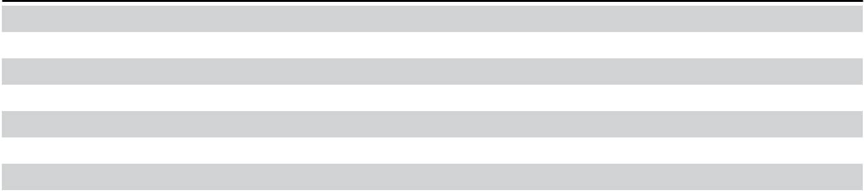

Consolidated Statements of Operations | 54
Consolidated Statements of Comprehensive Income (Loss) | 55
Consolidated Balance Sheets | 56
Consolidated Statements of Changes in Equity | 57
Consolidated Statements of Cash Flows | 58
Notes to Consolidated Financial Statements | 59
Report of Independent Registered Public Accounting Firm (PCAOB ID 238) | 88

53

Micron Technology, Inc.

Consolidated Statements of Operations

(In millions, except per share amounts)
For the year ended |  | August 31, | September 1, |  | September 2,
For the year ended |  | 2023 |  | 2022 |  | 2021
Revenue | $ | 15,540 | $ | 30,758 | $ | 27,705
Cost of goods sold |  | 16,956 |  | 16,860 |  | 17,282
Gross margin |  | (1,416) |  | 13,898 |  | 10,423
Research and development |  | 3,114 |  | 3,116 |  | 2,663
Selling, general, and administrative |  | 920 |  | 1,066 |  | 894
Restructure and asset impairments |  | 171 |  | 48 |  | 488
Other operating (income) expense, net |  | 124 |  | (34) |  | 95
Operating income (loss) |  | (5,745) |  | 9,702 |  | 6,283
Interest income |  | 468 |  | 96 |  | 37
Interest expense |  | (388) |  | (189) |  | (183)
Other non-operating income (expense), net |  | 7 |  | (38) |  | 81
 |  | (5,658) |  | 9,571 |  | 6,218
Income tax (provision) benefit |  | (177) |  | (888) |  | (394)
Equity in net income (loss) of equity method investees |  | 2 |  | 4 |  | 37
Net income (loss) | $ | (5,833) | $ | 8,687 | $ | 5,861
Earnings (loss) per share
Basic | $ | (5.34) | $ | 7.81 | $ | 5.23
Diluted |  | (5.34) |  | 7.75 |  | 5.14
Number of shares used in per share calculations
Basic |  | 1,093 |  | 1,112 |  | 1,120
Diluted |  | 1,093 |  | 1,122 |  | 1,141
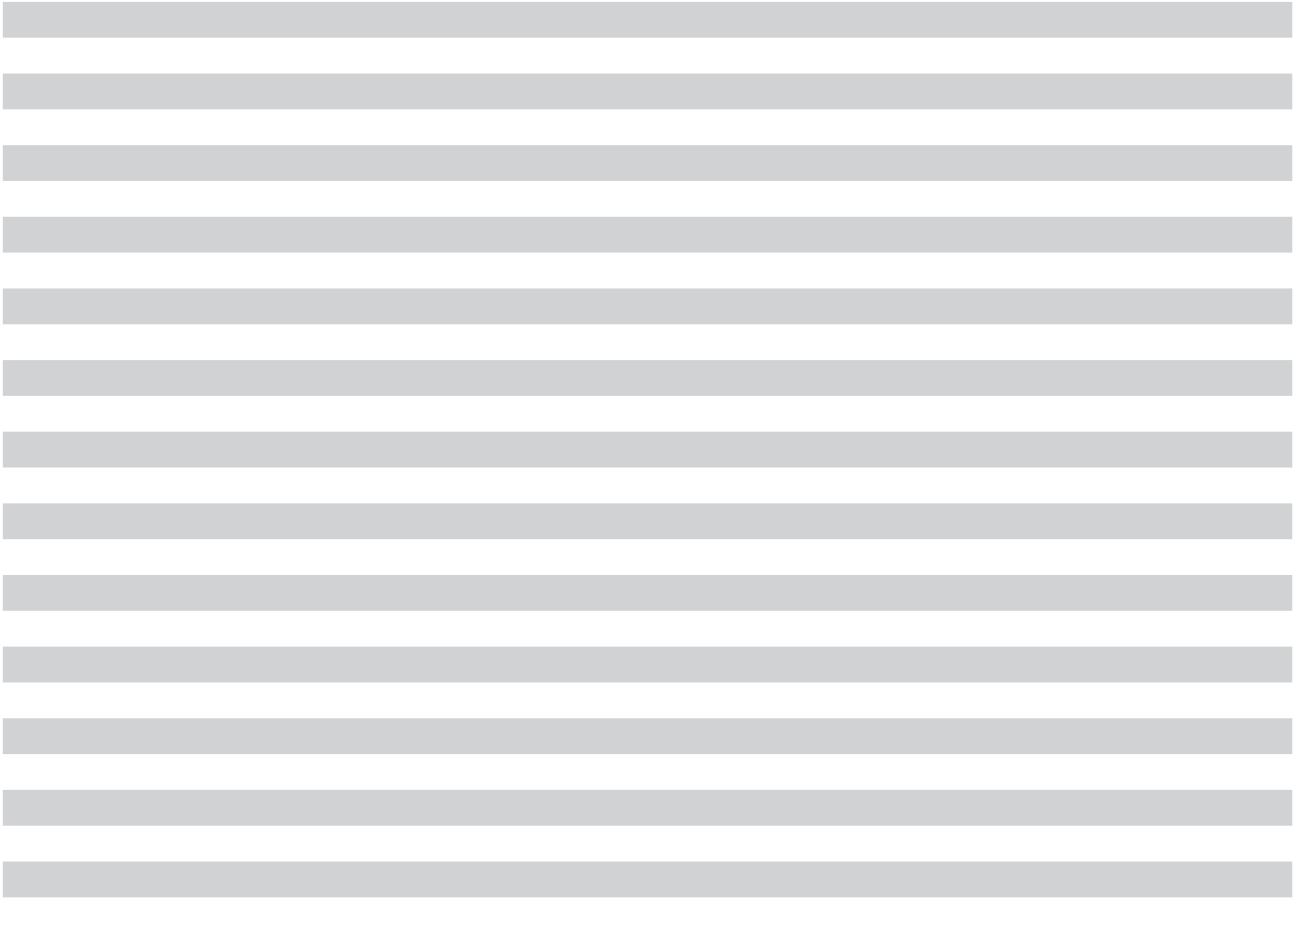

See accompanying notes to consolidated financial statements.

54 | 2023 10-K

Micron Technology, Inc.

Consolidated Statements of Comprehensive Income (Loss)

(In millions)
For the year ended |  | August 31, | September 1, |  | September 2,
For the year ended |  | 2023 |  | 2022 |  | 2021
Net income (loss) | $ | (5,833) | $ | 8,687 | $ | 5,861
Other comprehensive income (loss), net of tax
Gains (losses) on derivative instruments |  | 234 |  | (516) |  | (67)
Pension liability adjustments |  | 11 |  | 3 |  | 3
Unrealized gains (losses) on investments |  | 6 |  | (48) |  | (7)
Foreign currency translation adjustments |  | (3) |  | (1) |  | 2
Other comprehensive income (loss) |  | 248 |  | (562) |  | (69)
Total comprehensive income (loss) | $ | (5,585) | $ | 8,125 | $ | 5,792
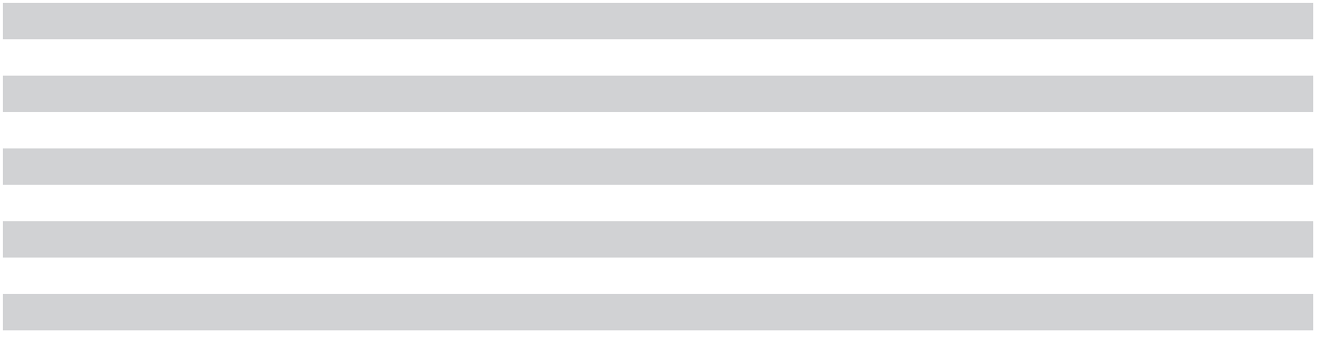

See accompanying notes to consolidated financial statements.

55

Micron Technology, Inc.

Consolidated Balance Sheets

(In millions, except par value amounts)
As of |  | August 31, | September 1,
As of |  | 2023 |  | 2022
Assets
Cash and equivalents | $ | 8,577 | $ | 8,262
Short-term investments |  | 1,017 |  | 1,069
Receivables |  | 2,443 |  | 5,130
Inventories |  | 8,387 |  | 6,663
Other current assets |  | 820 |  | 657
Total current assets |  | 21,244 |  | 21,781
Long-term marketable investments |  | 844 |  | 1,647
Property, plant, and equipment |  | 37,928 |  | 38,549
Operating lease right-of-use assets |  | 666 |  | 678
Intangible assets |  | 404 |  | 421
Deferred tax assets |  | 756 |  | 702
Goodwill |  | 1,150 |  | 1,228
Other noncurrent assets |  | 1,262 |  | 1,277
Total assets | $ | 64,254 | $ | 66,283
Liabilities and equity
Accounts payable and accrued expenses | $ | 3,958 | $ | 6,090
Current debt |  | 278 |  | 103
Other current liabilities |  | 529 |  | 1,346
Total current liabilities |  | 4,765 |  | 7,539
Long-term debt |  | 13,052 |  | 6,803
Noncurrent operating lease liabilities |  | 603 |  | 610
Noncurrent unearned government incentives |  | 727 |  | 589
Other noncurrent liabilities |  | 987 |  | 835
Total liabilities |  | 20,134 |  | 16,376
Commitments and contingencies
Shareholders’ equity
Common stock, $0.10 par value, 3,000 shares authorized, 1,239 shares issued and 1,098 |  | 124 |  | 123
outstanding (1,226 shares issued and 1,094 outstanding as of September 1, 2022) |  | 124 |  | 123
Additional capital |  | 11,036 |  | 10,197
Retained earnings |  | 40,824 |  | 47,274
Treasury stock, 141 shares held (132 shares as of September 1, 2022) |  | (7,552) |  | (7,127)
Accumulated other comprehensive income (loss) |  | (312) |  | (560)
Total equity |  | 44,120 |  | 49,907
Total liabilities and equity | $ | 64,254 | $ | 66,283


See accompanying notes to consolidated financial statements.

56 | 2023 10-K

Micron Technology, Inc.

Consolidated Statements of Changes in Equity

(In millions, except per share amounts)
 | Common Stock |  |  |  |  |  |  |  |  |  | Accumulated
 | Number |  |  | Additional |  | Retained |  | Treasury |  |  | Other |  | Total
 | Number |  | Amount |  |  |  |  |  |  | Comprehensive |  | Shareholders’
 | of Shares |  | Amount |  | Capital | Earnings |  |  | Stock |  | Income (Loss) |  | Equity
Balance at September 3, 2020 | 1,194 | $ | 119 | $ | 8,917 | $ | 33,384 | $ | (3,495) | $ | 71 | $ | 38,996
Net income (loss) | — |  | — |  | — |  | 5,861 |  | — |  | — |  | 5,861
Other comprehensive income (loss), net | — |  | — |  | — |  | — |  | — |  | (69) |  | (69)
Stock issued under stock plans | 13 |  | 2 |  | 223 |  | — |  | — |  | — |  | 225
Stock-based compensation expense | — |  | — |  | 378 |  | — |  | — |  | — |  | 378
Repurchase of stock - repurchase program | — |  | — |  | — |  | — |  | (1,200) |  | — |  | (1,200)
Repurchase of stock - withholdings on | (2) |  | — |  | (12) |  | (82) |  | — |  | — |  | (94)
employee equity awards | (2) |  | — |  | (12) |  | (82) |  | — |  | — |  | (94)
Stock issued for convertible notes | 11 |  | 1 |  | (1) |  | — |  | — |  | — |  | —
Cash settlement of convertible notes | — |  | — |  | (52) |  | — |  | — |  | — |  | (52)
Dividends and dividend equivalents declared | — |  | — |  | — |  | (112) |  | — |  | — |  | (112)
($0.10 per share) | — |  | — |  | — |  | (112) |  | — |  | — |  | (112)
Balance at September 2, 2021 | 1,216 | $ | 122 | $ | 9,453 | $ | 39,051 | $ | (4,695) | $ | 2 | $ | 43,933
Net income (loss) | — |  | — |  | — |  | 8,687 |  | — |  | — |  | 8,687
Other comprehensive income (loss), net | — |  | — |  | — |  | — |  | — |  | (562) |  | (562)
Stock issued under stock plans | 12 |  | 1 |  | 244 |  | — |  | — |  | — |  | 245
Stock-based compensation expense | — |  | — |  | 514 |  | — |  | — |  | — |  | 514
Repurchase of stock - repurchase program | — |  | — |  | — |  | — |  | (2,432) |  | — |  | (2,432)
Repurchase of stock - withholdings on | (2) |  | — |  | (14) |  | (112) |  | — |  | — |  | (126)
employee equity awards | (2) |  | — |  | (14) |  | (112) |  | — |  | — |  | (126)
Dividends and dividend equivalents declared | — |  | — |  | — |  | (352) |  | — |  | — |  | (352)
($0.315 per share) | — |  | — |  | — |  | (352) |  | — |  | — |  | (352)
Balance at September 1, 2022 | 1,226 | $ | 123 | $ | 10,197 | $ | 47,274 | $ | (7,127) | $ | (560) | $ | 49,907
Net income (loss) | — |  | — |  | — |  | (5,833) |  | — |  | — |  | (5,833)
Other comprehensive income (loss), net | — |  | — |  | — |  | — |  | — |  | 248 |  | 248
Stock issued under stock plans | 15 |  | 1 |  | 262 |  | — |  | — |  | — |  | 263
Stock-based compensation expense | — |  | — |  | 596 |  | — |  | — |  | — |  | 596
Repurchase of stock - repurchase program | — |  | — |  | — |  | — |  | (425) |  | — |  | (425)
Repurchase of stock - withholdings on | (2) |  | — |  | (19) |  | (108) |  | — |  | — |  | (127)
employee equity awards | (2) |  | — |  | (19) |  | (108) |  | — |  | — |  | (127)
Dividends and dividend equivalents declared | — |  | — |  | — |  | (509) |  | — |  | — |  | (509)
($0.460 per share) | — |  | — |  | — |  | (509) |  | — |  | — |  | (509)
Balance at August 31, 2023 | 1,239 | $ | 124 | $ | 11,036 | $ | 40,824 | $ | (7,552) | $ | (312) | $ | 44,120


See accompanying notes to consolidated financial statements.

57

Micron Technology, Inc.

Consolidated Statements of Cash Flows

(In millions)
For the year ended |  | August 31, | September 1, |  | September 2,
For the year ended |  | 2023 |  | 2022 |  | 2021
Cash flows from operating activities | $ | (5,833) | $ | 8,687 | $ | 5,861
Net income (loss)
Adjustments to reconcile net income (loss) to net cash provided by operating activities: |  | 7,756 |  | 7,116 |  | 6,214
Depreciation expense and amortization of intangible assets |  | 7,756 |  | 7,116 |  | 6,214
Provision to write down inventories to net realizable value |  | 1,831 |  | — |  | —
Stock-based compensation |  | 596 |  | 514 |  | 378
Goodwill impairment |  | 101 |  | — |  | —
Restructure and asset impairments |  | 11 |  | 44 |  | 454
Loss on debt repurchases and conversions |  | — |  | 83 |  | 1
Change in operating assets and liabilities: |  | 2,763 |  | 190 |  | (1,446)
Receivables |  | 2,763 |  | 190 |  | (1,446)
Inventories |  | (3,555) |  | (2,179) |  | 866
Accounts payable and accrued expenses |  | (2,104) |  | 744 |  | 210
Other |  | (7) |  | (18) |  | (70)
Net cash provided by operating activities |  | 1,559 |  | 15,181 |  | 12,468
Cash flows from investing activities |  | (7,676) |  | (12,067) |  | (10,030)
Expenditures for property, plant, and equipment |  | (7,676) |  | (12,067) |  | (10,030)
Purchases of available-for-sale securities |  | (723) |  | (1,770) |  | (3,163)
Proceeds from maturities of available-for-sale securities |  | 1,566 |  | 1,321 |  | 1,250
Proceeds from government incentives |  | 710 |  | 115 |  | 495
Proceeds from sales of available-for-sale securities |  | 25 |  | 294 |  | 856
Proceeds from sale of Lehi, Utah fab |  | — |  | 888 |  | —
Other |  | (93) |  | (366) |  | 3
Net cash provided by (used for) investing activities |  | (6,191) |  | (11,585) |  | (10,589)
Cash flows from financing activities |  | 6,716 |  | 2,000 |  | 1,188
Proceeds from issuance of debt |  | 6,716 |  | 2,000 |  | 1,188
Repayments of debt |  | (761) |  | (2,032) |  | (1,520)
Payments of dividends to shareholders |  | (504) |  | (461) |  | —
Repurchases of common stock - repurchase program |  | (425) |  | (2,432) |  | (1,200)
Payments on equipment purchase contracts |  | (138) |  | (141) |  | (295)
Other |  | 95 |  | 86 |  | 46
Net cash provided by (used for) financing activities |  | 4,983 |  | (2,980) |  | (1,781)


Effect of changes in currency exchange rates on cash, cash equivalents, and restricted cash

Net increase (decrease) in cash, cash equivalents, and restricted cash
Cash, cash equivalents, and restricted cash at beginning of period | $
Cash, cash equivalents, and restricted cash at end of period | $

(34) |  | (106) |  | 41
317 |  | 510 |  | 139
8,339 |  | 7,829 |  | 7,690
8,656 | $ | 8,339 | $ | 7,829

Supplemental disclosures | $ | (532) | $ | (493) | $ | (361)
Income taxes paid, net
Interest paid, net of amounts capitalized |  | (323) |  | (154) |  | (171)
Noncash equipment acquisitions on contracts payable |  | 165 |  | 157 |  | 289

See accompanying notes to consolidated financial statements.

58 | 2023 10-K

Micron Technology, Inc.

NOTES TO CONSOLIDATED FINANCIAL STATEMENTS

(All tabular amounts in millions, except per share amounts)

Significant Accounting Policies

Basis of Presentation

We are an industry leader in innovative memory and storage solutions transforming how the world uses information to enrich life for all. With a relentless focus on our customers, technology leadership, and manufacturing and operational excellence, Micron delivers a rich portfolio of high-performance DRAM, NAND, and NOR memory and storage products through our Micron® and Crucial® brands. Every day, the innovations that our people create fuel the data economy, enabling advances in artificial intelligence and 5G applications that unleash opportunities — from the data center to the intelligent edge and across the client and mobile user experience.

The accompanying consolidated financial statements include the accounts of Micron Technology, Inc. and our consolidated subsidiaries and have been prepared in accordance with accounting principles generally accepted in the United States of America. Intercompany balances and transactions have been eliminated in consolidation. Certain reclassifications have been made to prior period amounts to conform to current period presentation. See “Inventories” below for changes to our significant accounting policies, and the “Inventories” note for additional information.

Our fiscal year is the 52 or 53-week period ending on the Thursday closest to August 31. Fiscal 2023, 2022, and 2021 each contained 52 weeks. All period references are to our fiscal periods unless otherwise indicated.

Derivative and Hedging Instruments

We use derivative instruments to manage our exposure to changes in currency exchange rates from (1) our monetary assets and liabilities denominated in currencies other than the U.S. dollar and (2) forecasted cash flows for certain capital expenditures and manufacturing costs. We also use derivative instruments to manage our exposure to changes in commodity prices for manufacturing supplies and to minimize certain exposures to changes in the fair value of fixed-rate debt that result from fluctuations in benchmark interest rates. Derivative instruments are measured at their fair values and recognized as either assets or liabilities.

The accounting for changes in the fair value of derivative instruments is based on the intended use of the derivative and the resulting designation. For derivative instruments that are not designated for hedge accounting, gains or losses from changes in fair values are recognized in other non-operating income (expense) and cash flows are classified as investing activities in the statement of cash flows. For derivative instruments designated as cash flow hedges, gains or losses are included as a component of accumulated other comprehensive income and reclassified into earnings in the same line items and in the same periods in which the underlying transactions affect earnings. For derivative instruments designated as cash flow hedges, time value is excluded from the assessment of effectiveness and the gains and losses attributable to time value are recognized in earnings through an amortization approach. For derivative instruments designated as fair value hedges, changes in the fair values of the derivative instruments and the offsetting changes in the fair values of the underlying hedged items are both recognized in earnings. Cash flows from derivative instruments designated as cash flow hedges or fair value hedges are classified in the same category as the items being hedged.

We enter into master netting arrangements with our counterparties to mitigate credit risk in derivative hedge transactions. These master netting arrangements allow us and our counterparties to net settle amounts owed to each other. Derivative assets and liabilities that can be net settled with each counterparty have been presented in our consolidated balance sheet on a net basis.

59

Financial Instruments

Cash equivalents include highly liquid short-term investments with original maturities to us of three months or less that are readily convertible to known amounts of cash. Other investments with remaining maturities of less than one year are included in short-term investments. Investments with remaining maturities greater than one year are included in long-term marketable investments. The carrying value of investment securities sold is determined using the specific identification method.

Functional Currency

The U.S. dollar is the functional currency for us and all of our consolidated subsidiaries.

Goodwill

We perform an annual impairment assessment for goodwill in our fourth quarter each year.

Government Incentives

We receive incentives from governmental entities related to capital expenditures, expenses, and other activities. Our government incentives may require that we meet or maintain specified spending levels and other operational metrics and may be subject to reimbursement if such conditions are not met or maintained. Government incentives are recorded in the financial statements in accordance with their purpose: as a reduction of asset costs or a reduction of expenses. Incentives related to the acquisition or construction of fixed assets are recognized as a reduction in the carrying amounts of the related assets and reduce depreciation expense over the useful lives of the assets. Incentives related to specific operating activities are offset against the related expense in the period the expense is incurred. Government incentives received prior to being earned are recognized in current or noncurrent deferred income or restricted cash, whereas government incentives earned prior to being received are recognized in current or noncurrent receivables. Cash received from government incentives related to operating expenses is included as an operating activity in the statement of cash flows, whereas cash received from incentives related to the acquisition of property, plant, and equipment is included as an investing activity.

Inventories

Effective as of the beginning of the second quarter of 2021, we changed the method of inventory costing from average cost to FIFO. The difference between average cost and FIFO was not material to any previously reported financial statements. Therefore, we have recognized the cumulative effect of the change as a reduction of inventories and a charge to cost of goods sold of $133 million as of the beginning of the second quarter of 2021.

Inventories are stated at the lower of cost or net realizable value, with cost being determined on a FIFO basis. Cost includes depreciation, labor, material, and overhead costs, including product and process technology costs. Determining net realizable value of finished goods and work in process inventories requires projecting future average selling prices, sales volumes, and costs per part. When net realizable value is below cost, we record a charge to cost of goods sold to write down inventories to their estimated net realizable value in advance of when inventories are actually sold. We review the major characteristics of product type and markets in determining the unit of account for which we perform the lower of cost or net realizable value analysis and categorize all inventories (including DRAM, NAND, and other memory) as a single group.

Leases

We determine if an arrangement is a lease, or contains a lease, at the inception of the arrangement and evaluate whether the lease is an operating lease or a finance lease at the commencement date. We recognize right-of-use assets and lease liabilities for operating and finance leases with terms greater than 12 months. Right-of-use assets represent our right to use an asset for the lease term, while lease liabilities represent our obligation to make lease payments. We do not separate lease and non-lease components for real-estate and gas plant leases. Sublease income is included within lease expense.

60 | 2023 10-K

Product and Process Technology

Costs incurred to (1) acquire product and process technology, (2) patent technology, and (3) maintain patent technology, are capitalized and amortized on a straight-line basis over periods ranging up to 12.5 years. We capitalize a portion of costs incurred to patent technology based on historical data of patents issued as a percent of patents we file. Product and process technology costs are amortized over the shorter of (1) the estimated useful life of the technology, (2) the patent term, or (3) the term of the technology agreement. Fully-amortized assets are removed from product and process technology and accumulated amortization.

Product Warranty

We generally provide a limited warranty that our products are in compliance with applicable specifications existing at the time of delivery. Under our standard terms and conditions of sale, liability for certain failures of product during a stated warranty period is usually limited to repair or replacement of defective items or return of, or a credit with respect to, amounts paid for such items. Under certain circumstances, we provide more extensive limited warranty coverage than that provided under our standard terms and conditions. Our warranty obligations are not material.

Property, Plant, and Equipment

Property, plant, and equipment is stated at cost and depreciated using the straight-line method over estimated useful lives of generally 10 to 30 years for buildings, 7 years for production equipment, up to 7 years for other equipment, and 3 to 5 years for software. Assets held for sale are carried at the lower of estimated fair value or carrying value and are included in current assets. When property, plant, or equipment is retired or otherwise disposed, the net book value is removed and we recognize any gain or loss in results of operations.

We capitalize interest on borrowings during the period of time we carry out the activities necessary to bring assets to the condition of their intended use and location. Capitalized interest becomes part of the cost of assets.

Research and Development

Costs related to the conceptual formulation and design of products and processes are charged to R&D expense as incurred. Development of a product is deemed complete when it is qualified through reviews and tests for performance and reliability. Subsequent to product qualification, product costs are included in cost of goods sold. Amounts from cost-sharing arrangements are reflected as a reduction of R&D expense.

Revenue Recognition

Revenue is primarily recognized at a point in time when control of the promised goods is transferred to our customers in an amount that reflects the consideration we expect to be entitled to in exchange for those goods. Contracts with our customers are generally short-term in duration at fixed, negotiated prices with payment generally due shortly after delivery. We estimate a liability for returns using the expected value method based on historical returns. In addition, we generally offer price protection to our distributors, which is a form of variable consideration that decreases the transaction price. We use the expected value method, based on historical price adjustments and current pricing trends, to estimate the amount of revenue recognized from sales to distributors. Differences between the estimated and actual amounts are recognized as adjustments to revenue.

Stock-based Compensation

Stock-based compensation is measured at the grant date, based on the fair value of the award, and recognized as expense under the straight-line attribution method over the requisite service period. We account for forfeitures as they occur. We issue new shares upon the exercise of stock options, conversion of share units, or issuance of shares under our ESPP.

Treasury Stock

Treasury stock is carried at cost. When we retire our treasury stock, any excess of the repurchase price paid over par value is allocated between additional capital and retained earnings.

61

Use of Estimates

The preparation of financial statements and related disclosures in conformity with accounting principles generally accepted in the United States of America requires our management to make estimates and judgments that affect the reported amounts of assets, liabilities, revenues, expenses, and related disclosures. Estimates and judgments are based on historical experience, forecasted events, and various other assumptions that we believe to be reasonable under the circumstances. Estimates and judgments may differ under different assumptions or conditions. We evaluate our estimates and judgments on an ongoing basis. Actual results could differ from estimates.

Lehi, Utah Fab and 3D XPoint

In 2021, we updated our portfolio strategy to further strengthen our focus on memory and storage innovations for the data center market. In connection therewith, we determined that there was insufficient market validation to justify the ongoing investments required to commercialize 3D XPoint at scale. Accordingly, we ceased development of 3D XPoint technology and engaged in discussions for the sale of our facility located in Lehi, Utah that was dedicated to 3D XPoint production. As a result, we classified the property, plant, and equipment as held for sale in 2021, ceased depreciating the assets, and recognized a $435 million restructure and asset impairment charge and a $104 million tax benefit.

We closed the sale of our Lehi facility to TI in 2022 for $893 million and disposed of $918 million of net assets, consisting primarily of property, plant, and equipment, resulting in a $23 million loss, net of selling expenses and other adjustments.

Variable Interest Entities

A number of special purpose entities (the "Lease SPEs") were created by a third-party to facilitate equipment lease financing transactions between us and financial institutions that fund the lease financing transactions ("Financing Entities"). Neither we nor the Financing Entities have an equity interest in the Lease SPEs. The Lease SPEs are variable interest entities because their equity is not sufficient to permit them to finance their activities without additional support from the Financing Entities and because the third-party equity holder lacks characteristics of a controlling financial interest. By design, the arrangements with the Lease SPEs are merely financing vehicles and we do not bear any significant risks from variable interests with the Lease SPEs. We have determined that we do not have the power to direct the activities of the Lease SPEs that most significantly impact their economic performance and we do not consolidate the Lease SPEs.

62 | 2023 10-K

Cash and Investments

All of our short-term investments and long-term marketable investments were classified as available-for-sale as of the dates noted below. Cash and equivalents and the fair values of our available-for-sale investments, which approximated amortized costs, were as follows:

 |  |  |  | As of August 31, 2023 |  |  |  |  |  |  |  | As of September 1, 2022
 |  | Cash and | Short-term |  |  | Long-term |  | Total |  |  | Cash and | Short-term |  |  | Long-term |  | Total
 |  | Cash and |  |  |  | Marketable |  | Fair |  |  | Cash and |  |  |  | Marketable |  | Fair
 | Equivalents Investments |  |  |  | Investments⁽¹⁾ |  |  | Value |  | Equivalents |  | Investments |  | Investments⁽¹⁾ |  |  | Value
Cash | $ | 5,771 | $ | — | $ | — | $ | 5,771 | $ |  | 6,055 | $ | — | $ | — | $ | 6,055
Level 1⁽²⁾
Money market funds |  | 1,629 |  | — |  | — |  | 1,629 |  |  | 1,196 |  | — |  | — |  | 1,196
Level 2⁽³⁾
Certificates of deposit |  | 1,172 |  | 25 |  | — |  | 1,197 |  |  | 976 |  | 50 |  | — |  | 1,026
Corporate bonds |  | — |  | 737 |  | 437 |  | 1,174 |  |  | — |  | 759 |  | 995 |  | 1,754
Asset-backed securities |  | — |  | 15 |  | 387 |  | 402 |  |  | — |  | 20 |  | 608 |  | 628
Government securities |  | 5 |  | 131 |  | 20 |  | 156 |  |  | 2 |  | 155 |  | 44 |  | 201
Commercial paper |  | — |  | 109 |  | — |  | 109 |  |  | 33 |  | 85 |  | — |  | 118
 |  | 8,577 | $ | 1,017 | $ | 844 | $ | 10,438 |  |  | 8,262 | $ | 1,069 | $ | 1,647 | $ | 10,978
Restricted cash⁽⁴⁾ |  | 79 |  |  |  |  |  |  |  |  | 77
Cash, cash equivalents, | $ | 8,656 |  |  |  |  |  |  | $ |  | 8,339
and restricted cash | $ | 8,656 |  |  |  |  |  |  |  |  | 8,339
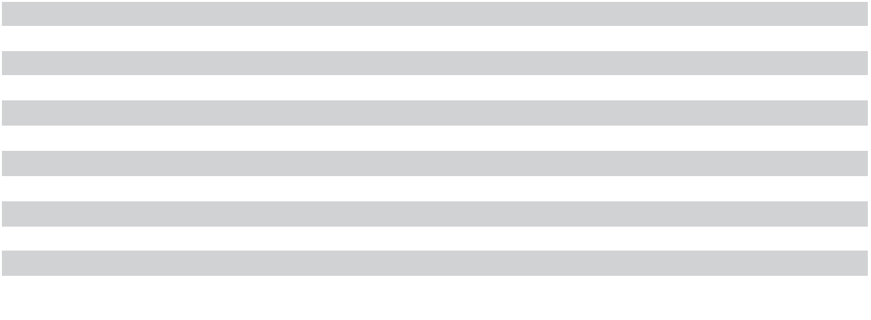
- The maturities of long-term marketable investments primarily range from one to five years, except for asset-backed securities which are not due at a single maturity date.

- The fair value of Level 1 securities is measured based on quoted prices in active markets for identical assets.
- The fair value of Level 2 securities is measured using information obtained from pricing services, which obtain quoted market prices for similar instruments, non-binding market consensus prices that are corroborated by observable market data, or various other methodologies, to determine the appropriate value at the measurement date. We perform supplemental analysis to validate information obtained from these pricing services. No adjustments were made to the fair values indicated by such pricing information as of August 31, 2023 or September 1, 2022.

- Restricted cash is included in other current assets and other noncurrent assets and primarily relates to certain government incentives received prior to being earned and for which restrictions lapse upon achieving certain performance conditions or which will be returned if performance conditions are not met.

Gross realized gains and losses from sales of available-for-sale securities were not significant for any period presented.

Non-marketable Equity Investments

In addition to the amounts included in the table above, we had $218 million and $222 million of non-marketable equity investments without a readily determinable fair value that were included in other noncurrent assets as of August 31, 2023 and September 1, 2022, respectively. For non-marketable investments, we recognized in other non-operating income (expense) a net loss of $7 million for 2023 and net gains of $36 million for 2022 and

$70 million for 2021. Our non-marketable equity investments are recorded at fair value on a non-recurring basis and classified as Level 3.

63

Receivables

As of |  | August 31, | September 1,
As of |  | 2023 |  | 2022
Trade receivables | $ | 2,048 | $ | 4,765
Income and other taxes |  | 194 |  | 251
Other |  | 201 |  | 114
 | $ | 2,443 | $ | 5,130
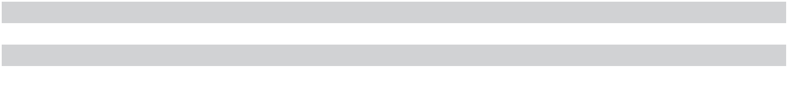

Inventories

As of |  | August 31, | September 1,
As of |  | 2023 |  | 2022
Finished goods | $ | 1,616 | $ | 1,028
Work in process |  | 6,111 |  | 4,830
Raw materials and supplies |  | 660 |  | 805
 | $ | 8,387 | $ | 6,663

In 2023, we recorded charges of $1.83 billion to cost of goods sold to write down the carrying value of work in process and finished goods inventories to their estimated net realizable value.

Effective as of the beginning of the second quarter of 2021, we changed our method of inventory costing from average cost to FIFO. This change in accounting principle is preferable because in an environment with continuously changing production costs FIFO more closely matches the actual cost of goods sold with the revenues from sales of those specific units, better represents the actual cost of inventories remaining on hand at any period-end, and improves comparability with our semiconductor industry peers. The change to FIFO was not material to any prior periods, nor was the cumulative effect of $133 million material to the second quarter of 2021. As such, prior periods were not retrospectively adjusted, and the cumulative effect was reported as an increase to cost of goods sold for the second quarter of 2021 of $133 million, with an offsetting reduction to beginning inventories. This charge resulted in a corresponding reduction to operating income (loss), a $128 million reduction to net income (loss), and an $0.11 reduction to diluted earnings per share for both the second quarter and the year ended 2021.

Property, Plant, and Equipment

As of |  | August 31, | September 1,
As of |  | 2023 |  | 2022
Land | $ | 283 | $ | 280
Buildings |  | 17,967 |  | 16,676
Equipment⁽¹⁾ |  | 65,555 |  | 61,354
Construction in progress⁽²⁾ |  | 2,464 |  | 1,897
Software |  | 1,316 |  | 1,124
 |  | 87,585 |  | 81,331
Accumulated depreciation |  | (49,657) |  | (42,782)
 | $ | 37,928 | $ | 38,549
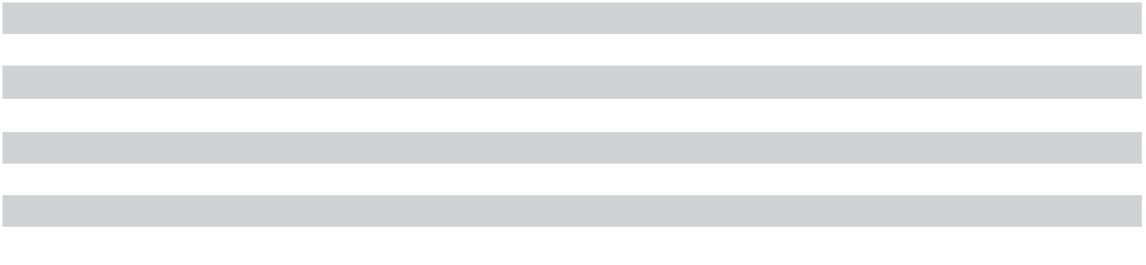

- Includes costs related to equipment not placed into service of $2.91 billion as of August 31, 2023 and $3.35 billion as of September 1, 2022.

- Includes building-related construction, tool installation, and software costs for assets not placed into service.

Depreciation expense was $7.67 billion, $7.03 billion, and $6.13 billion for 2023, 2022, and 2021, respectively. Interest capitalized as part of the cost of property, plant, and equipment was $208 million, $77 million, and $66 million for 2023, 2022, and 2021, respectively.

64 | 2023 10-K

Intangible Assets

As of August 31, 2023

 | Gross | Accumulated | Net Carrying
 | Amount | Amortization | Amount

As of September 1, 2022

Gross | Accumulated | Net Carrying
Amount | Amortization | Amount

Product and process technology $ 613 $ (209) $ 404 $ 742 $ (321) $ 421

In 2023, 2022, and 2021, we capitalized $87 million, $158 million, and $106 million, respectively, for product and process technology with weighted-average useful lives of 9 years. Amortization expense was $86 million, $85 million, and $82 million for 2023, 2022, and 2021, respectively. Expected amortization expense is $75 million for 2024, $51 million for 2025, $47 million for 2026, $43 million for 2027, and $42 million for 2028.

Goodwill

As of |  | August 31, | September 1,
As of |  | 2023 |  | 2022
Goodwill | $ | 1,150 | $ | 1,228

In the fourth quarter of 2023, we recognized a charge of $101 million included in other operating income (loss) to impair all of the goodwill assigned to our SBU reporting unit based on a quantitative assessment for impairment. We evaluated the fair value of our reporting units for the assessment based on an income approach, which uses a discounted cash flow methodology. The impairment of SBU goodwill reflects lower forecasted cash flows for SBU as a result of adverse conditions in the storage industry environment due to weak demand in many end markets combined with global and macroeconomic challenges and lower demand resulting from customer actions to reduce elevated inventory levels. These conditions led to significant reductions in SBU’s average selling prices and bit shipments, driving declines in revenue and cash flows. The quantitative assessment for impairment indicated that the fair value for all of our other reporting units substantially exceeded their carrying value.

As of August 31, 2023, CNBU, MBU, and EBU had goodwill of $855 million, $198 million, and $97 million, respectively. As of September 1, 2022, CNBU, MBU, SBU, and EBU had goodwill of $832 million, $198 million, $101 million, and $97 million, respectively. The Company added $23 million of goodwill to CNBU from an acquisition in the third quarter of 2023.

Leases

We have finance and operating leases through which we obtain the right to use facilities, land, and equipment that support our business operations. Our finance leases consist primarily of (i) gas and other supply agreements that are deemed to contain embedded leases and (ii) equipment leases. Our operating leases consist primarily of offices, laboratories, other facilities, and land. Certain of our operating leases include one or more options to extend the lease term for periods from one year to 10 years for real estate and one year to 99 years for land.

Certain supply or service agreements require us to exercise significant judgment to determine whether the agreement contains a lease. Our assessment includes determining whether we or the supplier control the assets used to fulfill the agreements by identifying whether we or the supplier have the right to change the type, quantity, timing, or location of the output of the assets. Our gas supply arrangements generally are deemed to contain a lease because we have the right to substantially all of the output of the assets used to produce the supply and we have the right to change the quantity and timing of the output of those assets. In determining the lease term, we assess whether we are reasonably certain to exercise any options to renew or terminate a lease or to purchase the right-of-use asset. Measuring the present value of the initial lease liability requires judgment to determine the discount rate, which we base on interest rates for borrowings with similar terms and collateral issued by entities with credit ratings similar to ours.

65

The components of lease cost are presented below:
For the year ended |  | 2023 |  | 2022 |  | 2021
Finance lease cost
Amortization of right-of-use asset | $ | 105 | $ | 99 | $ | 69
Interest on lease liability |  | 24 |  | 24 |  | 20
Operating lease cost⁽¹⁾ |  | 137 |  | 125 |  | 108
 | $ | 266 | $ | 248 | $ | 197

- Operating lease cost includes short-term and variable lease expenses, which were not material for the periods presented.

Supplemental cash flow information related to leases was as follows:
 | For the year ended |  | 2023 |  | 2022 |  | 2021
 | Cash flows used for operating activities
 | Finance leases | $ | 24 | $ | 23 | $ | 21
 | Operating leases |  | 139 |  | 110 |  | 106
 | Cash flows used for financing activities – Finance leases |  | 109 |  | 103 |  | 85
 | Noncash acquisitions of right-of-use assets
 | Finance leases |  | 508 |  | 309 |  | 395
 | Operating leases |  | 57 |  | 197 |  | 27
Supplemental balance sheet information related to leases was as follows:
 | As of |  |  |  | August 31, | September 1,
 | As of |  |  |  | 2023 |  | 2022
 | Finance lease right-of-use assets (included in property, plant, and equipment) |  |  | $ | 1,311 | $ | 904
 | Current operating lease liabilities (included in accounts payable and accrued expenses) |  |  |  | 66 |  | 60
 | Weighted-average remaining lease term (in years)
 | Finance leases |  |  |  | 9 |  | 12
 | Operating leases |  |  |  | 11 |  | 12
 | Weighted-average discount rate
 | Finance leases |  |  |  | 3.86 % |  | 2.65 %
 | Operating leases |  |  |  | 3.21 % |  | 2.90 %
As of August 31, 2023, maturities of lease liabilities by fiscal year were as follows:
 | For the year ending |  |  |  | Finance |  | Operating
 | For the year ending |  |  |  | Leases |  | Leases
2024 |  |  |  | $ | 219 | $ | 62
2025 |  |  |  |  | 200 |  | 77
2026 |  |  |  |  | 190 |  | 76
2027 |  |  |  |  | 185 |  | 76
2028 |  |  |  |  | 178 |  | 74
 | 2029 and thereafter |  |  |  | 506 |  | 453
 | Less imputed interest |  |  |  | (197) |  | (149)
 |  |  |  | $ | 1,281 | $ | 669
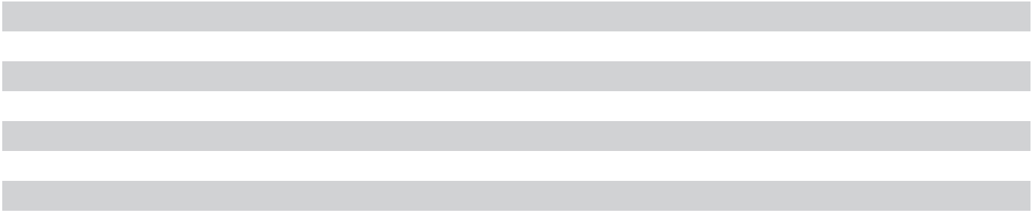
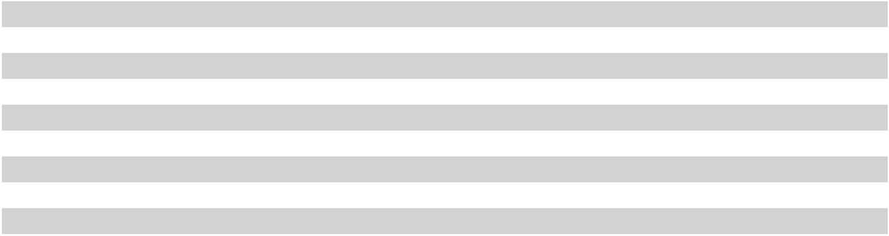
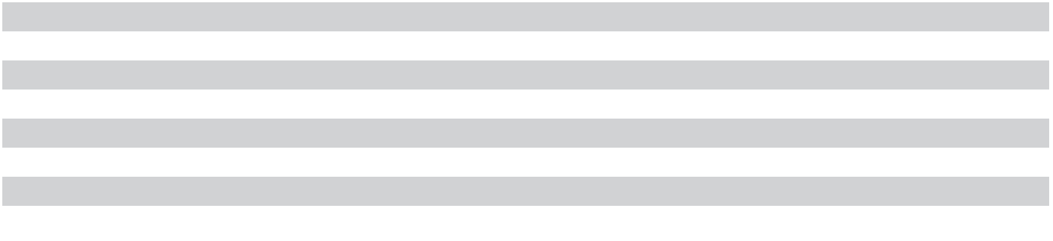

66 | 2023 10-K

The table above excludes obligations for leases that have been executed but have not yet commenced. As of August 31, 2023, excluded obligations consisted of $170 million of finance lease obligations over a weighted-average period of 12 years for gas supply arrangements deemed to contain embedded leases and equipment leases. We will recognize right-of-use assets and associated lease liabilities at the time such assets become available for our use.

Accounts Payable and Accrued Expenses

As of |  | August 31, | September 1,
As of |  | 2023 |  | 2022
Accounts payable | $ | 1,725 | $ | 2,142
Property, plant, and equipment |  | 1,419 |  | 2,170
Salaries, wages, and benefits |  | 367 |  | 877
Income and other taxes |  | 67 |  | 420
Other |  | 380 |  | 481
 | $ | 3,958 | $ | 6,090
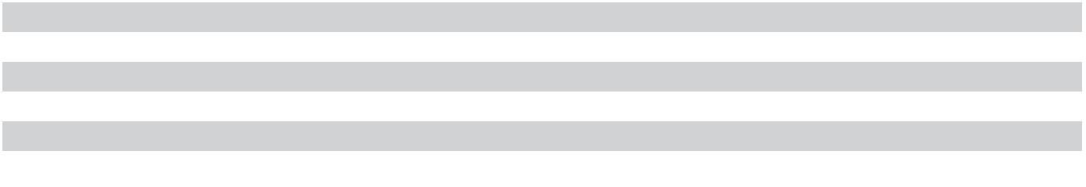

Debt

 |  |  | As of August 31, 2023 |  |  |  |  |  |  |  |  |  | As of September 1, 2022
 | Stated | Effective |  |  |  | Net Carrying Amount |  |  |  |  |  |  |  |  | Net Carrying Amount
 | Stated |  |  |  | Current |  |  | Long- |  | Total |  | Principal |  | Current |  |  | Long- |  | Total
 | Rate | Rate Principal |  |  |  |  |  | Term |  | Total |  |  |  |  |  |  | Term |  | Total
2024 Term Loan A | 6.146 % | 6.18 % $ |  | 588 | $ | — | $ | 587 | $ | 587 | $ |  | 1,188 | $ | — | $ | 1,187 | $ | 1,187
2025 Term Loan A | 6.681 % | 6.82 % |  | 1,052 |  | — |  | 1,050 |  | 1,050 |  |  | — |  | — |  | — |  | —
2026 Term Loan A | 6.806 % | 6.94 % |  | 971 |  | 49 |  | 921 |  | 970 |  |  | — |  | — |  | — |  | —
2027 Term Loan A | 6.931 % | 7.07 % |  | 1,123 |  | 57 |  | 1,063 |  | 1,120 |  |  | — |  | — |  | — |  | —
2026 Notes | 4.975 % | 5.07 % |  | 500 |  | — |  | 499 |  | 499 |  |  | 500 |  | — |  | 498 |  | 498
2027 Notes⁽¹⁾ | 4.185 % | 4.27 % |  | 900 |  | — |  | 798 |  | 798 |  |  | 900 |  | — |  | 806 |  | 806
2028 Notes | 5.375 % | 5.52 % |  | 600 |  | — |  | 596 |  | 596 |  |  | — |  | — |  | — |  | —
2029 A Notes | 5.327 % | 5.40 % |  | 700 |  | — |  | 697 |  | 697 |  |  | 700 |  | — |  | 697 |  | 697
2029 B Notes | 6.750 % | 6.54 % |  | 1,250 |  | — |  | 1,263 |  | 1,263 |  |  | — |  | — |  | — |  | —
2030 Notes | 4.663 % | 4.73 % |  | 850 |  | — |  | 846 |  | 846 |  |  | 850 |  | — |  | 846 |  | 846
2032 Green Bonds | 2.703 % | 2.77 % |  | 1,000 |  | — |  | 995 |  | 995 |  |  | 1,000 |  | — |  | 994 |  | 994
2033 A Notes | 5.875 % | 5.96 % |  | 750 |  | — |  | 745 |  | 745 |  |  | — |  | — |  | — |  | —
2033 B Notes | 5.875 % | 6.01 % |  | 900 |  | — |  | 890 |  | 890 |  |  | — |  | — |  | — |  | —
2041 Notes | 3.366 % | 3.41 % |  | 500 |  | — |  | 497 |  | 497 |  |  | 500 |  | — |  | 496 |  | 496
2051 Notes | 3.477 % | 3.52 % |  | 500 |  | — |  | 496 |  | 496 |  |  | 500 |  | — |  | 496 |  | 496
Finance lease obligations | N/A | 3.86 % |  | 1,281 |  | 172 |  | 1,109 |  | 1,281 |  |  | 886 |  | 103 |  | 783 |  | 886
 |  |  | $ | 13,465 | $ | 278 | $ | 13,052 | $ | 13,330 |  | $ | 7,024 | $ | 103 | $ | 6,803 | $ | 6,906
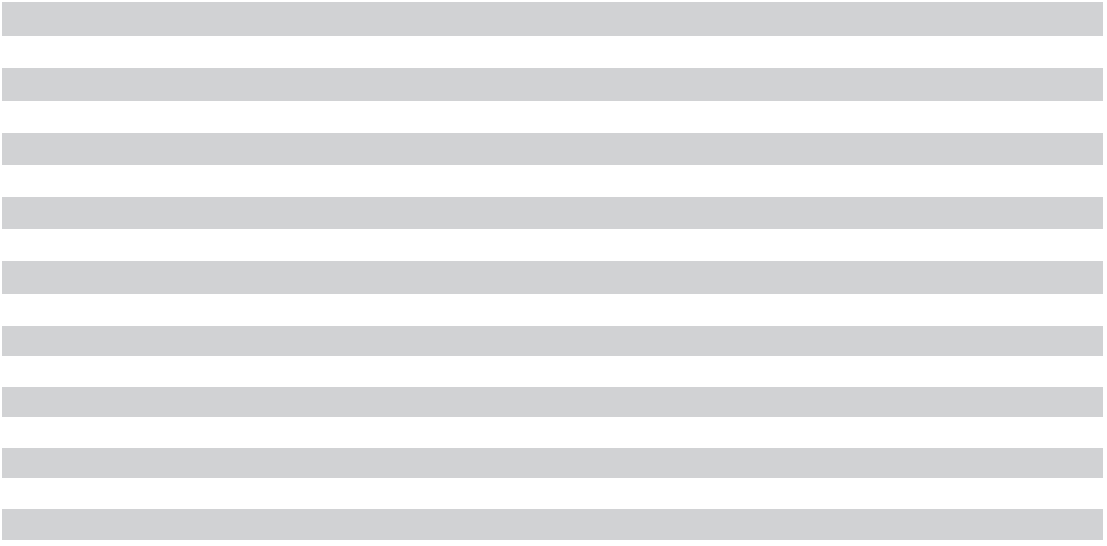
- In 2021, we entered into fixed-to-floating interest rate swaps on the 2027 Notes with an aggregate $900 million notional amount equal to the principal amount of the 2027 Notes. The resulting variable interest paid is at a rate equal to SOFR plus approximately 3.33%. The fixed-to-floating interest rate swaps are accounted for as fair value hedges, and as a result, the carrying values of our 2027 Notes reflect adjustments in fair value.

67

As of August 31, 2023, all of our debt, other than finance lease obligations, were unsecured obligations that rank equally in right of payment with all of our other existing and future unsecured indebtedness and were effectively subordinated to all future secured indebtedness, to the extent of the value of the assets securing such indebtedness. All our unsecured debt were obligations of our parent company, Micron, and were structurally subordinated to all liabilities of its subsidiaries, including trade payables. The terms of our indebtedness generally contain cross payment default and cross acceleration provisions. Micron’s guarantees of certain liabilities of its subsidiaries are unsecured obligations ranking equally in right of payment with all of Micron’s other existing and future unsecured indebtedness.

Debt Activity

The table below presents the effects of debt financing and prepayment activities in 2023:

 |  |  |  | Increase |  | Increase |  | Increase
 |  | Transaction Date | (Decrease) in |  | (Decrease) in |  | (Decrease) in
 |  | Transaction Date |  | Principal | Carrying Value |  |  | Cash
Issuances
2029 | B Notes | October 31, 2022 | $ | 750 | $ | 744 | $ | 744
2025 Term Loan A |  | November 3, 2022 |  | 927 |  | 925 |  | 925
2026 Term Loan A |  | November 3, 2022 |  | 746 |  | 745 |  | 745
2027 Term Loan A |  | November 3, 2022 |  | 927 |  | 924 |  | 924
2025 | Term Loan A | January 5, 2023 |  | 125 |  | 125 |  | 125
2026 | Term Loan A | January 5, 2023 |  | 250 |  | 249 |  | 249
2027 | Term Loan A | January 5, 2023 |  | 225 |  | 225 |  | 225
2029 | B Notes | February 9, 2023 |  | 500 |  | 520 |  | 520
2033 | A Notes | February 9, 2023 |  | 750 |  | 745 |  | 745
2028 | Notes | April 11, 2023 |  | 600 |  | 596 |  | 596
2033 | B Notes | April 11, 2023 |  | 900 |  | 890 |  | 890
Prepayments
2024 | Term Loan A | April 13, 2023 |  | (600) |  | (600) |  | (600)
 |  |  | $ | 6,100 | $ | 6,088 | $ | 6,088
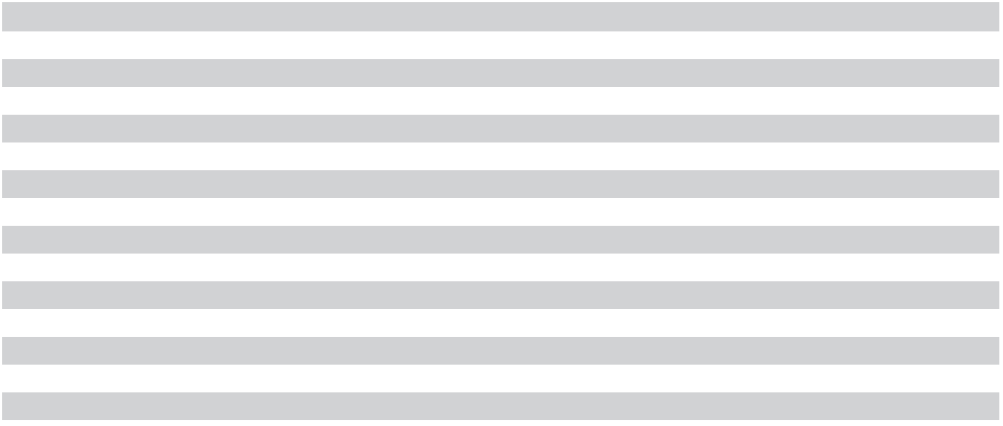

In 2022, we issued $2.00 billion of senior unsecured notes and received cash of $1.99 billion. The approximate $1.00 billion of net proceeds from the issuance of the 2032 Green Bonds are being used to fund eligible sustainability-focused projects. The remaining proceeds, along with cash on hand, were used to repay $1.85 billion of principal amount of notes (carrying value of $1.85 billion) for $1.93 billion in cash. We recognized losses of $83 million in connection with these repayments.

In 2021, substantially all holders of our 2032D Notes converted their notes. We settled these conversions and all remaining 2032D Notes with $185 million in cash and 11.1 million shares of our stock, which approximated the carrying value of debt and equity for those notes.

Senior Unsecured Notes

We may redeem our 2026 Notes, 2027 Notes, 2028 Notes, 2029 A Notes, 2029 B Notes, 2030 Notes, 2032 Green Bonds, 2033 A Notes, 2033 B Notes, 2041 Notes, and 2051 Notes (the “Senior Unsecured Notes”), in whole or in part, at our option prior to their respective maturity dates at a redemption price equal to the greater of (i) 100% of the principal amount of the notes to be redeemed and (ii) the present value of the remaining scheduled payments of principal and interest, in each case plus accrued interest. We may also redeem any series of our Senior Unsecured Notes, in whole or in part, at a price equal to par between one and six months prior to maturity in accordance with the respective terms of such series.

68 | 2023 10-K

Each series of Senior Unsecured Notes contains covenants that, among other things, limit, in certain circumstances, our ability and/or the ability of our restricted subsidiaries (which are generally domestic subsidiaries in which we own at least 80% of the voting stock and which own principal property, as defined in the indenture governing such series) to (1) create or incur certain liens; (2) enter into certain sale and lease-back transactions; and (3) consolidate with or merge with or into, or convey, transfer, or lease all or substantially all of our properties and assets, to another entity. These covenants are subject to a number of limitations and exceptions. Additionally, if a change of control triggering event, as defined in the indentures governing our Senior Unsecured Notes, occurs with respect to a series of Senior Unsecured Notes, we will be required to offer to purchase such Senior Unsecured Notes at 101% of the outstanding aggregate principal amount plus accrued interest up to the purchase date.

2032 Green Bonds: We plan to allocate an amount equal to the approximate $1.00 billion of net proceeds of our unsecured 2032 Green Bonds by November 1, 2023, to fund eligible sustainability-focused projects involving renewable energy, green buildings, energy efficiency, water management, waste abatement, and a circular economy.

Multi-Tranche Term Loan A

In 2023, we entered into a term loan agreement consisting of three tranches (the “Multi-Tranche Term Loan Agreement”) and borrowed $3.20 billion in aggregate principal amount. The tranches mature on November 3, 2025 (“2025 Term Loan A”); November 3, 2026 (“2026 Term Loan A”); and November 3, 2027 (“2027 Term Loan A”).

The 2026 Term Loan A and 2027 Term Loan A each require equal quarterly installment payments in an amount equal to 1.25% of the original principal amount. The 2025 Term Loan A does not require quarterly installment payments. Borrowings under the Multi-Tranche Term Loan Agreement will generally bear interest at adjusted term SOFR plus an applicable interest rate margin ranging from 1.00% to 2.00%, varying by tranche and depending on our corporate credit ratings. Adjusted term SOFR for the Multi-Tranche Term Loan Agreement is the SOFR benchmark plus 0.10%.

The Multi-Tranche Term Loan Agreement requires us to maintain, on a consolidated basis, a leverage ratio of total indebtedness to adjusted EBITDA, as defined in the Multi-Tranche Term Loan Agreement and calculated as of the last day of each fiscal quarter, not to exceed 3.25 to 1.00. On March 27, 2023, we amended the Multi-Tranche Term Loan Agreement to provide that in lieu of the foregoing leverage ratio, during the fourth quarter of 2023 and each quarter of 2024, we will be required to maintain, on a consolidated basis, a net leverage ratio of total net indebtedness to adjusted EBITDA, as defined in the Multi-Tranche Term Loan Agreement and calculated as of the last day of each fiscal quarter, not to exceed 3.25 to 1.00. Alternatively, for up to three of such five quarters, we may elect to comply with a requirement of minimum liquidity, as defined in the Multi-Tranche Term Loan Agreement, of not less than $5.0 billion. In the fourth quarter of 2023, we complied with the net leverage ratio. Each of the leverage ratio and net leverage ratio maximums, as applicable, is subject to a temporary four quarter increase in such ratio to 3.75 to 1.00 following certain material acquisitions.

The Multi-Tranche Term Loan Agreement contains other covenants that, among other things, limit, in certain circumstances, our ability and/or the ability of our restricted subsidiaries to (1) create or incur certain liens and enter into sale and lease-back transactions, (2) create, assume, incur, or guarantee certain additional secured indebtedness and unsecured indebtedness of our restricted subsidiaries, and (3) consolidate with or merge with or into, or convey, transfer, lease, or otherwise dispose of all or substantially all of our assets, to another entity. These covenants are subject to a number of limitations, exceptions, and qualifications. Our obligations under the Multi-Tranche Term Loan Agreement are unsecured.

2024 Term Loan A

On April 13, 2023, we used a portion of the proceeds from our April 2023 issuance of senior unsecured notes to prepay $600 million principal amount of our 2024 Term Loan A.

69

On June 7, 2023, the 2024 Term Loan A agreement was amended, pursuant to its transition provisions, to replace LIBOR-based benchmark rates with SOFR-based benchmark rates effective July 1, 2023. Subsequent to this amendment, borrowings under the 2024 Term Loan Agreement generally bear interest at adjusted term SOFR plus an applicable interest rate margin ranging from 0.625% to 1.375% depending on our corporate credit ratings. Adjusted term SOFR for the 2024 Term Loan A is the SOFR benchmark plus a credit spread adjustment ranging from approximately 0.11% to 0.43% depending on the applicable interest period selected. Prior to July 1, 2023, the 2024 Term Loan A bore interest at a rate equal to LIBOR plus 0.625% to 1.375% based on our corporate credit ratings.

The 2024 Term Loan A agreement contains the same leverage ratio, as amended, and substantially the same other covenants as the Multi-Tranche Term Loan Agreement. Our obligations under the 2024 Term Loan A agreement are unsecured.

Revolving Credit Facility

As of August 31, 2023, no amounts were outstanding under the Revolving Credit Facility and $2.50 billion was available to us. Under the Revolving Credit Facility, borrowings would generally bear interest at a rate equal to adjusted term SOFR plus 1.00% to 1.75%, depending on our corporate credit ratings. Adjusted term SOFR for the Revolving Credit Facility agreement is the SOFR benchmark plus a credit spread adjustment ranging from approximately 0.11% to 0.43% depending on the applicable interest period selected. Any amounts outstanding under the Revolving Credit Facility would mature in May 2026 and amounts borrowed may be prepaid without penalty.

The Revolving Credit Facility contains the same leverage ratio, as amended, and substantially the same other covenants as the Multi-Tranche Term Loan Agreement.

Maturities of Notes Payable

As of August 31, 2023, maturities of notes payable by fiscal year were as follows:
2024 | $ | 107
2025 |  | 695
2026 |  | 1,659
2027 |  | 1,780
2028 |  | 1,493
2029 and thereafter |  | 6,450
Unamortized issuance costs, discounts, and premium, net |  | (35)
Hedge accounting fair value adjustment |  | (100)
 | $ | 12,049

Commitments

As of August 31, 2023, we had noncancelable commitments with remaining contractual terms in excess of one year

of approximately $6.7 billion for purchase obligations, of which approximately $1.2 billion will be due in 2024,

$1.4 billion due in 2025, $1.0 billion due in 2026, $1.0 billion due in 2027, $700 million due in 2028, and $1.4 billion

due in 2029 and thereafter. Purchase obligations primarily include payments for goods or services with either a fixed

or minimum quantity and price, which includes payments for the acquisition of property, plant, and equipment.

Payments for leases that have been executed but have not yet commenced are excluded.

In 2023, we entered into an 18-year power purchase agreement in Singapore to purchase up to 450 megawatts of power at predominantly variable prices. This contract is expected to supply the majority of our power consumption needs in Singapore with more favorable pricing than our previous supply arrangements.

70 | 2023 10-K

Contingencies

We are currently a party to legal actions other than those described below arising from the normal course of business, none of which are expected to have a material adverse effect on our business, results of operations, or financial condition.

Patent Matters

As is typical in the semiconductor and other high-tech industries, from time to time, others have asserted, and may in the future assert, that our products or manufacturing processes infringe upon their intellectual property rights.

On March 19, 2018, Micron Semiconductor (Xi’an) Co., Ltd. (“MXA”) was served with a patent infringement complaint filed by Fujian Jinhua Integrated Circuit Co., Ltd. (“Jinhua”) in the Fuzhou Intermediate People’s Court in Fujian Province, China (the “Fuzhou Court”). On April 3, 2018, Micron Semiconductor (Shanghai) Co. Ltd. (“MSS”) was served with the same complaint. The complaint alleges that MXA and MSS infringed one Chinese patent by manufacturing and selling certain Crucial DDR4 DRAM modules. The complaint seeks an order requiring MXA and MSS to destroy inventory of the accused products and equipment for manufacturing the accused products in China; to stop manufacturing, using, selling, and offering for sale the accused products in China; and to pay damages of 98 million Chinese yuan plus court fees incurred.

On March 21, 2018, MXA was served with a patent infringement complaint filed by United Microelectronics Corporation (“UMC”) in the Fuzhou Court. On April 3, 2018, MSS was served with the same complaint. The complaint alleges that MXA and MSS infringed one Chinese patent by manufacturing and selling certain Crucial DDR4 DRAM modules. The complaint seeks an order requiring MXA and MSS to destroy inventory of the accused products and equipment for manufacturing the accused products in China; to stop manufacturing, using, selling, and offering for sale the accused products in China; and to pay damages of 90 million Chinese yuan plus court fees incurred. On November 26, 2021, pursuant to a settlement agreement between UMC and Micron, UMC filed an application to the Fuzhou Court to withdraw its complaints against MXA and MSS.

On April 3, 2018, MSS was served with another patent infringement complaint filed by Jinhua and an additional complaint filed by UMC in the Fuzhou Court. The additional complaints allege that MSS infringes two Chinese patents by manufacturing and selling certain Crucial MX300 SSDs. The complaint filed by UMC seeks an order requiring MSS to destroy inventory of the accused products and equipment for manufacturing the accused products in China; to stop manufacturing, using, selling, and offering for sale the accused products in China; and to pay damages of 90 million Chinese yuan plus court fees incurred. The complaint filed by Jinhua seeks an order requiring MSS to destroy inventory of the accused products and equipment for manufacturing the accused products in China; to stop manufacturing, using, selling, and offering for sale the accused products in China; and to pay damages of 98 million Chinese yuan plus court fees incurred. On November 26, 2021, pursuant to a settlement agreement between UMC and Micron, UMC filed an application to the Fuzhou Court to withdraw its complaint against MSS.

On July 5, 2018, MXA and MSS were notified that the Fuzhou Court granted a preliminary injunction against those entities that enjoins them from manufacturing, selling, or importing certain Crucial and Ballistix-branded DRAM modules and solid-state drives in China. We are complying with the ruling and have requested the Fuzhou Court to reconsider or stay its decision.

71

On April 28, 2021, Netlist, Inc. (“Netlist”) filed two patent infringement actions against Micron, Micron Semiconductor Products, Inc. (“MSP”), and Micron Technology Texas, LLC (“MTEC”) in the U.S. District Court for the Western District of Texas. The first complaint alleges that one U.S. patent is infringed by certain of our non-volatile dual in-line memory modules. The second complaint alleges that three U.S. patents are infringed by certain of our load-reduced dual in-line memory modules (“LRDIMMs”). Each complaint seeks injunctive relief, damages, attorneys’ fees, and costs. On March 31, 2022, Netlist filed a patent infringement complaint against Micron and Micron Semiconductor Germany, GmbH in Dusseldorf Regional Court alleging that two German patents are infringed by certain of our LRDIMMs. The complaint seeks damages, costs, and injunctive relief. On June 10, 2022, Netlist filed a patent infringement complaint against Micron, MSP, and MTEC in the U.S. District Court for the Eastern District of Texas (“E.D. Tex.”) alleging that six U.S. patents are infringed by certain of our memory modules and HBM products. On August 1, 2022, Netlist filed a second patent infringement complaint against the same defendants in E.D. Tex. alleging that one U.S. patent is infringed by certain of our LRDIMMs. On August 15, 2022, Netlist amended the second complaint to assert that two additional U.S. patents are infringed by certain of our LRDIMMs. The complaints in E.D. Tex. seek injunctive relief, damages, and attorneys’ fees.

On August 16, 2022, Sonrai Memory Ltd. filed a patent infringement action against Micron in the U.S. District Court for the Western District of Texas. The complaint alleges that two U.S. patents are infringed by certain SSD and NAND flash products. The complaint seeks damages, attorneys’ fees, and costs.

On January 23, 2023, Besang Inc. filed a patent infringement complaint against Micron in the U.S. District Court for the Eastern District of Texas. The complaint alleges that one U.S. patent is infringed by certain of our 3D NAND and SSD products. The complaint seeks an injunction, damages, attorneys’ fees, and costs.

Among other things, the above lawsuits pertain to substantially all of our DRAM, NAND, and other memory and storage products we manufacture, which account for substantially all of our revenue.

Qimonda

On January 20, 2011, Dr. Michael Jaffé, administrator for Qimonda’s insolvency proceedings, filed suit against Micron and Micron Semiconductor B.V. (“Micron B.V.”), in the District Court of Munich, Civil Chamber. The complaint sought to void, under Section 133 of the German Insolvency Act, a share purchase agreement between Micron B.V. and Qimonda signed in fall 2008, pursuant to which Micron B.V. purchased substantially all of Qimonda’s shares of Inotera (the “Inotera Shares”), representing approximately 18% of Inotera’s outstanding shares at that time, and sought an order requiring us to re-transfer those shares to the Qimonda estate. The complaint also sought, among other things, to recover damages for the alleged value of the joint venture relationship with Inotera and to terminate, under Sections 103 or 133 of the German Insolvency Code, a patent cross-license between us and Qimonda entered into at the same time as the share purchase agreement.

Following a series of hearings with pleadings, arguments, and witnesses on behalf of the Qimonda estate, on March 13, 2014, the court issued judgments: (1) ordering Micron B.V. to pay approximately $1 million in respect of certain Inotera Shares sold in connection with the original share purchase; (2) ordering Micron B.V. to disclose certain information with respect to any Inotera Shares sold by it to third parties; (3) ordering Micron B.V. to disclose the benefits derived by it from ownership of the Inotera Shares, including in particular, any profits distributed on the Inotera Shares and all other benefits; (4) denying Qimonda’s claims against Micron for any damages relating to the joint venture relationship with Inotera; and (5) determining that Qimonda’s obligations under the patent cross-license agreement are canceled. In addition, the court issued interlocutory judgments ordering, among other things: (1) that Micron B.V. transfer to the Qimonda estate the Inotera Shares still owned by Micron B.V. and pay to the Qimonda estate compensation in an amount to be specified for any Inotera Shares sold to third parties; and (2) that Micron B.V. pay the Qimonda estate as compensation an amount to be specified for benefits derived by Micron B.V. from ownership of the Inotera Shares. The interlocutory judgments had no immediate, enforceable effect and Micron, accordingly, was able to continue to operate with full control of the Inotera Shares subject to further developments in the case. Micron and Micron B.V. appealed the judgments to the German Appeals Court, which thereafter appointed an independent expert to perform an evaluation of Dr. Jaffé’s claims that the amount Micron paid for Qimonda was less than fair market value. On March 31, 2020, the expert presented an opinion to the Appeals Court concluding that the amount paid by Micron was within an acceptable range of fair value. On October 5, 2022, the Appeals Court ruled that the relevant issue to be addressed is whether Qimonda's creditors were prejudiced such that the original transaction should be voided.

72 | 2023 10-K

On May 9, 2023, Micron and Dr. Jaffé reached an agreement to dismiss the case in exchange for a one-time payment by Micron to the Qimonda estate and a waiver of each party’s claims. The agreement was formally entered by the Appeals Court in July 2023 and the case was dismissed.

Antitrust Matters

Six cases have been filed against Micron alleging price fixing of DRAM products in the following Canadian courts on the dates indicated: Superior Court of Quebec (April 30, 2018 and May 3, 2018), the Federal Court of Canada (May 2, 2018), the Ontario Superior Court of Justice (May 15, 2018), and the Supreme Court of British Columbia (May 10, 2018). The plaintiffs in these cases are individuals seeking certification of class actions on behalf of direct and indirect purchasers of DRAM in Canada (or regions of Canada) between June 1, 2016 and February 1, 2018.

On May 15, 2018, the Chinese State Administration for Market Regulation (“SAMR”) notified Micron that it was investigating potential collusion and other anticompetitive conduct by DRAM suppliers in China. On May 31, 2018, SAMR made unannounced visits to our sales offices in Beijing, Shanghai, and Shenzhen to seek certain information as part of its investigation. We are cooperating with SAMR in its investigation.

Securities Matters

On February 9, 2021, a derivative complaint was filed by a shareholder against Sanjay Mehrotra and other current and former directors of Micron, allegedly on behalf of and for the benefit of Micron, in the U.S. District Court for the District of Delaware alleging violations of securities laws, breaches of fiduciary duties, and other violations of law involving allegedly false and misleading statements about Micron’s commitment to diversity and progress in diversifying its workforce, executive leadership, and Board of Directors. The complaint seeks damages, fees, interest, costs, and an order requiring Micron to take various actions to allegedly improve its corporate governance and internal procedures.

Other Matters

In the normal course of business, we are a party to a variety of agreements pursuant to which we may be obligated to indemnify another party. It is not possible to predict the maximum potential amount of future payments under these types of agreements due to the conditional nature of our obligations and the unique facts and circumstances involved in each particular agreement. Historically, our payments under these types of agreements have not had a material adverse effect on our business, results of operations, or financial condition.

Contingency Assessment

We are unable to predict the outcome of any of the matters noted above and cannot make a reasonable estimate of the potential loss or range of possible losses. A determination that our products or manufacturing processes infringe the intellectual property rights of others or entering into a license agreement covering such intellectual property could result in significant liability and/or require us to make material changes to our products and/or manufacturing processes. Any of the foregoing, as well as the resolution of any other legal matter noted above, could have a material adverse effect on our business, results of operations, or financial condition.

Equity

Common Stock Repurchases

Our Board of Directors has authorized the discretionary repurchase of up to $10 billion of our outstanding common stock through open-market purchases, block trades, privately-negotiated transactions, derivative transactions, and/ or pursuant to Rule 10b5-1 trading plans. The repurchase authorization has no expiration date, does not obligate us to acquire any common stock, and is subject to market conditions and our ongoing determination of the best use of available cash. We repurchased 8.6 million shares of our common stock for $425 million in 2023 and 35.4 million shares for $2.43 billion in 2022. Through August 31, 2023, we had repurchased an aggregate of $6.89 billion under the authorization. Amounts repurchased are included in treasury stock.

73

Dividends

In each quarter of 2023, we declared and paid dividends of $126 million ($0.115 per share). On September 27, 2023, our Board of Directors declared a quarterly dividend of $0.115 per share, payable in cash on October 25, 2023, to shareholders of record as of the close of business on October 10, 2023.

Accumulated Other Comprehensive Income (Loss)

Changes in accumulated other comprehensive income (loss) by component for the year ended August 31, 2023 were as follows:
 |  | Gains |  | Unrealized |  |  |  | Cumulative
 |  | Gains |  | Unrealized |  | Pension |  | Foreign
 | (Losses) on |  |  | Gains |  | Pension |  | Currency
 |  | Derivative | (Losses) on |  |  | Liability |  | Translation |  | Total
 | Instruments |  | Investments |  | Adjustments |  |  | Adjustment |  | Total
As of September 1, 2022 | $ | (538) | $ | (47) | $ | 25 | $ | — | $ | (560)
Other comprehensive income (loss) before |  | 19 |  | 18 |  | 17 |  | (3) |  | 51
reclassifications |  | 19 |  | 18 |  | 17 |  | (3) |  | 51
Amount reclassified out of accumulated other |  | 261 |  | 1 |  | (2) |  | — |  | 260
comprehensive income (loss) |  | 261 |  | 1 |  | (2) |  | — |  | 260
Tax effects |  | (46) |  | (13) |  | (4) |  | — |  | (63)
Other comprehensive income (loss) |  | 234 |  | 6 |  | 11 |  | (3) |  | 248
As of August 31, 2023 | $ | (304) | $ | (41) | $ | 36 | $ | (3) | $ | (312)
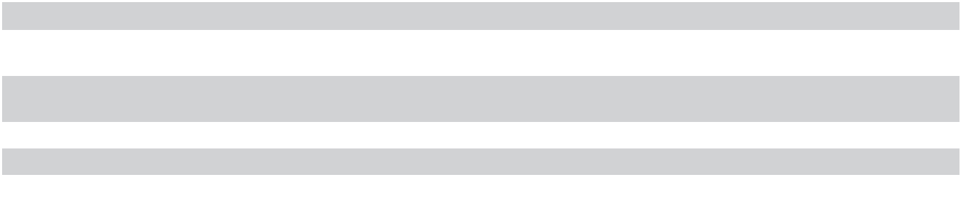

Fair Value Measurements

The estimated fair values and carrying values of our outstanding debt instruments were as follows:

As of August 31, 2023

Fair Carrying

Value Value

As of September 1, 2022

Fair Carrying

Value Value

Notes $ 11,549 $ 12,049 $ 5,472 $ 6,020

The fair values of our debt instruments were estimated based on Level 2 inputs, including the trading price of our notes when available, discounted cash flows, and interest rates based on similar debt issued by parties with credit ratings similar to ours.

74 | 2023 10-K

Derivative Instruments

 |  | Notional or |  | Fair Value of
 |  | Contractual
 |  | Contractual |  | Assets⁽¹⁾ |  | Liabilities⁽²⁾
 |  | Amount |  | Assets⁽¹⁾ |  | Liabilities⁽²⁾
As of August 31, 2023
Derivative instruments with hedge accounting designation
Cash flow currency hedges | $ | 3,873 | $ | 16 | $ | (180)
Cash flow commodity hedges |  | 331 |  | 45 |  | —
Fair value interest rate hedges |  | 900 |  | — |  | (100)
Derivative instruments without hedge accounting designation
Non-designated currency hedges |  | 1,839 |  | 2 |  | (17)
 |  |  | $ | 63 | $ | (297)
As of September 1, 2022
Derivative instruments with hedge accounting designation
Cash flow currency hedges | $ | 5,427 | $ | — | $ | (330)
Cash flow commodity hedges |  | 97 |  | 1 |  | (6)
Fair value interest rate hedges |  | 900 |  | — |  | (91)
Derivative instruments without hedge accounting designation
Non-designated currency hedges |  | 2,821 |  | 7 |  | (13)
 |  |  | $ | 8 | $ | (440)
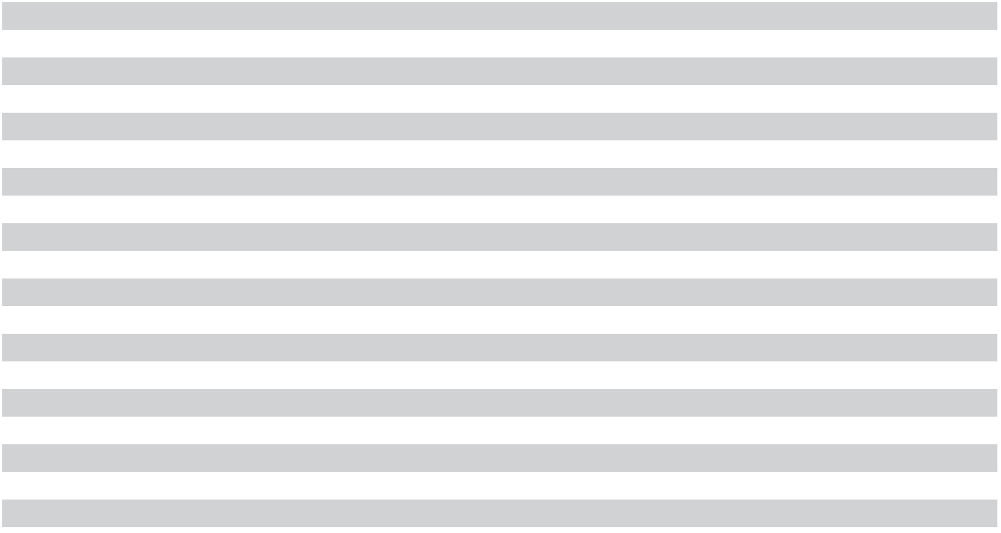
- Included in receivables and other noncurrent assets.
- Included in accounts payable and accrued expenses and other noncurrent liabilities.

Derivative Instruments with Hedge Accounting Designation

Cash Flow Hedges: We utilize forward and swap contracts that generally mature within two years designated as

cash flow hedges to minimize our exposure to changes in currency exchange rates or commodity prices for certain

capital expenditures and manufacturing costs. Forward and swap contracts are measured at fair value based on

market-based observable inputs including market spot and forward rates, interest rates, and credit-risk spreads

(Level 2). We recognized gains from cash flow hedges of $30 million for 2023, and losses of $735 million and $52

million for 2022 and 2021, respectively, in accumulated other comprehensive income (loss). We recognized losses

related to amounts excluded from hedge effectiveness testing on our cash flow hedges of $101 million in 2023 in

cost of goods sold through an amortization approach. The amounts recognized in 2022 and 2021 were not

significant. We reclassified losses of $261 million and $53 million in 2023 and 2022, respectively, and gains of

$41 million in 2021, from accumulated other comprehensive income (loss) to earnings, primarily to cost of goods

sold. As of August 31, 2023, we expect to reclassify $177 million of pre-tax losses related to cash flow hedges from

accumulated other comprehensive income (loss) into earnings in the next 12 months.

Fair Value Hedges: We utilize fixed-to-floating interest rate swaps designated as fair value hedges to minimize certain exposures to changes in the fair value of fixed-rate debt that result from fluctuations in benchmark interest rates. Interest rate swaps are measured at fair value based on market-based observable inputs including interest rates and credit-risk spreads (Level 2). The changes in the fair values of derivatives designated as fair value hedges and the offsetting changes in the underlying fair values of the hedged items are both recognized in earnings. When a derivative is no longer designated as a fair value hedge for any reason, including termination and maturity, the remaining unamortized difference between the carrying value of the hedged item at that time and the face value of the hedged item is amortized to earnings over the remaining life of the hedged item, or immediately if the hedged item has matured or been extinguished. We recognized interest expense of $96 million for changes in the fair value of our interest rate swaps in 2022 and the impact to interest expense was not significant for 2023 or 2021. We also recognized offsetting reductions in interest expense of the same amounts related to the changes in the fair value of the hedged portion of the underlying debt for these periods.

75

Derivative Instruments without Hedge Accounting Designation

Currency Derivatives: We generally utilize a rolling hedge strategy with currency forward contracts that mature within three months to hedge our exposures of monetary assets and liabilities from changes in currency exchange rates. At the end of each reporting period, monetary assets and liabilities denominated in currencies other than the U.S. dollar are remeasured into U.S. dollars and the associated outstanding forward contracts are marked to market. Currency forward contracts are valued at fair values based on the middle of bid and ask prices of dealers or exchange quotations (Level 2). Realized and unrealized gains and losses on derivative instruments without hedge accounting designation as well as the changes in the underlying monetary assets and liabilities from changes in currency exchange rates are included in other non-operating income (expense), net. The amounts recognized for derivative instruments without hedge accounting designation were not significant for the periods presented. We do not use derivative instruments for speculative purposes.

Derivative Counterparty Credit Risk and Master Netting Arrangements

Our derivative instruments expose us to credit risk to the extent counterparties may be unable to meet the terms of the contracts. Our maximum exposure to loss due to credit risk if counterparties fail completely to perform according to the terms of the contracts would generally equal the fair value of assets for these contracts as listed in the tables above. We seek to mitigate such risk by limiting our counterparties to major financial institutions and by spreading risk across multiple financial institutions. As of August 31, 2023 and September 1, 2022, amounts netted under our master netting arrangements were not significant.

Equity Plans

As of August 31, 2023, 95 million shares of our common stock were available for future awards under our equity plans, including 14 million shares approved for issuance under our employee stock purchase plan (“ESPP”).

Restricted Stock and Restricted Stock Units (“Restricted Stock Awards”)

As of August 31, 2023, there were 29 million shares of Restricted Stock Awards outstanding, 26 million of which contained only service conditions. For service-based Restricted Stock Awards granted through October 2021, restrictions generally lapse in one-fourth or one-third increments during each year of employment after the grant date. For service-based Restricted Stock Awards granted beginning in November 2021, restrictions generally lapse on 25% or 33% of the units granted after the first year and on 6.25% or 8.33% each quarter thereafter over the remaining three or two years of employment. Restrictions generally lapse on Restricted Stock with performance or market conditions as conditions are met over a 3-year period. At the end of the performance period, the number of actual shares to be awarded will vary between 0% and 200% of target amounts, depending upon the achievement level. In 2022, our Board of Directors approved dividend equivalent rights for unvested restricted stock units awarded on or after October 13, 2021.

Restricted Stock Awards activity for 2023 is summarized as follows:

 |  |  |  | Weighted-
 | Number of |  |  | Average Grant
 | Number of |  | Date Fair Value
 | Shares |  |  | Per Share
Outstanding as of September 1, 2022 |  | 23 | $ | 60.93
Granted |  | 17 |  | 55.99
Restrictions lapsed |  | (9) |  | 58.23
Canceled |  | (2) |  | 58.00
Outstanding as of August 31, 2023 |  | 29 |  | 59.11
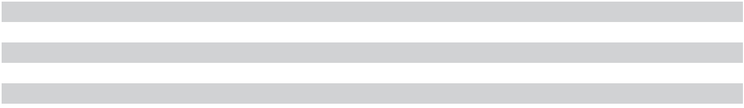

76 | 2023 10-K

For the year ended |  | 2023 |  | 2022 |  | 2021
Restricted stock award shares granted |  | 17 |  | 13 |  | 11
Weighted-average grant-date fair value per share | $ | 55.99 | $ | 70.81 | $ | 53.58
Aggregate vesting-date fair value of shares vested | $ | 514 | $ | 498 | $ | 385

Employee Stock Purchase Plan (“ESPP”)

Our ESPP is offered to substantially all employees and permitted eligible employees to purchase shares of our common stock through payroll deductions of up to 10% of their eligible compensation, subject to certain limitations prior to August 2021. Beginning in August 2021, employees are permitted to deduct up to 15% of their eligible compensation to purchase shares under the ESPP. The purchase price of the shares under the ESPP equals 85% of the lower of the fair market value of our common stock on either the first or last day of each six-month offering period. Compensation expense is calculated as of the beginning of the offering period as the fair value of the employees’ purchase rights utilizing the Black-Scholes option valuation model and is recognized over the offering period. Grant-date fair value and assumptions used in the Black-Scholes option valuation model were as follows:

For the year ended |  | 2023 |  | 2022 |  | 2021
Weighted-average grant-date fair value per share | $ | 17.06 | $ | 18.87 | $ | 20.71
Average expected life in years |  | 0.5 |  | 0.5 |  | 0.5
Weighted-average expected volatility (based on implied volatility) |  | 37 % |  | 43 % |  | 41 %
Weighted-average risk-free interest rate |  | 5.1 % |  | 2.0 % |  | 0.1 %
Expected dividend yield |  | 0.7 % |  | 0.6 % |  | 0.3 %


Under the ESPP, employees purchased 5 million, 4 million, and 3 million shares of common stock in 2023, 2022, and 2021, respectively, at a per share weighted average price of $51.93, $58.52, and $51.42, respectively.

Stock Options

As of August 31, 2023, stock options of 2 million shares were outstanding, all of which were fully exercisable. Stock options expire 8 years from the date of grant. We did not grant any stock options in 2023, 2022, or 2021. Stock options of 1 million shares were exercised in 2023. The total intrinsic value for options exercised was $30 million, $54 million, and $143 million in 2023, 2022, and 2021, respectively.

Stock-based Compensation Expense

For the year ended |  | 2023 |  | 2022 |  | 2021
Stock-based compensation expense by caption
Research and development | $ | 226 | $ | 175 | $ | 110
Cost of goods sold |  | 201 |  | 193 |  | 186
Selling, general, and administrative |  | 137 |  | 133 |  | 99
Restructure |  | (7) |  | (5) |  | —
 | $ | 557 | $ | 496 | $ | 395
Stock-based compensation expense by type of award
Restricted stock awards | $ | 488 | $ | 429 | $ | 333
ESPP |  | 69 |  | 66 |  | 52
Stock options |  | — |  | 1 |  | 10
 | $ | 557 | $ | 496 | $ | 395
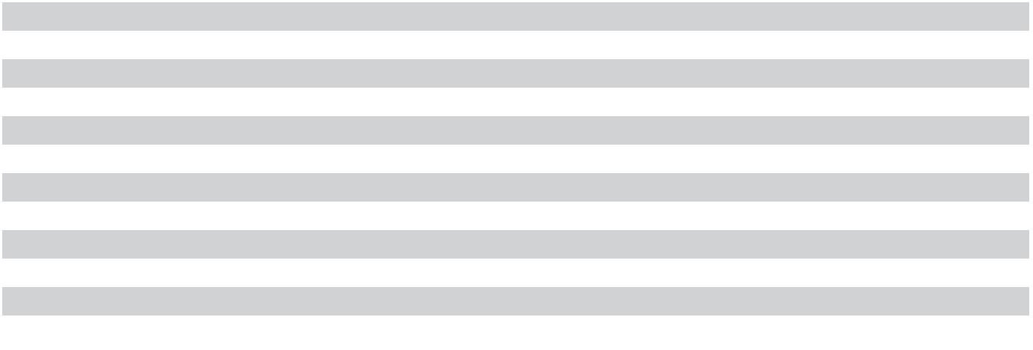

77

Income tax benefits related to the tax deductions for share-based awards are recognized only upon the settlement of the related share-based awards. Income tax benefits for share-based awards were $68 million, $77 million, and $83 million for 2023, 2022, and 2021, respectively. Stock-based compensation expense of $88 million and $48 million was capitalized and remained in inventory as of August 31, 2023 and September 1, 2022, respectively. As of August 31, 2023, $1.26 billion of total unrecognized compensation costs for unvested awards, before the effect of any future forfeitures, was expected to be recognized through the fourth quarter of 2027, resulting in a weighted-average period of 1.3 years.

Employee Benefit Plans

We have employee retirement plans at our U.S. and international sites. Details of significant plans are as follows:

Employee Savings Plan for U.S. Employees

We have a 401(k) retirement plan under which U.S. employees may contribute up to 75% of their eligible pay, subject to Internal Revenue Service annual contribution limits, to various savings alternatives, none of which include direct investment in our stock. We match in cash eligible contributions from employees up to 5% of the employee’s annual eligible earnings. Contribution expense for the 401(k) plan was $59 million, $66 million, and $77 million in 2023, 2022, and 2021, respectively.

Retirement Plans

We have pension plans available to employees at various foreign sites. As of August 31, 2023, the projected benefit obligations of our plans were $175 million and plan assets were $232 million. As of September 1, 2022, the projected benefit obligations of our plans were $186 million and plan assets were $221 million. Pension expense was not material for 2023, 2022, or 2021.

Government Incentives

We receive incentives from governmental entities primarily in India, Japan, Singapore, Taiwan, and the United States principally in the form of cash grants and tax credits. These incentives primarily relate to capital expenditures, have initial terms ranging from one year to 15 years, and may be subject to reimbursement if certain conditions are not met or maintained. The conditions attached to these incentives require us to incur expenditures related to the construction of new manufacturing facilities, the purchase and installation of specialized tools and equipment, R&D expenditures, and/or maintain certain levels of fixed asset investment or employee headcount during the incentive terms.

The line items on the balance sheet affected by government incentives were as follows:
As of |  | August 31,
As of |  | 2023
Receivables | $ | 105
Other noncurrent assets |  | 179
Other current liabilities |  | 11
Noncurrent unearned government incentives |  | 727
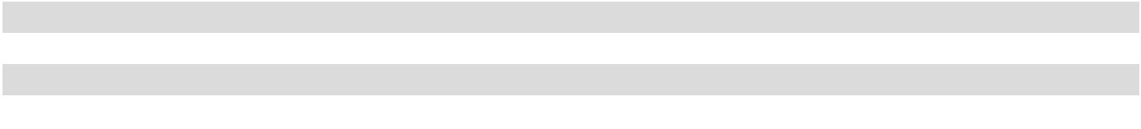

As of August 31, 2023, we had aggregate commitments from various governmental entities of up to $2 billion to be received through 2033 (in addition to the receivables and other noncurrent assets in the table above), subject to achievement of certain performance conditions. We also receive a 25% investment tax credit on qualified investments in U.S. semiconductor manufacturing under the CHIPS Act. Subsequent to August 31, 2023, we finalized an incentive arrangement under which we will receive additional grants of up to $1.3 billion.

78 | 2023 10-K

Government incentives related to capital expenditures have reduced property, plant and equipment by $1.57 billion as of August 31, 2023, of which $584 million pertained to 2023 expenditures.

In 2023, operating income (loss) benefited by $318 million (approximately 93% in COGS and 7% in R&D) from government incentives recognized as a reduction of expense, primarily in the form of reduced depreciation expense.

Revenue

Revenue is primarily recognized at a point in time when control of the promised goods is transferred to our customers in an amount that reflects the consideration we expect to be entitled to in exchange for those goods. Substantially all contracts with our customers are short-term in duration at fixed, negotiated prices with payment generally due shortly after delivery. From time to time, we have contracts with initial terms that include performance obligations that extend beyond one year. As of August 31, 2023, our future performance obligations beyond one year were not significant.

As of August 31, 2023 and September 1, 2022, other current liabilities included $453 million and $1.26 billion, respectively, for estimates of consideration payable to customers including estimates for pricing adjustments and returns.

In 2023, we received an aggregate of $228 million from settlements of insurance claims involving a power disruption in 2022 and an operational disruption in 2017, of which $186 million was for business interruption and recognized in revenue.

Revenue by Technology

For the year ended |  | 2023 |  | 2022 |  | 2021
DRAM | $ | 10,978 | $ | 22,386 | $ | 20,039
NAND |  | 4,206 |  | 7,811 |  | 7,007
Other (primarily NOR) |  | 356 |  | 561 |  | 659
 | $ | 15,540 | $ | 30,758 | $ | 27,705

See “Segment and Other Information” for disclosure of disaggregated revenue by market segment.

Restructure and Asset Impairments

For the year ended |  | 2023 |  | 2022 |  | 2021
Employee severance | $ | 163 | $ | — | $ | 3
Asset impairments and other asset-related costs |  | 14 |  | 63 |  | 478
Other |  | (6) |  | (15) |  | 7
 | $ | 171 | $ | 48 | $ | 488

In 2023, we initiated the 2023 Restructure Plan in response to challenging industry conditions. Under the 2023 Restructure Plan, we expect our headcount reduction to approach 15% by the end of calendar 2023 through a combination of voluntary attrition and personnel reductions. In connection with the plan, we incurred restructure charges of $171 million in 2023, primarily related to employee severance costs. The plan was substantially completed in the third quarter of 2023. As of August 31, 2023, we had paid $167 million in 2023 in connection with the 2023 Restructure Plan and the remaining liability was $4 million.

Restructure and asset impairments for 2022 and 2021 are primarily related to the sale of our Lehi, Utah facility. See “Lehi, Utah Fab and 3D XPoint.”

79

Other Operating (Income) Expense, Net

For the year ended |  | 2023 |  | 2022 |  | 2021
Goodwill impairment | $ | 101 | $ | — | $ | —
Litigation settlement |  | 68 |  | — |  | —
Patent license charges |  | — |  | — |  | 128
(Gain) loss on disposition of property, plant, and equipment |  | (54) |  | (41) |  | (24)
Other |  | 9 |  | 7 |  | (9)
 | $ | 124 | $ | (34) | $ | 95

Other Non-Operating Income (Expense), Net

For the year ended |  | 2023 |  | 2022 |  | 2021
Gain (loss) on investments | $ | (8) | $ | 26 | $ | 82
Loss on debt repurchases and conversions |  | — |  | (83) |  | (1)
Other |  | 15 |  | 19 |  | —
 | $ | 7 | $ | (38) | $ | 81

Income Taxes

Our income tax (provision) benefit consisted of the following:
For the year ended |  | 2023 |  | 2022 |  | 2021
Income (loss) before income taxes and equity in net income (loss) of equity method
investees
U.S. | $ | 235 | $ | 112 | $ | (211)
Foreign |  | (5,893) |  | 9,459 |  | 6,429
 | $ | (5,658) | $ | 9,571 | $ | 6,218
Income tax (provision) benefit
Current
U.S. federal | $ | (5) | $ | (65) | $ | (42)
State |  | (1) |  | (1) |  | (1)
Foreign |  | (178) |  | (528) |  | (370)
 |  | (184) |  | (594) |  | (413)
Deferred
U.S. federal |  | (84) |  | (166) |  | (9)
State |  | — |  | (225) |  | 28
Foreign |  | 91 |  | 97 |  | —
 |  | 7 |  | (294) |  | 19
Income tax (provision) benefit | $ | (177) | $ | (888) | $ | (394)
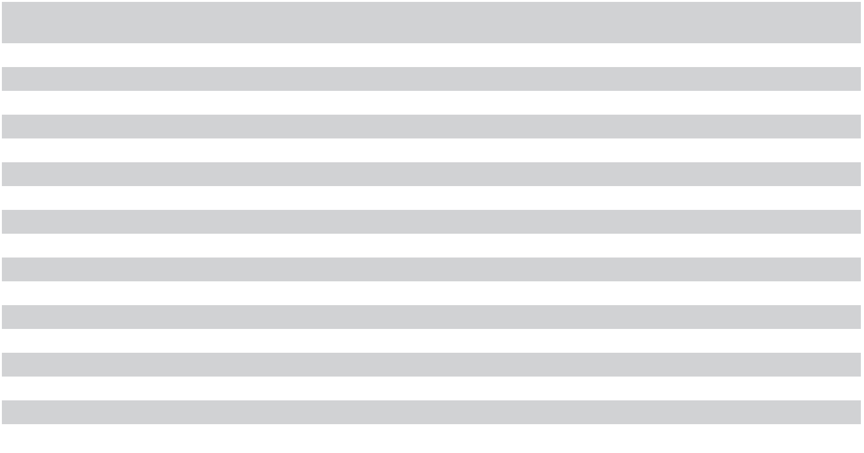

80 | 2023 10-K

The table below reconciles our tax (provision) benefit based on the U.S. federal statutory rate to our effective rate:

For the year ended |  | 2023 |  | 2022 |  | 2021
U.S. federal income tax (provision) benefit at statutory rate | $ | 1,188 | 21.0 % $ | (2,010) | 21.0 % $ | (1,306) | 21.0 %
U.S. tax on foreign operations |  | 6 | 0.1 % | (322) | 3.4 % | (226) | 3.6 %
Change in valuation allowance |  | (50) | (0.9)% | (241) | 2.5 % | 54 | (0.9)%
Change in unrecognized tax benefits |  | (30) | (0.5)% | (67) | 0.7 % | (238) | 3.8 %
Foreign tax rate differential |  | (1,285) | (22.8)% | 1,601 | (16.7)% | 951 | (15.4)%
Research and development tax credits |  | 43 | 0.8 % | 66 | (0.7)% | 123 | (2.0)%
State taxes, net of federal benefit |  | 37 | 0.7 % | — | — % | 59 | (0.9)%
Debt premium deductions |  | — | — % | — | — % | 130 | (2.1)%
Other |  | (86) | (1.5)% | 85 | (0.9)% | 59 | (0.8)%
Income tax (provision) benefit | $ | (177) | (3.1)% $ | (888) | 9.3 % $ | (394) | 6.3 %
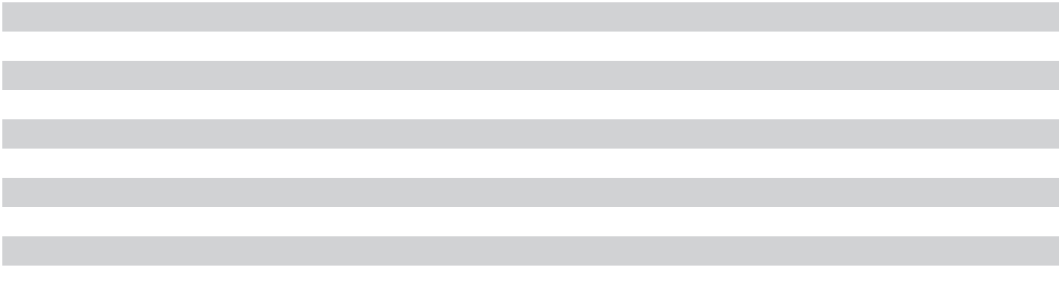

We operate in a number of jurisdictions outside the United States, including Singapore, where we have tax incentive arrangements. These incentives expire, in whole or in part, at various dates through 2034 and are conditional, in part, upon meeting certain business operations and employment thresholds. As a result of a loss before taxes and geographic mix of income, the benefit from tax incentive arrangements was not material for 2023. These arrangements reduced our tax provision by $1.12 billion (benefiting our diluted earnings per share by $1.00) for 2022 and by $758 million ($0.66 per diluted share) for 2021.

As of August 31, 2023, certain non-U.S. subsidiaries had cumulative undistributed earnings of $4.28 billion that were deemed to be indefinitely reinvested. A provision has not been recognized to the extent that distributions from such subsidiaries are subject to additional foreign withholding or state income tax. Determination of the amount of unrecognized deferred tax liabilities related to investments in these foreign subsidiaries is not practicable.

81

Deferred income taxes reflect the net tax effects of temporary differences between the bases of assets and liabilities for financial reporting and income tax purposes as well as carryforwards. Deferred tax assets and liabilities consist of the following:
As of |  | August 31, | September 1,
As of |  | 2023 |  | 2022
Deferred tax assets
Net operating loss and tax credit carryforwards | $ | 1,112 | $ | 796
Accrued salaries, wages, and benefits |  | 39 |  | 157
Operating lease liabilities |  | 135 |  | 138
Inventories |  | 52 |  | 77
Property, plant, and equipment |  | — |  | 44
Other |  | 75 |  | 142
Gross deferred tax assets |  | 1,413 |  | 1,354
Less valuation allowance |  | (528) |  | (471)
Deferred tax assets, net of valuation allowance |  | 885 |  | 883
Deferred tax liabilities
Right-of-use assets |  | (115) |  | (126)
Property, plant, and equipment |  | (31) |  | —
Other |  | (100) |  | (68)
Deferred tax liabilities |  | (246) |  | (194)
Net deferred tax assets | $ | 639 | $ | 689
Reported as
Deferred tax assets | $ | 756 | $ | 702
Deferred tax liabilities (included in other noncurrent liabilities) |  | (117) |  | (13)
Net deferred tax assets | $ | 639 | $ | 689
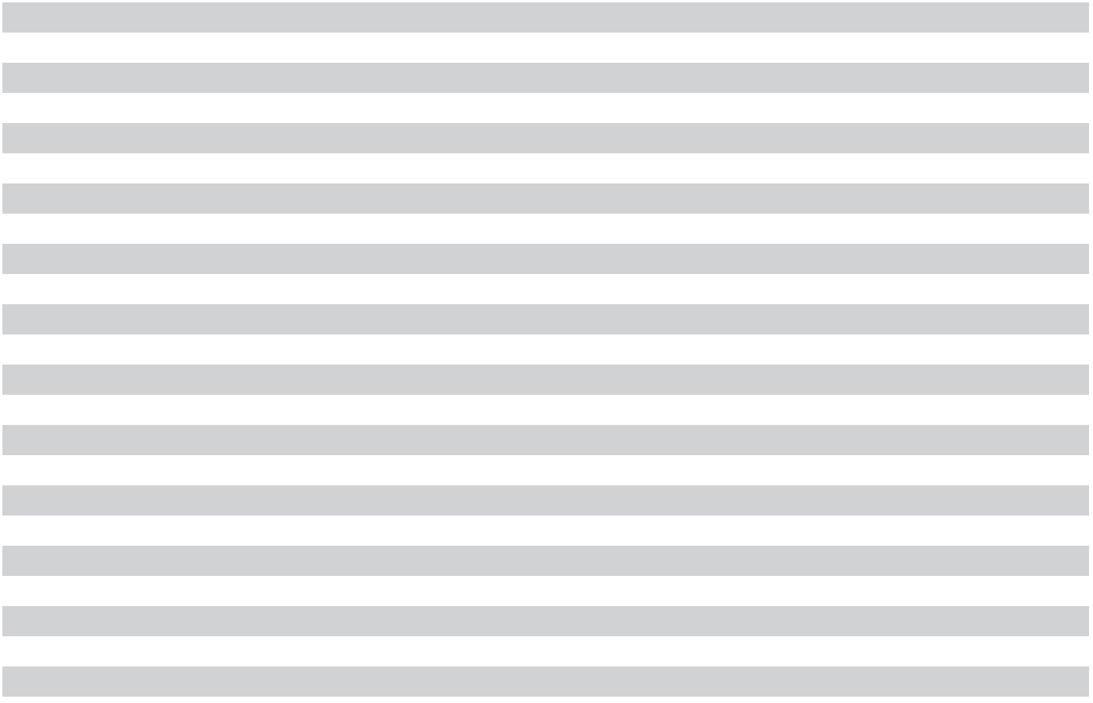

We assess positive and negative evidence for each jurisdiction to determine whether it is more likely than not that existing deferred tax assets will be realized. As of August 31, 2023, and September 1, 2022, we had a valuation allowance of $528 million and $471 million, respectively, against our net deferred tax assets, primarily related to carryforwards in U.S. states and Malaysia. Changes in 2023 in the valuation allowance were due to adjustments based on management's assessment of the realizability of tax credits, allowances and net operating losses based on a level that is more likely than not to be realized.

As of August 31, 2023, our net operating loss carryforward amounts and expiration periods, as reported to tax authorities, were as follows:
Year of Expiration |  | Singapore |  | Malaysia |  | State |  | Japan | Other |  |  | Total
2024 - 2028 | $ | — | $ | — | $ | 47 | $ | 336 | $ | 25 | $ | 408
2029 - 2033 |  | — |  | — |  | 348 |  | 321 |  | 109 |  | 778
2034 - 2038 |  | — |  | — |  | 237 |  | — |  | — |  | 237
2039 - 2043 |  | — |  | — |  | 183 |  | — |  | — |  | 183
Indefinite |  | 1,688 |  | 1,025 |  | 60 |  | — |  | 202 |  | 2,975
 | $ | 1,688 | $ | 1,025 | $ | 875 | $ | 657 | $ | 336 | $ | 4,581

82 | 2023 10-K

As of August 31, 2023, our federal and state tax credit carryforward amounts and expiration periods, as reported to tax authorities, were as follows:
Year of Tax Credit Expiration |  | U.S. Federal |  | State |  | Total
2024 - 2028 | $ | — | $ | 51 | $ | 51
2029 - 2033 |  | — |  | 120 |  | 120
2034 - 2038 |  | — |  | 137 |  | 137
2039 - 2043 |  | 306 |  | 5 |  | 311
Indefinite |  | — |  | 131 |  | 131
 | $ | 306 | $ | 444 | $ | 750
Below is a reconciliation of the beginning and ending amount of our unrecognized tax benefits:
For the year ended |  | 2023 |  | 2022 |  | 2021
Beginning unrecognized tax benefits | $ | 731 | $ | 660 | $ | 411
Increases related to tax positions from prior years |  | 2 |  | 14 |  | 2
Increases related to prior year tax positions taken in current year |  | 27 |  | — |  | —
Increases related to tax positions taken in current year |  | 17 |  | 80 |  | 260
Decreases related to tax positions from prior years |  | (33) |  | (23) |  | (13)
Ending unrecognized tax benefits | $ | 744 | $ | 731 | $ | 660

As of August 31, 2023, gross unrecognized tax benefits were $744 million, which would have an impact of approximately $581 million on our effective tax rate in the future, if recognized. Amounts accrued for interest and penalties related to uncertain tax positions were not significant for any period presented. The resolution of tax audits or expiration of statute of limitations could also reduce our unrecognized tax benefits. Although the timing of final resolution is uncertain, the estimated potential reduction in our unrecognized tax benefits in the next 12 months would not be significant.

We and our subsidiaries file income tax returns with the U.S. federal government, various U.S. states, and various foreign jurisdictions throughout the world. We regularly engage in discussions and negotiations with tax authorities regarding tax matters, including transfer pricing, and we continue to defend any and all such claims presented. Our U.S. federal and state tax returns remain open to examination for 2018 through 2023. We are currently under audit by the Internal Revenue Service for our 2018 and 2019 tax years. In addition, tax returns that remain open to examination in Singapore, Taiwan and Japan range from the years 2014 to 2023. We believe that adequate amounts of taxes and related interest and penalties have been provided, and any adjustments as a result of examinations are not expected to materially adversely affect our business, results of operations, or financial condition.

Earnings Per Share

For the year ended |  | 2023 |  | 2022 |  | 2021
Net income (loss) – Basic and Diluted | $ | (5,833) | $ | 8,687 | $ | 5,861
Weighted-average common shares outstanding – Basic |  | 1,093 |  | 1,112 |  | 1,120
Dilutive effect of equity plans and convertible notes |  | — |  | 10 |  | 21
Weighted-average common shares outstanding – Diluted |  | 1,093 |  | 1,122 |  | 1,141
Earnings (loss) per share
Basic | $ | (5.34) | $ | 7.81 | $ | 5.23
Diluted |  | (5.34) |  | 7.75 |  | 5.14
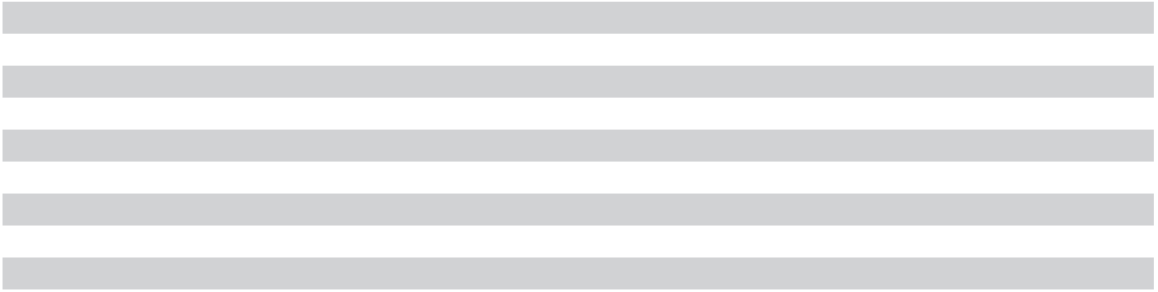

83

Antidilutive potential common shares excluded from the computation of diluted earnings per share, that could dilute basic earnings per share in the future, were as follows at the end of the periods shown:
For the year ended | 2023 | 2022 | 2021
Equity plans | 33 | 5 | 2

Segment and Other Information

Segment information reported herein is consistent with how it is reviewed and evaluated by our chief operating decision maker. We have the following four business units, which are our reportable segments:

Compute and Networking Business Unit (“CNBU”): Includes memory products and solutions sold into client, cloud server, enterprise, graphics, and networking markets.

Mobile Business Unit (“MBU”): Includes memory and storage products sold into smartphone and other mobile-device markets.

Embedded Business Unit (“EBU”): Includes memory and storage products and solutions sold into automotive, industrial, and consumer markets.

Storage Business Unit (“SBU”): Includes SSDs and component-level solutions sold into enterprise and cloud, client, and consumer storage markets.

Certain operating expenses directly associated with the activities of a specific segment are charged to that segment. Other indirect operating income and expenses are generally allocated to segments based on their respective percentage of cost of goods sold or forecasted wafer production. We do not identify or report internally our assets (other than goodwill) or capital expenditures by segment, nor do we allocate gains and losses from equity method investments, interest, other non-operating income or expense items, or taxes to segments.

84 | 2023 10-K

For the year ended |  | 2023 |  | 2022 |  | 2021
Revenue
CNBU | $ | 5,710 | $ | 13,693 | $ | 12,280
MBU |  | 3,630 |  | 7,260 |  | 7,203
EBU |  | 3,637 |  | 5,235 |  | 4,209
SBU |  | 2,553 |  | 4,553 |  | 3,973
All Other |  | 10 |  | 17 |  | 40
 | $ | 15,540 | $ | 30,758 | $ | 27,705
Operating income (loss)
CNBU | $ | (585) | $ | 5,844 | $ | 4,295
MBU |  | (1,750) |  | 2,160 |  | 2,173
EBU |  | 382 |  | 1,752 |  | 1,006
SBU |  | (1,887) |  | 513 |  | 173
All Other |  | 8 |  | 12 |  | 20
 |  | (3,832) |  | 10,281 |  | 7,667
Unallocated
Provision to write down inventories to net realizable value |  | (1,831) |  | — |  | —
Lower costs from sale of inventory written down in prior periods |  | 844 |  | — |  | —
Stock-based compensation |  | (564) |  | (501) |  | (395)
Inventory accounting policy change to FIFO |  | — |  | — |  | (133)
Change in inventory cost absorption |  | — |  | — |  | (160)
3D XPoint inventory write-down |  | — |  | — |  | (49)
Restructure and asset impairments |  | (171) |  | (48) |  | (488)
Goodwill impairment |  | (101) |  | — |  | —
Litigation settlement |  | (68) |  | — |  | —
Patent license charges |  | — |  | — |  | (128)
Other |  | (22) |  | (30) |  | (31)
 |  | (1,913) |  | (579) |  | (1,384)
Operating income (loss)
Operating income (loss) | $ | (5,745) | $ | 9,702 | $ | 6,283
Depreciation and amortization expense included in operating income (loss) was as follows:
For the year ended |  | 2023 |  | 2022 |  | 2021
CNBU | $ | 2,512 | $ | 2,766 | $ | 2,497
MBU |  | 2,149 |  | 1,725 |  | 1,553
EBU |  | 1,324 |  | 1,280 |  | 1,028
SBU |  | 1,751 |  | 1,323 |  | 1,101
All Other |  | 1 |  | 2 |  | 8
Unallocated |  | 19 |  | 20 |  | 27
 | $ | 7,756 | $ | 7,116 | $ | 6,214


85

Certain Concentrations

Revenue by market segment as an approximate percent of total revenue is presented in the table below:

For the year ended | 2023 | 2022 | 2021
Automotive, industrial, and consumer | 25 % | 15 % | 15 %
Mobile | 25 % | 25 % | 25 %
Client and graphics | 15 % | 20 % | 20 %
Enterprise and cloud server | 15 % | 20 % | 20 %
SSDs and other storage | 15 % | 15 % | 15 %

No customer accounted for 10% or more of total revenue in 2023. Revenue from Kingston Technology Company, Inc. was 12% of total revenue in 2022 and revenue from WPG Holdings Limited was 11% and 13% of total revenue in 2022 and 2021, respectively. Sales to Kingston were primarily included in our CNBU and SBU segments and sales to WPG were primarily included in our MBU, CNBU, and EBU segments.

We generally have multiple sources of supply for our raw materials and production equipment; however, only a limited number of suppliers are capable of delivering certain raw materials and production equipment that meet our standards and, in some cases, materials or production equipment are provided by a single supplier.

Financial instruments that potentially subject us to concentrations of credit risk consist principally of cash, money market accounts, certificates of deposit, fixed-rate debt securities, trade receivables, share repurchase, and derivative contracts. We invest through high-credit-quality financial institutions and, by policy, generally limit the concentration of credit exposure by restricting investments with any single obligor and monitoring credit risk of bank counterparties on an ongoing basis. A concentration of credit risk may exist with respect to receivables of certain customers. We perform ongoing credit evaluations of customers worldwide and generally do not require collateral from our customers. Historically, we have not experienced material losses on receivables. A concentration of risk may also exist with respect to our foreign currency hedges as the number of counterparties to our hedges is limited and the notional amounts are relatively large. We seek to mitigate such risk by limiting our counterparties to major financial institutions and through entering into master netting arrangements.

86 | 2023 10-K

Geographic Information

Revenue based on the geographic location of our customers’ headquarters was as follows:
For the year ended |  | 2023 |  | 2022 |  | 2021
United States | $ | 7,805 | $ | 16,026 | $ | 12,155
Taiwan |  | 2,697 |  | 6,185 |  | 6,606
Mainland China (excluding Hong Kong) |  | 2,181 |  | 3,311 |  | 2,456
Japan |  | 987 |  | 1,696 |  | 1,652
Other Asia Pacific |  | 752 |  | 1,223 |  | 1,420
Europe |  | 682 |  | 505 |  | 573
Hong Kong |  | 340 |  | 1,665 |  | 2,582
Other |  | 96 |  | 147 |  | 261
 | $ | 15,540 | $ | 30,758 | $ | 27,705

Long-lived assets by geographic area consisted of property, plant, and equipment and operating lease right-of-use assets and were as follows:
As of |  | August 31, | September 1,
As of |  | 2023 |  | 2022
Taiwan | $ | 12,926 | $ | 13,143
Singapore |  | 11,283 |  | 12,045
Japan |  | 7,323 |  | 7,113
United States |  | 5,196 |  | 5,155
Malaysia |  | 1,124 |  | 994
China |  | 395 |  | 440
Other |  | 347 |  | 337
 | $ | 38,594 | $ | 39,227

87

Report of Independent Registered Public Accounting Firm

To the Board of Directors and Shareholders of Micron Technology, Inc.

Opinions on the Financial Statements and Internal Control over Financial Reporting

We have audited the accompanying consolidated balance sheets of Micron Technology, Inc. and its subsidiaries (the “Company”) as of August 31, 2023 and September 1, 2022, and the related consolidated statements of operations, of comprehensive income (loss), of changes in equity and of cash flows for each of the three years in the period ended August 31, 2023, including the related notes and schedule of valuation and qualifying accounts for each of the three years in the period ended August 31, 2023 appearing under Item 15 (collectively referred to as the “consolidated financial statements”). We also have audited the Company’s internal control over financial reporting as of August 31, 2023, based on criteria established in Internal Control - Integrated Framework (2013) issued by the Committee of Sponsoring Organizations of the Treadway Commission (COSO).

In our opinion, the consolidated financial statements referred to above present fairly, in all material respects, the financial position of the Company as of August 31, 2023 and September 1, 2022, and the results of its operations and its cash flows for each of the three years in the period ended August 31, 2023 in conformity with accounting principles generally accepted in the United States of America. Also in our opinion, the Company maintained, in all material respects, effective internal control over financial reporting as of August 31, 2023, based on criteria established in Internal Control - Integrated Framework (2013) issued by the COSO.

Change in Accounting Principle

As discussed in the Significant Accounting Policies and Inventories notes to the consolidated financial statements, the Company changed the manner in which it accounts for inventory costing from the average cost inventory accounting method to the first-in, first-out inventory accounting method in 2021.

Basis for Opinions

The Company’s management is responsible for these consolidated financial statements, for maintaining effective internal control over financial reporting, and for its assessment of the effectiveness of internal control over financial reporting, included in Management’s Report on Internal Control over Financial Reporting appearing under Item 9A. Our responsibility is to express opinions on the Company’s consolidated financial statements and on the Company’s internal control over financial reporting based on our audits. We are a public accounting firm registered with the Public Company Accounting Oversight Board (United States) (PCAOB) and are required to be independent with respect to the Company in accordance with the U.S. federal securities laws and the applicable rules and regulations of the Securities and Exchange Commission and the PCAOB.

We conducted our audits in accordance with the standards of the PCAOB. Those standards require that we plan and perform the audits to obtain reasonable assurance about whether the consolidated financial statements are free of material misstatement, whether due to error or fraud, and whether effective internal control over financial reporting was maintained in all material respects.

Our audits of the consolidated financial statements included performing procedures to assess the risks of material misstatement of the consolidated financial statements, whether due to error or fraud, and performing procedures that respond to those risks. Such procedures included examining, on a test basis, evidence regarding the amounts and disclosures in the consolidated financial statements. Our audits also included evaluating the accounting principles used and significant estimates made by management, as well as evaluating the overall presentation of the consolidated financial statements. Our audit of internal control over financial reporting included obtaining an understanding of internal control over financial reporting, assessing the risk that a material weakness exists, and testing and evaluating the design and operating effectiveness of internal control based on the assessed risk. Our audits also included performing such other procedures as we considered necessary in the circumstances. We believe that our audits provide a reasonable basis for our opinions.

88 | 2023 10-K

Definition and Limitations of Internal Control over Financial Reporting

A company’s internal control over financial reporting is a process designed to provide reasonable assurance regarding the reliability of financial reporting and the preparation of financial statements for external purposes in accordance with generally accepted accounting principles. A company’s internal control over financial reporting includes those policies and procedures that (i) pertain to the maintenance of records that, in reasonable detail, accurately and fairly reflect the transactions and dispositions of the assets of the company; (ii) provide reasonable assurance that transactions are recorded as necessary to permit preparation of financial statements in accordance with generally accepted accounting principles, and that receipts and expenditures of the company are being made only in accordance with authorizations of management and directors of the company; and (iii) provide reasonable assurance regarding prevention or timely detection of unauthorized acquisition, use, or disposition of the company’s assets that could have a material effect on the financial statements.

Because of its inherent limitations, internal control over financial reporting may not prevent or detect misstatements. Also, projections of any evaluation of effectiveness to future periods are subject to the risk that controls may become inadequate because of changes in conditions, or that the degree of compliance with the policies or procedures may deteriorate.

Critical Audit Matters

The critical audit matter communicated below is a matter arising from the current period audit of the consolidated financial statements that was communicated or required to be communicated to the audit committee and that (i) relates to accounts or disclosures that are material to the consolidated financial statements and (ii) involved our especially challenging, subjective, or complex judgments. The communication of critical audit matters does not alter in any way our opinion on the consolidated financial statements, taken as a whole, and we are not, by communicating the critical audit matter below, providing a separate opinion on the critical audit matter or on the accounts or disclosures to which it relates.

Net Realizable Value of Finished Goods and Work in Process Inventories

As described in the Inventories note to the consolidated financial statements, as of August 31, 2023, the Company had net finished goods and work in process inventories totaling $7.7 billion. As disclosed by management, determining the net realizable value of the Company's finished goods and work in process inventories involves significant judgments, including projecting future average selling prices, future sales volumes, and future cost per part. The memory and storage industry environment deteriorated sharply in the fourth quarter of 2022 and throughout 2023 due to weak demand in many end markets combined with global and macroeconomic challenges and lower demand resulting from customer actions to reduce elevated inventory levels. This led to significant reductions in average selling prices for both DRAM and NAND, resulting in declines in revenue across all of the Company’s business segments and nearly all end markets. The Company recorded charges of $1.83 billion to cost of goods sold to write down the carrying value of work in process and finished goods inventories to their estimated net realizable value.

The principal considerations for our determination that performing procedures relating to the net realizable value of finished goods and work in process inventories is a critical audit matter are (i) the significant judgment by management in determining the net realizable value of finished goods and work in process inventories and (ii) a high degree of auditor judgment, subjectivity, and effort in performing procedures and evaluating management’s significant assumptions related to future average selling prices and future cost per part.

89

Addressing the matter involved performing procedures and evaluating audit evidence in connection with forming our overall opinion on the consolidated financial statements. These procedures included testing the effectiveness of controls relating to management’s determination of the net realizable value of finished goods and work in process inventories, including controls over significant assumptions and data utilized. These procedures also included, among others (i) testing management's process for determining the net realizable value of finished goods and work in process inventories; (ii) evaluating the appropriateness of management’s methodology; (iii) testing the completeness and accuracy of underlying data used in determining the net realizable value; and (iv) evaluating the reasonableness of management's significant assumptions related to future average selling prices and future cost per part. Evaluating management's assumption related to future average selling prices for certain products involved evaluating whether the assumption used by management was reasonable considering (i) current and past results, including recent sales; (ii) the consistency with external market, industry data or current contract prices; (iii) a comparison of the prior year estimates to actual results in the current fiscal year; and (iv) whether the assumption was consistent with evidence obtained in other areas of the audit. Evaluating management's assumption related to future cost per part for certain products involved evaluating whether the assumption used by management was reasonable considering (i) current and past results; (ii) a comparison of the prior year estimates to actual results in the current fiscal year; and (iii) whether the assumption was consistent with evidence obtained in other areas of the audit.

/s/ PricewaterhouseCoopers LLP

San Jose, California

October 6, 2023

We have served as the Company’s auditor since 1984.

90 | 2023 10-K

ITEM 9. CHANGES IN AND DISAGREEMENTS WITH ACCOUNTANTS ON ACCOUNTING AND FINANCIAL DISCLOSURE

None.

ITEM 9A. CONTROLS AND PROCEDURES

An evaluation was carried out under the supervision and with the participation of our management, including our principal executive officer and principal financial officer, of the effectiveness of the design and operation of our disclosure controls and procedures (as defined in Rules 13a-15(e) and 15d-15(e) under the Securities Exchange Act of 1934, as amended (the “Exchange Act”)) as of the end of the period covered by this report. Based upon that evaluation, the principal executive officer and principal financial officer concluded that those disclosure controls and procedures were effective to ensure that information required to be disclosed by us in the reports that we file or submit under the Exchange Act are recorded, processed, summarized, and reported within the time periods specified in the SEC’s rules and forms and that such information is accumulated and communicated to our management, including the principal executive officer and principal financial officer, to allow timely decisions regarding disclosure.

During the fourth quarter of 2023, there were no changes in our internal control over financial reporting that have materially affected, or are reasonably likely to materially affect, our internal control over financial reporting.

Management’s Report on Internal Control Over Financial Reporting

Our management is responsible for establishing and maintaining adequate internal control over financial reporting. Internal control over financial reporting is a process designed to provide reasonable assurance regarding the reliability of financial reporting and the preparation of financial statements for external purposes in accordance with accounting principles generally accepted in the United States of America. Our internal control over financial reporting includes those policies and procedures that (i) pertain to the maintenance of records that in reasonable detail accurately reflect the transactions and dispositions of our assets; (ii) provide reasonable assurance that transactions are recorded as necessary to permit preparation of financial statements in accordance with generally accepted accounting principles, and that our receipts and expenditures are being made only in accordance with authorizations of our management and directors; and (iii) provide reasonable assurance regarding prevention or timely detection of unauthorized acquisition, use, or disposition of our assets that could have a material effect on our financial statements.

Because of its inherent limitations, internal control over financial reporting may not prevent or detect misstatements. Also, projections of any evaluation of effectiveness to future periods are subject to the risk that controls may become inadequate because of changes in conditions or that the degree of compliance with the policies or procedures may deteriorate.

Management conducted an evaluation of the effectiveness of our internal control over financial reporting based on the framework in Internal Control – Integrated Framework (2013) issued by the Committee of Sponsoring Organizations of the Treadway Commission. Based on this evaluation, management concluded that our internal control over financial reporting was effective as of August 31, 2023. The effectiveness of our internal control over financial reporting as of August 31, 2023 has been audited by PricewaterhouseCoopers LLP, an independent registered public accounting firm, as stated in their report, which is included in Part II, Item 8, of this Form 10-K.

91

ITEM 9B. OTHER INFORMATION

Securities Trading Plans of Directors and Executive Officers

The following director and officer, as defined in Rule 16a-1(f) of the Exchange Act, adopted a “Rule 10b5-1 trading arrangement,” as defined in Item 408 of Regulation S-K, as follows:

On May 15, 2023, Sanjay Mehrotra, our President, Chief Executive Officer and Director, adopted a Rule 10b5-1 trading arrangement providing for the sale of an aggregate of up to 812,284 shares of our common stock, including up to 612,284 shares subject to outstanding stock options, which were granted in calendar 2017 and would otherwise expire in calendar 2025. The remaining shares subject to the trading arrangement are shares acquired by Mr. Mehrotra pursuant to our Restricted Stock Awards. The trading arrangement is intended to satisfy the affirmative defense in Rule 10b5-1(c). The first date that sales of any shares were permitted to be sold under the trading arrangement was August 14, 2023, and subsequent sales under the trading arrangement may occur on a regular basis for the duration of the trading arrangement until May 8, 2025, or earlier if all transactions under the trading arrangement are completed.

No other officers or directors, as defined in Rule 16a-1(f), adopted and/or terminated a “Rule 10b5-1 trading arrangement” or a “non-Rule 10b5-1 trading arrangement,” as defined in Item 408 of Regulation S-K, during the last fiscal quarter.

ITEM 9C. DISCLOSURE REGARDING FOREIGN JURISDICTIONS THAT PREVENT INSPECTIONS

Not applicable.

PART III

ITEM 10. DIRECTORS, EXECUTIVE OFFICERS, AND CORPORATE GOVERNANCE ITEM 11. EXECUTIVE COMPENSATION

ITEM 12. SECURITY OWNERSHIP OF CERTAIN BENEFICIAL OWNERS AND MANAGEMENT AND RELATED STOCKHOLDER MATTERS

ITEM 13. CERTAIN RELATIONSHIPS AND RELATED TRANSACTIONS, AND DIRECTOR INDEPENDENCE

ITEM 14. PRINCIPAL ACCOUNTANT FEES AND SERVICES

Certain information concerning our executive officers is included under the caption, “Information About Our Executive Officers” in Part I, Item 1 of this report. Other information required by Items 10, 11, 12, 13, and 14 will be contained in our 2023 Proxy Statement which will be filed with the SEC within 120 days after August 31, 2023 and is incorporated herein by reference.

92 | 2023 10-K

PART IV

ITEM 15. EXHIBITS AND FINANCIAL STATEMENT SCHEDULE

(a) The following documents are filed as part of this report:

- Financial Statements: See our consolidated financial statements under Item 8.

- Financial Statement Schedule:
See “Schedule II – Valuation and Qualifying Accounts” within Item 15 below.

Certain Financial Statement Schedules have been omitted since they are either not required, not applicable, or the information is otherwise included.

- Exhibits. See “Index to Exhibits” within Item 15 below.

93

SCHEDULE II

VALUATION AND QUALIFYING ACCOUNTS

(In millions)

 |  |  |  | Charged |  | Currency
 |  | Balance at |  | Charged |  | Translation |  | Balance at
 |  | Balance at | (Credited) to |  | and Charges |  |  | Balance at
 | Beginning of |  |  | Income Tax |  | to Other |  | End of
 |  | Year |  | Provision |  | Accounts |  | Year
Deferred Tax Asset Valuation Allowance
Year ended August 31, 2023 | $ | 471 | $ | 58 | $ | (1) | $ | 528
Year ended September 1, 2022 |  | 233 |  | 241 |  | (3) |  | 471
Year ended September 2, 2021 |  | 294 |  | (54) |  | (7) |  | 233
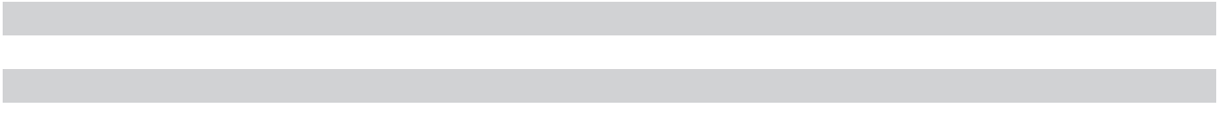

94 | 2023 10-K

Index to Exhibits

Exhibit | Description of Exhibit | Filed | Period | Exhibit/ | Filing
Number | Description of Exhibit | Herewith Form | Ending | Appendix | Date
3.1 | Restated Certificate of Incorporation of the Registrant | 8-K |  | 99.2 | 1/26/15
3.2 | Bylaws of the Registrant, Amended and Restated | 8-K |  | 3.1 | 2/16/21
4.1 | Indenture, dated as of February 6, 2019, by and between Micron | 8-K |  | 4.1 | 2/6/19
 | Technology, Inc. and U.S. Bank National Association, as Trustee
4.2 | First Supplemental Indenture, dated as of February 6, 2019, by and | 8-K |  | 4.2 | 2/6/19
 | between Micron Technology, Inc. and U.S. Bank National
 | Association, as Trustee
4.3 | Form of Note for Micron Technology, Inc.’s 4.975% Senior Notes | 8-K |  | 4.4 | 2/6/19
 | due 2026 (included in Exhibit 4.2)
4.4 | Form of Note for Micron Technology, Inc.’s 5.327% Senior Notes | 8-K |  | 4.5 | 2/6/19
 | due 2029 (included in Exhibit 4.2)
4.5 | Second Supplemental Indenture, dated as of July 12, 2019, by and | 8-K |  | 4.2 | 7/12/19
 | between Micron Technology, Inc. and U.S. Bank National
 | Association, as Trustee
4.6 | Form of Note for Micron Technology, Inc.’s 4.185% Senior Notes | 8-K |  | 4.3 | 7/12/19
 | due 2027 (included in Exhibit 4.5)
4.7 | Form of Note for Micron Technology, Inc.’s 4.663% Senior Notes | 8-K |  | 4.4 | 7/12/19
 | due 2030 (included in Exhibit 4.5)
4.8 | Fourth Supplemental Indenture, dated as of November 1, 2021, by | 8-K |  | 4.2 | 11/1/21
 | and between Micron Technology, Inc. and U.S. Bank National
 | Association, as Trustee
4.9 | Form of Note for Micron Technology, Inc.’s 2.703% Senior Notes | 8-K |  | 4.3 | 11/1/21
 | due 2032 (included in Exhibit 4.8)
4.10 | Form of Note for Micron Technology, Inc.’s 3.366% Senior Notes | 8-K |  | 4.4 | 11/1/21
 | due 2041 (included in Exhibit 4.8)
4.11 | Form of Note for Micron Technology, Inc.’s 3.477% Senior Notes | 8-K |  | 4.5 | 11/1/21
 | due 2051 (included in Exhibit 4.8)


4.12 Description of Registrant’s Securities

4.13 Fifth Supplemental Indenture, dated as of October 31, 2022, by and between Micron Technology, Inc. and U.S. Bank Trust Company, National Association, as Trustee

10-K | 9/1/22 | 4.12 | 10/7/22
8-K |  | 4.2 | 10/31/22

4.14 | Form of Note for Micron Technology, Inc.’s 6.750% Senior Notes | 8-K |  | 4.3 | 10/31/22
 | due 2029 (included in Exhibit 4.13)
4.15 | Sixth Supplemental Indenture, dated as of February 9, 2023, by and | 8-K |  | 4.3 | 2/9/23
 | between Micron Technology, Inc. and U.S. Bank Trust Company,
 | National Association, as Trustee
4.16 | Form of Note for Micron Technology, Inc.’s 5.875% Senior Notes | 8-K |  | 4.5 | 2/9/23
 | due 2033 (included in Exhibit 4.15)
4.17 | Seventh Supplemental Indenture, dated as of April 11, 2023, by and | 8-K |  | 4.2 | 4/11/23
 | between Micron Technology, Inc. and U.S. Bank Trust Company,
 | National Association, as Trustee
4.18 | Form of Note for Micron Technology, Inc.’s 5.375% Senior Notes | 8-K |  | 4.3 | 4/11/23
 | due 2028 (included in Exhibit 4.17)
4.19 | Form of Note for Micron Technology, Inc.’s 5.875% Senior Notes | 8-K |  | 4.4 | 4/11/23
 | due 2033 (included in Exhibit 4.17)
10.1* | Micron Technology, Inc. Executive Officer Performance Incentive | DEF |  | B | 12/7/17
 | Plan | 14A
10.2* | Amended and Restated 2004 Equity Incentive Plan | 10-Q | 12/1/22 | 10.1 | 12/22/22
10.3* | 2004 Equity Incentive Plan Forms of Agreement and Terms and | 10-Q | 12/1/22 | 10.2 | 12/22/22
 | Conditions
10.4* | Amended and Restated 2007 Equity Incentive Plan | DEF |  | A | 12/1/20
 |  | 14A

95

Exhibit | Description of Exhibit | Filed | Period | Exhibit/ | Filing
Number | Description of Exhibit | Herewith Form | Ending | Appendix | Date
10.5* | 2007 Equity Incentive Plan Forms of Agreement and Terms and | 10-Q | 12/1/22 | 10.3 | 12/22/22
 | Conditions
10.6* | Nonstatutory Stock Option Plan, as Amended | 10-K | 9/1/16 | 10.10 | 10/28/16
10.7* | Nonstatutory Stock Option Plan Form of Agreement and Terms and | 10-K | 9/1/16 | 10.11 | 10/28/16
 | Conditions
10.8* | Form of Indemnification Agreement between the Registrant and its | 10-Q | 2/27/14 | 10.3 | 4/7/14
 | officers and directors
10.9* | Form of Severance Agreement | 8-K |  | 99.2 | 11/1/07
10.10* | Deferred Compensation Plan, as amended | X
10.11* | Amended and Restated Executive Agreement by and between | 10-K | 9/1/22 | 10.11 | 10/7/22
 | Micron Technology, Inc. and Sanjay Mehrotra
10.12* | Severance Benefits for Sumit Sadana | 10-Q | 11/30/17 | 10.70 | 12/20/17
10.13* | Form of Amendment to Executive/Severance Agreement | 8-K |  | 99.1 | 11/13/17
10.14* | Severance Benefits for Manish Bhatia | 10-Q | 11/30/17 | 10.74 | 12/20/17
10.15* | Micron Technology, Inc. Employee Stock Purchase Plan, as | 10-Q | 6/2/22 | 10.1 | 7/1/22
 | amended and restated
10.16* | Severance Benefits for Mark Murphy | 10-Q | 6/2/22 | 10.3 | 7/1/22
10.17 | Credit Agreement, dated as of May 14, 2021, by and among Micron | 10-Q | 6/3/21 | 10.22 | 7/1/21
 | Technology, Inc., as borrower, HSBC Bank USA, National
 | Association, as administrative agent, the other agents party thereto,
 | and each financial institution party from time to time thereto
10.18 | Term Loan Credit Agreement, dated as of May 14, 2021, by and | 10-Q | 6/3/21 | 10.23 | 7/1/21
 | among Micron Technology, Inc., as borrower, Wells Fargo Bank,
 | National Association, as administrative agent, the other agents party
 | thereto, and each financial institution party from time to time thereto
10.19 | Term Loan Credit Agreement, dated as of November 3, 2022, by | 10-Q | 12/1/22 | 10.4 | 12/22/22
 | and among Micron Technology, Inc., as borrower, Wells Fargo Bank,
 | National Association, as administrative agent, the other agents party
 | thereto, and each financial institution party from time to time thereto
10.20 | Incremental Amendment No. 1, dated as of January 5, 2023, to the | 10-Q | 3/2/23 | 10.1 | 3/29/23
 | Term Loan Credit Agreement, dated as of November 3, 2022, by
 | and among Micron Technology, Inc., as borrower, Wells Fargo Bank,
 | National Association, as administrative agent, and the lenders party
 | thereto
10.21 | Amendment No. 1 to Term Loan Credit Agreement, dated as of | 10-Q | 3/2/23 | 10.3 | 3/29/23
 | March 27, 2023, by and among Micron Technology, Inc., as
 | borrower, Wells Fargo Bank, National Association, as administrative
 | agent, and the lenders party thereto
10.22 | Amendment No. 2 to Term Loan Credit Agreement, dated as of | 10-Q | 3/2/23 | 10.2 | 3/29/23
 | March 27, 2023, by and among Micron Technology, Inc., as
 | borrower, Wells Fargo Bank, National Association, as administrative
 | agent, and the lenders party thereto
10.23 | Amendment No. 1 to Credit Agreement, dated as of March 27, 2023, | 10-Q | 3/2/23 | 10.4 | 3/29/23
 | by and among Micron Technology, Inc., as borrower, HSBC Bank
 | USA, National Association, as administrative agent, and the lenders
 | party thereto
10.24* | Form of Consent for Named Executive Officers | 10-Q | 3/2/23 | 10.5 | 3/29/23
10.25 | Amendment No. 2 to Credit Agreement, dated as of June 7, 2023, | 10-Q | 6/1/23 | 10.1 | 6/29/23
 | by HSBC Bank USA, National Association, as administrative agent
10.26 | Amendment No. 2 to Term Loan Credit Agreement, dated as of June | 10-Q | 6/1/23 | 10.2 | 6/29/23
 | 7, 2023, by Wells Fargo Bank, National Association, as
 | administrative agent
21.1 | Subsidiaries of the Registrant | X
23.1 | Consent of Independent Registered Public Accounting Firm | X
31.1 | Rule 13a-14(a) Certification of Chief Executive Officer | X


96 | 2023 10-K

Exhibit | Description of Exhibit | Filed | Period | Exhibit/ | Filing
Number | Description of Exhibit | Herewith Form | Ending | Appendix | Date
31.2 | Rule 13a-14(a) Certification of Chief Financial Officer | X
32.1 | Certification of Chief Executive Officer Pursuant to 18 U.S.C. 1350 | X
32.2 | Certification of Chief Financial Officer Pursuant to 18 U.S.C. 1350 | X
97.1 | Compensation Recoupment (Clawback) Policy, as amended and | X
 | restated
101.INS | Inline XBRL Instance Document - the instance document does not | X
 | appear in the Interactive Data File because its XBRL tags are
 | embedded within the Inline XBRL document
101.SCH | Inline XBRL Taxonomy Extension Schema Document | X
101.CAL | Inline XBRL Taxonomy Extension Calculation Linkbase Document | X
101.DEF | Inline XBRL Taxonomy Extension Definition Linkbase Document | X
101.LAB | Inline XBRL Taxonomy Extension Label Linkbase Document | X
101.PRE | Inline XBRL Taxonomy Extension Presentation Linkbase Document | X
104 | Cover Page Interactive Data File (formatted as Inline XBRL and | X
 | contained in Exhibit 101)
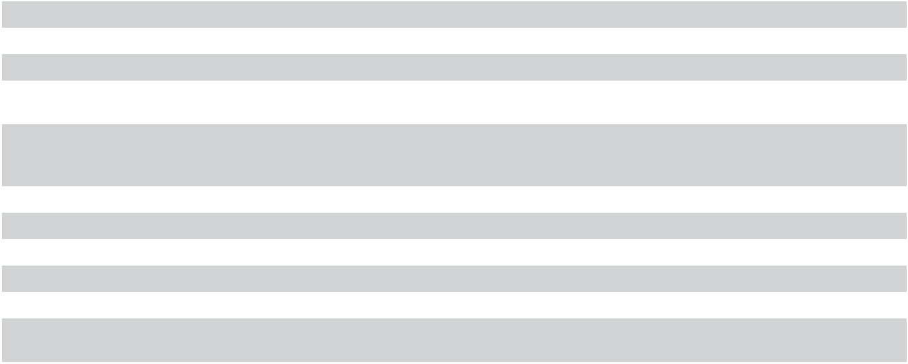

* Indicates management contract or compensatory plan or arrangement.

ITEM 16. FORM 10-K SUMMARY

None.

97

SIGNATURES

Pursuant to the requirements of Section 13 or 15(d) of the Securities Exchange Act of 1934, the Registrant has duly caused this report to be signed on its behalf by the undersigned, thereunto duly authorized.
Micron Technology, Inc.

Date October 6, 2023 By: /s/ Mark Murphy

Mark Murphy

Executive Vice President and Chief Financial Officer

(Principal Financial Officer)

Pursuant to the requirements of the Securities Exchange Act of 1934, this report has been signed below by the following persons on behalf of the Registrant and in the capacities and on the dates indicated.

 | Signature |  |  | Title |  |  | Date
/s/ Sanjay Mehrotra |  |  | President and |  |  | October 6, 2023
(Sanjay Mehrotra) |  |  | Chief Executive Officer and
 |  |  | Director
 |  |  | (Principal Executive Officer)
/s/ Mark Murphy |  |  | Executive Vice President and |  |  | October 6, 2023
(Mark Murphy) |  |  | Chief Financial Officer
 |  |  | (Principal Financial Officer)
/s/ Scott Allen |  |  | Corporate Vice President and |  |  | October 6, 2023
(Scott Allen) |  |  | Chief Accounting Officer
 |  |  | (Principal Accounting Officer)
/s/ Richard M. Beyer |  |  | Director |  |  | October 6, 2023
(Richard M. Beyer)
/s/ Lynn Dugle |  |  | Director |  |  | October 6, 2023
(Lynn Dugle)
/s/ Steve Gomo |  |  | Director |  |  | October 6, 2023
(Steve Gomo)
/s/ Linnie Haynesworth |  |  | Director |  |  | October 6, 2023
(Linnie Haynesworth)
/s/ Mary Pat McCarthy |  |  | Director |  |  | October 6, 2023
(Mary Pat McCarthy)
/s/ Robert E. Switz |  |  | Chair of the Board |  |  | October 6, 2023
(Robert E. Switz) |  |  | Director
/s/ MaryAnn Wright |  |  | Director |  |  | October 6, 2023
(MaryAnn Wright)

98 | 2023 10-K

