Filed by Micron Technology, Inc.

pursuant to Rule 425 under the Securities Act of 1933

and deemed filed pursuant to Rule 14a-12

under the Securities and Exchange Act of 1934, as amended

Subject Company: Lexar Media, Inc.

Commission File No.: 000-31103

This filing consists of a press release, two presentations and an email communication to Micron employees from Steven R. Appleton relating to the planned merger (the “Merger”) of March 2006 Merger Corp., a wholly-owned subsidiary of Micron Technology, Inc. (“Micron”), with and into Lexar Media, Inc. (“Lexar “) whereby Lexar will survive as a wholly-owned subsidiary of Micron pursuant to the terms of an Agreement and Plan of Merger, dated as of March 6, 2006 (the “Merger Agreement”), between Micron, Lexar and March 2006 Merger Corp.

FOR IMMEDIATE RELEASE
Contacts: | Daniel Francisco | Diane Carlini
 | Micron Technology, Inc. | Lexar Media, Inc.
 | 208-368-5584 | 510-580-5604
 | dfrancisco@micron.com | dcarlini@lexar.com

MICRON TECHNOLOGY, INC., TO ACQUIRE LEXAR MEDIA, INC.

BOISE, Idaho, and FREMONT, Calif., March 8, 2006 – Micron Technology, Inc., (NYSE: MU) and Lexar Media, Inc., (Nasdaq: LEXR) today announced that they have entered into a definitive agreement for Micron to acquire Lexar in a stock-for-stock merger. Under terms of the agreement, each outstanding common share of Lexar will receive 0.5625 shares of Micron stock. Micron anticipates issuing shares in exchange for 81.6 million Lexar shares outstanding. Additional Micron shares will be issued upon the exercise of assumed stock options.

The acquisition will strengthen Micron’s position in the NAND flash business and enable the company to deliver innovative NAND flash solutions from design, development and manufacturing to marketing and sales of products to worldwide consumers and device manufacturers. The merger is designed to combine Micron’s technology and manufacturing leadership in NAND flash memory with Lexar’s leadership in NAND controller and system design technology, brand recognition and retail channel strength to create a vertically integrated entity fully focused on the NAND business.

“With this acquisition, Micron will have a complete package of NAND memory solutions for our customers,” said Steve Appleton, Micron chairman, CEO and president. “Together with our NAND designs, technology, manufacturing capability and distribution channels, Micron is in a strong position to serve the flash storage requirements of consumer electronics and enterprise customers.”

“Through this acquisition, we expect to better align Lexar’s cost structure with market conditions and increase our development and go-to-market scale in order to compete more effectively in the marketplace,” said Eric Stang, Lexar chairman, CEO and president. “By merging with Micron, Lexar can achieve significant cost synergies and become better positioned to satisfy customer needs and establish faster growth, especially in new emerging mobile handset and solid-state

computing businesses. We view this as an exciting opportunity for our company and its shareholders.”

The transaction is subject to regulatory review, Lexar stockholder approval and other customary closing conditions. Completion of the merger is expected by the end of the third calendar quarter. Upon closing, Lexar, as a continuing entity, will become a wholly-owned subsidiary of Micron, and Lexar’s stock will cease trading on the NASDAQ stock market.

Lexar is a leading marketer and manufacturer of NAND flash memory products including memory cards, USB flash drives, card readers and ATA controller technology for the digital photography, consumer electronics, industrial and communications markets. The company holds over 94 issued or allowed controller and system patents, and licenses its technology to companies including Olympus Corporation, Samsung Electronics Co., Ltd., SanDisk Corporation and Sony Corporation. Lexar sells its memory cards worldwide and through an exclusive agreement, also sells memory cards under the Kodak brand. Headquartered in Fremont, Calif., Lexar has operations in countries around the world. More information is available at www.lexar.com.

Micron Technology, Inc., is one of the world’s leading providers of advanced semiconductor solutions. Through its worldwide operations, Micron manufactures and markets DRAMs, NAND flash memory, CMOS image sensors, other semiconductor components, and memory modules for use in leading-edge computing, consumer, networking, and mobile products. Micron’s common stock is traded on the New York Stock Exchange (NYSE) under the MU symbol. To learn more about Micron Technology, Inc., visit www.micron.com.

# # #

Micron and the Micron orbit logo are trademarks of Micron Technology, Inc. Lexar and the Lexar logo are trademarks of Lexar Media, Inc. All other trademarks are the property of their respective owners.

This press release contains forward-looking statements that involve risks and uncertainties concerning Micron’s proposed acquisition of Lexar Media, Inc., Micron’s expected financial performance, as well as Micron’s strategic and operational plans. Actual events or results may differ materially from those described in this press release due to a number of risks and uncertainties. The potential risks and uncertainties include, among others, the possibility that the transaction will not close or that the closing may be delayed; the reaction of customers of Micron and Lexar to the transaction; Micron’s ability to successfully integrate Lexar’s operations and employees; and general economic conditions. In addition, please refer to the documents that Micron and Lexar

file with the Securities and Exchange Commission on Forms 10-K, 10-Q and 8-K. The filings by each of Micron and Lexar identify and address other important factors that could cause their respective financial and operational results to differ materially from those contained in the forward-looking statements set forth in this press release. Micron and Lexar are under no duty to update any of the forward-looking statements after the date of this press release to conform to actual results.

ADDITIONAL INFORMATION ABOUT THE MERGER AND WHERE TO FIND IT

Micron and Lexar intend to file with the SEC a prospectus/proxy statement and other relevant materials in connection with the proposed acquisition of Lexar by Micron pursuant to the terms of an Agreement and Plan of Merger by and among Micron, March 2006 Merger Corp., a wholly-owned subsidiary of Micron, and Lexar. The prospectus/proxy statement will be mailed to the stockholders of Lexar. Investors and security holders of Lexar are urged to read the prospectus/proxy statement and the other relevant materials when they become available because they will contain important information about Micron, Lexar and the proposed merger. The prospectus/proxy statement and other relevant materials (when they become available), and any other documents filed by Micron or Lexar with the SEC, may be obtained free of charge at the SEC’s web site at www.sec.gov. In addition, investors and security holders may obtain free copies of the documents filed with the SEC by Micron by contacting Micron Investor Relations, Kipp Bedard, 208-368-4465. Investors and security holders may obtain free copies of the documents filed with the SEC by Lexar by contacting Lexar Investor Relations, Diane Carlini, (510) 580-5604. Investors and security holders of Lexar are urged to read the prospectus/proxy statement and the other relevant materials when they become available before making any voting or investment decision with respect to the proposed merger.

Micron, Steven Appleton, Micron’s Chairman, Chief Executive Officer and President, and certain of Micron’s other executive officers may be deemed to be participants in the solicitation of proxies of Lexar stockholders in connection with the proposed merger. Investors and security holders may obtain more detailed information regarding the names, affiliations and interests of Mr. Appleton and certain of Micron’s other executive officers in the solicitation by reading the prospectus/proxy statement when it becomes available.

Lexar, Eric Stang, Lexar’s Chairman, Chief Executive Officer and President, and Lexar’s other directors and executive officers may be deemed to be participants in the solicitation of proxies of Lexar stockholders in connection with the proposed merger. Such individuals may have interests in the proposed merger, including as a result of holding options or shares of Lexar common stock. Investors and security holders may obtain more detailed information regarding the names, affiliations and interests of Mr. Stang and Lexar’s other directors and executive officers in the solicitation by reading the prospectus/proxy statement when it becomes available.
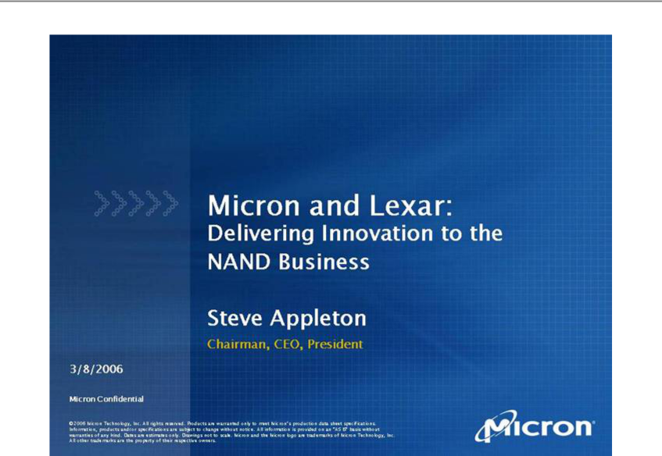

Link to searchable text of slide shown above

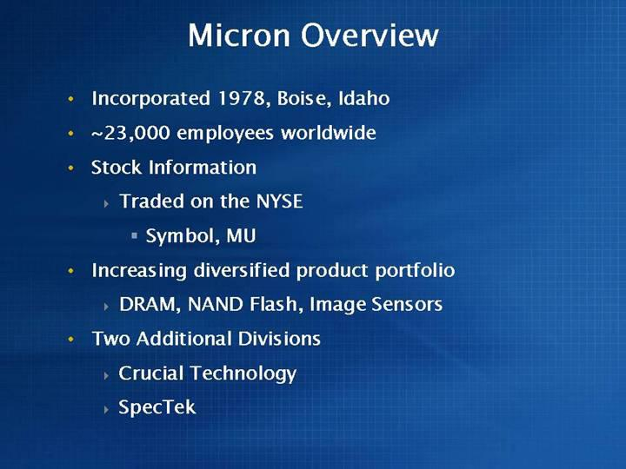

Link to searchable text of slide shown above
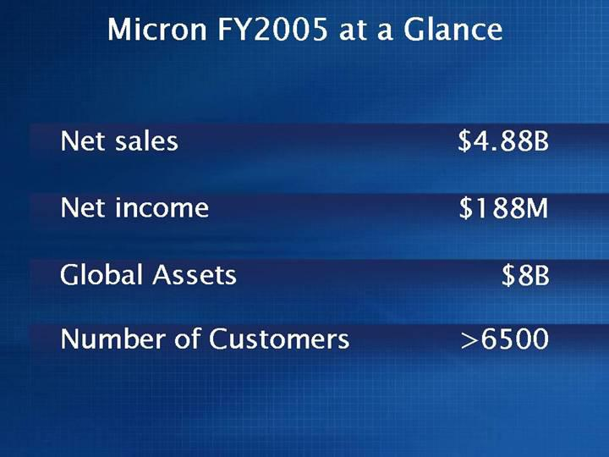

Link to searchable text of slide shown above

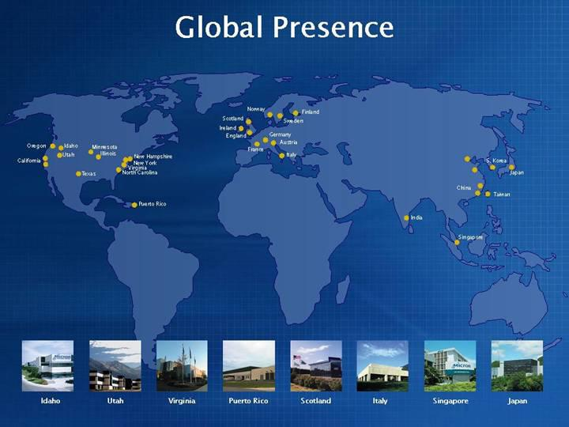

Link to searchable text of slide shown above

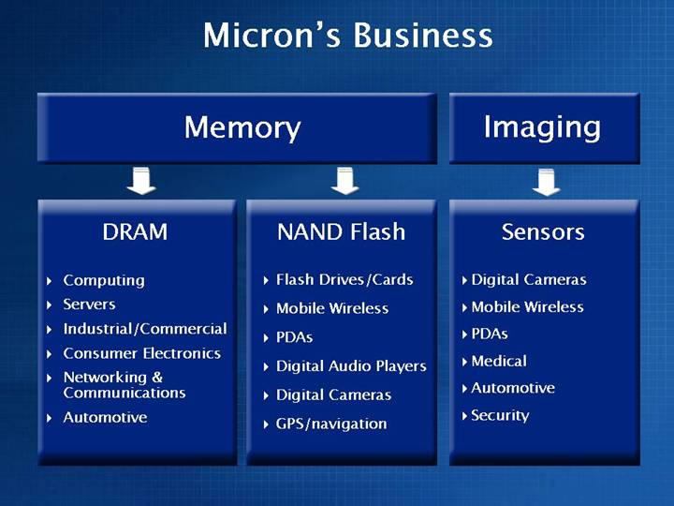

Link to searchable text of slide shown above
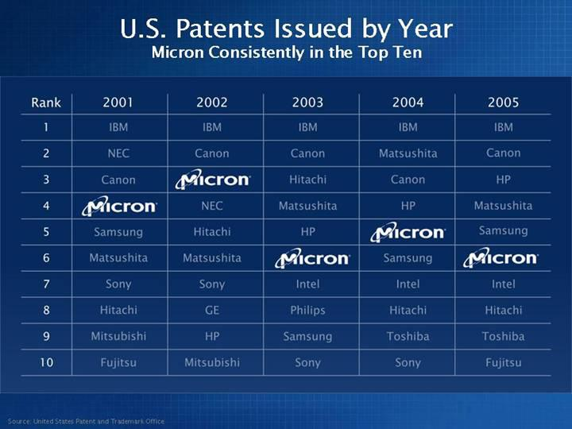

Link to searchable text of slide shown above

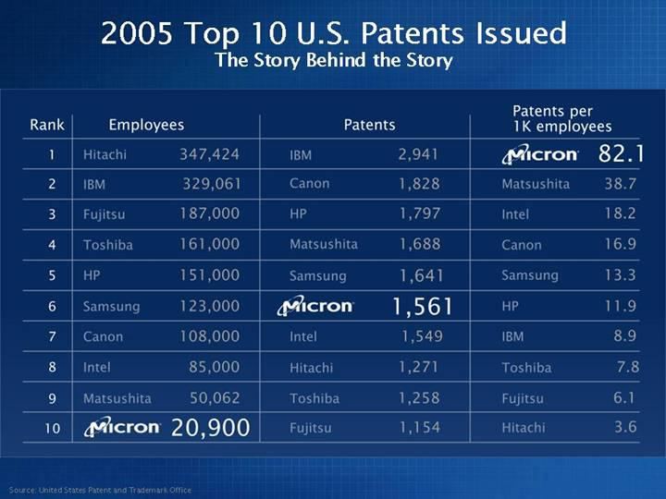

Link to searchable text of slide shown above

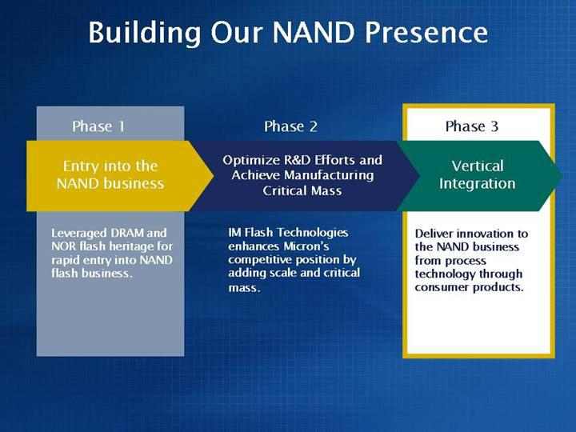

Link to searchable text of slide shown above
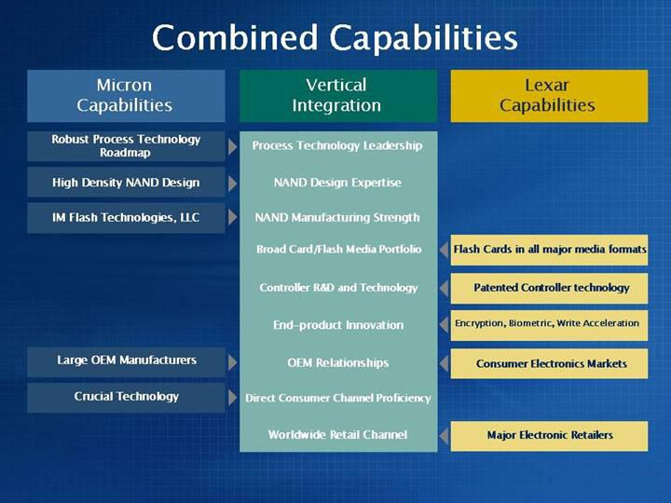

Link to searchable text of slide shown above

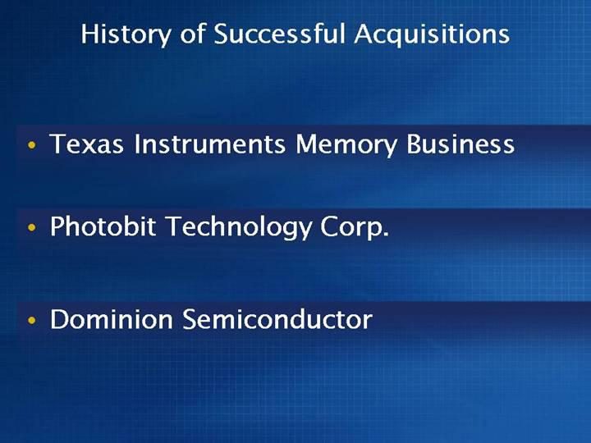

Link to searchable text of slide shown above

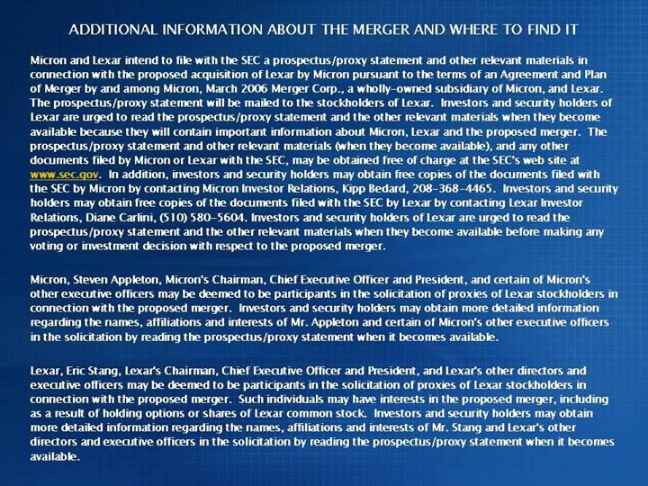

Link to searchable text of slide shown above
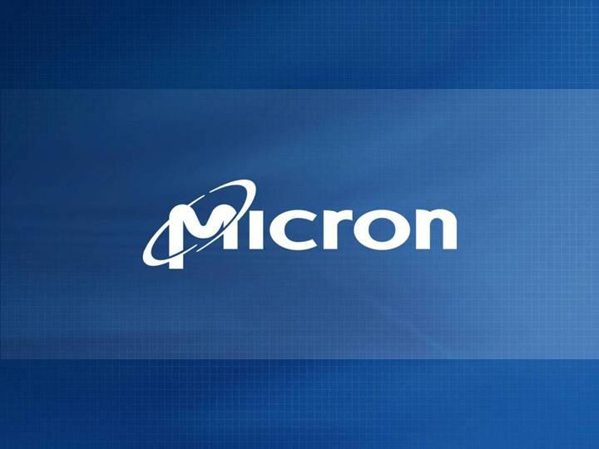

Link to searchable text of slide shown above

Searchable text section of graphics shown above

[GRAPHIC]

Micron and Lexar:

Delivering Innovation to the NAND Business

Steve Appleton

Chairman, CEO, President

3/8/2006

Micron Confidential

©2006 Micron Technology, Inc. All rights reserved. Products are warranted only to meet Micron’s production data sheet specifications. Information, products and/or specifications are subject to change without notice. All information is provided on an “AS IS” basis without warranties of any kind. Dates are estimates only. Drawings not to scale. Micron and the Micron logo are trademarks of Micron Technology, Inc. All other trademarks are the property of their respective owners.

[LOGO]

Micron Overview

- Incorporated 1978, Boise, Idaho

- ~23,000 employees worldwide

- Stock Information

  - Traded on the NYSE

    - Symbol, MU

- Increasing diversified product portfolio

  - DRAM, NAND Flash, Image Sensors

- Two Additional Divisions

  - Crucial Technology

  - SpecTek

 |  | Micron FY2005 at a Glance
 | Net sales | $ | 4.88B
 | Net income | $ | 188M
 | Global Assets | $ | 8B
 | Number of Customers | >6500

Global Presence

[GRAPHIC]

[GRAPHIC] [GRAPHIC] [GRAPHIC] [GRAPHIC] [GRAPHIC] [GRAPHIC] [GRAPHIC] [GRAPHIC]

Idaho Utah Virginia Puerto Rico Scotland Italy Singapore Japan

 |  |  | Micron’s Business
 | Memory |  |  |  | Imaging
 | DRAM |  | NAND Flash |  | Sensors
• | Computing | • | Flash Drives/Cards | • | Digital Cameras
• | Servers | • | Mobile Wireless | • | Mobile Wireless
• | Industrial/Commercial | • | PDAs | • | PDAs
• | Consumer Electronics | • | Digital Audio Players | • | Medical
• | Networking & Communications | • | Digital Cameras | • | Automotive
• | Automotive | • | GPS/navigation | • | Security

U.S. Patents Issued by Year

Micron Consistently in the Top Ten

Rank |  | 2001 |  | 2002 |  | 2003 |  | 2004 |  | 2005
1 |  | IBM |  | IBM |  | IBM |  | IBM |  | IBM
2 |  | NEC |  | Canon |  | Canon |  | Matsushita |  | Canon
3 |  | Canon |  | Micron® |  | Hitachi |  | Canon |  | HP
4 |  | Micron® |  | NEC |  | Matsushita |  | HP |  | Matsushita
5 |  | Samsung |  | Hitachi |  | HP |  | Micron® |  | Samsung
6 |  | Matsushita |  | Matsushita |  | Micron® |  | Samsung |  | Micron®
7 |  | Sony |  | Sony |  | Intel |  | Intel |  | Intel
8 |  | Hitachi |  | GE |  | Philips |  | Hitachi |  | Hitachi
9 |  | Mitsubishi |  | HP |  | Samsung |  | Toshiba |  | Toshiba
10 |  | Fujitsu |  | Mitsubishi |  | Sony |  | Sony |  | Fujitsu

Source: United States Patent and Trademark Office

2005 Top 10 U.S. Patents Issued

The Story Behind the Story

Rank |  | Employees |  |  |  |  | Patents |  |  | Patents Per 1K employees
1 |  | Hitachi | 347,424 |  |  | IBM | 2,941 |  | Micron® | 82.1
2 | IBM |  | 329,061 |  | Canon |  | 1,828 |  | Matsushita | 38.7
3 | Fujitsu |  | 187,000 |  | HP |  | 1,797 |  | Intel | 18.2
4 | Toshiba |  | 161,000 |  | Matsushita |  | 1,688 |  | Canon | 16.9
5 | HP |  | 151,000 |  | Samsung |  | 1,641 |  | Samsung | 13.3
6 | Samsung |  | 123,000 |  | Micron® |  | 1,561 |  | HP | 11.9
7 | Canon |  | 108,000 |  | Intel |  | 1,549 |  | IBM | 8.9
8 | Intel |  | 85,000 |  | Hitachi |  | 1,271 |  | Toshiba | 7.8
9 | Matsushita |  | 50,062 |  | Toshiba |  | 1,258 |  | Fujitsu | 6.1
10 | Micron® |  | 20,900 |  | Fujitsu |  | 1,154 |  | Hitachi | 3.6

Source: United States Patent and Trademark Office

Building Our NAND Presence

Phase 1

Phase 2

Phase 3

Entry into the

NAND business

Optimize R&D Efforts and Achieve

Manufacturing Critical Mass

Vertical

Integration

Leveraged DRAM and

IM Flash Technologies

Deliver innovation to

NOR flash heritage for | enhances Micron’s | the NAND business
rapid entry into NAND | competitive position by | from process
flash business. | adding scale and critical | technology through
 | mass. | consumer products.

 | Combined Capabilities
Micron | Vertical | Lexar
Capabilities | Integration | Capabilities
Robust Process Technology Roadmap | Process Technology Leadership
High Density NAND Design | NAND Design Expertise
IM Flash Technologies, LLC | NAND Manufacturing Strength
 | Broad Card/Flash Media Portfolio | Flash Cards in all major media formats
 | Controller R&D and Technology | Patented Controller technology
 | End-product Innovation | Encryption, Biometric, Write Acceleration
Large OEM Manufacturers | OEM Relationships | Consumer Electronics Markets|
Crucial Technology | Direct Consumer Channel Proficiency
 | Worldwide Retail Channel | Major Electronic Retailers

History of Successful Acquisitions

- Texas Instruments Memory Business

- Photobit Technology Corp.

- Dominion Semiconductor

ADDITIONAL INFORMATION ABOUT THE MERGER AND WHERE TO FIND IT

Micron and Lexar intend to file with the SEC a prospectus/proxy statement and other relevant materials in connection with the proposed acquisition of Lexar by Micron pursuant to the terms of an Agreement and Plan of Merger by and among Micron, March 2006 Merger Corp., a wholly-owned subsidiary of Micron, and Lexar. The prospectus/proxy statement will be mailed to the stockholders of Lexar. Investors and security holders of Lexar are urged to read the prospectus/proxy statement and the other relevant materials when they become available because they will contain important information about Micron, Lexar and the proposed merger. The prospectus/proxy statement and other relevant materials (when they become available), and any other documents filed by Micron or Lexar with the SEC, may be obtained free of charge at the SEC’s web site at www.sec.gov. In addition, investors and security holders may obtain free copies of the documents filed with the SEC by Micron by contacting Micron Investor Relations, Kipp Bedard, 208-368-4465. Investors and security holders may obtain free copies of the documents filed with the SEC by Lexar by contacting Lexar Investor Relations, Diane Carlini, (510) 580-5604. Investors and security holders of Lexar are urged to read the prospectus/proxy statement and the other relevant materials when they become available before making any voting or investment decision with respect to the proposed merger.

Micron, Steven Appleton, Micron’s Chairman, Chief Executive Officer and President, and certain of Micron’s other executive officers may be deemed to be participants in the solicitation of proxies of Lexar stockholders in connection with the proposed merger. Investors and security holders may obtain more detailed information regarding the names, affiliations and interests of Mr. Appleton and certain of Micron’s other executive officers in the solicitation by reading the prospectus/proxy statement when it becomes available.

Lexar, Eric Stang, Lexar’s Chairman, Chief Executive Officer and President, and Lexar’s other directors and executive officers may be deemed to be participants in the solicitation of proxies of Lexar stockholders in connection with the proposed merger. Such individuals may have interests in the proposed merger, including as a result of holding options or shares of Lexar common stock. Investors and security holders may obtain more detailed information regarding the names, affiliations and interests of Mr. Stang and Lexar’s other directors and executive officers in the solicitation by reading the prospectus/proxy statement when it becomes available.

[LOGO]

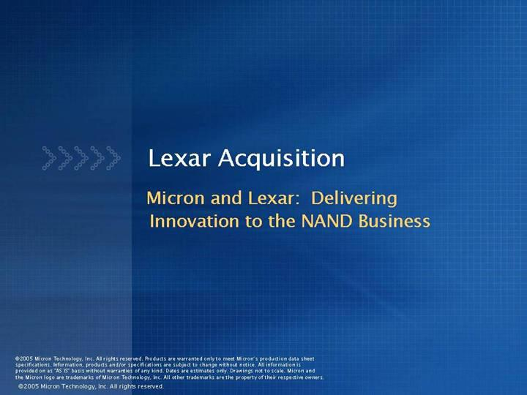

Link to searchable text of slide shown above
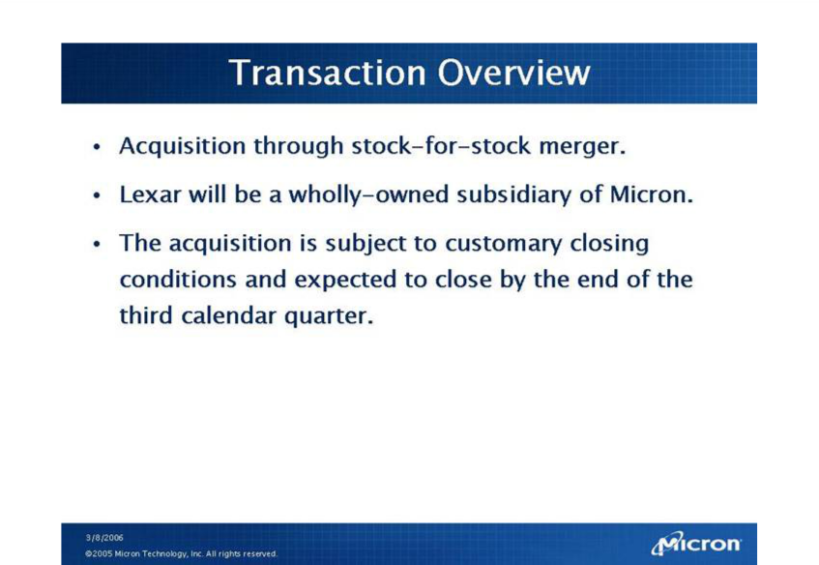

Link to searchable text of slide shown above
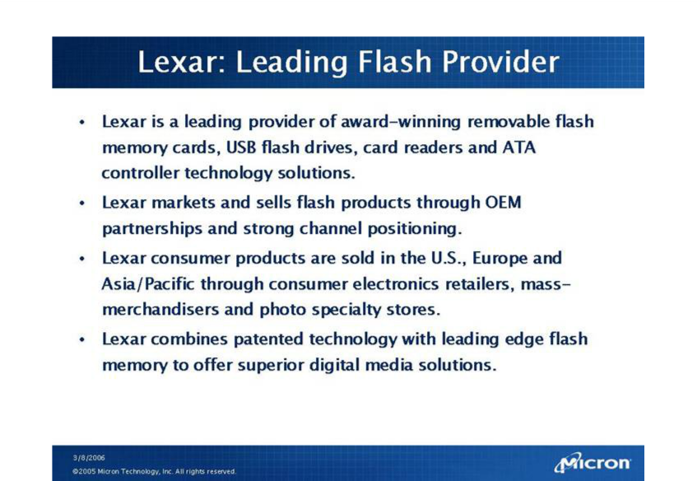

Link to searchable text of slide shown above

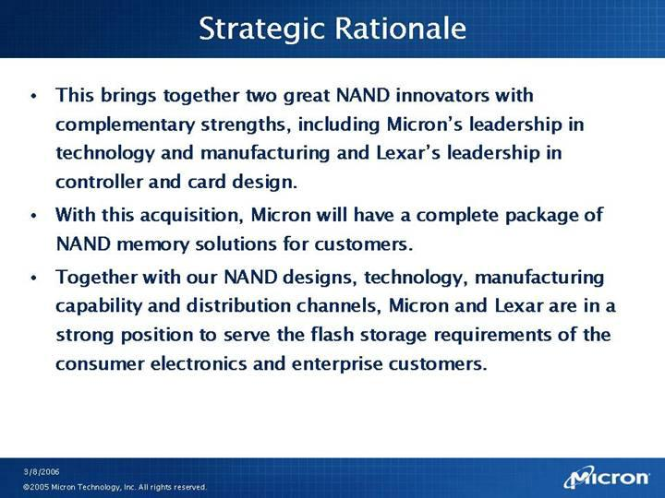

Link to searchable text of slide shown above
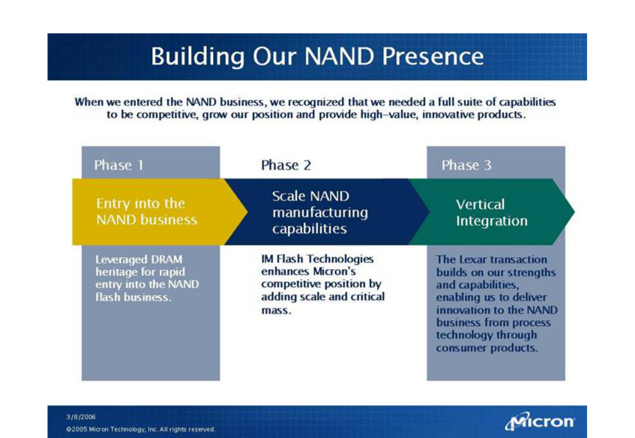

Link to searchable text of slide shown above

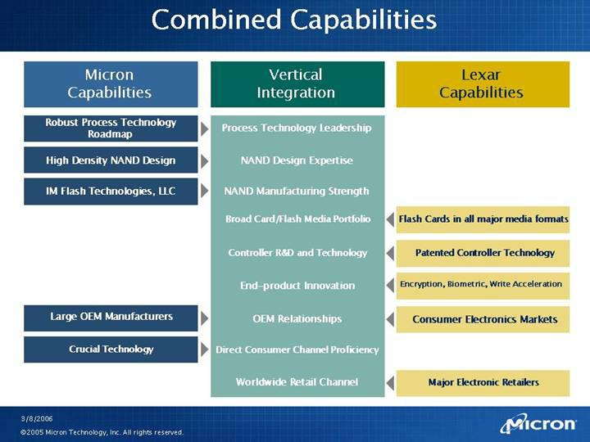

Link to searchable text of slide shown above
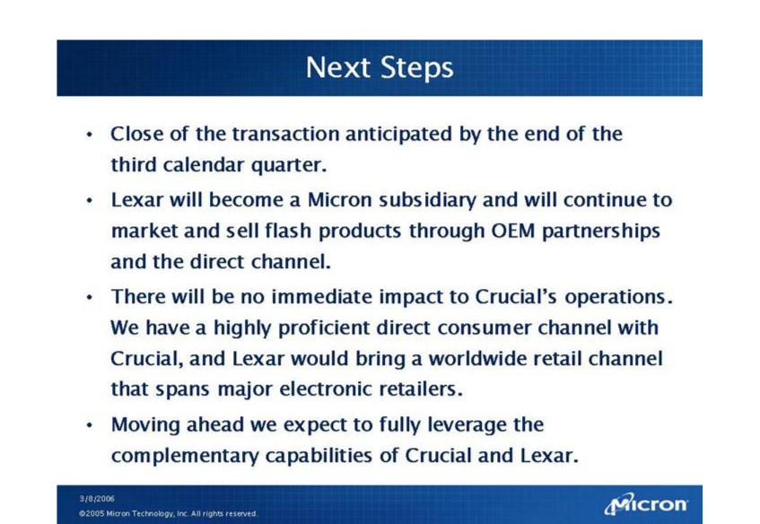

Link to searchable text of slide shown above
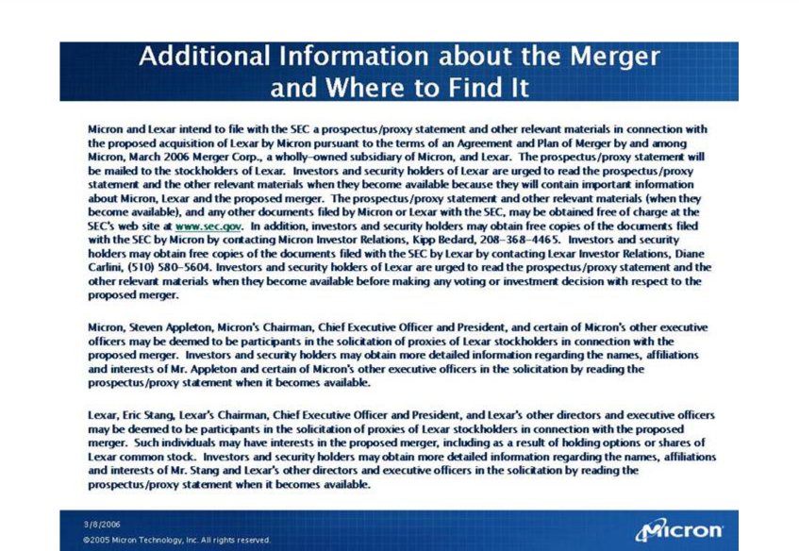

Link to searchable text of slide shown above

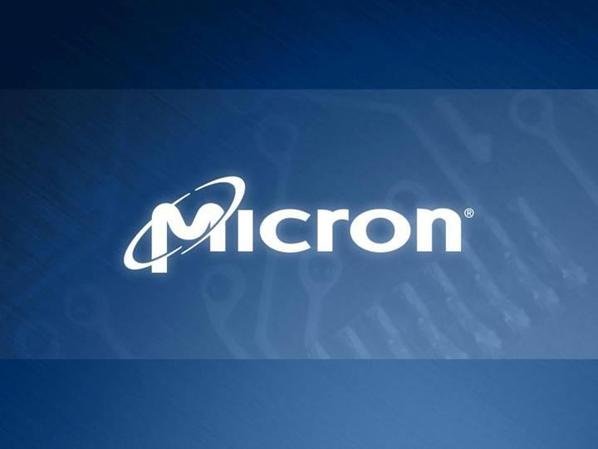

Link to searchable text of slide shown above

Searchable text section of graphics shown above

[GRAPHIC]

Lexar Acquisition

Micron and Lexar: Delivering Innovation to the NAND Business

©2005 Micron Technology, Inc. All rights reserved. Products are warranted only to meet Micron’s production data sheet specifications. Information, products and/or specifications are subject to change without notice. All information is provided on as “AS IS” basis without warranties of any kind. Dates are estimates only. Drawings not to scale. Micron and the Micron logo are trademarks of Micron Technology, Inc. All other trademarks are the property of their respective owners.

©2005 Micron Technology, Inc. All rights reserved.

Transaction Overview

- Acquisition through stock-for-stock merger.

- Lexar will be a wholly-owned subsidiary of Micron.

- The acquisition is subject to customary closing conditions and expected to close by the end of the third calendar quarter.

3/8/2006

©2005 Micron Technology, Inc. All rights reserved.

[LOGO]

Lexar: Leading Flash Provider

- Lexar is a leading provider of award-winning removable flash memory cards, USB flash drives, card readers and ATA controller technology solutions.

- Lexar markets and sells flash products through OEM partnerships and strong channel positioning.

- Lexar consumer products are sold in the U.S., Europe and Asia/Pacific through consumer electronics retailers, mass-merchandisers and photo specialty stores.

- Lexar combines patented technology with leading edge flash memory to offer superior digital media solutions.

Strategic Rationale

- This brings together two great NAND innovators with complementary strengths, including Micron’s leadership in technology and manufacturing and Lexar’s leadership in controller and card design.

- With this acquisition, Micron will have a complete package of NAND memory solutions for customers.

- Together with our NAND designs, technology, manufacturing capability and distribution channels, Micron and Lexar are in a strong position to serve the flash storage requirements of the consumer electronics and enterprise customers.

Building Our NAND Presence

When we entered the NAND business, we recognized that we needed a full suite of capabilities to be competitive, grow our position and provide high-value, innovative products.

Phase 1 Phase 2 Phase 3

Entry into the NAND business Scale NAND manufacturing capabilities Vertical Integration

Leveraged DRAM heritage for rapid entry into the NAND flash business.

IM Flash Technologies enhances Micron’s competitive position by adding scale and critical mass.

The Lexar transaction builds on our strengths and capabilities, enabling us to deliver innovation to the NAND business from process technology through consumer products.

 | Combined Capabilities
Micron | Vertical | Lexar
Capabilities | Integration | Capabilities
Robust Process Technology Roadmap | Process Technology Leadership
High Density NAND Design | NAND Design Expertise
IM Flash Technologies, LLC | NAND Manufacturing Strength
 | Broad Card/Flash Media Portfolio | Flash Cards in all major media formats
 | Controller R&D and Technology | Patented Controller Technology
 | End-product Innovation | Encryption, Biometric, Write Acceleration
Large OEM Manufacturers | OEM Relationships | Consumer Electronics Markets
Crucial Technology | Direct Consumer Channel Proficiency
 | Worldwide Retail Channel | Major Electronic Retailers

Next Steps

- Close of the transaction anticipated by the end of the third calendar quarter.

- Lexar will become a Micron subsidiary and will continue to market and sell flash products through OEM partnerships and the direct channel.

- There will be no immediate impact to Crucial’s operations. We have a highly proficient direct consumer channel with Crucial, and Lexar would bring a worldwide retail channel that spans major electronic retailers.

- Moving ahead we expect to fully leverage the complementary capabilities of Crucial and Lexar.

Additional Information about the Merger and Where to Find It

Micron and Lexar intend to file with the SEC a prospectus/proxy statement and other relevant materials in connection with the proposed acquisition of Lexar by Micron pursuant to the terms of an Agreement and Plan of Merger by and among Micron, March 2006 Merger Corp., a wholly-owned subsidiary of Micron, and Lexar. The prospectus/proxy statement will be mailed to the stockholders of Lexar. Investors and security holders of Lexar are urged to read the prospectus/proxy statement and the other relevant materials when they become available because they will contain important information about Micron, Lexar and the proposed merger. The prospectus/proxy statement and other relevant materials (when they become available), and any other documents filed by Micron or Lexar with the SEC, may be obtained free of charge at the SEC’s web site at www.sec.gov. In addition, investors and security holders may obtain free copies of the documents filed with the SEC by Micron by contacting Micron Investor Relations, Kipp Bedard, 208-368-4465. Investors and security holders may obtain free copies of the documents filed with the SEC by Lexar by contacting Lexar Investor Relations, Diane Carlini, (510) 580-5604. Investors and security holders of Lexar are urged to read the prospectus/proxy statement and the other relevant materials when they become available before making any voting or investment decision with respect to the proposed merger.

Micron, Steven Appleton, Micron’s Chairman, Chief Executive Officer and President, and certain of Micron’s other executive officers may be deemed to be participants in the solicitation of proxies of Lexar stockholders in connection with the proposed merger. Investors and security holders may obtain more detailed information regarding the names, affiliations and interests of Mr. Appleton and certain of Micron’s other executive officers in the solicitation by reading the prospectus/proxy statement when it becomes available.

Lexar, Eric Stang, Lexar’s Chairman, Chief Executive Officer and President, and Lexar’s other directors and executive officers may be deemed to be participants in the solicitation of proxies of Lexar stockholders in connection with the proposed merger. Such individuals may have interests in the proposed merger, including as a result of holding options or shares of Lexar common stock. Investors and security holders may obtain more detailed information regarding the names, affiliations and interests of Mr. Stang and Lexar’s other directors and executive officers in the solicitation by reading the prospectus/proxy statement when it becomes available.

[LOGO]

Lexar Acquisition

Micron All Employee Email

In my last update, I referenced the many positive changes we are experiencing as Micron evolves. Today I have another milestone to report as we continue to increase the value of the company by furthering the success of our product diversification efforts and our competitiveness in the global marketplace.

We are acquiring a leading flash memory provider, Lexar, in a stock-for-stock merger. Lexar supplies award-winning removable flash memory cards, USB flash drives, card readers and controller technology solutions for the consumer electronics market. Lexar also has healthy OEM partnerships and a strong presence in the retail channel. With this acquisition, Micron gains a complete package of NAND memory solutions for our customers, and we are better able to meet the flash storage requirements of consumer electronics and enterprise customers.

When we entered the NAND business, we recognized that we needed a full suite of capabilities to be competitive, grow our position and provide high-value, innovative products.

In only 18 months, we leveraged our DRAM technology to rapidly build a position in the NAND business. Through the partnership with Intel and recent creation of IM Flash Technologies, we laid the foundation to bring critical mass and scale to our NAND manufacturing.

Our acquisition of Lexar rounds out our capabilities and brings together two great NAND innovators with complementary strengths. We’ll have a complete package of NAND memory solutions to provide to our customers and a robust retail channel that adds to our OEM channel and our direct channel with Crucial Technology.

The acquisition still needs to go through customary closing conditions that we expect to be completed by the end of the third calendar quarter, but this is an exciting development for Micron as we work to increase the value of our company and take leadership strides in key areas like NAND. As the Lexar employees join us in the coming months, please welcome them to the Micron team.

ADDITIONAL INFORMATION ABOUT THE MERGER AND WHERE TO FIND IT

Micron and Lexar intend to file with the SEC a prospectus/proxy statement and other relevant materials in connection with the proposed acquisition of Lexar by Micron pursuant to the terms of an Agreement and Plan of Merger by and among Micron, March 2006 Merger Corp., a wholly-owned subsidiary of Micron, and Lexar. The prospectus/proxy statement will be mailed to the stockholders of Lexar. Investors and security holders of Lexar are urged to read the prospectus/proxy statement and the other relevant materials when they become available because they will contain important information about Micron,

Lexar and the proposed merger. The prospectus/proxy statement and other relevant materials (when they become available), and any other documents filed by Micron or Lexar with the SEC, may be obtained free of charge at the SEC’s web site at www.sec.gov. In addition, investors

and security holders may obtain free copies of the documents filed with the SEC by Micron by contacting Micron Investor Relations, Kipp Bedard, 208-368-4465. Investors and security holders may obtain free copies of the documents filed with the SEC by Lexar by contacting Lexar Investor Relations, Diane Carlini, (510) 580-5604. Investors and security holders of Lexar are urged to read the prospectus/proxy statement and the other relevant materials when they become available before making any voting or investment decision with respect to the proposed merger.

Micron, Steven Appleton, Micron’s Chairman, Chief Executive Officer and President, and certain of Micron’s other executive officers may be deemed to be participants in the solicitation of proxies of Lexar stockholders in connection with the proposed merger. Investors and security holders may obtain more detailed information regarding the names, affiliations and interests of Mr. Appleton and certain of Micron’s other executive officers in the solicitation by reading the prospectus/proxy statement when it becomes available.

Lexar, Eric Stang, Lexar’s Chairman, Chief Executive Officer and President, and Lexar’s other directors and executive officers may be deemed to be participants in the solicitation of proxies of Lexar stockholders in connection with the proposed merger. Such individuals may have interests in the proposed merger, including as a result of holding options or shares of Lexar common stock. Investors and security holders may obtain more detailed information regarding the names, affiliations and interests of Mr. Stang and Lexar’s other directors and executive officers in the solicitation by reading the prospectus/proxy statement when it becomes available.

ADDITIONAL INFORMATION ABOUT THE MERGER AND WHERE TO FIND IT

Micron and Lexar intend to file with the SEC a prospectus/proxy statement and other relevant materials in connection with the proposed acquisition of Lexar by Micron pursuant to the terms of an Agreement and Plan of Merger by and among Micron, March 2006 Merger Corp., a wholly-owned subsidiary of Micron, and Lexar. The prospectus/proxy statement will be mailed to the stockholders of Lexar. Investors and security holders of Lexar are urged to read the prospectus/proxy statement and the other relevant materials when they become available because they will contain important information about Micron, Lexar and the proposed merger. The prospectus/proxy statement and other relevant materials (when they become available), and any other documents filed by Micron or Lexar with the SEC, may be obtained free of charge at the SEC’s web site at www.sec.gov. In addition, investors and security holders may obtain free copies of the documents filed with the SEC by Micron by contacting Micron Investor Relations, Kipp Bedard, 208-368-4465. Investors and security holders may obtain free copies of the documents filed with the SEC by Lexar by contacting Lexar Investor Relations, Diane Carlini, (510) 580-5604. Investors and security holders of Lexar are urged to read the prospectus/proxy statement and the other relevant materials when they become available before making any voting or investment decision with respect to the proposed merger.

Micron, Steven Appleton, Micron’s Chairman, Chief Executive Officer and President, and certain of Micron’s other executive officers may be deemed to be participants in the solicitation of proxies of Lexar stockholders in connection with the proposed merger. Investors and security holders may obtain more detailed information regarding the names, affiliations and interests of Mr. Appleton and certain of Micron’s other executive officers in the solicitation by reading the prospectus/proxy statement when it becomes available.

Lexar, Eric Stang, Lexar’s Chairman, Chief Executive Officer and President, and Lexar’s other directors and executive officers may be deemed to be participants in the solicitation of proxies of Lexar stockholders in connection with the proposed merger. Such individuals may have interests in the proposed merger, including as a result of holding options or shares of Lexar common stock. Investors and security holders may obtain more detailed information regarding the names, affiliations and interests of Mr. Stang and Lexar’s other directors and executive officers in the solicitation by reading the prospectus/proxy statement when it becomes available.

This filing contains forward-looking statements that involve risks and uncertainties concerning Micron’s proposed acquisition of Lexar Media, Inc., Micron’s expected financial performance, as well as Micron’s strategic and operational plans. Actual events or results may differ materially from those described in this press release due to a number of risks and uncertainties. The potential risks and uncertainties include, among others, the possibility that the transaction will not close or that the closing may be delayed; the reaction of customers of Micron and Lexar to the transaction; Micron’s ability to successfully integrate Lexar’s operations and employees; and general economic conditions. In addition, please refer to the documents that Micron and Lexar file with the Securities and Exchange Commission on Forms 10-K, 10-Q and 8-K. The filings by each of Micron and Lexar identify and address other important factors that could cause their respective financial and operational results to differ materially from those contained in the forward-looking statements set forth in this press release. Micron and Lexar are under no duty to update any of the forward-looking statements after the date of this press release to conform to actual results.

