UNITED STATES

SECURITIES AND EXCHANGE COMMISSION

Washington, D.C. 20549

FORM 8-K

CURRENT REPORT

Pursuant to Section 13 or 15(d) of The Securities Exchange Act of 1934

September 8, 2016

Date of Report (date of earliest event reported)

MICRON TECHNOLOGY, INC.

(Exact name of registrant as specified in its charter)

Delaware | 1-10658 | 75-1618004
(State or other jurisdiction of incorporation) | (Commission File Number) | (I.R.S. Employer Identification No.)

8000 South Federal Way

Boise, Idaho 83716-9632

(Address of principal executive offices)

(208) 368-4000

(Registrant’s telephone number, including area code)

Check the appropriate box below if the Form 8-K filing is intended to simultaneously satisfy the filing obligation of the registrant under any of the following provisions (see General Instruction A.2. below):

- Written communications pursuant to Rule 425 under the Securities Act (17 CFR 230.425)

- Soliciting material pursuant to Rule 14a-12 under the Exchange Act (17 CFR 240.14a-12)

- Pre-commencement communications pursuant to Rule 14d-2(b) under the Exchange Act (17 CFR 240.14d-2(b))

- Pre-commencement communications pursuant to Rule 13e-4(c) under the Exchange Act (17 CFR 240.13e-4c))

Item 8.01. Other Events.

On September 8, 2016, the Company's Chief Financial Officer, Ernest E. Maddock, presented the materials included in Exhibit 99.1 at the Citi Global Tech Conference in New York, New York.

The information set forth in this Item 8.01 is intended to be furnished under Item 8.01 of Form 8-K. This information shall not be deemed "filed" for purposes of Section 18 of the Securities Exchange Act of 1934, as amended (the "Exchange Act"), or otherwise subject to the liabilities of that section. In addition, this information shall not be incorporated by reference into any registration statement filing under the Securities Act of 1933, as amended, or the Exchange Act, regardless of any general incorporation language in such filing, unless it is specifically incorporated by reference in such filing.

The Company is furnishing certain information regarding its business on Exhibit 99.1 to this report.

Item 9.01. Financial Statements and Exhibits.

(d) Exhibits.

Exhibit No. |  | Description
99.1 |  | Disclosure regarding Micron Technology, Inc.'s business.

SIGNATURE

Pursuant to the requirements of the Securities Exchange Act of 1934, the Registrant has duly caused this report to be signed on its behalf by the undersigned hereunto duly authorized.

 |  | MICRON TECHNOLOGY, INC.
Date: | September 8, 2016 | By: | /s/ Ernest E. Maddock
 |  | Name:
 |  | Name: | Ernest E. Maddock
 |  | Title: | Chief Financial Officer and
 |  |  | Vice President, Finance

INDEX TO EXHIBITS FILED WITH

THE CURRENT REPORT ON FORM 8-K

Exhibit Description

99.1 Disclosure regarding Micron Technology, Inc.'s business.

Exhibit 99.1
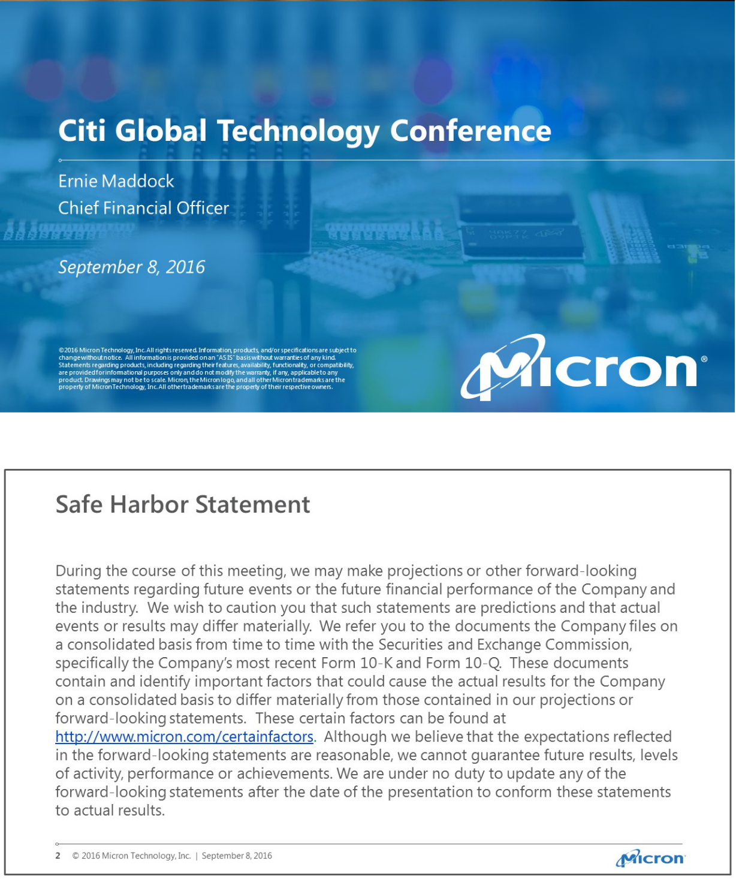

1

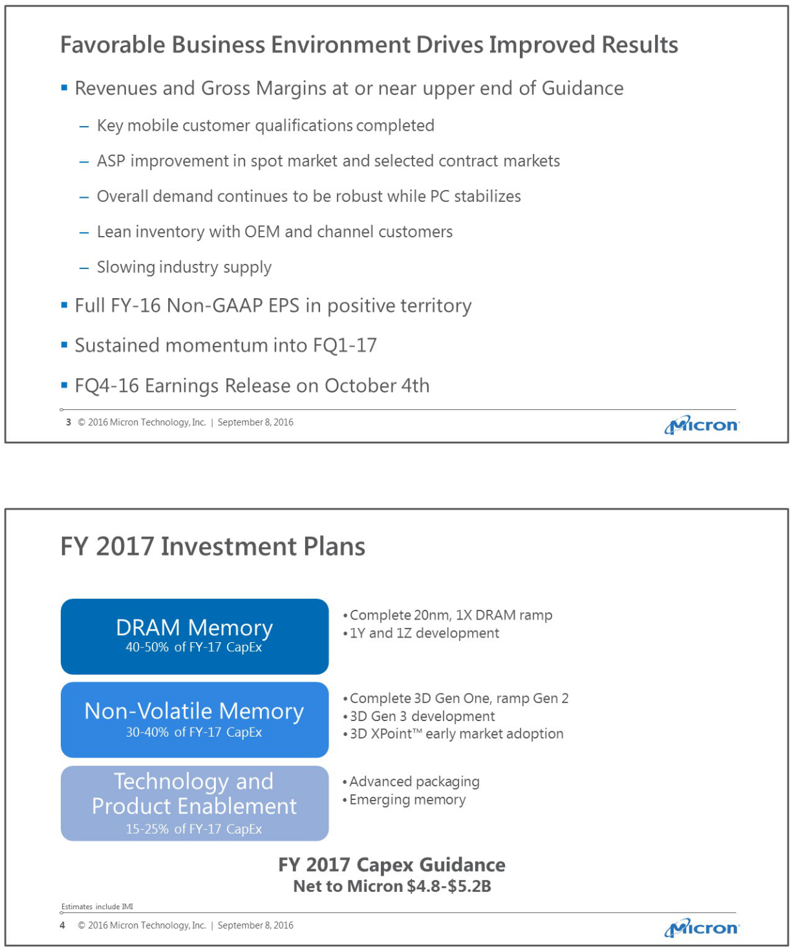

2

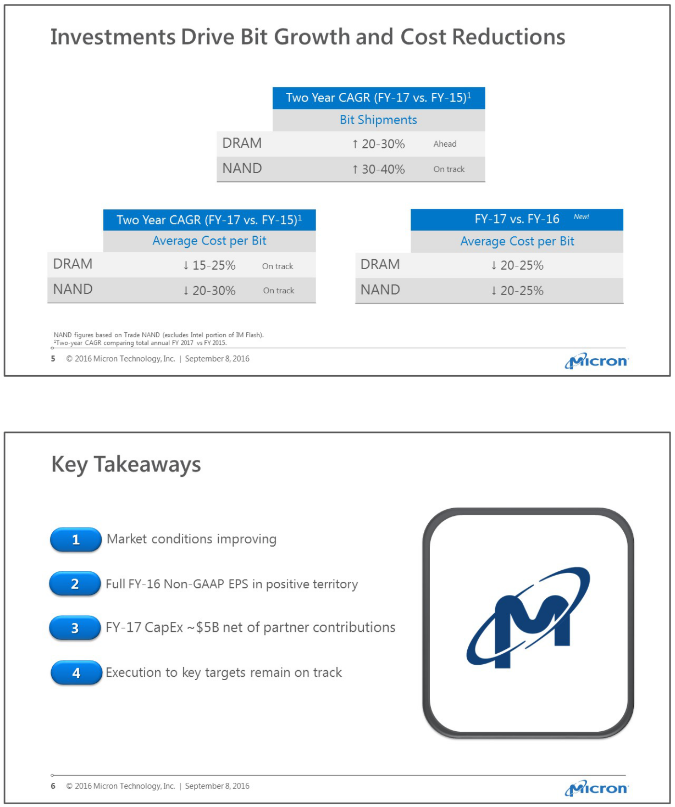

3

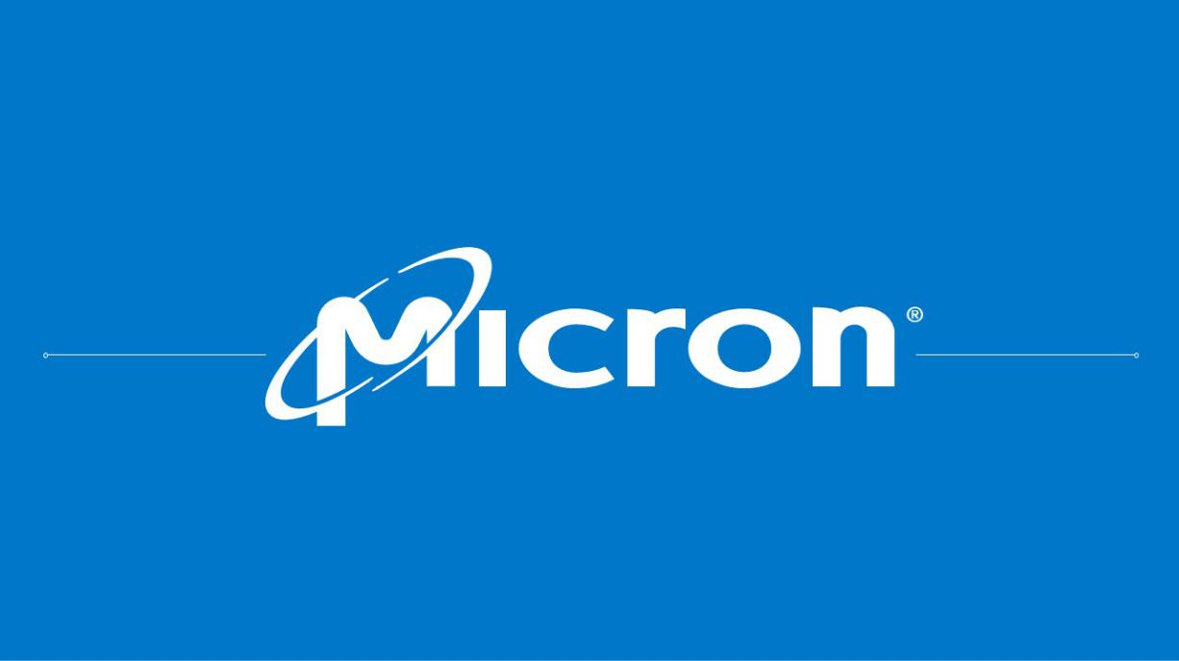

4

