UNITED STATES SECURITIES AND EXCHANGE

COMMISSION

Washington, D.C. 20549

FORM 8-K

CURRENT REPORT

Pursuant to Section 13 OR 15(d) of the Securities Exchange Act of 1934

July 23, 2014

Date of Report (date of earliest event reported)

MICRON TECHNOLOGY, INC.

(Exact name of registrant as specified in its charter)

Delaware

(State or other jurisdiction of

1-10658

(Commission File Number)

75-1618004

(I.R.S. Employer Identification No.)

incorporation)

8000 South Federal Way

Boise, Idaho 83716-9632

(Address of principal executive offices)

(208) 368-4000

(Registrant’s telephone number, including area code)

Check the appropriate box below if the Form 8-K filing is intended to simultaneously satisfy the filing obligation of the registrant under any of the following provisions (see General Instruction A.2. below):

o Written communications pursuant to Rule 425 under the Securities Act (17 CFR 230.425)

o Soliciting material pursuant to Rule 14a-12 under the Exchange Act (17 CFR 240.14a-12)

o Pre-commencement communications pursuant to Rule 14d-2(b) under the Exchange Act (17 CFR 240.14d-2(b))

o Pre-commencement communications pursuant to Rule 13e-4(c) under the Exchange Act (17 CFR 240.13e-4c))

Item 7.01. Regulation FD Disclosure.

The information set forth in this Item 7.01 is intended to be furnished under Item 7.01 of Form 8-K (Regulation FD Disclosure). This information shall not be deemed “filed” for purposes of Section 18 of the Securities Exchange Act of 1934, as amended (the “Exchange Act”), or otherwise subject to the liabilities of that section. In addition, this information shall not be incorporated by reference into any registration statement filing under the Securities Act of 1933, as amended, or the Exchange Act, regardless of any general incorporation language in such filing, unless it is specifically incorporated by reference in such filing.

Micron Technology, Inc. is furnishing certain financial information regarding its business, including the following events that occurred subsequent to May 29, 2014:

- We prepaid a capital lease obligation of approximately $50 million that was due in quarterly installments through 2016. The prepayment of this financing resulted in a reduction of (i) cash of $50 million, (ii) current debt of $23 million and (iii) long-term debt of $27 million.

- We repurchased approximately $28 million and $30 million in aggregate principal amount of our 2.375% convertible senior notes due 2032 and 3.125% convertible senior notes due 2032, respectively, for an aggregate price of approximately $197 million. The repurchase of these notes resulted in reductions in (i) cash aggregating $197 million, (ii) long-term debt aggregating $49 million and (iii) total Micron shareholders’ equity aggregating $148 million.

- We entered into a capital lease obligation for approximately $79 million, resulting in increases in (i) current debt of $15 million and (ii) long-term debt of $64 million.

- We delivered an irrevocable notice to prepay $32 million aggregate principal amount in respect of a term loan, which payment is scheduled to be made on July 31, 2014. The loan is due in semi-annual installments through 2018.

On July 23, 2014, we gave notice to holders of our outstanding 1.875% Convertible Senior Notes due 2031 (the “2031B Notes”) that their notes will be redeemed on August 22, 2014, except to the extent such notes are converted or repurchased by us prior to such date. Based on the current conversion rate of 105.2632 shares per $1,000 principal amount of the 2031B Notes and assuming for purposes of calculating the settlement value under the indenture for the 2031B Notes that the volume weighted average price of our common stock is $33.15 per share (the closing sales price of the our common stock on July 18, 2014) for each trading day of the applicable measurement period, if all of the 2031B Notes were converted prior to the redemption date for such notes, the aggregate amount the we would be required to pay with respect to such conversions if we elected to pay solely cash upon conversion, which is our current intent, would be approximately $402 million. Based on such assumptions, we expect to incur a non-operating loss of $28 million on the conversion and settlement of the 2031B Notes.

As used herein, “we,” “our,” “us” and similar terms included herein refer to Micron Technology, Inc. and its subsidiaries.

We are furnishing certain information regarding our business on Exhibit 99.1 to this report.

Item 8.01. Other Events.

On July 23, 2014, we issued a press release announcing that we propose to offer $750.0 million aggregate principal amount of Senior Notes due 2025 (the “Notes”). We intend to use a portion of the net proceeds from the offering to extinguish our obligations with respect to our 2031B Notes, which may include payments in settlement of conversions of, or to repurchase or redeem, the 2031B Notes. We expect to use the balance of the net proceeds for retirement of other convertible notes and debt and other general corporate purposes. A copy of the press release is attached as Exhibit 99.2 and is incorporated herein by reference.

Item 9.01. Financial Statements and Exhibits.

 | (d) Exhibits.
 | The following exhibits are filed herewith:
Exhibit No. |  | Description
99.1 |  | Disclosure regarding Micron Technology, Inc.’s Business.
99.2 | Press Release of Micron Technology, Inc., dated July 23, 2014, announcing that we propose to offer senior notes.
 | 2

SIGNATURE

Pursuant to the requirements of the Securities Exchange Act of 1934, the Registrant has duly caused this report to be signed on its behalf by the undersigned hereunto duly authorized.

 | MICRON TECHNOLOGY, INC.
Date: July 23, 2014 | By: | /s/ Ronald C. Foster
 | Name: | Ronald C. Foster
 | Title: | Chief Financial Officer and
 |  | Vice President of Finance
 | 3

 |  | INDEX TO EXHIBITS FILED WITH
 |  | THE CURRENT REPORT ON FORM 8-K
Exhibit No. |  | Description
99.1 |  | Disclosure regarding Micron Technology, Inc.’s Business.
99.2 | Press Release of Micron Technology, Inc., dated July 23, 2014, announcing that we propose to offer senior notes.
 | 4

Exhibit 99.1
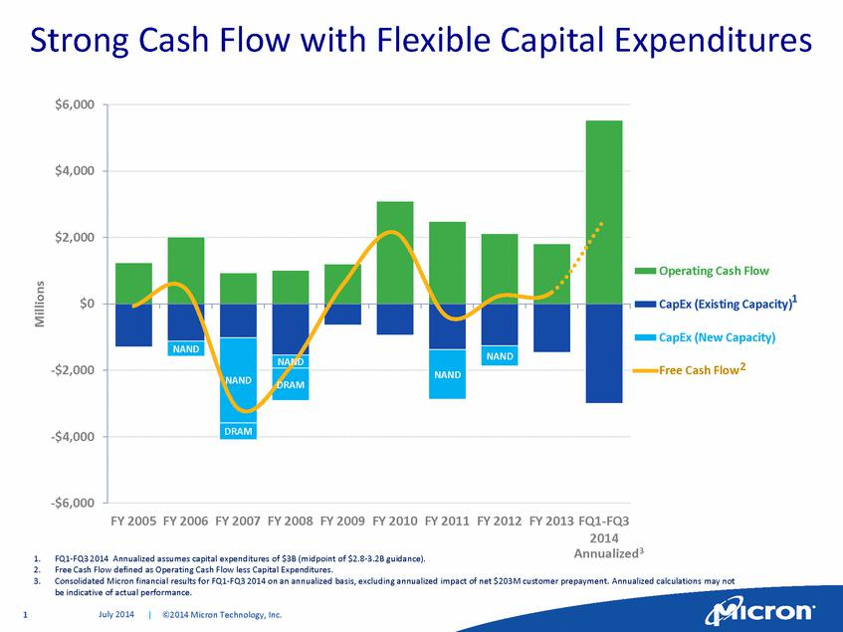

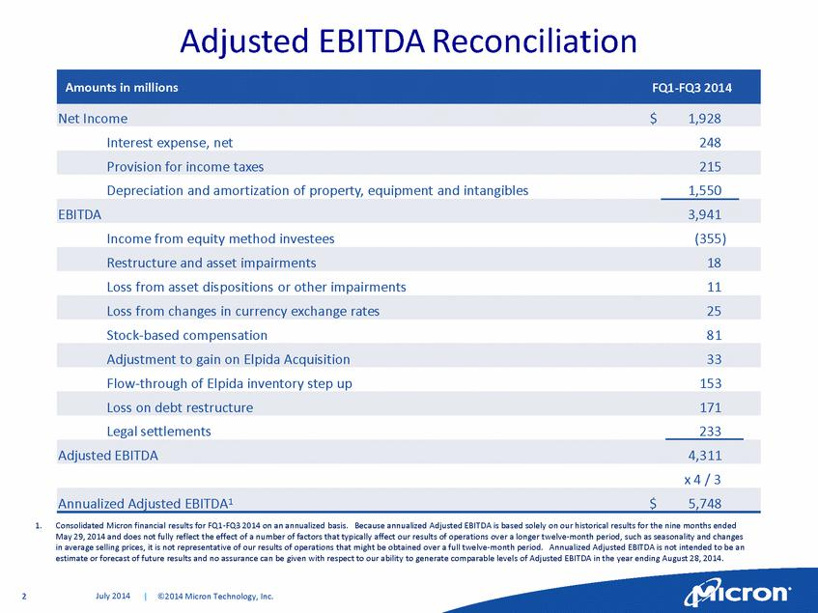

Exhibit 99.2

FOR IMMEDIATE RELEASE
Contacts: | Kipp A. Bedard | Daniel Francisco
 | Investor Relations | Media Relations
 | kbedard@micron.com | dfrancisco@micron.com
 | (208) 368-4465 | (208) 368-5584

MICRON ANNOUNCES PROPOSED $750 MILLION OFFERING OF SENIOR NOTES

BOISE, Idaho, July 23, 2014 — Micron Technology, Inc., (NASDAQ: MU) today announced that it intends to offer, subject to market and other considerations, $750 million aggregate principal amount of senior notes due 2025 (the “Notes”) through an offering to qualified institutional buyers pursuant to Rule 144A under the Securities Act of 1933, as amended (the “Securities Act”), and outside the United States to non-U.S. persons pursuant to Regulation S under the Securities Act.

The interest rate, redemption provisions and other terms of the Notes will be determined by negotiations between Micron and the initial purchasers.

Micron intends to use a portion of the net proceeds from the offering to extinguish its obligations with respect to its 1.875% convertible senior notes due 2031 (the “2031B Notes”), which may include payments in settlement of conversions of or to repurchase or redeem such notes. Micron expects to use the balance of the net proceeds for retirement of other convertible notes and debt and other general corporate purposes. Earlier today, Micron gave notice to holders of the 2031B Notes that their notes will be redeemed on August 22, 2014, except to the extent such notes are converted or repurchased by Micron prior to such date, and its current intent is to settle any such conversions entirely in cash with a portion of the proceeds from the offering.

This announcement does not constitute an offer to sell or a solicitation of an offer to buy any of the foregoing securities, nor shall there be any offer, solicitation or sale in any state or jurisdiction in which such an offer, solicitation or sale would be unlawful.

The Notes have not been registered under the Securities Act or any state securities laws and may not be offered or sold in the United States absent registration or an applicable exemption from such registration requirements.

