Registration No. 333-220882

SECURITIES AND EXCHANGE COMMISSION

Washington, D.C. 20549

FORM T-1

STATEMENT OF ELIGIBILITY UNDER

THE TRUST INDENTURE ACT OF 1939 OF A
CORPORATION DESIGNATED TO ACT AS TRUSTEE
Check if an Application to Determine Eligibility of
a Trustee Pursuant to Section 305(b)(2) x

U.S. BANK NATIONAL ASSOCIATION

(Exact name of Trustee as specified in its charter)

31-0841368

I.R.S. Employer Identification No.

800 Nicollet Mall

Minneapolis, Minnesota

(Address of principal executive offices)

55402

(Zip Code)

Paula Oswald

U.S. Bank National Association
633 West Fifth Street, 24th Floor, Los Angeles, CA 90071

(213) 615-6043

(Name, address and telephone number of agent for service)

Micron Technology, Inc.

(Issuer with respect to the Securities)

Delaware | 75-1618004
(State or other jurisdiction of incorporation or organization) | (I.R.S. Employer Identification No.)
8000 South Federal Way Boise, Idaho | 83716-9632
(Address of Principal Executive Offices) | (Zip Code)
Debt Securities
(Title of the Indenture Securities)

FORM T-1

Item 1. GENERAL INFORMATION. Furnish the following information as to the Trustee.

- Name and address of each examining or supervising authority to which it is subject. Comptroller of the Currency
Washington, D.C.

- Whether it is authorized to exercise corporate trust powers.

Item 2. AFFILIATIONS WITH OBLIGOR. If the obligor is an affiliate of the Trustee, describe each such affiliation. None
Items 3-15 Items 3-15 are not applicable because to the best of the Trustee’s knowledge, the obligor is not in default under any Indenture for which the Trustee acts as Trustee.

Item 16. LIST OF EXHIBITS: List below all exhibits filed as a part of this statement of eligibility and qualification.

  - A copy of the Articles of Association of the Trustee.*

  - A copy of the certificate of authority of the Trustee to commence business, attached as Exhibit 2.

  - A copy of the certificate of authority of the Trustee to exercise corporate trust powers, attached as Exhibit 3.

  - A copy of the existing bylaws of the Trustee.**

  - A copy of each Indenture referred to in Item 4. Not applicable.

  - The consent of the Trustee required by Section 321(b) of the Trust Indenture Act of 1939, attached as Exhibit 6.

  - Report of Condition of the Trustee as of September 30, 2018 published pursuant to law or the requirements of its supervising or examining authority, attached as Exhibit 7.

* Incorporated by reference to Exhibit 25.1 to Amendment No. 2 to registration statement on S-4, Registration Number 333-128217 filed on November 15, 2005.

- Incorporated by reference to Exhibit 25.1 to registration statement on form S-3ASR, Registration Number 333-199863 filed on November 5, 2014. 2

SIGNATURE

Pursuant to the requirements of the Trust Indenture Act of 1939, as amended, the Trustee, U.S. BANK NATIONAL ASSOCIATION, a national banking association organized and existing under the laws of the United States of America, has duly caused this statement of eligibility and qualification to be signed on its behalf by the undersigned, thereunto duly authorized, all in the City of Los Angeles, State of California on the 31st Day of January, 2019.

By: /s/ Paula Oswald

Paula Oswald

Vice President

3

Exhibit 2
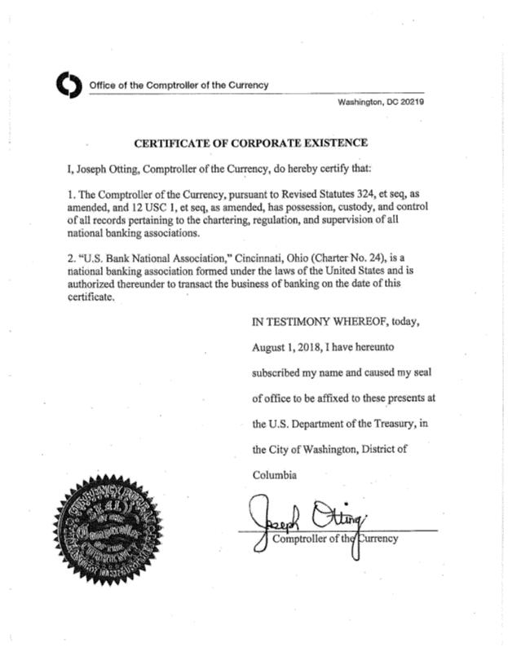

4

Exhibit 3
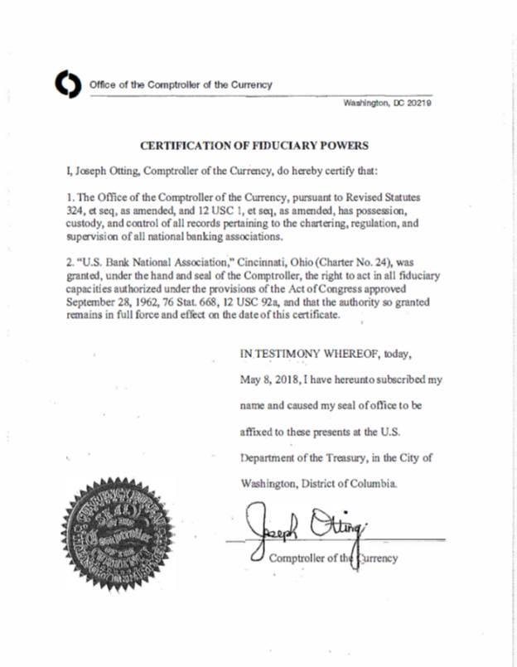

5

Exhibit 6

CONSENT

In accordance with Section 321(b) of the Trust Indenture Act of 1939, the undersigned, U.S. BANK NATIONAL ASSOCIATION hereby consents that reports of examination of the undersigned by Federal, State, Territorial or District authorities may be furnished by such authorities to the Securities and Exchange Commission upon its request therefor.

Dated: January 31, 2019

By: /s/ Paula Oswald

Paula Oswald

Vice President

6

 |  |  | Exhibit 7
 |  | U.S. Bank National Association
 |  | Statement of Financial Condition
 |  | As of 9/30/2018
 |  |  | ($000’s)
 |  |  |  |  |  | 9/30/2018
 | Assets
 | Cash and Balances Due From Depository Institutions | $ |  |  |  | 20,003,448
 | Securities |  |  |  |  | 110,034,104
 | Federal Funds |  |  |  |  | 31,434
 | Loans & Lease Financing Receivables |  |  |  |  | 281,653,128
 | Fixed Assets |  |  |  |  | 3,819,093
 | Intangible Assets |  |  |  |  | 13,233,498
 | Other Assets |  |  |  |  | 27,236,326
 | Total Assets |  |  |  | $ | 456,011,031
 | Liabilities
 | Deposits | $ |  |  |  | 342,906,860
 | Fed Funds |  |  |  |  | 6,964,321
 | Treasury Demand Notes |  |  |  |  | 0
 | Trading Liabilities |  |  |  |  | 977,478
 | Other Borrowed Money |  |  |  |  | 38,881,574
 | Acceptances |  |  |  |  | 0
 | Subordinated Notes and Debentures |  |  |  |  | 3,800,000
 | Other Liabilities |  |  |  |  | 14,600,333
 | Total Liabilities |  |  |  | $ | 408,130,566
 | Equity
 | Common and Preferred Stock |  |  |  |  | 18,200
 | Surplus |  |  |  |  | 14,266,915
 | Undivided Profits |  |  |  |  | 32,793,053
 | Minority Interest in Subsidiaries |  |  |  |  | 802,297
 | Total Equity Capital |  |  |  | $ | 47,880,465
 | Total Liabilities and Equity Capital | $ |  |  |  | 456,011,031
 |  | 7

